Fluids filling information
KDI 3404 TM Workshop Manual (Rev. 08.4)

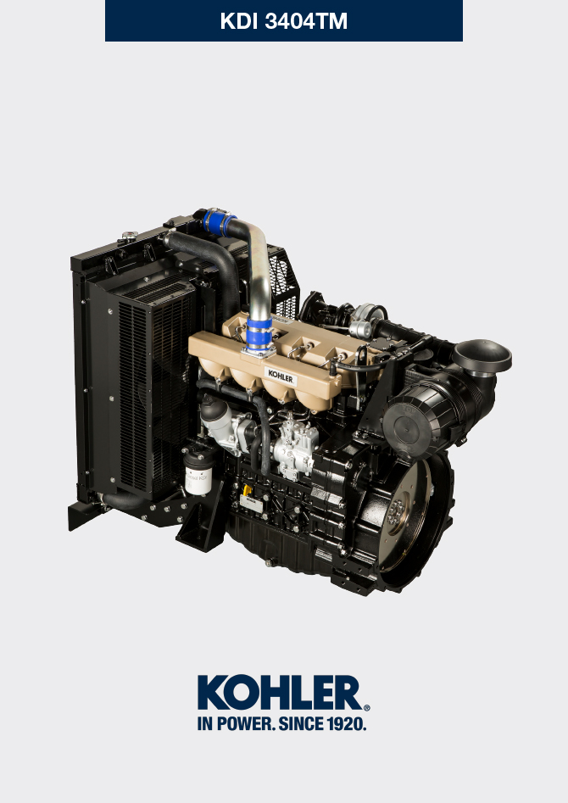

Registration of modifications to the document
Any modifications to this document must be registered by the drafting body, by completing the following table.

Released by | Code | Revision | Release Date | Revision date | Edited by | Endorsed
 | manoff

Translated from the original manual in Italian language
Data reported in this issue can be modified at any time by KOHLER.

Sommario
1. TITOLO 1 2
1.1. Asdfsdfsdf 2
1.2. Asdfsdfsdfggg 2

Fluids filling information

Engine oil
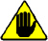
Warning

- Before proceeding with operation, carefully read Par. 3.3.2 .

- Loosen the oil filler cap A .  - Add the type and amount of oil recommended ( Tab. 2.2 ).  - Remove the oil dipstick B and check that the level is up to but does not exceed the MAX .  Important  - Do not use the engine with the level of oil below MIN or above MAX  - If the oil level is not at MAX , insert more oil until the MAX level is reached as indicated on the dipstick.  - Re-tighten the cap A . | 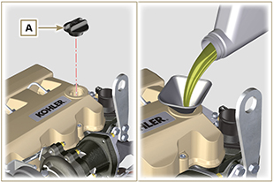  Fig 10.1
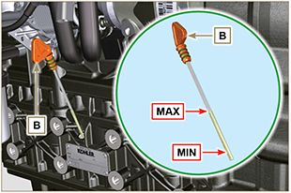
Fig 10.2
NOTE : Click by side to play the procedure. | https://www.youtube.com/embed/AKB8FW8k5rY?rel=0

Coolant
Important

- Before proceeding with operation, read Par. 3.3.2 .
- Fit tube A onto radiator B and secure it with clamp C . | 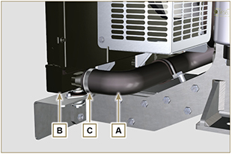  Fig 10.3
- Refill the radiator with coolant (refer to Par. 2.6 for the liquid specifications).  - Top liquid up until the pipes inside the radiator are covered by about 5 mm.  - For engines equipped with separate expansion tank, pour in fluid until reaching the max level mark.  - Loosen the screw F on the head H , release any air and tighten the screw F (Tightening torque of: 8 Nm for screw M6 (Rev. 00); 30 Nm for screw M12 (Rev. 01) ).  - Start the engine without the radiator cap D or the expansion tank cap. | 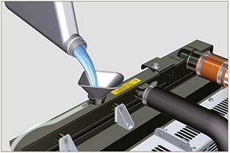  Fig 10.4
- Keep it running at idle speed until the cooling liquid level goes down and becomes steady (the waiting times varies according to the ambient temperature).  - Stop the engine and allow it to cool.  - If there is an expansion tank ( C ) top liquid up to the mark MAX .  - Without expansion tank top liquid up until the pipes inside the radiator are covered by 5 mm. Do not overfill the radiator, but leave room for the coolant to expand.  - Tighten the radiator cap D or the expansion tank cap.  Warning  - Before starting make sure that the radiator cap and expansion tank cap, if present, are installed correctly to avoid spillage of liquid or vapour at high temperatures.  - After a few hours of operation stop the engine and allow it to cool.  Check and top up the coolant liquid. | 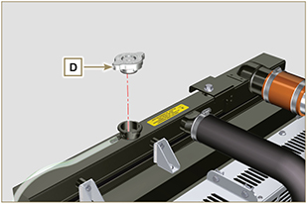  Fig 10.5  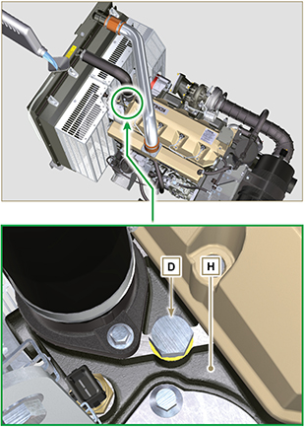  Fig 10.6
NOTE: Click on the right to play the procedure. | https://www.youtube.com/embed/AHBKX3Q90p4?rel=0

