Technical information
KDI-TCP 3404 E5 Owner Manual (REV. 01.2)

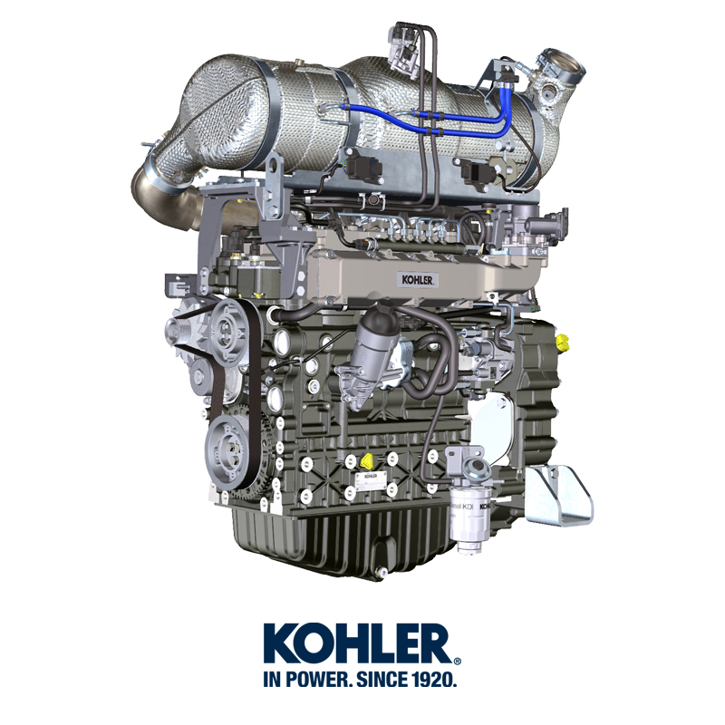

Registration of modifications to the document
Any modifications to this document must be registered by the drafting body, by completing the following table.

Released by | Code | Revision | Release Date | Revision date | Edited by | Endorsed
 | 3404tcr

Translated from the original manual in Italian language
Data reported in this issue can be modified at any time by KOHLER.

Sommario
1. TITOLO 1 2
1.1. Asdfsdfsdf 2
1.2. Asdfsdfsdfggg 2

Technical information

General description of the engine
- 4-stroke, in-line cylinders Diesel engine; - Liquid-cooling system;

- 4 valves per cylinder with hydraulic tappets;

- Turbocharger with Waste-gate valve;

- Common rail - Direct injection.

Engine specifications
2.1
TECHNICAL DATA |  | UNIT OF MEASURE
Engine type |  |  | KDI-TCP 3404 E5
Cylinders |  | n. | 4
Bore |  | mm | 96
Stroke |  | mm | 116
Displacement |  | cm ³ | 3359
MAX INCLINATION DURING OPERATION (even in combined) |  | α | 40° max 30 min.
 |  | α | 45° max 1 min.
OIL CAPACITY (MAX level.) including oil filter | standard version | lt. | 15.6
DRY WEIGHT |  |  | 394

Oil

Important

- The engine may be damaged if operated with improper oil level.
- Do not exceed the MAX level because a sudden increase in engine rpm could be caused by its combustion.
- Use only the recommended oil to ensure adequate protection, efficiency and service life of the engine.
- The use of lubricants other than recommended may shorten the engine life.
- Viscosity must be appropriate to the ambient temperature to which the engine is to be exposed.

Danger

- Prolonged skin contact with the exhausted engine oil can cause cancer of the skin.
- If contact with oil cannot be avoided, thoroughly wash your hands with soap and water as soon as possible.
- For the exhausted oil disposal, refer to the Par. DISPOSAL and SCRAPPING .
2.4.1 SAE oil classification
- In the SAE classification, oils are identified according to viscosity without considering any other qualitative characteristic.
- The code is composed of two numbers, which indicate, and must correspond to, the ambient temperature in which the engine operates, the first number refers to the viscosity when cold, for use during winter (" W "), while the second number is for viscosity at high temperatures.

2.2
RECCOMENDED OIL
 |  | TCR STAGE-V (*1) (*2) | TCR TIER IV FINAL (*1) | TCR/D TIER III o NON CERTIFICATO (*3)
WITH SPECIFICATIONS | API | CJ-4 Low S.A.P.S  CK-4 Low S.A.P.S | CJ-4 Low S.A.P.S  CK-4 Low S.A.P.S | CI-4 Plus  CI-4  CH-4
 | ACEA | E6 Low S.A.P.S. | E6 Low S.A.P.S. | E7  E4
VISCOSITY | SAE | 0w-40 (-40°C ÷ +50°C)  5w-40 (-30°C ÷ +50°C)  10w-40 (-25°C ÷ +50°C) | 0w-40 (-40°C ÷ +50°C)  5w-40 (-30°C ÷ +50°C)  10w-40 (-25°C ÷ +50°C) | 0w-40 (-40°C ÷ +50°C)  5w-40 (-30°C ÷ +50°C)  10w-40 (-25°C ÷ +50°C)
- Low S.A.P.S. technology (oil with low Sulfated Ash, Phosphorus, Sulfur content) keeps catalyst in good working conditions. The presence of sulfated ash, phosphorus and sulfur causes with time the catalyst clogging and its consequent inefficiency.
- For Mid S.A.P.S oil sequence the sulfated ash level is the same as API CJ-4 ≤ 1.0% but as per ACEA standardization those oils are referenced as mid SAPS.
- Filtration of oils is critical to proper operation and lubrication; always change filters regularly as specified in this manual.

(*1) NOTA : Do NOT use fuel with sulphur content above 15ppm.

(*2) - On all engines compliant with Stage-V emission regulation (engines with DPF device), the oil to use must comply with the specification API CJ-4 Low S.A.P.S or ACEA E6 Low S.A.P.S.

(*3) - NOTE : Do NOT use fuel with sulphur content above 500ppm.

(*3) - NOTE : Low S.A.P.S. oils, sulfate ashes <1% may not be used with fuels with a sulfur content >50ppm.

Fuel
Important  - Use of other types of fuel could damage the engine. Do not use dirty diesel fuel or mixtures of diesel fuel and water since this will cause serious engine faults. | Warning  - Clean fuel prevents the fuel injectors from clogging. Immediately clean up any spillage during refuelling.  - Never store diesel fuel in galvanized containers (i.e. coated with zinc). Diesel fuel and the galvanized coating react chemically to each other, producing flaking that quickly clogs filters or causes fuel pump and/or injector failure.  - Any failure resulting from the use of fuel other than Tab. 2.3, 2.4 will not be covered by warranty.
Cetane number of 40 minimum. Cetane number greater than 47 is preferred, especially for temperatures below –20 °C (–4 °F) or elevations above 1675 m (5500 ft.).

2.3
Certification --> | Stage 5  Stage 4  Stage 3B | Stage 3A | Tier IVF | Tier III | no certification (*1) | Remarks  *1: the regions known as poor lubricity diesel fuel quality or if the engine is operated with Jet fuels, the primary filter must be with lubricity dosing capability. Contact Kohler for information about the approved filter for this purpose .
Fuel Type --> | (EN 590 - DIN 51628) |  |  |  | (EN 590 - DIN 51628) | Do NOT USE vegetable oils as a biofuel not compliant with EN590 prescription.
 | HVO 100% (EN 15940) |  |  |  |  | Power and torque might be 1% to 5% lower due to low fuel density compared to standard diesel fuel.
 | Military NATO Fuel F-54 (S = 10 ppm)
 | JIS K 2204 No.1, No.2
 |  |  | Grade 1-D S15 |  |  | For ambient temperatures below 0°C (32°F) with no arctic fuel available (Grade 1-D S15, Grade 2-D S15, ASTM D 975) use the following additives to prevent possible engine damage with low engine load in cold weather:  - Power Service Diesel Fuel Supplement+Cetane Boost  Different additives are not allowed.  The use of approved additives has no impact on the engine maintenance schedule.  Do NOT USE vegetable oils as a biofuel not compliant with ASTM D975 Grade1 and Grade2 prescription.
 |  |  | Grade 2-D S15
 |  | Sulphur Fuel S < 500 ppm |  | Sulphur Fuel S < 500 ppm
 |  |  |  |  | High Sulphur Fuel S < 2000 ppm
 |  |  |  |  | F-34/F-35 (kerosene, NATO designation) | Operations with Jet Fuels  The jet fuels can be used but only adopting an additional fuel filter with lubricity doser.  Because of lower density and greater leak fuel volume due to lower viscosity, depending on the engine speed and torque, a power loss up to 10% is possible.  There are some problematical fuel proprieties amongst the listed jet fuels (viscosity, lubricating capacities and low boiling point). A slight increase in wear in the injection system is to be expected which can lead to a statistically shorter life of these components. Sulphur content must be below 2000ppm.
 |  |  |  |  | F-44 (kerosene, NATO designation)
 |  |  |  |  | F-63 (kerosene, NATO designation, equivalent to F-34/F-35 with additives)
 |  |  |  |  | JP-8 (kerosene, US military designation)
 |  |  |  |  | JP-5 (kerosene, US military designation)
 |  |  |  |  | Jet A (kerosene for civil aviation)
 |  |  |  |  | Jet A1 (kerosene for civil aviation)

2.4
FUEL ADDITIVES | Remarks
Fuel additives with biocide/algaecide functions only are allowed in case of storage of fuel in the tank for long periods (one year or more). | For suggested brands and types contact Kohler staff
These additives must be diluted in the fuel following the product prescribed percentages when filling the tank.
Additives with functions other than biocide / algaecide are not al-lowed.

DEF
- Also known as "AUS 32" in Europe, "DEF" or "Urea Solution" in the USA, it is registered with the “AdBlue ® ” brand at the Verband der Automobilindustrie (VDA), and must comply with the following ISO standards:
- ISO 22241-1 Quality requirements
- ISO 22241-2 Test Methods
- ISO 22241-3 Handling, transportation and Storing
- ISO 22241-4 Refilling Interface
- The DEF tank must be filled by means of the specific automatic filling nozzle at the authorised distributors, refer to the car manual for refilling operations.
- Upon refilling, comply with the MAX level indicated on the tank.
- During the refilling operations prevent any impurity from entering the tank.
- At tank inlet there is a filter that must be periodically cleaned or replaced (see maintenance and replacement table - for tank supplied by Kohler only).
- DEF quality must comply with the specifications described in Table 2.5.
Warning
- Do not mix DEF with fuel or other liquids (including water) and do not fill the fuel tank with DEF.
- The presence of DEF inside the specific tank is required to start the engine.
- Purchase in containers: the container, even if opened, can be stocked with the same conditions of a sealed container.
- Do not stock the container with a temperature higher than 35°C as this could alter the DEF.
- In case of DEF freezing inside the container (< -11,5 °C | 11,3 °F), DEF can be used when it returns to its liquid state.
- Do not expose DEF to direct sunlight.
- In case of opening and closing of the original purchase container, DEF must be checked through a spectrometer to check its quality before use.
- Do not insert altered DEF in the tank as the engine could not respect the emission parameters, generate DCU errors and as a consequence turn off or fail to start the engine.
2.5
PARAMETERS | UNIT OF MEASUREMENT | VALUE
Title | Weight % | 31,8 ÷ 33,2
Density at 20°C | kg/m3 | 1.087 ÷ 1.093
Refraction index at 20°C | °C | 1,3814 ÷ 1,3843
Alkalinity like NH3 | Weight % | < 0,2
Biuret | Weight % | < 0,3
Aldehyde | mg/kg | < 5
Insoluble | mg/kg | < 20
Phosphates like PO4 | mg/kg | < 0,5
Calcium | mg/kg | < 0,5
Iron | mg/kg | < 0,5
Copper | mg/kg | < 0,2
Zinc | mg/kg | < 0,2
Chrome | mg/kg | < 0,2
Nickel | mg/kg | < 0,2
Aluminium | mg/kg | < 0,5
Magnesium | mg/kg | < 0,5
Sodium | mg/kg | < 0,5
Potassium | mg/kg | < 0,5
Freezing point | °C | 11

Coolant recommendation
A mixture of 50% demineralized water and 50% low silicate ethylene glycol based coolant liquid must be used. Use a Long Life or Extended Life Heavy Duty OAT coolant free of: silicates, phosphates, borates, nitrites and amines.

The following ethylene-glycol based engine coolant for all models within KDI engine family may be used:

- OAT (Organic Acid Technology) Low Silicate: ASTM D-3306 D-6210
- HOAT (Hybrid Organic Acid Technology) Low Silicate: ASTM D-3306 D-6210

The above coolants in concentrated formulation must be mixed with distilled, deionized, or demineralized water. A pre-mixed formulation (40-60% or 50-50%) can be used directly when available.

Important
- Do not mix ethylene glycol and propylene glycol based coolants. Do not mix OAT and HOAT based coolant. OAT performance life can be drastically reduced if contaminated with nitrite-containing coolants.
- Never use automotive-type coolants. These coolants do not contain the correct additives to protect heavy – duty diesel engines.

OAT coolants are maintenance free up to 6 years or 6000hrs of operation , provided that the cooling system is topped up using the same type of coolant. Do not mix different coolant types. Test the coolant condition annually with coolant test strips.
HOAT are not all maintenance free and it is recommended to have SCA (Supplemental Coolant Additives) added at the first maintenance interval.

Battery recommendation
Battery not supplied by Kohler

2.6
RECOMMENDED BATTERIES
AMBIENT TEMPERATURE | STARTER MOTOR | OIL | BATTERY TYPE | MACHINE CONDITION
≥ - 25°C | 3.2kW + HEATER | 10W-40  5W-40 | 880CCA SAE (=1000 A (EN)) | light hydraulic parasitic loads or mechanical clutch and gearbox
≥ - 25°C | 4.2kW + HEATER |  | 1000CCA SAE =(1250 A (EN)) | heavy hydraulic parasitic loads

Inducement strategy of ATS system
The inducement is the operation aimed at reducing the engine performance due to a malfunction or tampering with the ATS system detected by the DCU.
The inducement degree is decided by the ECU according to the error detected by the DCU.
The information on the car panel or the activation of the inducement can occur for the following reasons:

- Low DEF level
- Poor DEF quality
- Interruption of DEF supply
- EGR valve malfunctioning
- Tampering with the monitoring systems of the ATS system.
The inducement strategy is applied according to:

- detected problem
- hours passed.
NOTE: Hours are reset after 40h if the DCU does not detect any fault, otherwise the hours are added to those already counted. For low DEF level, activation depends on the percentage of liquid inside the DEF tank, and the fault hours are not counted.
The strategy for the different faults is listed below (Stage V - EU):

The inducement can have the following 2 levels:
- Level 1: 25% reduction of the MAX available torque.
- Level 2: 50% reduction of the MAX available torque and 40% reduction of MAX rpm available.

Before activating the inducement (level 1 or level 2) the ECU activates a warning or a warning light on the car panel (refer to the car documentation for the warning type).
Low DEF level
- information activation on car panel: <10% of MAX level
- Level 1 inducement: <2.5% of MAX level
- Level 2 inducement: 0% of MAX level
Poor DEF quality
- information activation on car panel: upon fault detection
- Level 1 inducement: after 10h from fault detection
- Level 2 inducement: after 20h from fault detection
Interruption of DEF supply
- information activation on car panel: upon fault detection
- Level 1 inducement: after 10h from fault detection
- Level 2 inducement: after 20h from fault detection
EGR valve malfunctioning
- information activation on car panel: upon fault detection
- Level 1 inducement: after 36h from fault detection
- Level 2 inducement: after 100h from fault detection
Tampering with the monitoring systems of the ATS system
- information activation on car panel: upon fault detection
- Level 1 inducement: after 36h from fault detection
- Level 2 inducement: after 100h from fault detection
The strategy for the different faults is listed below (Tier 4 Final - USA):

The inducement can have the following 3 levels:
- Level 1: 25% reduction of the MAX available torque.
- Level 2: 50% reduction of the MAX available torque and 40% reduction of MAX rpm available.
- Level 3: the engine operates at minimum rpm and MAX torque available

Before activating the inducement (level 1, level 2 or level 3) the ECU activates a warning or a warning light on the car panel (refer to the car documentation for the warning type).
Low DEF level
- information activation on car panel: <10% of MAX level
- Level 1 inducement: <5% of MAX level
- Level 2 inducement: <2.5% of MAX level
- Level 3 inducement: <0.5% of MAX level
Poor DEF quality
- information activation on car panel: upon fault detection
- Level 1 inducement: after 1h from fault detection
- Level 2 inducement: after 2h from fault detection
- Level 3 inducement: after 3h from fault detection
Interruption of DEF supply
- information activation on car panel: upon fault detection
- Level 1 inducement: after 1h from fault detection
- Level 2 inducement: after 2h from fault detection
- Level 3 inducement: after 3h from fault detection
EGR valve malfunctioning
- information activation on car panel: upon fault detection
- Level 1 inducement: after 1h from fault detection
- Level 2 inducement: after 2h from fault detection
- Level 3 inducement: after 3h from fault detection
Tampering with the monitoring systems of the ATS system
- information activation on car panel: upon fault detection
- Level 1 inducement: after 1h from fault detection
- Level 2 inducement: after 2h from fault detection
- Level 3 inducement: after 3h from fault detection

Control panel
Tab. 2.8 shows the control panel components.  Tab 2.8  POS. DESCRIPTION  A Switch key to start the panel and motor  B Engine data or errors display  C Top navigation menu arrow push button  D Bottom navigation menu arrow push button  E Data selection or entry push button  F Engine operating status (green = no problem detected) | 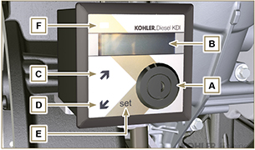  Fig 2.1
NOTE : if LED F is red, contact authorised KOHLER workshops to know what type of problem it is. Certain problems automatically switch off the engine.

Tab. 2.9 shows data that can be consulted on display B by pressing push buttons C or D .

NOTE : data described in Tab. 2.9 can differ, therefore, consult the machine's manual.
Tab 2.9
DESCRIPTION
Operating hours
Hours left for maintenance
Engine rpm
Engine oil pressure
Coolant temperature
Torque used @ rpm (% used)

