Information regarding discharge of liquids
KDI 2504 M Workshop manual (Rev. 09.6)

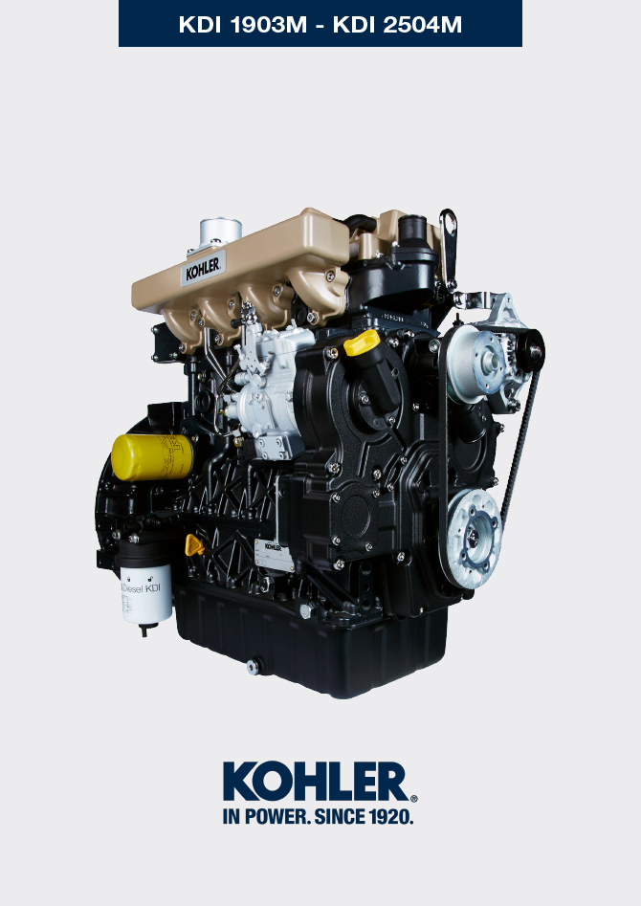

Registration of modifications to the document
Any modifications to this document must be registered by the drafting body, by completing the following table.

Released by | Code | Revision | Release Date | Revision date | Edited by | Endorsed
Technical Documentation | ED005302-961 | 9.6 | 04/2013 | 03/2023 | M. SILVESTRONE | V. MANINI

Translated from the original manual in Italian language
Data reported in this issue can be modified at any time by KOHLER.

Sommario
1. TITOLO 1 2
1.1. Asdfsdfsdf 2
1.2. Asdfsdfsdfggg 2

Information regarding discharge of liquids

Coolant
Important  - Before proceeding with operation, read Par. 3.3.2 .  N OTE: Component not necessarily supplied by KOHLER .  The representation of the radiator is purely indicative.  Warning  - Presence of steam pressurized coolant danger of burns.  - Undo the cap A carefully (circuit under pressure). | 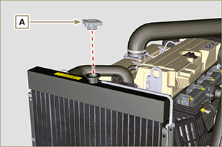  Fig 5.1
- Loosen cap D , remove gasket E , drain all coolant in radiator G into a suitable container and refer to Par. 3.6 . | 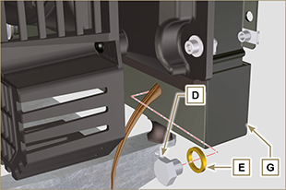  Fig 5.2
- Undo cap F to drain all liquid from the system contained in the engine crankcase ducts into an appropriate container ( Par. 3.6 ). | 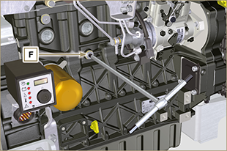  Fig 5.3  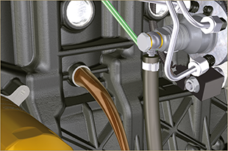  Fig 5.4
NOTE : Click by side to play the procedure. | https://www.youtube.com/embed/wXSb6sOYsD8?rel=0

Engine oil
Important  - This operation should be carried out with vacuum pump. The oil must be drained whilst the engine is hot, which requires particular care to prevent burns. Do not allow oil to come into contact with the skin because of the health hazards involved. It is recommended to use an oil intake pump via the oil dipstick hole B.  - Before proceeding with operation, read Par. 3.3.2 .  NOTE: Perform this operation with warm engine, to get a better fluidity of the oil and get a full discharge of oil and impurities contained in it.  - Undo the oil filler cap A .  - Remove the oil dipstick B .  - Remove the oil drain plug D and the gasket E (the oil drain plug is on both sides of the oil sump).  - Drain oil in an appropriate container.  (For used oil disposal refer to the Par 3.6 ).  - Perform the operations described in Par. 6.6. | 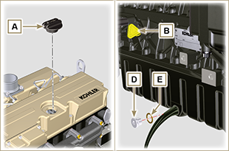 Fig. 5.4
NOTE : Click by side to play the procedure. | https://www.youtube.com/embed/KgZ2JBPCGPk?rel=0

