Information for disassembly
KDI 1903TCR / KDI 1903TCRE5 Workshop manual (Rev. 17.8)



Registration of modifications to the document
Any modifications to this document must be registered by the drafting body, by completing the following table.

Released by | Code | Revision | Release Date | Revision date | Edited by | Endorsed
 | manoff

Translated from the original manual in Italian language
Data reported in this issue can be modified at any time by KOHLER.

Sommario
1. TITOLO 1 2
1.1. Asdfsdfsdf 2
1.2. Asdfsdfsdfggg 2

Information for disassembly

Recommendations for disassembly

Important

- The mark ( ) after the title of a paragraph, indicates that the procedure is not required in order to disassemble the engine, however the procedures are featured in order to illustrate the disassembly of components.
- The operator should prepare all equipment and tools in order to enable him to carry out the operations correctly and safely.
- Before disassembly, perform the operation described in Chap. 5 .
- Before proceeding with operation, carefully read Chap. 3 .
- In order to operate safely and easily, we recommend positioning the engine on a rotating stand for engine overhauling.
- Seal all injection component unions as illustrated in Par. 2.9.8 during assembly.
- Protect all disassembled components and coupling surfaces subject to oxidation with lubricant.
- Where necessary, reference to special tools to use during disassembly operations is indicated (es. ST_05 ), identified in Tab. 13.1 - 13.2 - 13.3 .

EGR circuit disassembly
7.2.1 EGR cooler unit  - Undo the screws A ( ST_06 ) and B and remove the pipe C with the relative gaskets. | 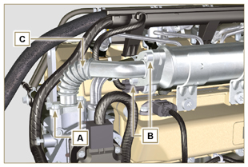  Fig 7.1
- Undo the screws D, E ( ST_06 ) and remove pipe F and the relevant gaskets. | 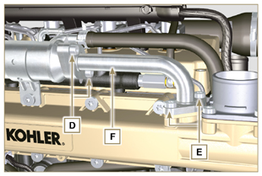  Fig 7.2
- Release the clamp M and remove pipe N .  - Release the clamp L .  - Undo capscrews G and remove EGR Cooler H from hose X ( ST_05 ) . | 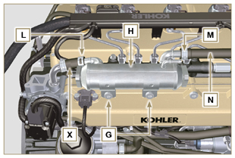  Fig 7.3
7.2.2 EGR Valve  - Disconnect the connector P .  - Undo the screws Q and remove the EGR valve R with the relevant gasket.  NOTE: The EGR valve is not a serviceable item, and if damaged/worn, it should be replaced with a new one. | 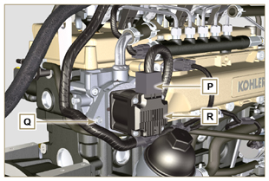  Fig 7.4
- Undo capscrews S and remove flange T with the relative gasket. | 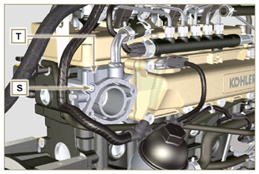  Fig 7.5

Electric components disassembly
7.3.1 Electric wiring  Important  - Refer to Par. 2.13 prior to proceeding with disassembly.  - Disconnect the connectors A, B and C .  - Release the clamp D . | 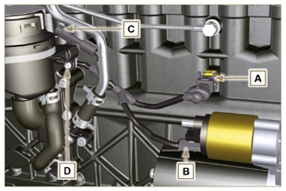  Fig 7.6
- Disconnect the connectors E, F and G .  - Release the clamps J and H . | 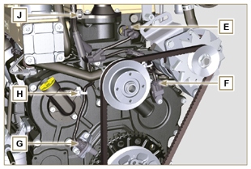  Fig 7.7
- Disconnect the connectors K and L . | 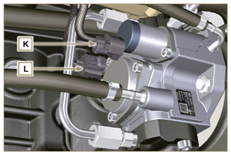  Fig 7.8
- Disconnect the connectors M and P .  - Release the clamp Q . | 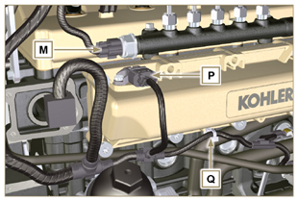  Fig 7.9
- Disconnect the connectors R .  - Undo the screws S and remove the wiring support T ( ST_06 ) . | 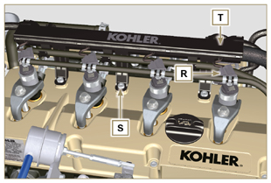  Fig 7.10
7.3.2 Starter motor  Important  - The motor is not repairable.  - Undo the screws U and remove the starter motor V . | 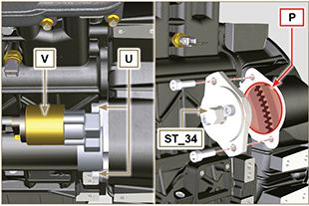  Fig 7.11
7.3.3 Belt and alternator  - Loosen the screws Z and W .  - Push the alternator AA in the direction of the arrow AB .  - Remove the belt AC from the pulleys AR .  - Undo the screws Z and W and remove the alternator AA .  Important  - The belt must always be replaced every time it is disassembled, even if it has not reached the scheduled hours for replacement. | 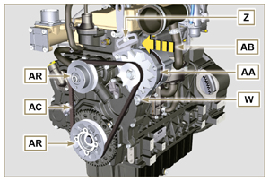  Fig 7.12
7.3.4 Sensors and switches  Important  - After disassembly, protect the sensors suitably against knocks, dampness and any high temperature sources.  - The sensors and switches cannot be repaired, therefore they must be replaced in the event of anomalies.  7.3.4.1 Oil pressure switch ( )  - Unscrew and remove the oil pressure switch AD . | 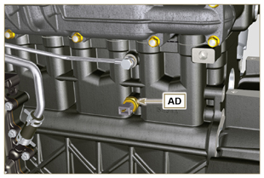  Fig 7.13
7.3.4.2 Coolant temperature sensor ( )  - Unscrew and remove the coolant temperature sensor AE . | 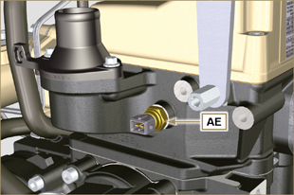  Fig 7.14
7.3.4.3 Speed sensor ( )  - Undo the screw AF and remove the sensor AG with the relative spacer ( ST_06 ) .  - Undo the screws AH and remove the sensor ( ST_06 ) . | 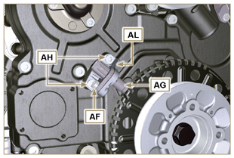  Fig 7.15
7.3.4.4 Camshaft phase sensor  - Undo the screw AM and remove the sensor AN with the relative spacer ( ST_06 ). | 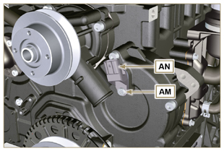  Fig 7.16
7.3.4.5 T-MAP Sensor ( )  - Undo the screw AP and remove the sensor AQ ( ST_06 ). | 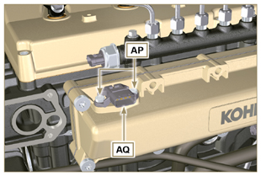  Fig 7.17
7.3.4.6 Fuel filter water detection sensor ( )  Warning  - The fuel filter is not always mounted on the engine.  - When disassembling the sensor A , use a suitable container to recover the fuel contained in the cartridge B .  - Unscrew the sensor A from the cartridge B . | 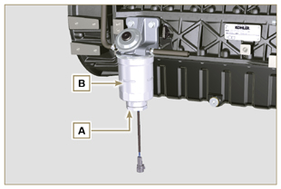  Fig 7.18

Turbocharger disassembly
- Release the clamps A and B and remove the manifold C . | 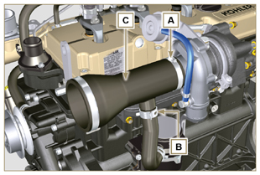  Fig 7.19
- Unscrew the fittings D and remove the pipe E with the relative gaskets G .  - Undo the screws F .  - Release clamp M . | 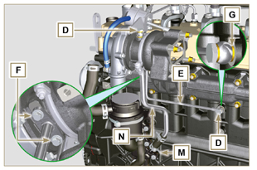  Fig 7.20
- Undo the nuts L .  - Remove tube N . | 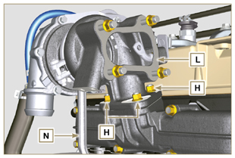  Fig 7.21

Exhaust manifold disassembly
- Undo the nuts A and remove the manifold B and the gaskets C .  - Close the openings and manifolds to prevent foreign bodies from entering. | 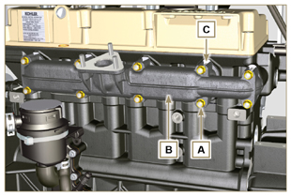  Fig 7.22

Coolant recirculation components disassembly
7.6.1 Oil Cooler manifold  - Release the clamps Z .  - Undo the screw W and remove hoses J ( ST_05 ) . | 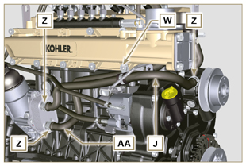  Fig 7.23
- Release the clamp K and remove hoses AA . | 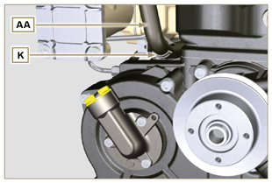  Fig 7.24
7.6.2 Coolant pump  Important  - The pump B is not repairable.  - Undo the screws A and remove the water pump unit B with its gasket C . | 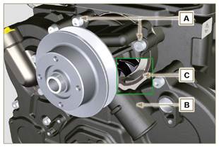  Fig 7.25
7.6.3 Thermostatic valve  - Undo the screws A and remove the thermostatic valve cover B .  - Remove the thermostatic valve C and its gasket.  Important  - Always replace the gasket D every time it is disassembled.  - Check that the air bleeding hole is not clogged or blocked ( Par. 2.11.4 ). | 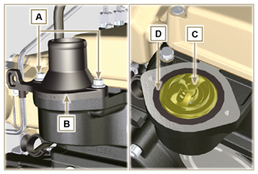  Fig 7.26

Crankshaft and target wheel pulley disassembly
- Position the crankshaft with the 1st cylinder at TDC,reference H .  - Undo the screw C clockwise.  - Remove the drive pulley unit and the target wheel D . | 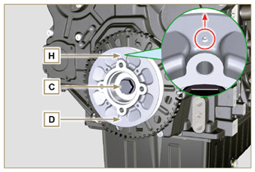  Fig 7.27

Lubrication circuit disassembly
7.8.1 Oil pressure valve( )  - Undo the cap A .  - Remove the spring B , check its condition and replace it if broken.  - Remove the valve piston C using a magnet. | 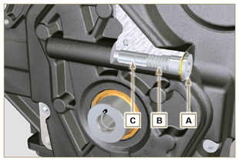  Fig 7.28
7.8.2 Timing system carter oil filling flange ( )  - Undo the screws D and remove the oil filling flange E ( ST_06 ) .  - Remove the gasket F . | 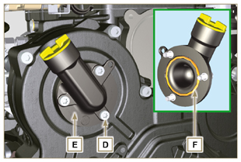  Fig 7.29
7.8.3 Timing system carter  - Ensure that the crankshaft with the 1st cylinder is at the TDC (taper pin W must be facing upwards).  - Undo the screws G .  - Remove the timing system semi-crankcase H . | 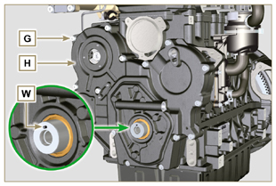  Fig 7.30
7.8.4 Oil pump  Important  - The oil pump is not repairable.  - Undo the screws L and remove the pump unit M from the timing system carter H ( ST_06 ) . | 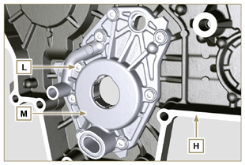  Fig 7.31
- Remove the rotors N and P from oil pump carter M . | 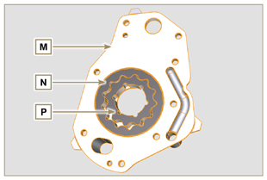  Fig 7.32
7.8.5 Oil Cooler unit and lub. oil filter  - Screw the lid cartridge holder V .  - Undo the screws Q, R and remove Oil Cooler group S .  Warning  - Use a suitable container to recover any residue oil.  - Oil Cooler unit S is not repairable. | 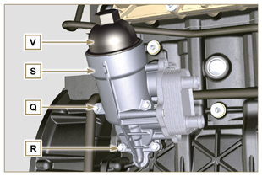  Fig 7.33
- Remove the gaskets T and U .  NOTE: To replace the oil cartridge, refer to Par. 6.10.2 . | 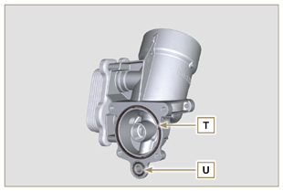  Fig 7.34
7.8.6 Oil vapour separator unit  - Release the clamps AA .  - Remove the manifolds AB, AC and AD .  - Remove the clamp AE by carefully cutting it at the point indicated and remove the oil separator AF . | 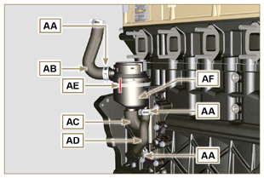  Fig 7.35
- Undo the screws AG .  - Remove la flangia di supportoRemove flange support AH and the gasket seal AL . | 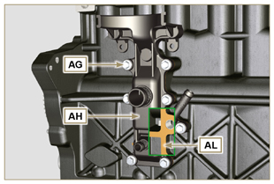  Fig 7.36

Intake manifold disassembly
- Undo the screws A and remove the semi-manifold B ( ST_05 ) .  - Remove the separation plate C and the gaskets H . | 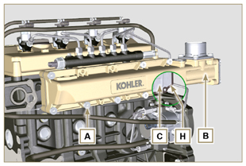  Fig 7.37
- Undo the screws D ( ST_06 ) and E .  - Remove the semi-manifold F and the gasket G . | 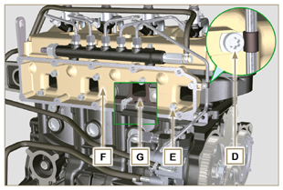  Fig 7.38

Fuel system disassembly
7.10.1 Fuel return pipes  - Release the clip A .  Warning  - After removing the union, the clip A must automatically return to its initial position; otherwise it must be replaced.  - Undo the B distributor return fixing capscrew.  - Release the clamp D .  - Disconnect the pipe E from the fuel return fitting.  - Undo and remove the screw G with the relative gaskets and put the cap on the Common Rail pressure relief valve AA .  - Disconnect unions M from electronic injectors N .  - Remove the fuel return pipes. | 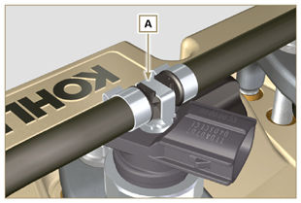  Fig 7.39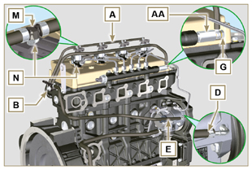  Fig 7.40
7.10.2 Fuel flow pipes  Important  - Seal all openings of the inlet and return unions on the injection pump D with the relevant caps, in order to prevent impurities from entering.  - Loosen the clamps P .  - Remove the pipes Q and R . | 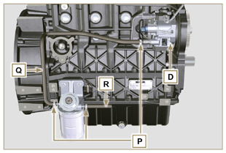  Fig 7.41
7.10.3 High pressure fuel pipes  Danger  - The fuel injection circuit undergoes high pressure, use safety protections as described in Par 3.4.3 .  - Ensure that the Common Rail is not under pressure by slowly and carefully unscrewing one of the nuts S .  - Loosen the nuts S and T in sequence.  - Fully undo the nuts S and T in sequence, and remove the high pressure pipes U and V . | 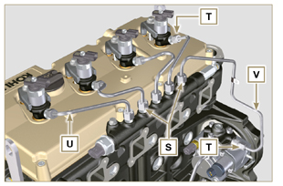  Fig 7.42
7.10.4 Common Rail  - Undo the screws AB and remove the Common Rail AC .  NOTE: Take care to protect te sensor AD from knocks, moisture and any high temperature source. The internal parts of the rail cannot be repaired.  Important  - Seal all injection component unions as illustrated in Par. 2.9.8 .  - Common rail cannot be repaired. | 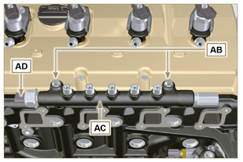  Fig 7.43
7.10.5 Electronic injectors  Important  - In the event that the electronic injectors are disassembled (not necessarily replaced), mark them with the relevant cylinder number from which they originate so as not to confuse them during re-assembly (Fig. 7.45) .  - The electronic injectors cannot be repaired.  - If one or more electronic injectors are to be replaced, the new calibration data must be inserted in the ECU via a specific instrument ( ST_01 ).  - Be careful not to damage the gaskets X .  - Undo capscrews AE and remove them together with the relative washers AF and then brace AG .  - Pull out the electronic injector AH .  NOTE: Should you be unable to remove the electronic injector (acting only on point BC ), use an open-ended spanner (Ø 34 mm), by applying small rotations to unblock the component.  - Seal all injection component unions as illustrated in Par. 2.9.8 .  - Ensure that gasket AL has remained in the correct position (Fig. 7.46) .  Otherwise, recover the gasket from inside the electronic injector AM . | 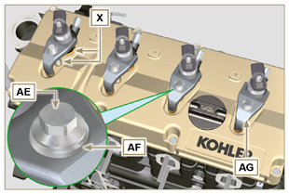  Fig 7.44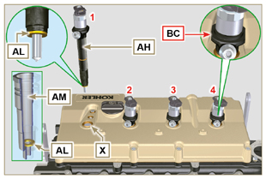  Fig 7.45
7.10.6 Fuel filter ( )  - Undo the fuel cartridge AW from support AP .  - Undo the screws AN and remove the filter support AP . | 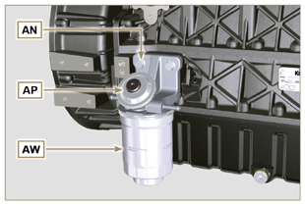  Fig 7.46
7.10.7 High-pressure fuel injection pump  Important  - Before disassembling, carefully read Par. 2.17 .  - The injection pump is not repairable  - Should the fuel feeding pump need to be replaced, after assembly, it is necessary to perform the Pump Learning procedure by means of instrument ST_01 .  - Undo the nut AQ .  - Loosen the screws AR of the injection pump.  - Screw the tool ST_04 on the thread of the gear AS .  - Tighten the screw AT on the puller to disconnect the gear AS from the injection pump and remove the injection pump control gear AS .  - Undo the screws AR .  - Remove injection pump AU and the relative gasket AV .  - Seal all injection component unions as illustrated in Par. 2.9.8 . | 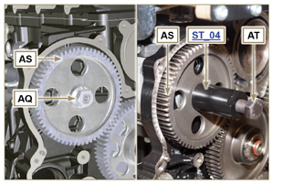  Fig 7.47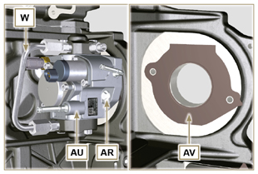  Fig 7.48

Timing system gear disassembly
- Unscrew screws H and remove target wheel G .  - Unscrew screws D and remove camshaft gear E .  - Remove retainer ring A and the shoulder ring B .  - Remove the intermediate gear C . | 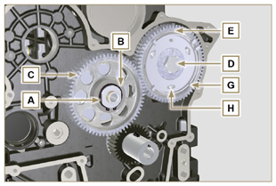  Fig 7.49
- Remove the shoulder ring F .  - Unscrew the screws L and remove the intermediate gear support M . | 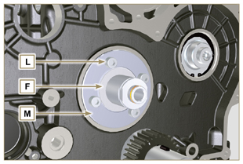  Fig 7.50

Flange unit disassembly
7.12.1 Flywheel  Important  - Leave the special tool ST_34 for blocking the flywheel ( Par. 7.7 ) .  - Only undo the screw C located uppermost.  - Insert the tool ST_09 in the seat of the screw C tightening it all the way.  - Undo the remaining screws D .  Danger  - The flywheel E is very heavy. Pay the utmost attention while removing it in order to prevent it dropping or falling, as this may have serious consequences for the operative.  - Remove the flywheel E .  - Remove the tool ST_09 .  - Remove the tool ST_34 shown in Fig. 7.11 . | 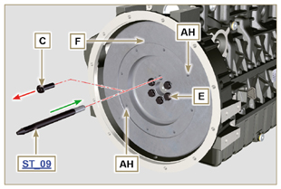  Fig 7.51
7.12.2 Flange housing  - Undo the screws A and remove the engine housing B .  Danger  - The flange housing is very heavy. Pay the utmost attention while removing it in order to prevent it dropping or falling, as this may have serious consequences for the operative. | 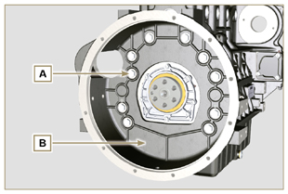  Fig 7.52

Cylinder head unit disassembly
7.13.1 Rocker arms cover  - Undo the screws A .  - Remove the rocker arms cover B .  - Remove the gasket C . | 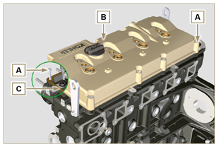  Fig 7.53
7.13.2 Rocker arm pin  - Undo the screws D .  - Remove the rocker arm pin unit E . | 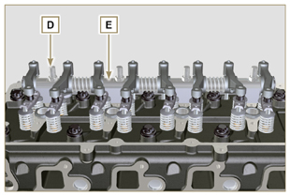  Fig 7.54
7.13.2.1 Rocker arm ( )  - Remove the retainer ring F .  - Remove the shoulder rings G .  - Remove the rocker arms H . | 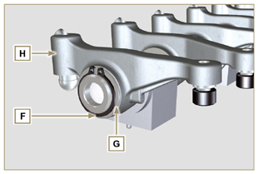  Fig 7.55
7.13.3 Valve rods and bridges  - Remove the valve control U-bolts M .  - Remove the rocker arm control rods N . | 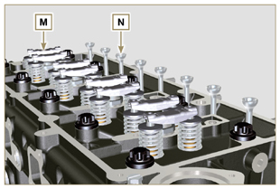  Fig 7.57
7.13.4 Cylinder head  Important  - The cylinder head fastening bolts P must be replaced every time they are disassembled.  - Undo the bolts P .  Important  - To lift cylinder head Q , only use both eyebolts AE provided by KOHLER (refer to Fig. 7.66 ).  - When removing the cylinder head Q and subsequent disassembly, control, and assembly operations, it is necessary to protect the contact surface W of cylinder head Q and crankcase J against impacts.  - Remove the cylinder head Q .  - Remove the head gasket R . | 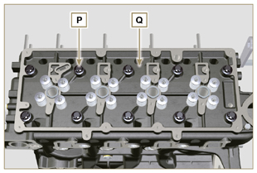  Fig 7.58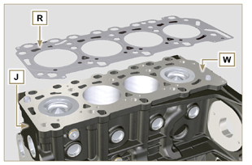  Fig 7.59
7.13.4.1 Valves ( )  - Mount the tool ST_07 on the head AF fixing it on one of the holes for fixing the rocker arm cover.  NOTE: Change the fixing hole according to the position of the valves to be removed.  - Position the tool ST_07 on the valve as shown in the figure. | 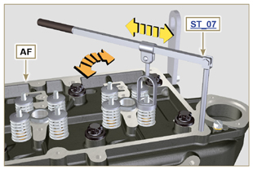  Fig 7.60
- Push the lever of the tool ST_07 downwards, in order to lower the valve plates S in the direction of the arrow T , remove cotters U using a magnet.  NOTE: Repeat all the operations for all the valves concerned. | 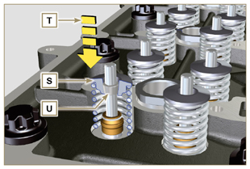  Fig 7.61
Important  - Before removing the valves, make some marks to record their original position, in order to avoid confusing them when reassembling (if they are not replaced).  - Remove the valves V . | 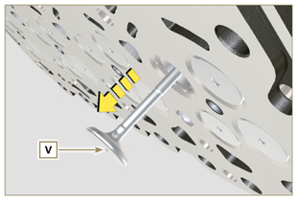  Fig 7.62
7.13.4.2 Electronic injector sleeves ( )  - Unscrew and remove the sleeves Z from the head Q .  - Remove the gaskets AA and AB . | 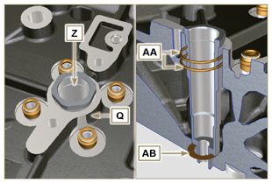  Fig 7.63
7.13.4.3 Valve stem gasket ( )  - Remove the gaskets AC . | 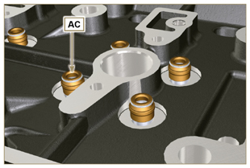  Fig 7.64
7.13.4.4 Lifting eyebolts ( )  - Undo the screws AD and remove the eyebolts AE .  - Thoroughly wash the cylinder head Q . | 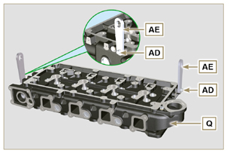  Fig 7.65

Oil sump unit disassembly
7.14.1 Oil sump  - Undo the screws A .  - Remove the oil sump B by inserting a plate in the areas indicated by the arrow AA . | 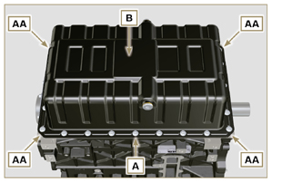  Fig 7.66
7.14.2 Oil suction pipe  - Undo the screws C and remove the oil pipe D . | 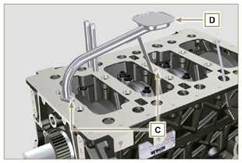  Fig 7.67
7.14.3 Oil vapour pipes ( )  - Unscrew and remove the pipes E . | 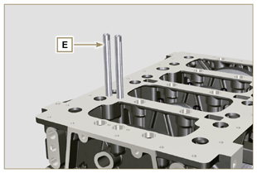  Fig 7.68

Engine block disassembly
7.15.1 Crankshaft gasket flange  - Undo the screws A .  - Remove the flange B and the gasket C . | 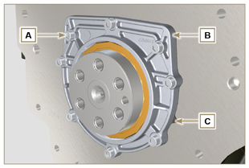  Fig 7.69
7.15.2 Piston unit/connecting rod  Important  - Mark some numerical references (cylinder n°) on the connecting rods, connecting rod caps F1 , pistons and gudgeon pins to prevent unintentionally confusing the components not replaced during assembly. Failure to do this may result in engine malfunctions.  - References on connecting rod M and cap F1 must only be carried out on a side in correspondence with K1 and K2 , as illustrated in Fig. 7.70a .  - Screw the bolt AM temporarily.  - Unsrew bolts E1 and remove the connecting rod caps F1 . | 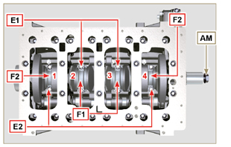  Fig 7.70
NOTE : coupling cap F1 on the connecting rod can be carried out with centring taper pins (Fig. 7.70b) or broken ( Fig. 7.70c - without centring taper pins).  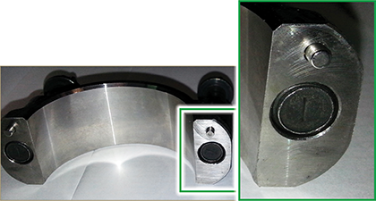  Fig. 7.70b  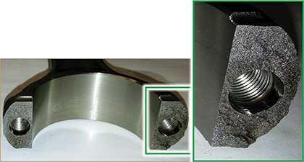  Fig. 7.70c | 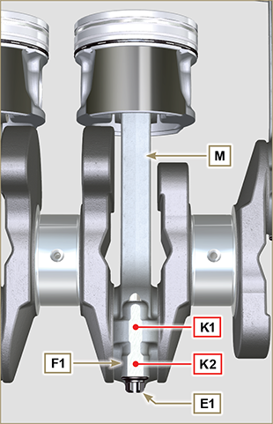  Fig 7.70a
- Pull out the connecting rod - piston assembly from position 2 and 3 by manually applying pressure on the connecting rod big end L in the direction of arrow AK .  - Couple the connecting rod big end caps L with the relevant piston and connecting rod unit M .  - Turn capscrew AM and rotate the crankshaft by 180°.  - Repeat points 2 to 5 to disassemble the connecting rod-piston assembly to position 1 and 4 . | 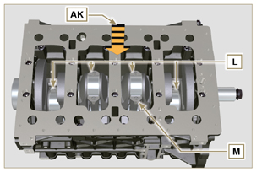  Fig 7.71
Warning  - The connecting rod half-bearings Z are made of special material. Therefore, they must be replaced every time they are removed to prevent seizures. | 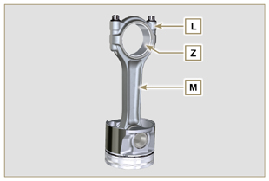  Fig 7.72
7.15.3 Lower semi-crankcase  3 CYLINDERS  - Undo capscrews E and F by following the order indicated in the figure.  - Remove the lower semi-crankcase D and store it in a suitable container for washing. | 3 Cylinders  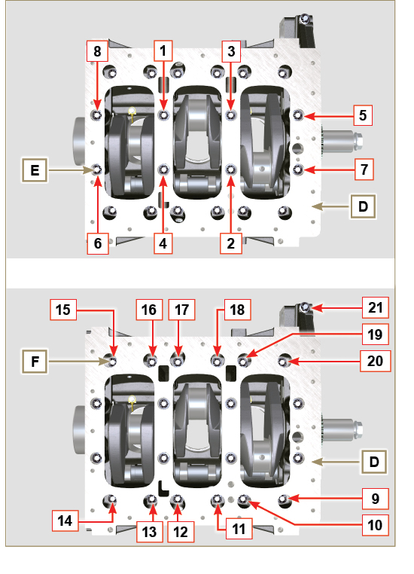  Fig 7.73
4 CYLINDERS  - Undo capscrews E and F by following the order indicated in the figure.  - Remove the lower semi-crankcase D and store it in a suitable container for washing. | 4 Cylinders  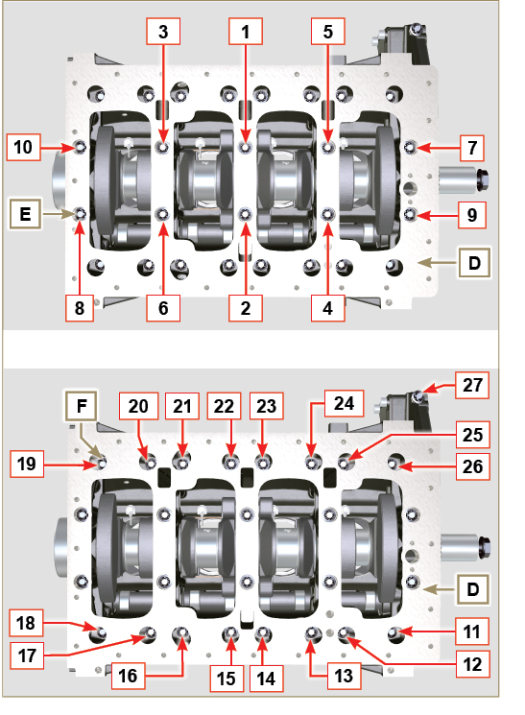  Fig 7.74
7.15.4 Crankshaft  Remove:  - Crankshaft G .  - The shoulder semi-rings H . | 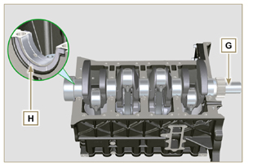  Fig 7.75
7.15.5 7.15.5 Piston ( )  - Remove the retainer ring N .  - Remove the pin P to separate the piston Q from the connecting rod R .  Important  - If they are not replaced, keep the components together (connecting rod - piston - gudgeon pin) by using references in order to prevent them from getting mixed up during assembly. | 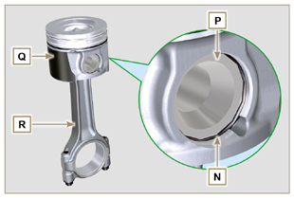  Fig 7.76
7.15.5.1 Rings ( )  - Remove the rings S . | 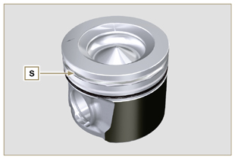  Fig 7.77
7.15.6 Oil spray nozzles ( )  - Undo the screws T and remove the spray nozzles U from the upper semi-crankcase AB . | 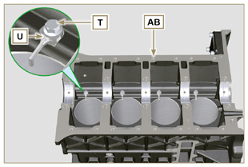  Fig 7.78
7.15.7 Camshaft  - Remove the lock ring V .  - Extract the camshaft W from the upper semi-crankcase AB . | 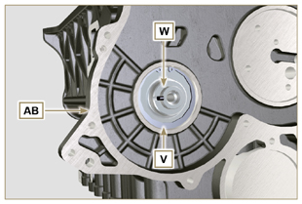  Fig 7.79
7.15.8 Camshaft tappets  - With a magnet, remove the tappets AA from the upper semi-crankcase AB . | 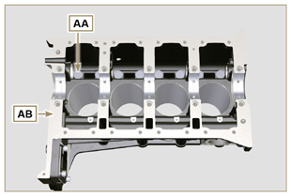  Fig 7.80
7.15.9 Crankshaft bushings  - Remove the crankshaft bushings AC from the upper crankcase AB .  Important  - The crankshaft half-bearings AC are made of special material. Therefore, they must be replaced every time they are removed to prevent seizures. | 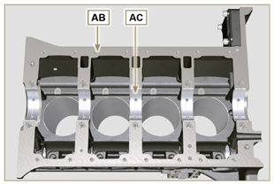  Fig 7.81
- Remove the crankshaft bushings AF from the lower semicrankcase AE . | 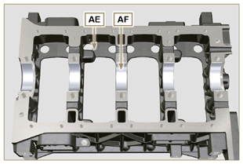  Fig 7.82
7.15.10 Cover 3 ^{th} PTO ( )  - Undo the screws AG .  - Remove the cover AH and the gasket AL from the semicrankcase top. | 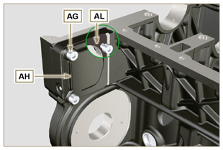  Fig 7.83

