General Information
KDI-TCP 3404 E5 Owner Manual (REV. 01.2)

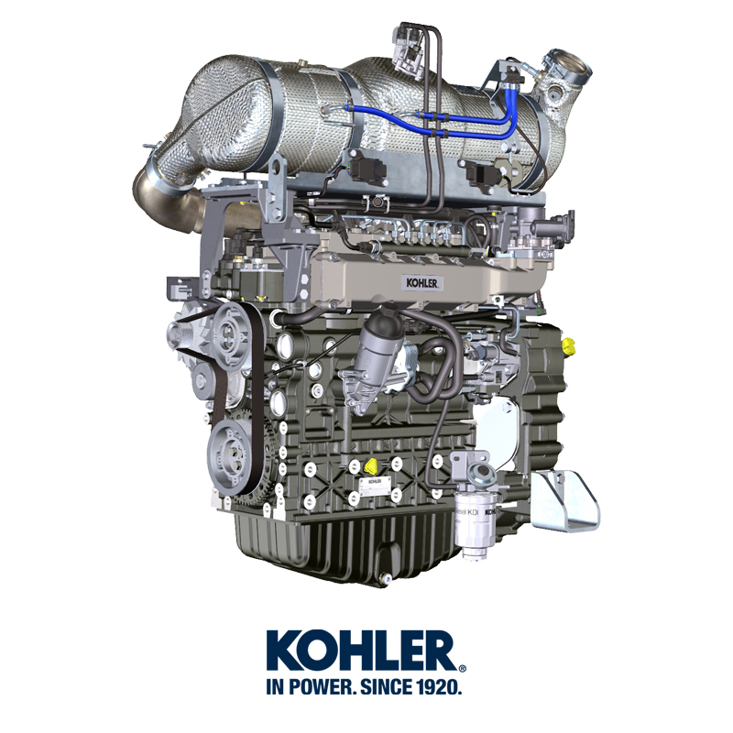

Registration of modifications to the document
Any modifications to this document must be registered by the drafting body, by completing the following table.

Released by | Code | Revision | Release Date | Revision date | Edited by | Endorsed
 | 3404tcr

Translated from the original manual in Italian language
Data reported in this issue can be modified at any time by KOHLER.

Sommario
1. TITOLO 1 2
1.1. Asdfsdfsdf 2
1.2. Asdfsdfsdfggg 2

General Information

Manual's Purpose
- This manual contains the instructions needed to carry out proper use and maintenance of the engine, therefore it must always be available, for future reference when required.
- This manual is an integral part of the engine, in the event of transfer or sale, it must be attached to it.
- Safety pictograms can be found on the engine and it is the operator's responsibility to keep them in a perfectly visible place and replace them when they are no longer legible.
- Information, description and pictures in this manual reflect the state of the art at the time of the marketing of engine.
- However, development on the engines is continuous. Therefore, the information within this manual is subject to change without notice and without obligation.
- KOHLER reserves the right to make, at any time, changes in the engines for technical or commercial reasons.
- These changes do not require KOHLER to intervene on the marketed production up to that time and not to consider this manual as inappropriate.
- Any additional section that KOHLER will deem necessary to supply some time after the main text shall be kept together with the manual and considered as an integral part of it.
- The information contained within this manual is the sole property of KOHLER . As such, no reproduction or replication in whole or part is allowed without the express written permission of KOHLER .

Glossary and Definitions
The paragraphs, tables and figure are divided into chapter with their progressive numbers.
Es: Par. 2.3 - chapter 2 paragraph 3.
Tab. 3.4 - chapter 3 table 4.
Fig. 5.5 - chapter 5 figure 5.

The references of the objects described in the text and in figure and number are indicated by letters, which are always and only related to the paragraph you are reading unless there are specific references to other figures or paragraphs.
NOTE: All data, measurements and relevant symbols are shown in the glossary section.

Emission-Related Installation Instructions
Failing to follow the instructions in the applications guidebook when installing a certified engine in a piece of nonroad equipment violates federal law (40 CFR 1068.105(b)), subject to fines or other penalties as described in the Clean Air Act. OEM must apply a separate label with the following statement: “ULTRA LOW SULFUR FUEL ONLY” near the fuel inlet.

Ensure you are installing an engine appropriately certified for your application. Constant speed engines may only be installed on constant speed equipment for constant speed operation.

If you install the engine in a way that makes the engine's emission control information label hard to read during normal engine maintenance, you must place a duplicate label on the equipment, as described in 40 CFR 1068.105.

Service request
- The complete and updated list of authorized Kohler Co. service centers can be found on websites:
www.kohlerengines.com & dealers.kohlerpower.it .
- If you have any questions regarding your warranty rights and responsibilities or the location of the nearest Kohler Co. authorized service location, you should contact Kohler Co. at 1-800-544-2444 or access our website at www.kohlerengines.com (USA and North American).

Manufacturer and engine identification
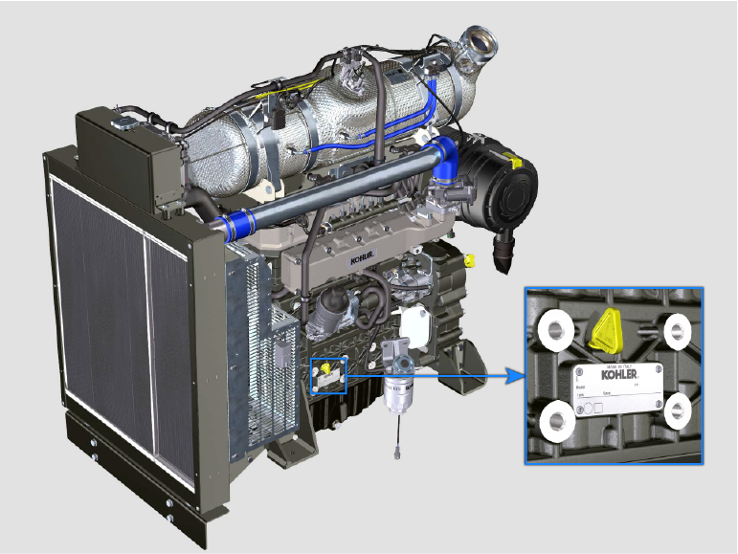
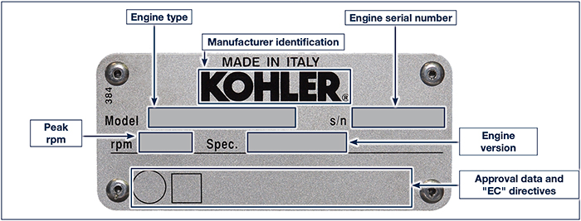
1.1

Engine component identification
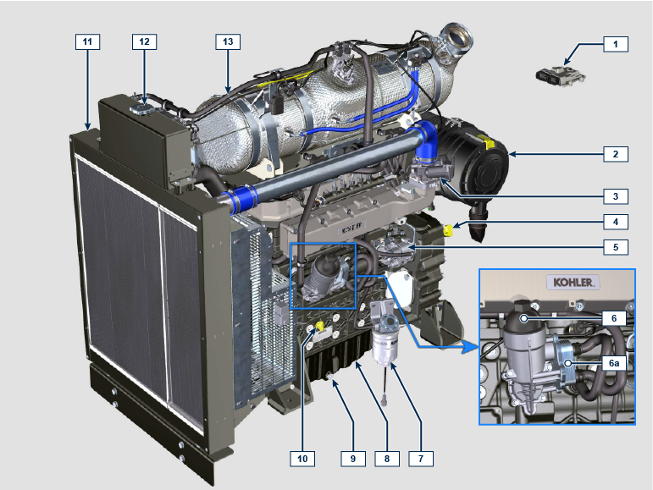

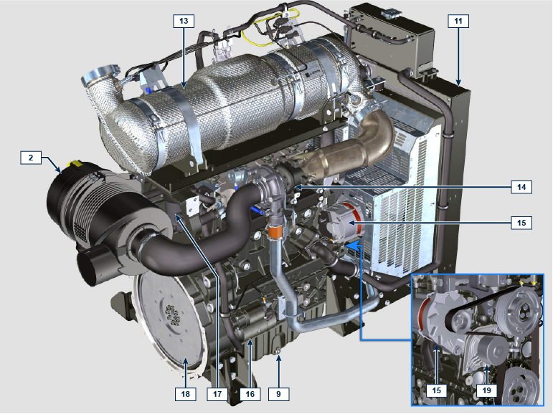

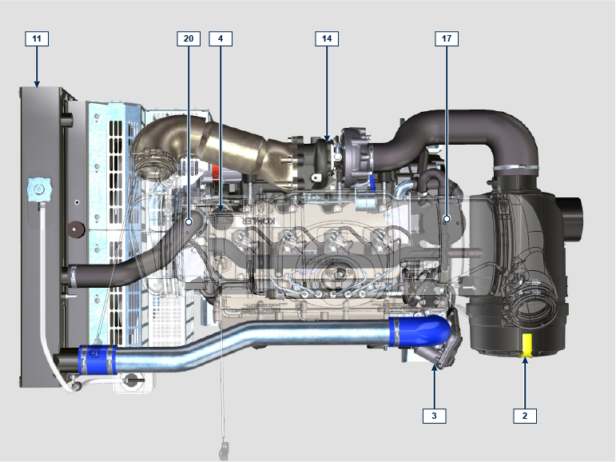

NOTE: Some components are for illustrative purposes only and may vary or they are not supplied by Kohler.
POS. | DESCRIPTION
1 | ECU
2 | Air filter
3 | Air inlet valve
4 | Oil filler cap
5 | High-pressure fuel injection pump
6 | Lub. oil filter
6a | Oil cooler
7 | Fuel filter
8 | Oil sump
9 | Oil drain plug
10 | Oil dipstick
11 | Radiator/Intercooler
12 | Coolant filler cap
13 | ATS
14 | Turbocharger
15 | Alternator
16 | Starter motor
17 | Oil steam separator
18 | Flywheel
19 | Coolant pump
20 | Thermostatic valve

Cooling circuit
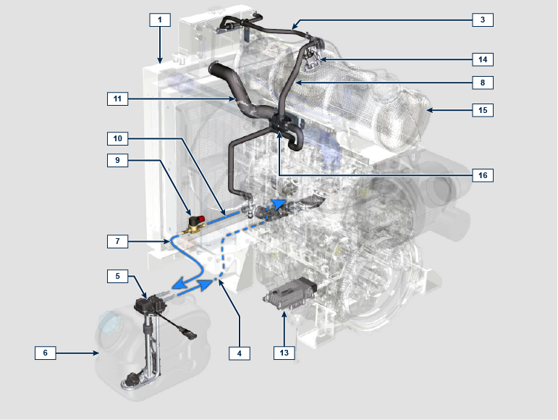
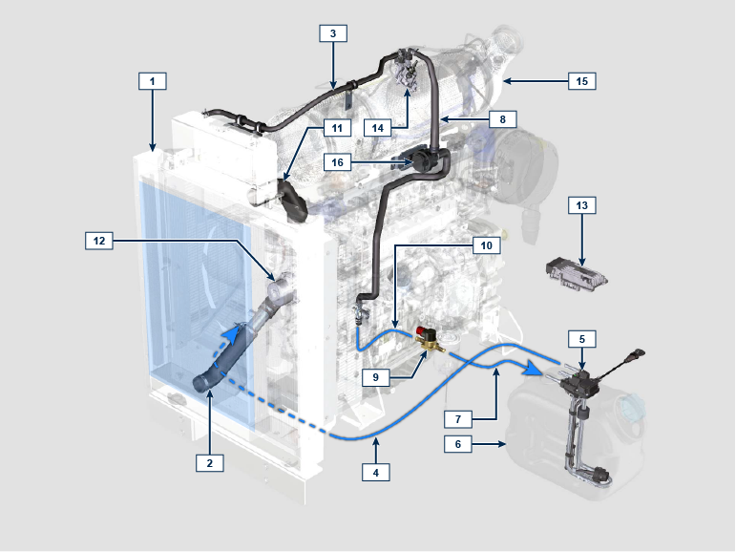

NOTE: Some components are for illustrative purposes only and may vary or they are not supplied by Kohler.
POS. | DESCRIPTION
1 | Radiator
2 | Intake sleeve
3 | Return tube to radiator
4 | Intake return tube
5 | Circuit for DEF heating
6 | DEF tank
7 | Coolant delivery tube in DEF tank
8 | Coolant delivery tube to DEF injector
9 | Electronic valve for coolant delivery to DEF tank
10 | Coolant delivery tube to SCR system
11 | Coolant to radiator return sleeve
12 | Coolant pump
13 | SCR system control unit
14 | DEF Injector
15 | ATS
16 | Coolant delivery pump to DEF injector (provided if needed)

DEF circuit
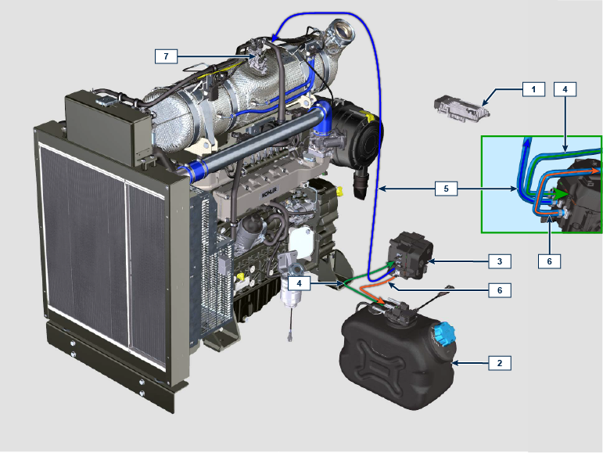

NOTE: Some components are for illustrative purposes only and may vary or they are not supplied by Kohler.
POS. | DESCRIPTION
1 | SCR system control unit
2 | DEF tank
3 | DEF pump
4 | DEF intake tube
5 | DEF delivery tube to injector
6 | Return tube in DEF tank
7 | DEF injector

Intake and exhaust circuit
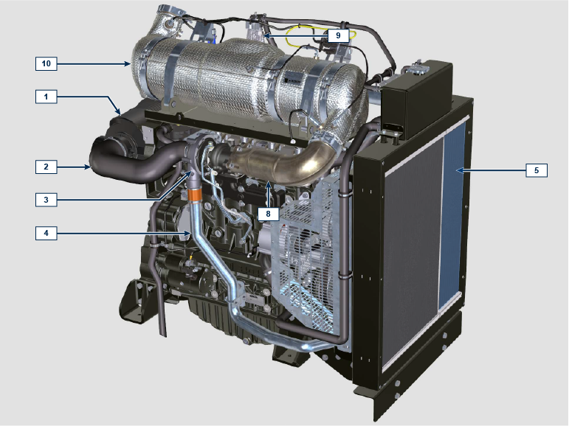

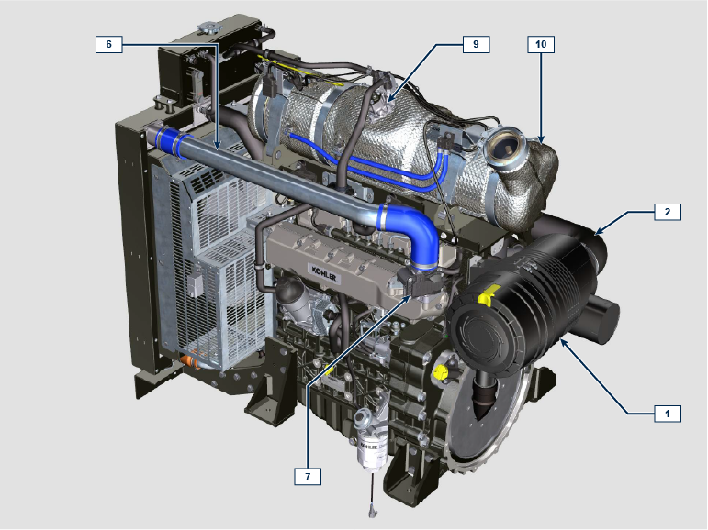

NOTE: Some components are for illustrative purposes only and may vary or they are not supplied by Kohler.
POS. | DESCRIPTION
1 | Air filter
2 | Air intake sleeve
3 | Turbocharger
4 | Air delivery tube to Intercooler
5 | Intercooler
6 | Air delivery tube to intake manifold
7 | Air inlet valve
8 | Exhaust gas delivery hose to SCR
9 | DEF injector
10 | ATS

Homologation labels
1.10.1 Label for EPA rules (compilation example)

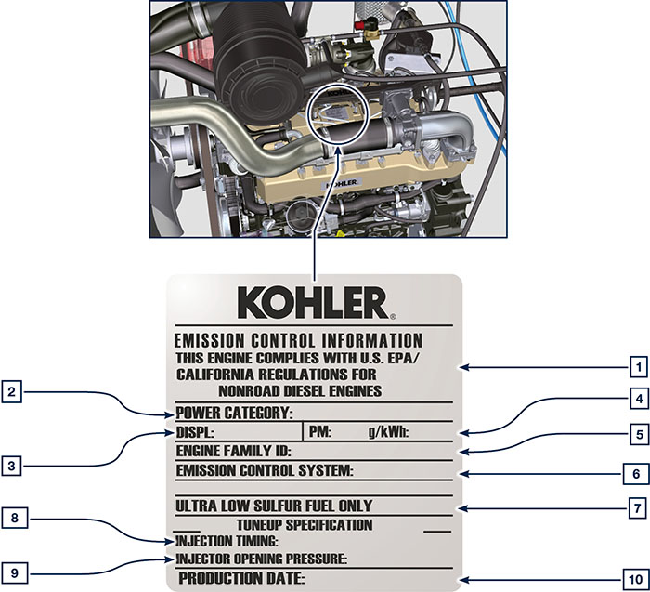

POS. | DESCRIPTION
1 | Model year in compliance with the rules
2 | Power category (kW)
3 | Engine displacement (L)
4 | Particulate emission limit (g/kWh)
5 | Engine family ID
6 | Emission Control System = ECS
7 | Fuel with low sulphur content
8 | Injection timing
9 | Electronic injector opening pressure (bar)
10 | Production date (example: 2013.JAN)

1.10.2 Label for China Standards (compilation example)

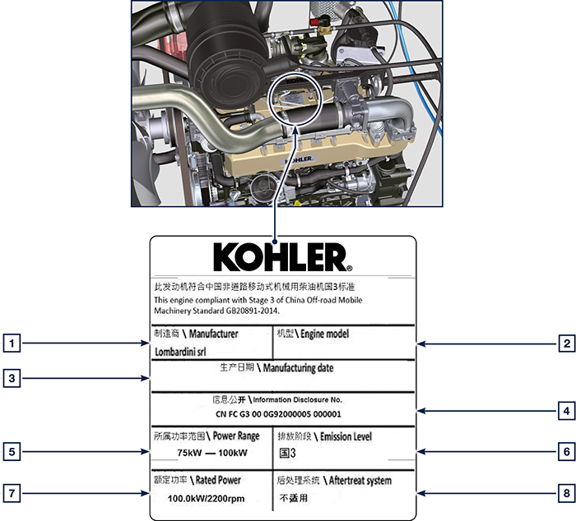

POS. | DESCRIPTION
1 | Manufacturer
2 | Engine model
3 | Manufactoring date
4 | Certificate N°
5 | Power range (kW)
6 | Emission level
7 | Rated power
8 | Aftertreat system

1.10.3 Label for Korea Standards (compilation example)

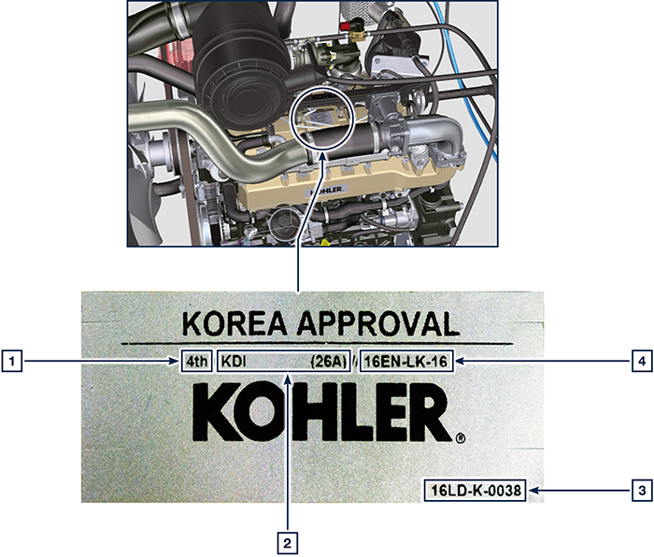

POS. | DESCRIPTION
1 | Tier 4 Final
2 | Engine model
3 | Manufactoring date and manufacturer code
4 | N° Korea emission certificate

ATS (After Treatment System)
ATS with DOC+DPF+SCR filter  NOTE: the ATS system with DPF filter is only present for versions compliant with "Stage V" emission regulations.  The ATS system can be installed in a different way than shown. | Tab 1.5  POS. DESCRIZIONE  1 Turbocharger  2 Turbine exhaust pipe  3 DOC  4 DPF  5 SCR  6 ETB
