Information on adjustments
KDI 2504 M Workshop manual (Rev. 09.6)

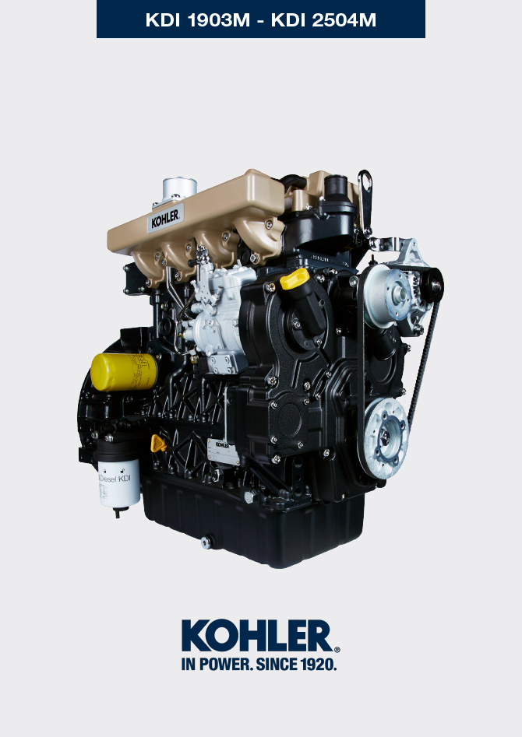

Registration of modifications to the document
Any modifications to this document must be registered by the drafting body, by completing the following table.

Released by | Code | Revision | Release Date | Revision date | Edited by | Endorsed
Technical Documentation | ED005302-961 | 9.6 | 04/2013 | 03/2023 | M. SILVESTRONE | V. MANINI

Translated from the original manual in Italian language
Data reported in this issue can be modified at any time by KOHLER.

Sommario
1. TITOLO 1 2
1.1. Asdfsdfsdf 2
1.2. Asdfsdfsdfggg 2

Information on adjustments

Air filter check
Important

- Before proceeding with operation, read Par. 3.3.2 .

- Hose A must be completely clean and not damaged.  - Air filter cartridge B and its housing C must be completely clean and free from impurities. | 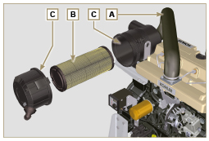  Fig 12.1

Rubber hose and manifold control
Important

- Before proceeding with operation, read Par. 3.3.2 .

The check is carried out by applying slight deflection or bending along the tube/hose and next to the hose clamps.  Components must be replaced if they have clear signs of cracks, tears, cuts, leaks, or do not retain a certain degree of elasticity.  - Check the condition of all rubber hoses A .  - Check whether there are any leakages of air, water, oil or fuel next to their connections. | 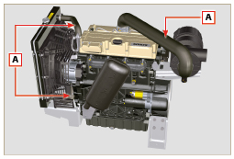  Fig 12.2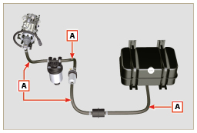  Fig 12.3

Oil leak check
Important

- Before proceeding with operation, read Par. 3.3.2 .

Check that there are no leakages next to area A .  - Start the engine at idle speed or without a load and check whether there are any leakages next to area A.  - It is anyhow necessary to also check the seals of all main components and their surface contact, such as:  - crankcase and oil seal (side 1 ª PTO) - oil sump and exhaust caps  - cylinder head and its assembled components  - rocker arm cover  - Timing system carter and oil seal (side 2 ª PTO) - oil dipstick housing or rod support tube.  NOTE: Perform the checks described in Points 1 and 2 periodically and during maintenance procedures.  It is also necessary to check for leakages on the components that are not listed.  If necessary, disassemble the components that have a leakage and investigate the possible cause.  The components must be replaced otherwise they do notguarantee their sealing. | 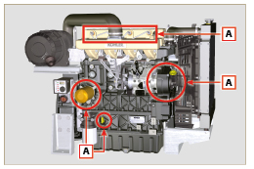  Fig 12.4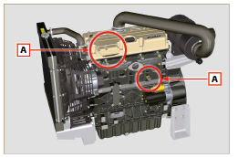  Fig 12.5

Oil pressure check
- Insert a thermocouple instead of the oil dipstick A .  - Unscrew and remove the oil pressure switch B and screw on a 10 bar pressure gauge in its seat (Fig. 12.8) .  - Start the engine at idle speed and without a load, check the oil pressure value according to the oil temperature (Fig. 12.7 ).  NOTE : The graph in Fig. 12.7 illustrates the pressure line with speed of 1000 Rpm.  - If the pressure values are below the values indicated in Fig. 12.7 , check to identify the cause of the problem.  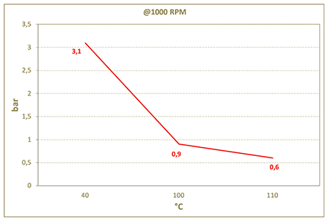  Fig. 12.7 | 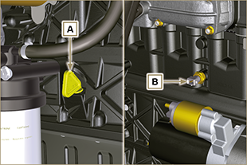  Fig. 12.6  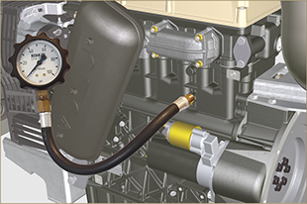  Fig. 12.8

