Storage information
KDI 3404 TCR-SCR Workshop Manual (Rev. 10.4)

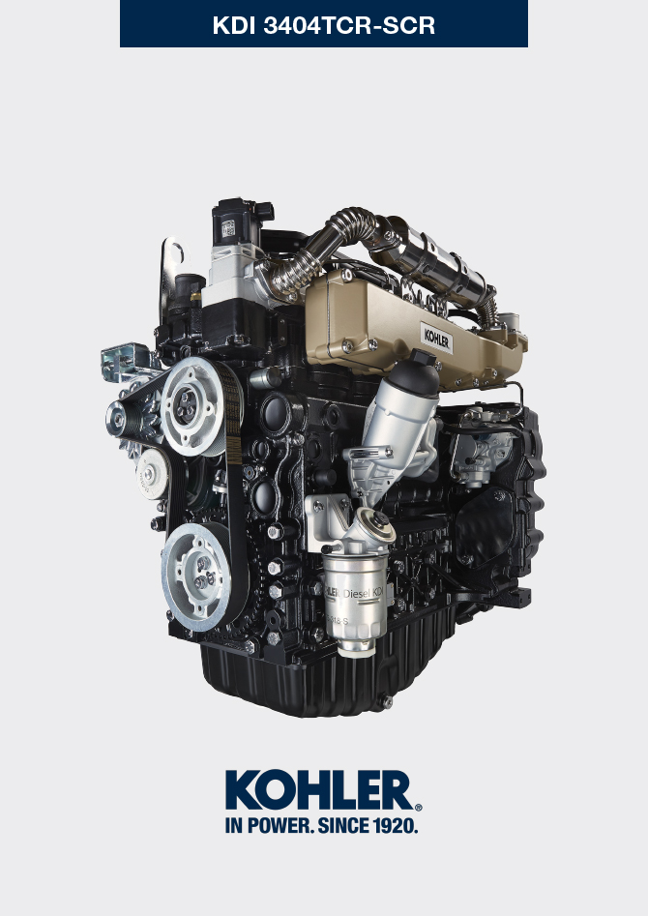

Registration of modifications to the document
Any modifications to this document must be registered by the drafting body, by completing the following table.

Released by | Code | Revision | Release Date | Revision date | Edited by | Endorsed
 | manoff

Translated from the original manual in Italian language
Data reported in this issue can be modified at any time by KOHLER.

Sommario
1. TITOLO 1 2
1.1. Asdfsdfsdf 2
1.2. Asdfsdfsdfggg 2

Storage information

Product preservation

Important

- If the engines are not to be used for 6 months, they must be protected by carrying out the operations described in Engine storage (up to 6 months) (Par. 4.2) .
- If the engine is still not in use after the first 6 months, it is necessary to carry out a further procedure to extend the protection period (more than 6 months) (Par. 4.3) .
- If the engine is not to be used for an extended period, the protective treatment procedure must be repeated within 24 months of the previous one.

Engine storage (up to 6 months)
Before storing the engine check that:
- The environments are not humid or exposed to bad weather. Cover the engine with a proper protective sheet against dampness and atmospheric contaminants.
- The place is not near electric panel.
- Avoid storing the engine in direct contact with the ground.

Engine storage (over 6 months)
Follow the steps described in Par. 4.2 .
- Pour protective oil in the carter up to the MAX level.
- Refuel with fuel additives for long storage.
- With expansion tank:
make sure that the coolant is up to the maximum level.
- Without expansion tank: Top liquid up until the pipes inside the radiator are covered by about 5 mm.

Do not overfill the radiator, but leave room for the fuel to expand.
- Start the engine and run it at idle speed for around 2 minutes.
- Bring the engine to 75% of maximum rated speed for 5 to 10 minutes.
- Turn off the engine.
- Empty out completely the fuel tank.
- Spray SAE 10W-40 on the exhaust and intake manifolds.
- Seal the exhaust and intake ducts to prevent foreign bodies from entering.
- When cleaning the engine, if using a pressure washer or steam cleaning device, avoid directing the nozzle on electrical components, cable connections and sealed rings (oil seals etc).
If cleaning engine with a pressure washer or steam cleaner, it is important to maintain a minimum distance of at least 200mm between the surface to be washed and the nozzle - avoiding absolutely electrical components such as alternators, starter motors and engine control units (ECU).
- Treat non-painted parts with protective products.
- Loosen the alternator belt Par. 6.5.1 point 1 and 2 .
If the engine protection is performed according to the suggestions indicated no corrosion damage will be found.

Engine starting after storage
- Remove the protective sheet.
- Use a cloth soaked in degreasing product to remove the protective treatment from the external parts.
- Inject lubricating oil (no more than 2 cm3) into the intake ducts.
- Adjust the alternator belt tension ( Par. 6.5.2 ) or replace if there are signs of deterioration.
- Refill the tank with fresh fuel.

Warning

- Over time, lubricants and filters lose their properties, so itis important to consider whether they need replacing, also based on the criteria described in Tab. 2.9 .

- Make sure that the oil and the coolant are up to the maximum level.
- Start the engine and run it at idle speed for around 2 minutes.
- Bring the engine to 75% of maximum rated speed for 5 to 10 minutes.
- Stop the engine and while the oil still hot, perform the operation in Par. 5.2 .
- Replace the filters (air, oil, fuel) with original spare parts.
- Perform the operations described in Par. 10.1 .
- Perform the operations described in Par. 5.1 and Par. 10.2 .

Unused machine
If the machine is not used for a certain amount of time, follow the operations below:

4.5.1 Operations for TCR versions

Tab 4.1
POINT | PERIOD | OPERATION
1 | up to 2 months | - The place must be dry and fresh throughout the period in which the machine is not used.  - Consult the machine’s manual to disconnect the battery (before disconnecting the battery, wait for minimum 5 mins after turning off the engine).  - Make sure the engine is not exposed to direct sunlight.  - Make sure the engine is not near any heat sources.
1a | Start-up after 2 months | - Before starting the engine, check Para. 2.8 for maintenance operations.  - Consult the machine’s manual to connect the battery and start the engine.
2 | Fino a 9 mesi | - Perform the operations described in point 1.  - Perform the operations described in Para. 12.4 and 12.5.  - Start the engine at least every 4 months as per operations described in point 1a:  - Avoid sudden accelerations for the first few minutes.  - Bring the engine to the working temperature by pressing the accelerator 3/4 from MAX.  - Leave the engine running at minimum speed for a few minutes and turning off the engine.
2a | Start-up after 9 months | - Before starting the engine, check Para. 2.8 for maintenance operations.  - Consult the machine’s manual to connect the battery and start the engine.  - Avoid sudden accelerations for the first few minutes.
3 | over 9 months | - Perform the operations described in point 1 and 2.
3a | Start-up after 9+ months | - Before starting the engine, check Para. 2.8 for maintenance operations.  - Check the quality of coolant from the relative testing strips.  - Consult the machine’s manual to connect the battery and start the engine.  - Avoid sudden accelerations for the first few minutes.

4.5.2 Operations for TCR-SCR versions

Tab 4.2
POINT | PERIOD | OPERATION
1 | up to 2 months | - Perform the operations described in point 1 of Tab. 4.1  - Fill the DEF tank with DEF to the MAX level  - The ambient temperature must be kept between -40 and 40 °C  - Do not disconnect any electrical or hydraulic connections
1a | Start-up after 2 months | - Before starting the engine, check Para. 2.8 for maintenance operations.  - Consult the machine’s manual to connect the battery and start the engine.
2 | up to 9 months | - Perform the operations described in point 2 in Tab. 4.1  - Fill the DEF tank with DEF to the MAX level  - The ambient temperature must be kept between -40 and 25 °C  - Do not disconnect any electrical or hydraulic connections
2a | Start-up after 9 months | - Before starting the engine, check Para. 2.8 for maintenance operations  - Consult the machine’s manual to connect the battery and start the engine.
3 | over 9 months | - Perform the operations described in point 3 of Tab. 4.1  - Fill the DEF tank with DEF to the MAX level  - The ambient temperature must be kept between -40 and 25 °C  - Do not disconnect any electrical or hydraulic connections
3a | Start-up after 9+ months | Before starting the vehicle, proceed as follows:  - Replace the DEF in the tank (consult the machine’s manual)  - Replace the DEF filter (Par. 6.10)  - Check Par. 2.8 for maintenance frequency.  - Consult the machine’s manual to connect the battery.  - Start the engine. If faults are detected when starting the engine or during operation, turn off the engine and wait 5 mins before starting the engine.

