Information about optional components
KDI 3404 TM Workshop Manual (Rev. 08.4)

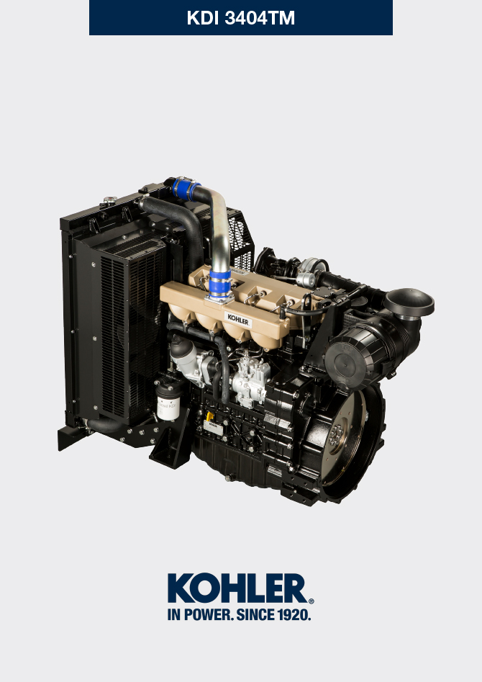

Registration of modifications to the document
Any modifications to this document must be registered by the drafting body, by completing the following table.

Released by | Code | Revision | Release Date | Revision date | Edited by | Endorsed
 | manoff

Translated from the original manual in Italian language
Data reported in this issue can be modified at any time by KOHLER.

Sommario
1. TITOLO 1 2
1.1. Asdfsdfsdf 2
1.2. Asdfsdfsdfggg 2

Information about optional components

Heater (replacement)
Important

- Before proceeding with operation, read Par. 3.3.2 .
11.1.1 Disassembly  - Undo the screws A .  - Remove the flange C .  - Remove the heater E and the relevant gaskets F . | 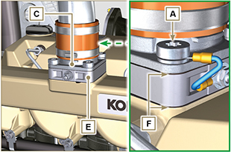  Fig 11.1
11.1.2 Assembly  Important  - Always replace gaskets F , with each assembly.  - In sequence, fit the manifold G with the gasket F , the new heater E , the second gasket F , the flange C , the washers H , the screws A and the cable B .  - Secure the flange C with the screws A (tightening torque at 22 Nm ). | 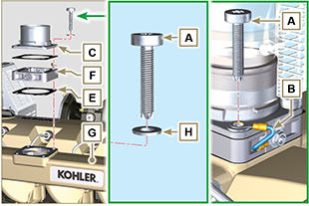  Fig 11.2

Air filter (cartridge replacement)
Important

- Before proceeding with operation, read Par. 3.3.2 .
- Release the two hooks A and remove the cover B from the body C .  - Remove the cartridges D . | 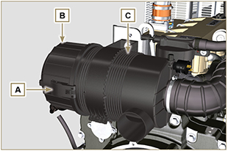  Fig 11.3
- Insert the new cartridge D and both of them inside the filter body C .  - Secure the cover B via the hooks A . | 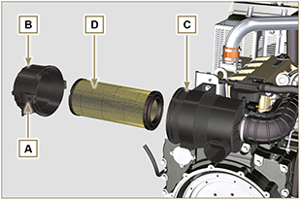  Fig. 11.4

Cooling circuit (replacement)
Important

- Before proceeding with operation, read Par. 3.3.2 .
11.3.1 Radiator disassembly  - Release the clamp A1, A2 .  - Disconnect hose B from radiator C . | 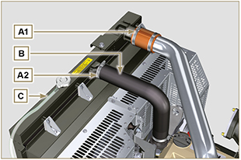  Fig. 11.5
- Release the clamp A3, A4 .  - Disconnect hose D from radiator C . | 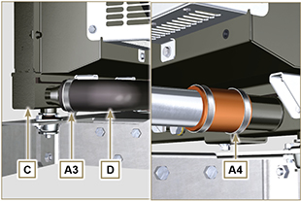  Fig. 11.6
- Loosen all capscrews E1 , E2 and E3 .  - Release nut F .  - Remove floodgates G1 and G2 .  - Loosen capscrews K .  - Disconnect radiator C from hoses H1 and H2 , being careful not to deform tubes J1 and J2 .  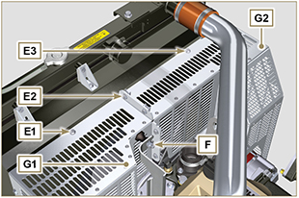  Fig. 11.7 | 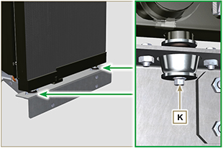  Fig. 11.8
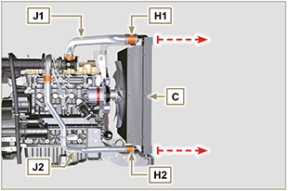
Fig. 11.9
11.3.2 Fan disassembly  - Undo the screws P and remove the fan R . | 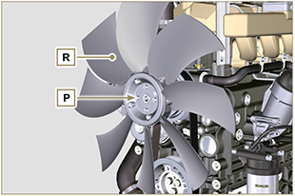  Fig. 11.10
11.3.3 Fan assembly  - Assemble the fan R on the pulley U .  - Fasten the fan R by using the screws P (tightening torque at 10 Nm ). | 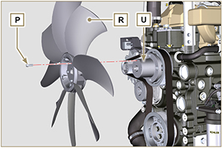  Fig. 11.11

11.3.4 Radiator assembly  - Fit radiator C onto hose H2 , being careful not to deform tube J2 .  - Centre radiator C onto vibration-dampening devices V .  - Secure radiator C onto vibration-dampening devices V by means of capscrews K (tightening torque at 25 Nm ). | 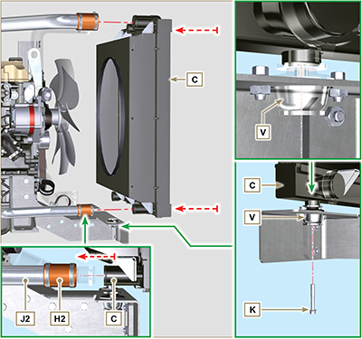  Fig. 11.12
- Position floodgate G1 onto radiator C .  - Secure all capscrews E1 .  - Place floodgate G2 onto radiator C .  - Secure all capscrews E3 and E2 . | 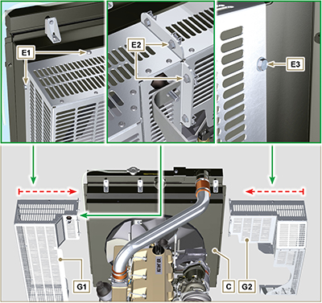  Fig. 11.13

- Fit hose H1 onto radiator C , being careful not to deform tube J1 .  NOTE : Make sure vibration-dampening device V2 is correctly installed in its place on brace S . | 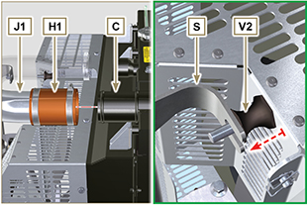  Fig. 11.14
- Secure vibration-dampening device V2 onto brace S by means of nut F , inserting washer F1 (tightening torque at 25 Nm).  - Secure hoses B and D by means of clamps A2 and A3 ( Fig. 11.5 - 11.6 ).  - Secure hoses H1 and H2 by means of clamps A1 and A4 ( Fig. 11.5 - 11.6 ). | 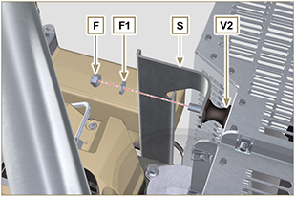  Fig. 11.15

