Fluids filling information
KDI 3404 TCR Workshop Manual (Rev. 10.4)

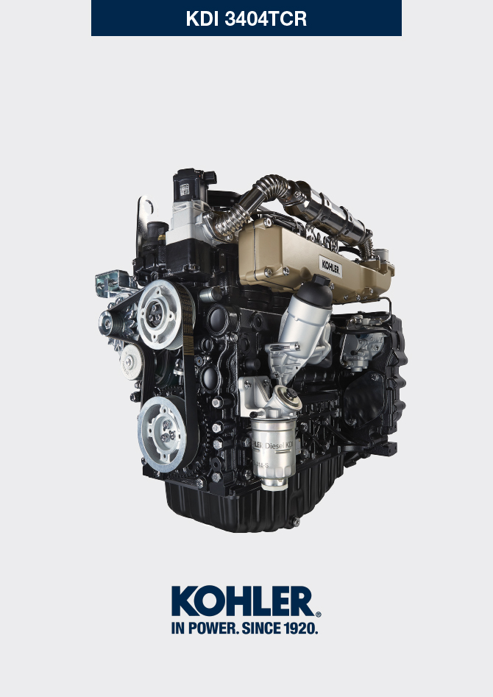

Registration of modifications to the document
Any modifications to this document must be registered by the drafting body, by completing the following table.

Released by | Code | Revision | Release Date | Revision date | Edited by | Endorsed
 | manoff

Translated from the original manual in Italian language
Data reported in this issue can be modified at any time by KOHLER.

Sommario
1. TITOLO 1 2
1.1. Asdfsdfsdf 2
1.2. Asdfsdfsdfggg 2

Fluids filling information

Engine oil
Warning

- Before proceeding with operation, carefully read Par. 3.3.2 .

- Loosen the oil filler cap A .  - Add the type and amount of oil recommended ( Tab. 2.2 ).  - Remove the oil dipstick B and check that the level is up to but does not exceed the MAX .  Important  - Do not use the engine with the level of oil below MIN or above MAX  - If the oil level is not at MAX , insert more oil until the MAX level is reached as indicated on the dipstick.  - Re-tighten the cap A . | 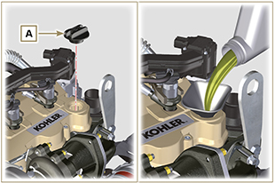  Fig 10.1
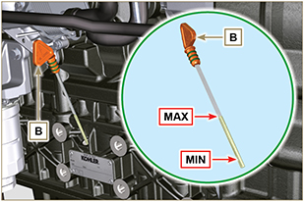
Fig 10.2
NOTE : Click by side to play the procedure. | https://www.youtube.com/embed/HWCzK41Br1U?showinfo=0&rel=0

Coolant
NOTE : Component not supplied by KOHLER .

Refer to the technical documentation of the vehicle.

