KDI 2504TCR / KDI 2504TCRE5
KDI 2504TCR / KDI 2504TCRE5 Workshop Manual (Rev. 17.4)


Sommario
1. TITOLO 1 2
1.1. Asdfsdfsdf 2
1.2. Asdfsdfsdfggg 2

General information

Useful information
- This manual contains the instructions needed to carry out proper use and maintenance of the engine, therefore it must always be available, for future reference when required.
- Information, descriptions and pictures contained in this manual reflect the basic configuration of the engines ( Par. 1.4 and Par. 1.5 ).
- However, the development of engines is continuous. Therefore, the information in this manual is subject to change without notice.
- KOHLER reserves the right to make, at any time, changes on the engines for technical or commercial reasons.
- These changes do not require KOHLER to intervene on the production marketed up to that time and nor to consider this manual as inappropriate.
- The paragraphs, tables and figures are numbered by chapter and followed by the progressive paragraph, table and/or figure number.
Es: Par. 1.3 - chapter 1 paragraph 3 .
Tab. 2.4 - chapter 2 table 4 .
Fig. 4.5 - chapter 4 figure 5 .
NOTE: The paragraphs may contain sub-paragraphs.

- All technical terms, specific components and symbols ( Tab. 15.1 ) that are in the manual are listed and described inside the glossary, which can be consulted in ( Chap. 15 ).
- The references of the objects described in the text and in the figure are indicated by letters and numbers, which are always and only related to the paragraph you are reading unless there are specific references to other figures or paragraphs.
- Reference to values are indicated by letters or numbers.
- The mark ( ) after the title of a paragraph, indicates that the procedure is not required in order to disassemble the engine, however the procedures are featured in order to illustrate the disassembly of components.
- Any additional section that KOHLER will deem necessary to supply at a later stage must be kept with the manual and considered as an integral part of it.
- The information contained in this manual is the sole property of KOHLER , therefore no partial or total reproduction or replication is allowed without the express permission of KOHLER .

1.1.1 Useful Information - accident prevention - environmental impact

- Before proceeding repair - handling the motor , read the entire chapter 3, which contains important information about the procedures to be followed for safety and environment .

Manufacturer and engine identification
The engine identification name plate is situated in the lower part of the crankcase; it is visible from the intake or exhaust side.
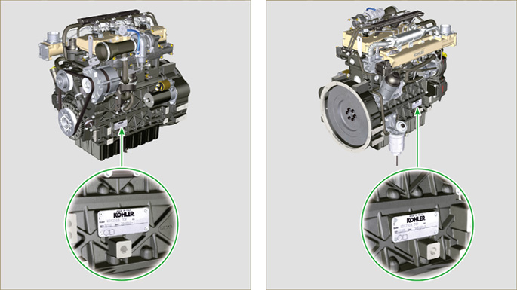
Fig 1.1 - Fig 1.2

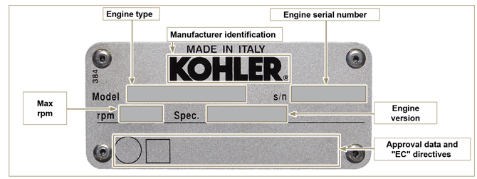
Fig 1.3

Homologation labels
Label for EPA rules (compilation example)

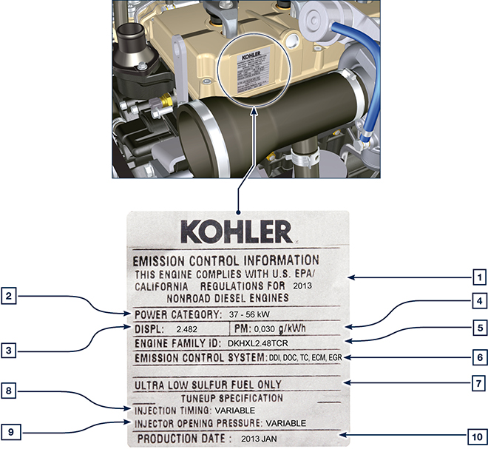

Tab 1.1
POS. | DESCRIPTION
1 | Model year in compliance with the rules
2 | Power category (kW)
3 | Engine displacement (L)
4 | Particulate emission limit (g/kWh)
5 | Engine family ID
6 | Emission Control System = ECS
7 | Fuel with low sulphur content
8 | Injection timing
9 | Electronic injector opening pressure (bar)
10 | Production date (example: 2013.JAN)

Label for China Standards (compilation example)

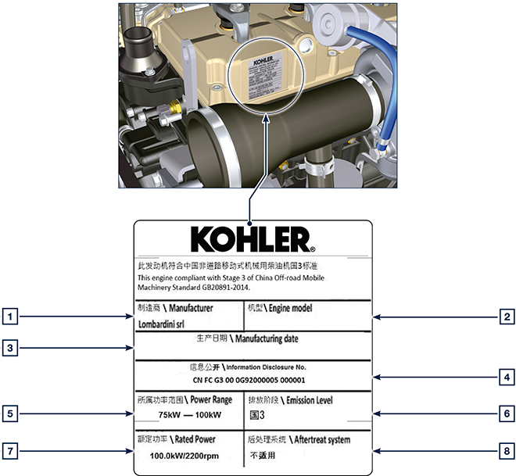
Tab 1.2
POS | DESCRIPTION
1 | Manufacturer
2 | Engine model
3 | Manufactoring date
4 | Certificate N°
5 | Power range (kW)
6 | Emission level
7 | Rated power
8 | Aftertreat system

Label for Korea Standards (compilation example)

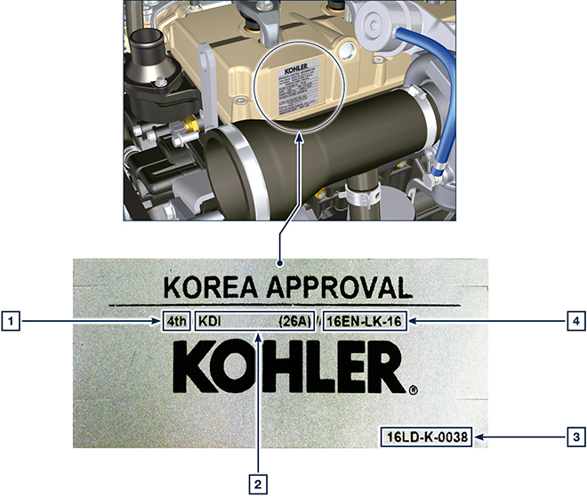
Tab 1.3
POS | DESCRIPTION
1 | Tier 4 Final
2 | Engine model
3 | Manufactoring date and manufacturer code
4 | N° Korea emission certificate

Identification of the main internal components of the engine and operating reference (BASE CONFIGURATION)
WIEW OF EXHAUST SIDE
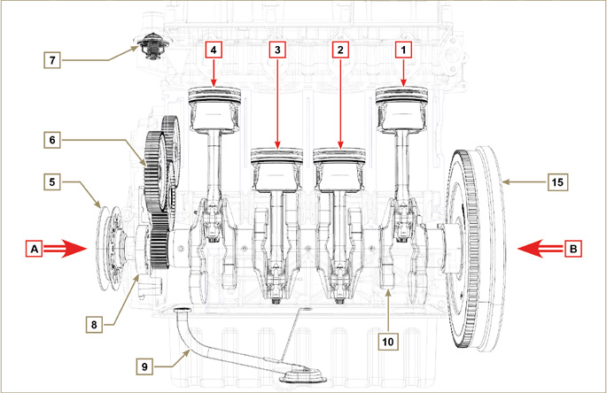
Fig 1.5

The following chapters contain operating references in order to clearly understand the engine. This paragraph illustrates these references that may be recognised by means of some main internal components.  Should you need to execute complex operations, always consult this paragraph | Tab 1.2  REF. DESCRIPTION  A View of timing system side (2 ^{nd} PTO)  B View of flywheel side (1 ^{nd} PTO)  C View of exhaust side  D View of intake side  1 Cylinder/Piston N. 1 (KDI 1903 - KDI 2504)  2 Cylinder/Piston N. 2 (KDI 1903 - KDI 2504)  3 Cylinder/Piston N. 3 (KDI 1903 - KDI 2504)  4 Cylinder/Piston N. 4 (KDI 2504)  POS. DESCRIPTION  5 Crankshaft pulley (2 ^{nd} PTO)  6 Gear timing system  7 Thermostatic valve  8 Oil pump  9 Oil suction hose  10 Crankshaft  11 Exhaust manifold  12 Intake manifold  13 Camshaft  14 Gears adaptor for 3 ^{th} /4 ^{th} PTO (optional)  15 Flywheel (1 ^{st} PTO)

WIEW OF FLYWHEEL SIDE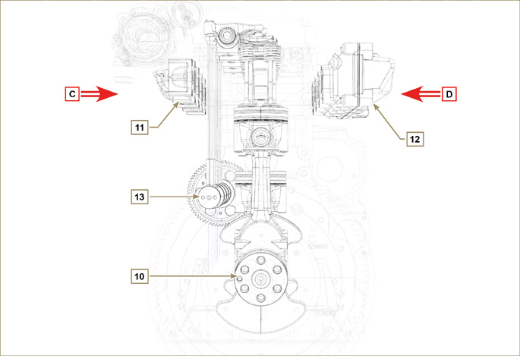
Fig 1.6

WIEW OF TIMING SYSTEM SIDE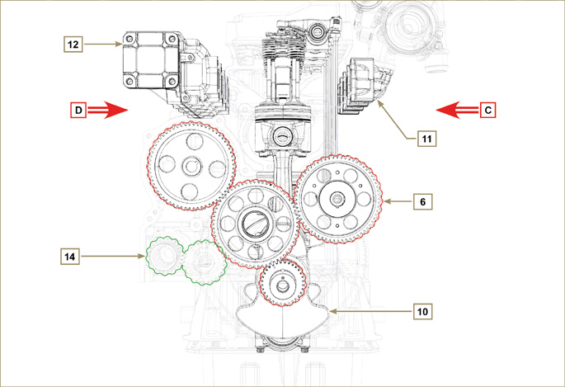
Fig 1.7

Identification of the external components of the engine (BASE CONFIGURATION)
VIEW OF TIMING SYSTEM SIDE - EXHAUST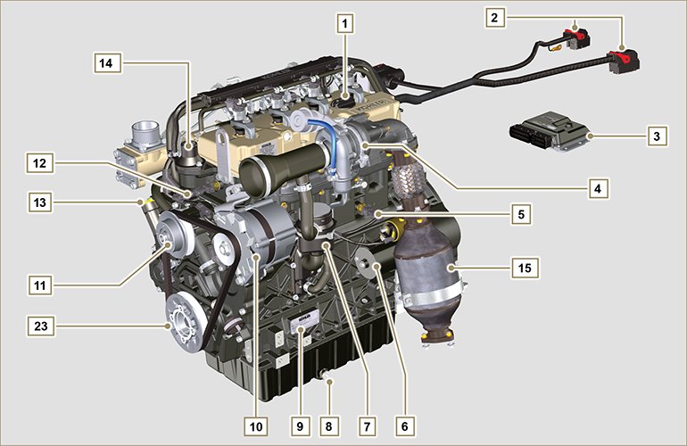
Fig 1.8

VIEW OF FLYWHEEL SIDE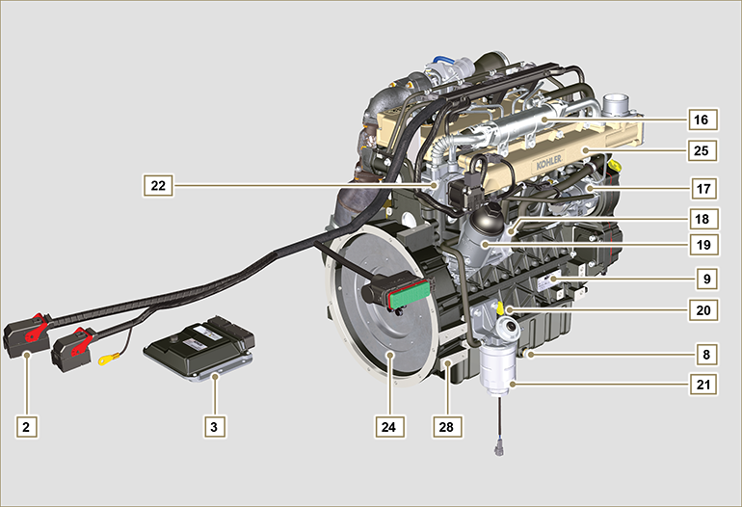
Fig 1.9

This paragraph illustrates all external components that are present in the base configuration of the engine.  For components present on engines that differ from those represented in these illustrations, refer to Chap. 11 . | NOTE: The illustrated components may differ from those illustrated; the illustration is only as an example.
Tab 1.3  POS. DESCRIPTION  1 Oil filler cap  2 Wiring  3 ECU  4 Turbocharger  5 Oil pressure switch  6 Starter motor  7 Oil steam separator  8 Oil drain plug  9 Engine identification name plate  10 Alternator  11 Coolant pump  12 Coolant temperature sensor  13 Oil filler cap side  14 Thermostatic valve  15 Catalyst  16 EGR Cooler  17 High-pressure fuel injection pump | POS. DESCRIPTION  18 Oil Cooler  19 Lub. oil filter  20 Oil dipstick  21 Fuel filter  22 EGR valve  23 Crankshaft pulley (2 ^{nd} PTO)  24 Flywheel (1 ^{st} PTO)  25 Intake manifold  26 Waste Gate valve control actuator  27 Exhaust manifold  28 Flange bell  29 Electronic injectors  30 Common Rail  31 Air intake hose

UPPER VIEW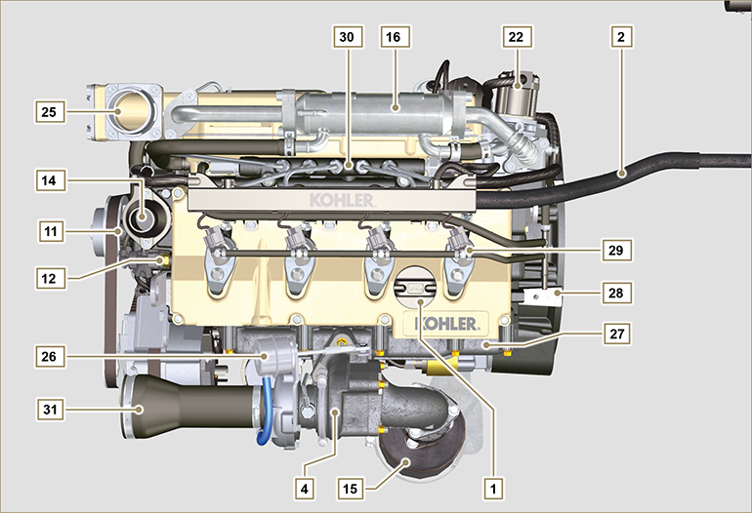
Fig 1.10

ATS (After Treatment System)
1.6.1 ATS with DOC filter  NOTE: The ATS system can be installed in a different way than shown.  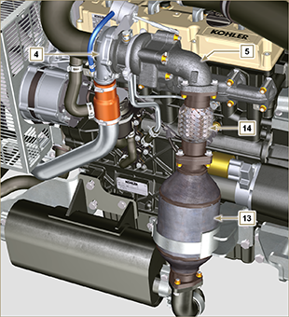  Fig 1.10 | Tab 1.4  POS. DESCRIZIONE  4 Turbocharger  5 Gas exhaust flange  13 DOC  14 Flexible exhaust tube
1.6.2 ATS with DOC+DPF filter  NOTE: the ATS system with DPF filter is only present for versions compliant with "Stage V" emission regulations.  The ATS system can be installed in a different way than shown. | Tab 1.5  POS. DESCRIZIONE  1 Turbocharger  2 Turbine exhaust pipe  3 DOC  4 DPF  5 ETB
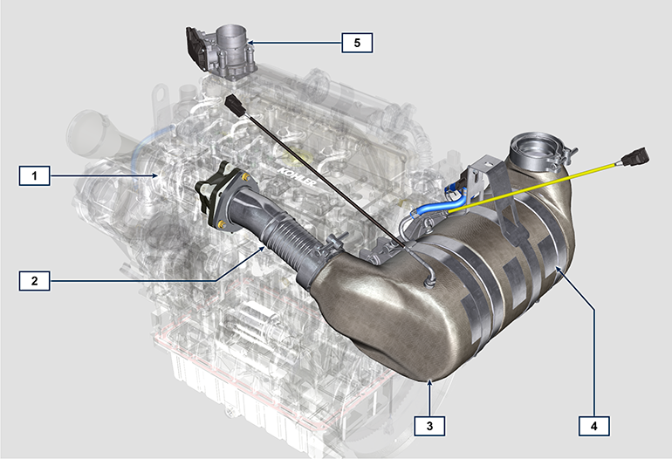
Fig 1.11

Technical information

Engine specifications
MANUFACTURER SPECIFICATIONS AND OPERATION
GENERAL INFORMATION | UNIT OF MEASURE | KDI 1903 TCR | KDI 2504 TCR
Operating cycle |  | diesel - 4 stroke
Cylinders | N° | 3 | 4
Bore x stroke | mm | 88x102
Displacement | cm ³ | 1861 | 2482
Compression ratio |  | 17.4:1
Intake |  | Supercharged with Turbocharger
Cooling |  | Liquid
Crankshaft rotation (view from flywheel side) |  | Counterclockwise
Combustion sequence |  | 1-3-2 | 1-3-4-2
Timing System
Valves per cylinder | N° | 4
Timing System |  | Rods and rocker arms - Camshaft in the crankcase
Tappets |  | Hydraulic
Injection |  | Direct - Common Rail
Engine dry weight | Kg | 233 | 267
MAX inclination 30' continuous operation | α | 25°
MAX inclination 1' continuous operation | α | 35°
Volume of aspirated air (2600 rpm) | m ³ /h | 2.4 | 2.8
POWER AND TORQUE
GENERAL INFORMATION | UNIT OF MEASURE | KDI 1903 TCR | KDI 2504 TCR
MAX operating speed | Rpm | 2600
MAX operating power (ISO TR 14396 - SAE J1995 - CE 97/68) | kW | 42 | 55.4
Maximum torque (at 1500 rpm) | Nm | 225 | 300
Admissible axial load on crankshaft | Kg | 300
CONSUMPTIONS
GENERAL INFORMATION | UNIT OF MEASURE | KDI 1903 TCR | KDI 2504 TCR
Specific fuel consumption (best point) | g/kWh | 210
Oil consumption | %Fuel | < 0.05
FUEL SUPPLY SYSTEM
GENERAL INFORMATION | UNIT OF MEASURE | KDI 1903 TCR | KDI 2504 TCR
Type of fuel |  | Diesel UNI-EN590 - ASTM D975
High-pressure fuel injection pump |  | DENSO HP3
Fuel supply |  | Low pressure electric pump (if necessary)
Fuel filter
Filtering surface | cm ² | 2300
Degree of filtration | µm | 5
Maximum pressure at injection pump inlet | bar | 0,2
LUBRICATION CIRCUIT
GENERAL INFORMATION | UNIT OF MEASURE | KDI 1903 TCR | KDI 2504 TCR
Lubrication
Recommended oil |  | See Par. 2.4
Circuit forced |  | Lobe pump
Oil sump capacity ( MAX ) | Lt. | 8,9 | 11,5
Oil pressure switch
Intervention pressure ( MIN ) | bar | 0.8±0.1
Oil filter

Maximum operating pressure | bar | 4.0
Degree of filtration | µm | 17±2
Filtering surface | cm ² | 1744
COOLING CIRCUIT
GENERAL INFORMATION | UNIT OF MEASURE | KDI 1903 TCR | KDI 2504 TCR
Coolant | % | See Par. 2.6
Coolant pump | Lt./min | 75
Thermostatic valve
Opening temperature | °C | +79
Stroke at 91°C | mm | 7.50
Liquid recirculation | Lt./h | 9
ELECTRICAL SYSTEM - ELECTRIC FAN
GENERAL INFORMATION | UNIT OF MEASURE | KDI 1903 TCR | KDI 2504 TCR
Circuit rated voltage | V | 12
External alternator (rated current) | A | 80
Starter motor power | kW | 2
System electrical consumption, excluding:  heater, electric pump, electric fan, starter motor | W | 25
Coolant temperature indicator light
Indicator light operating temperature | °C | +100/+110

Engine dimensions (mm)
NOTE : Dimensions vary according to engine configuration.

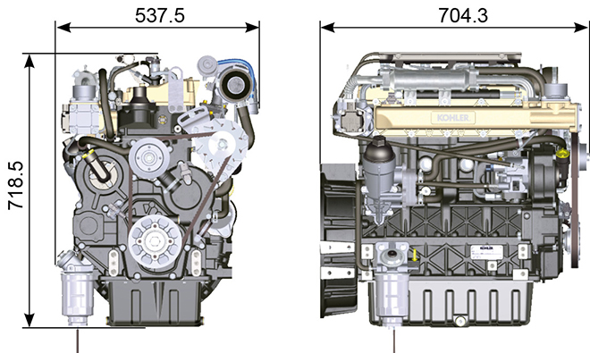
Fig 2.1

Performance
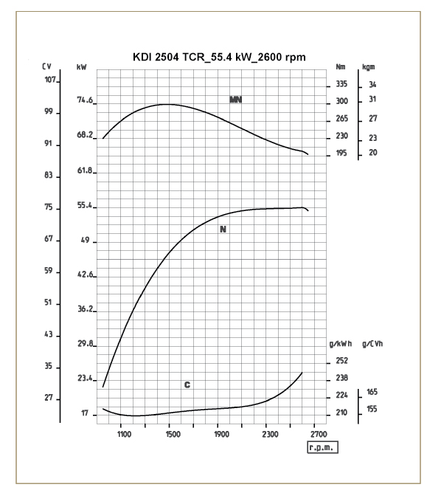

Fig. 2.3
N = Automotive rating curve
MN = Torque curve
C = Specific fuel consumption curve

NOTE: Refer to KOHLER for power curves, torque curves and specific consumptions at speeds other than those given above.

Key

- N ( ISO TR 14396 - SAE J1995 - CE 97/68 ) AUTOMOTIVE RATING CURVE : Intermittent duty at variable speed and load. Engine capacity at intermittent conditions with variable speed and load.

- MN: = TORQUE RATING CURVE : Also called twisting moment, it is the push generated by the engine through transmission. The highest engine performance is obtained at the maximum torque.

- C = SPECIFIC CONSUMPTION CURVE : Engine fuel consumption in a given time at a certain revolution value. Expressed in g/kW (grams/kilowatt), it expresses fuel yield.

* The above curves express indicative values, in that the overall performance depends on the type of application and the ECU control uni.

- The ratings reported in the diagram regard the run-in engine, fitted with air and exhaust filters, at the atmospheric pressure of 1 Bar and at a room temperature of +20°C
- Maximum rating is guaranteed with a 5% tolerance.

Warning

- Non approval by KOHLER for any modification releases the company from liability for damage incurred on the engine.

Oil

Important

- The engine may be damaged if operated with improper oil level.
- Do not exceed the MAX level because a sudden increase in engine rpm could be caused by its combustion.
- Use only the recommended oil to ensure adequate protection, efficiency and service life of the engine.
- The use of lubricants other than recommended may shorten the engine life.
- Viscosity must be appropriate to the ambient temperature to which the engine is to be exposed.

Danger

- Prolonged skin contact with the exhausted engine oil can cause cancer of the skin.
- If contact with oil cannot be avoided, thoroughly wash your hands with soap and water as soon as possible.
- For the exhausted oil disposal, refer to the Par. DISPOSAL and SCRAPPING .
2.4.1 SAE oil classification
- In the SAE classification, oils are identified according to viscosity without considering any other qualitative characteristic.
- The code is composed of two numbers, which indicate, and must correspond to, the ambient temperature in which the engine operates, the first number refers to the viscosity when cold, for use during winter (" W "), while the second number is for viscosity at high temperatures.

2.2
RECCOMENDED OIL
 |  | TCR STAGE-V (*1) (*2) | TCR TIER IV FINAL (*1) | TCR/D TIER III o NON CERTIFICATO (*3)
WITH SPECIFICATIONS | API | CJ-4 Low S.A.P.S  CK-4 Low S.A.P.S | CJ-4 Low S.A.P.S  CK-4 Low S.A.P.S | CI-4 Plus  CI-4  CH-4
 | ACEA | E6 Low S.A.P.S. | E6 Low S.A.P.S. | E7  E4
VISCOSITY | SAE | 10w-30 (-25°c ÷ +40°C) 10w-40 (-25°C ÷ +50°C)  5w-30 (-30°c ÷ +40°C)  5w-40 (-30°c ÷ +50°C)  0w-40 (-40°c ÷ +50°C) | 10w-30 (-25°c ÷ +40°C) 10w-40 (-25°C ÷ +50°C)  5w-30 (-30°c ÷ +40°C)  5w-40 (-30°c ÷ +50°C)  0w-40 (-40°c ÷ +50°C) | 10w-30 (-25°c ÷ +40°C) 10w-40 (-25°C ÷ +50°C)  5w-30 (-30°c ÷ +40°C)  5w-40 (-30°c ÷ +50°C)  0w-40 (-40°c ÷ +50°C)
- Low S.A.P.S. technology (oil with low Sulfated Ash, Phosphorus, Sulfur content) keeps catalyst in good working conditions. The presence of sulfated ash, phosphorus and sulfur causes with time the catalyst clogging and its consequent inefficiency.
- For Mid S.A.P.S oil sequence the sulfated ash level is the same as API CJ-4 ≤ 1.0% but as per ACEA standardization those oils are referenced as mid SAPS.
- Filtration of oils is critical to proper operation and lubrication; always change filters regularly as specified in this manual.

(*1) NOTA : Do NOT use fuel with sulphur content above 15ppm.

(*2) - On all engines compliant with Stage-V emission regulation (engines with DPF device), the oil to use must comply with the specification API CJ-4 Low S.A.P.S or ACEA E6 Low S.A.P.S.

(*3) - NOTE : Do NOT use fuel with sulphur content above 500ppm.

(*3) - NOTE : Low S.A.P.S. oils, sulfate ashes <1% may not be used with fuels with a sulfur content >50ppm.

Fuel

Important

- Use of other types of fuel could damage the engine. Do not use dirty diesel fuel or mixtures of diesel fuel and water since this will cause serious engine faults.
- Any failures resulting from the use of fuels other than recommended will not be warranted.

Warning

- Clean fuel prevents the fuel injectors from clogging. Immediately clean up any spillage during refuelling.
- Never store diesel fuel in galvanized containers (i.e. coated with zinc). Diesel fuel and the galvanized coating react chemically to each other, producing flaking that quickly clogs filters or causes fuel pump and/or injector failure.
2.3
FUEL COMPATIBILITY
EN 590 (biodiesel content max. 7% (V/V))
ASTM D 975 Grade 1-D S15
ASTM D 975 Grade 2-D S15
NATO F-54, equivalent to diesel fuel in accordance with EN 590
EN 590 or ASTM D 975 Grade 1, 2 -D S15 Arctic Diesel
JIS K 2204 No. 1, No. 2
NOTE : In a warranty case the customer must prove by a certificate from the fuel supplier that an allowed fuel was used.
KDI Electronic Injection Tier 4 final – Stage IIIB – Stage IV- Stage V certified Engines
- Those engines are designed for fuels in accordance with EN 590 and ASTM D975 for a cetane number of at least 45. Since those engines are equipped with exhaust gas after-treatment such as Diesel Oxidation Catalyst (DOC), Diesel Particulate Filter (DPF), Selective Catalytic Reduction (SCR), they may only be operated with sulfur-free diesel fuels (EN 590, DIN 5168, ASTM D975 Grade 2-D S15, ASTM D975 Grade 1-D S15). Otherwise, compliance with the emission requirements and durability are not guaranteed.
Insufficient lubricating capacity can lead to serious wear problems above all in common rail injection systems. Too low a lubricating capacity is particularly a problem in fuels with a low sulfur content (and in this respect sulfur contents ‹500 mg/kg can already be considered low). An adequate lubricating capacity is guaranteed by the appropriate additives in low-sulfur (‹50 mg/kg) or sulfur-free (‹10 mg/kg or ‹15 mg/kg) diesel fuels according to EN 590 and ASTM D 975. In low-sulpur and sulfur-free diesel fuels which do not comply with this standard, the lubricating capacity may have to be guaranteed by additives. The parameter for sufficient lubricating capacity is a maximum wear spot of 460 micrometers in the HFRR test (EN ISO 12156-1).

KDI Electronic Injection Tier 3 – Stage IIIA emission equivalent certified Engines (EGR engines)
- Those engines are designed for fuels in accordance with EN 590 and ASTM D975 for a cetane number of at least 45. Since those engines are not equipped with exhaust gas after-treatment, they can be operated with diesel fuels with sulfur content up to 500 mg/kg (ppm). Compliance with the emission requirements is guaranteed only with sulfur content up to 350 mg/kg (ppm).
Fuels with a sulfur content > 50 mg/kg demand a shorter lubricating oil change interval. This is set at 250hrs. However, the engine oil must be changed when the Total Base Number TBN is reduced to 6.0 mgKOH/g test method ASTM D4739. Do not use low SAPS engine oils.

KDI Electronic Injection uncertified Engines (no EGR engines)
- Those engines are designed for fuels in accordance with EN 590 and ASTM D975 for a cetane number of at least 45. Since those engines are not equipped with exhaust gas after-treatment, they can be operated with diesel fuels with sulfur content up to 2000 mg/kg (ppm). Fuels with a sulfur content > 15 mg/kg demand a shorter lubricating oil change interval. This is set at 250hrs. However, the engine oil must be changed when the Total Base Number TBN is reduced to 6.0 mgKOH/g test method ASTM D4739.

2.5.1 Fuel for low temperatures
- When operating the engine in ambient temperatures lower than 0 degrees C, use suitable low temperature fuel normally available from fuel distributors and corresponding to the specifications of Tab. 2.3 .
- These fuels reduce the formation of paraffin in diesel at low temperatures.
- When paraffin forms in the diesel, the fuel filter becomes blocked interrupting the flow of fuel.

2.5.2 Biodiesel fuel
- Fuels containing 10% methyl ester or B10, are suitable for use in this engine provided that they meet the specifications listed in the Tab. 2.3.
- DO NOT USE vegetable oil as a biofuel for this engine.
2.4
BIODIESEL COMPATIBILITY
Biodiesel according to EN 14214 (only permissible for mixture with diesel fuel at max. 10% (V/V))
US biodiesel according to ASTM D6751 – 09a (B100) (only permissible for mixtures with diesel fuel at 10% (V/V))

2.5.3 Synthetic fuels: GTL, CTL, BTL, HV
It is a well-known fact that engines which are operated for longer periods with conventional diesel fuel and then converted to synthetic fuels suffer shrinkage of polymer seals in the injection system and thus fuel leaks. The reason for this behavior is that the aromatic-free synthetic fuels can lead to a change in the sealing behavior of polymer seals.
Therefore, conversion from diesel fuel to synthetic fuel may only be done after changing the critical seals. The problem of shrinkage does not occur when an engine was operated with synthetic fuel from the start.

2.5.4 Non-Road Fuels
Only for KDI De- Contented Electronic Injection Tier 3 – Stage IIIA emission equivalent certified Engines (EGR engines) and KDI De- Contented Electronic Injection Uncertified Engines (no EGR engines).
Other non-road fuels may be used if they comply with all the limit values of EN 590 except for the fuel density, the cetane number and the sulfur content.
The following limits apply for these parameters:
2.5
FUEL PARAMETER | UNIT | LIMIT VALUE
Cetane number |  | Min. 49
Fuel density at 15°C | Kg/m ³ | 820 - 860
Sulfur content | mg/kg or ppm | max. 500

2.5.5 Jet Fuels
Only for KDI De- Contented Electronic Injection Uncertified Engines (no EGR engines).
The following jet fuels can be used but only adopting an additional fuel filter with lubricity doser:
2.6
FUEL
F-34/F-35 (kerosene, NATO designation) | JP-8 (kerosene, US military designation)
F-44 (kerosene, NATO designation | JP-5 (kerosene, US military designation)
F-63 (kerosene, NATO designation, equivalent to F-34/F-35 with additives) | Jet A (kerosene for civil aviation)
F-65 (kerosene, NATO designation, 1:1 mixture of F-54 and F-34/F-35) | Jet A1 (kerosene for civil aviation)

2.5.6 Emission-Related Installation Instructions Failing to follow the instructions in the applications guidebook when installing a certified engine in a piece of nonroad equipment violates federal law (40 CFR 1068.105(b)), subject to fines or other penalties as described in the Clean Air Act.

OEM must apply a separate label with the following statement: “ULTRA LOW SULFUR FUEL ONLY” near the fuel inlet.

Ensure you are installing an engine appropriately certified for your application. Constant speed engines may only be installed on constant speed equipment for constant speed operation.

If you install the engine in a way that makes the engine's emission control information label hard to read during normal engine maintenance, you must place a duplicate label on the equipment, as described in 40 CFR 1068.105.

Coolant recommendation
A mixture of 50% demineralized water and 50% low silicate ethylene glycol based coolant liquid must be used. Use a Long Life or Extended Life Heavy Duty OAT coolant free of: silicates, phosphates, borates, nitrites and amines.

The following ethylene-glycol based engine coolant for all models within KDI engine family may be used:

- OAT (Organic Acid Technology) Low Silicate: ASTM D-3306 D-6210
- HOAT (Hybrid Organic Acid Technology) Low Silicate: ASTM D-3306 D-6210

The above coolants in concentrated formulation must be mixed with distilled, deionized, or demineralized water. A pre-mixed formulation (40-60% or 50-50%) can be used directly when available.

Important
- Do not mix ethylene glycol and propylene glycol based coolants. Do not mix OAT and HOAT based coolant. OAT performance life can be drastically reduced if contaminated with nitrite-containing coolants.
- Never use automotive-type coolants. These coolants do not contain the correct additives to protect heavy – duty diesel engines.

OAT coolants are maintenance free up to 6 years or 6000hrs of operation , provided that the cooling system is topped up using the same type of coolant. Do not mix different coolant types. Test the coolant condition annually with coolant test strips.
HOAT are not all maintenance free and it is recommended to have SCA (Supplemental Coolant Additives) added at the first maintenance interval.

Battery recommendation
Battery not supplied by Kohler

Tab. 2.7
RECOMMENDED BATTERIES
AMBIENT TEMPERATURE | BATTERY TYPE
≥ - 15°C | 100 Ah - 800 CCA/SAE
< -15°C | 120 Ah - 1000 CCA/SAE

Periodic maintenance
The intervals of preventive maintenance in Tab. 2.8, Tab. 2.9, Tab. 2.10 and Tab. 2.11 refer to the engine operating under normal operating conditions with fuel and oil meeting the recommended specifications.

2.8
CLEANING AND CHECKING
OPERATION DESCRIPTION | PERIOD (HOURS)
 | 100 | 250 | 500 | 5000
Engine oil level ⁽⁸⁾
Coolant level ⁽⁸⁾ ⁽⁹⁾
Cartridge dry-type air filter ⁽²⁾
Radiator heat-exchange surface and Intercooler ⁽²⁾ ⁽⁸⁾
Standard alternator belt ⁽⁸⁾
Poly-V alternator belt ⁽⁸⁾
Rubber hose (intake air / coolant)
Fuel hose
Starter Motor

Alternator

2.9
REPLACEMENT
OPERATION DESCRIPTION |  | PERIOD (HOURS)
 |  | 500 | 2000 | 5000
Cartridge dry-type air filter ⁽²⁾
Intake manifold hose (air filter - intake manifold) ⁽⁷⁾
Coolant hoses ⁽⁷⁾
Fuel line hose ⁽⁷⁾
Alternator belt | Standard alternator belt (trapezoidal) ⁽³⁾
 | Poly-V belt heavy environmental condition
 | Poly-V belt standard condition
Coolant | OAT
 | HOAT ⁽¹⁰⁾

2.10
ENGINE OIL AND OIL FILTER CARTRIDGE REPLACEMENT
ENGINE VERSION | PERIOD (HOURS)
 | 250 | 500
KDI TCR Tier 4 final – Stage IIIB – Stage IV- Stage V ⁽¹⁾
KDI TCR/D Tier 3 – Stage IIIA ⁽¹⁾ ⁽¹¹⁾
KDI TCR/D uncertified ⁽¹⁾

2.11
FUEL FILTER AND PREFILTER CARTRIDGE REPLACEMENT
ENGINE VERSION | PERIOD (HOURS)
 | 250 | 500
KDI TCR Tier 4 final – Stage IIIB – Stage IV- Stage V ⁽¹⁾
KDI TCR/D Tier 3 – Stage IIIA ⁽¹⁾
KDI TCR/D uncertified ⁽¹⁾
(1) - In case of low use: 12 months.

(2) - The period of time that must elapse before checking the filter element depends on the environment in which the engine operates. The air filter must be cleaned and replaced more frequently under very dusty conditions.

(3) - In case of low use: 36 months.
(7) - The replacement interval is only an indication, it strongly depends from environmental condition and hose status detected during regular visual inspection.
(8) - The first check must be done after 10 hours.
(9) - Test the coolant condition annually with coolant test strips.
(10) - It is recommended to have SCA (Supplemental Coolant Additives) added at the first maintenance interval.
(11) - Read Cap. 2.5, "KDI De- Contented Electronic Injection Tier 3 – Stage IIIA emission equivalent certified Engines (EGR engines)" and "KDI De- Contented Electronic Injection Uncertified Engines (no EGR engines)".

Fuel system
2.9.1 Injection circuit (pressure 2000 bar) (Fig 2.4)
The materials of the fuel system components (pipes, tank, filters, etc.) and any surface treatments must be free from chemical elements that, transported in the fuel, compromise the operation of the injectors over time (hole clogging).

The most critical chemical element is Zinc (Zn), therefore it is forbidden to use galvanised components.

Other damaging elements are indicated in the table below.
Tab 2.12
METALS | LIMIT VALUES OF PRESENCE IN FUEL | LIMIT VALUE
Zn (Zinc) | - Zinc (Zn) is eluted from the rubber (NBR) in the fuel line. Thus, the growing carboxylate (Zn) was adhered on the parts in the injection system for reacting carboxylic acid in the fuel.  - In case that the changed injection quantity, nozzle coking occurs the fuel contents Zn≥1ppm.  - Zinc (Zn) is ≤ 0.3ppm is the limited value to avoid occur coking. | Zn ≤ 0.3ppm
Pb (Lead) | - Lead (Pb)is eluted from Pd coading in the fuel tank. Thus, the growing carboxylate (Pd) was adhered on the injection system for reacting carboxylic acid in the fuel.  - In case that the changed injection quantity and nozzle coking occurs the fuel contents Pd.  - As interim, the identical level is the limited value with Zn. | Pd ≤ 0.3ppm
Na (Sodium) | - The growing carboxylate (Na) was adhered on the parts in the injection system for reacting carboxylic acid in the fuel with fuel contents Na ≥ 0.5ppm. Thus, sliding malfunction was occurred.  - In case that the changed injection quantity and nozzle coking occurs the fuel contents Na.  - Especially concerns of occurring defects, NaOH is residue for using production process of bio fuel.  - ≤ 0.3ppm is the limited value to avoid occur nozzle coking and carboxylate. Combine K with Na equivalent alkali metal that are less than 0.3ppm. | Na + K ≤ 0.3ppm
K (Potassium)
Ca (Calcium) | - In case that carboxylate (Ca) was adhered the injection system inside.  - Under study on the results in the moment.  - Maximum value is 0.3ppm when using fuel that is B100 fuel with regulation EN14214 of contents 7%. | Ca + Mg ≤ 0.3ppm
Mg (Magnesium)
Cu (Copper) | - Copper (Cu) on the fuel that can be acted wear and catalyst for making decline.  - In case that the changed injector quantity and nozzle coking occurs in the fuel contents Cu.  - As interim, the identical level is the limited value with Zn. | Cu ≤ 0.3ppm
Ba (Barium) | - In case that changed injection quantity and nozzle coking occurs in the fuel contents Barium (Ba).  - As interim, the identical level is the limited value with Zn. | Ba ≤ 0.3ppm
P (Phosphorus) | - Phosphorus (P) in the fuel can poison catalyst.  - No failure case is in the injection system in the moment.  - Maximum value is 0.3ppm when using a B100 fuel with regulation EN 14214 of contents 7%. | P ≤ 0.3ppm
Na - K - Ca - Mg - P | These metals are regulated in EN14214

Important

- The high pressure supply injection system is highly susceptible to damage if the fuel is contaminated.
- It is crucial that all components of the injection circuit are thoroughly cleaned before the components are removed.
- Thoroughly wash and clean the engine before maintenance.
- Contamination in the injection system may cause a reduction in in performance or engine faults.
- If the engine is cleaned with high pressure washer, then the nozzle must be kept at a minimum distance of 200mm from the surface, and not directed at electrical components and connectors.

The fuel supply system is under low pressure from fuel tank 1 to the high-pressure fuel injection pump 5 .  NOTE : The representation of fuel tank is purely indicative. Component not necessarily supplied by KOHLER .  Tab 2.13  POS. DESCRIPTION  1 Fuel tank  2 Fuel pipe under low pressure from the tank to the fuel filter  3 Fuel filter  4 Low-pressure fuel tube from the fuel filter to the high-pressure injection pump  5 High-pressure fuel injection pump  6 High-pressure fuel tube from the high-pressure fuel injection pump to the Common Rail  7 Common Rail  8 Fuel pipes under high pressure from the Common Rail to the electronic injectors  9 Electronic injectors | 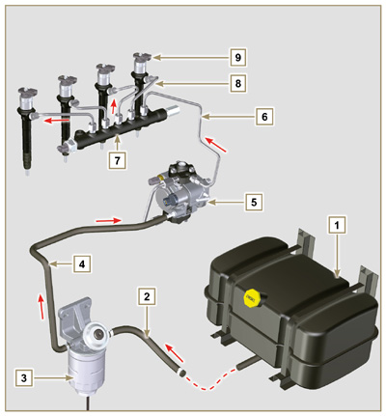  Fig 2.4
2.9.2 Fuel return circuit  The fuel return circuit is under low pressure.  NOTE : The representation of fuel tank is purely indicative. Component not necessarily supplied by KOHLER .  Tab 2.14  POS. DESCRIPTION  1 Electronic injectors  2 Common Rail  3 Low-pressure fuel return tube from the Common Rail to the fuel return distributor  4 Low-pressure fuel return tube from the electronic injectors to the fuel return distributor  5 Low-pressure fuel return distributor  6 Low-pressure fuel return tube from the return distributor to the fuel tank  7 High-pressure fuel injection pump  8 Low-pressure fuel return tube from the injection pump to the fuel return distributor  9 Fuel tank | 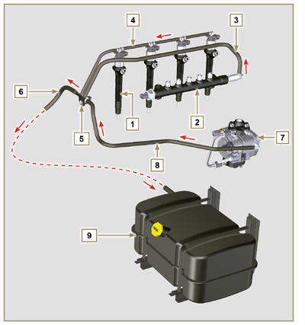  Fig 2.5

2.9.3 High-pressure injection pump (2000 bar)  Important  - DO NOT use the cylinder connecting pipe (item 5) to carry the pump during movement as this may cause damage resulting in fuel leakag; to handle the injection pump, refer Par. 2.17.1.  - The injection pump CANNOT be repaired.  - DO NOT attempt to remove the temperature sensor 7 from the pump. Should the sensor 7 be defective, replace the injection pump.  - It is NOT possible to perform any maintenance on the fuel intake regulating valve 6 as it is an integral part of the injection pump.  - DO NOT attempt to remove the fuel intake regulating valve 6 from the injection pump. Should the valve be defective, replace the injection pump.  NOTE: In the event of leakage from the high pressure circuit do not intervene when the engine is running, but turn it off and wait 5 - 10 minutes before checking the leakage.  The inlet pressure to the high pressure pump must be between 300 mbar (suction pump without electric supply) and 200 mbar (with electric pump power) to the high pressure rail.  The high pressure pump is operated via the pump control gear and sends high pressure fuel to the common rail.  NOTE: The supply tube (on union 8) and fuel return (on union 9), have different diameters.  Tab 2.15  POS. COMPONENTS DESCRIPTION  1 High-pressure fuel injection pump  2 Name plate with QR code  3 Fitting for high pressure outlet to Common Rail  4 Plunger housing  5 Connection pipe plunger housing  6 Fuel intake regulating valve  7 Fuel temperature sensor  8 Fuel inlet fitting  9 Fuel return fitting  10 Shaft key positioning on the pump control gear  11 Pump control shaft  12 Gasket | 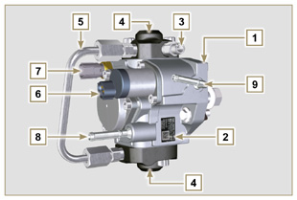  Fig 2.6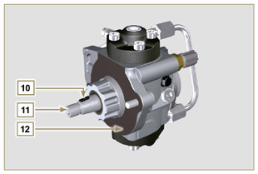  Fig 2.7

2.9.4 Electronic injector  The electronic injector is equipped with an integral solenoid valve which, when excited electronically, manages a valve controlled from  inside the electronic injector to commence fuel injection.  The ECU output signal is digital.  Important  - The electronic injector is NOT repairable.  - The electronic injectors are calibrated individually.  - They are NOT interchangeable with the other cylinders of the same - or other - engines.  - It is assembled on the engine; the new calibration code (QR code) must be inserted in the ECU by means of a diagnostics instrument (ST_01).  - Do NOT fit new or different electronic injectors without the instruments required to enter the injector calibration code.  - Fuel containing impurities causes serious damage to the electronic injectors.  - The electronic injector for Stage V engines is different and it is not interchangeable with other engine | 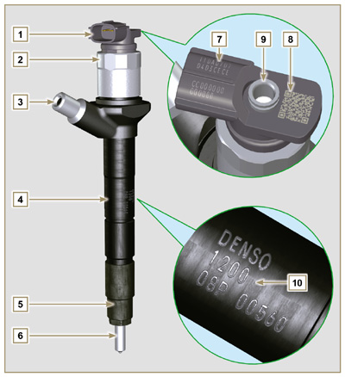  Fig 2.8  Tab 2.16  POS. COMPONENTS DESCRIPTION  1 Connector for solenoid control  2 Solenoid and valve closure ring  3 High pressure pipe inlet fitting  4 Electronic injectors body  5 Nozzle closure ring nut  6 Nozzle  7 QR code (Visual reading)  8 QR code (Electronic reading)  9 Return pipe fitting  10 Electronic injector identification code
2.9.5 Common Rail
Fuel is injected under pressure into the Common Rail ( Pos.3 ), from the high-pressure fuel injection pump.
- The internal volume of the Common Rail is optimised to obtain the best compromise in order to minimise pressure peaks due to the cyclical flow of the injection pump;
- Opening the electronic injectors;
- The high speed response of the system to the requests of the ECU control unit.
The pressure sensor 5 measures the pressure of the fuel in the Common Rail.
Safety valve 2 , only opens if internal pressure of the Common Rail exceeds the maximum value of 2400 bar.
Pressure inside the Common Rail is regulated by the highpressure fuel injection pump by means of the fuel intake regulation valve ( Pos. 6 Fig. 2.6 ).

The fuel ejected from the safety valve is introduced in the circuit of rejection returning to the tank.

Important

- Common Rail is NOT reparaible.
- It is NOT possible to perform any maintenance on the fuel pressure sensor 5 , as it is an integral part of the Common Rail unit.
- Do NOT remove the pressure sensor or the fuel pressure limit valve from the Common Rail.
- If the pressure sensor or the pressure limit valve are not working, replace the entire Common Rail unit.
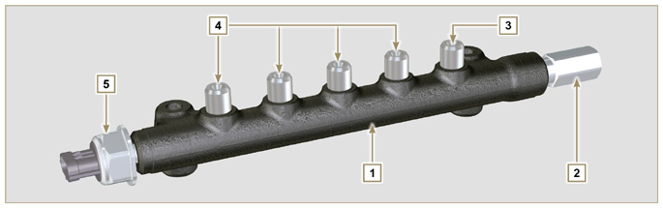
Fig 2.9

Tab 2.17
POS. | DESCRIPTION
1 | Common Rail
2 | Pressure limit valve (return due to overpressure)
3 | Tube inlet union from high-pressure fuel injection pump
4 | Outlet fittings for supply pipes to electronic injectors
5 | Fuel pressure sensor

2.9.6 Fuel filter  The fuel filter is situated on the crankcase of the engine or it may be assembled on the frame of the vehicle.  Tab 2.18  POS. COMPONENTS DESCRIPTION  1 Fuel filter support  2 Fuel system filling button  3 Cartridge  4 Water in fuel sensor  5 Wing nut, filter drainage  Tab 2.19  DESCRIPTION VALUE  Filtering surface 2.300 cm ²  Degree of filtration 5 µm  Max operating pressure 2.0 Bar  Max flow rate 190 litres/hour | 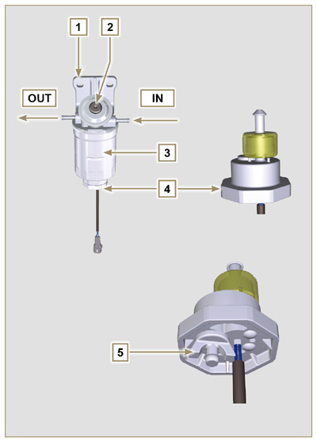  Fig 2.10

2.9.7 Electric fuel pump (optional)  When the electric fuel pump is installed in a diesel engine, one must:  - Remove any filters installed on the inlet of the electric injection pump;  - Insert a pre-filter between the tank and the electric pump;  - The electric pump may be assembled on application at a maximum height of 500 mm from the position of the fuel tank.  - Insert a shut-off valve to prevent dry operation due to the emptying of the intake manifold;  - The supply pressure given from the electric pump must not exceed the pressure of 0.2 bar to the input of highpressure injection pump.  Tab 2.20  POS. DESCRIPTION  1 Arrival pipe from the tank  2 Electric pump  3 Flow pipe to the fuel filter  4 Fuel filter | 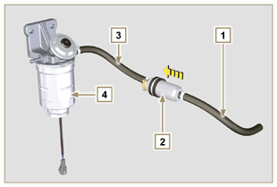  Fig 2.11
2.9.8 Guards for fuel injection circuit components  High-pressure injection circuit components are particularly sensitive to impurities.  To prevent impurities, even microscopic ones, from accessing the fuel input or output unions, you are required to close these accesses by means of specific caps as soon as the various tubes are disassembled and disconnected.  Disassembly of any component of the injection circuit must not occur in dusty environments.  Cap protections must remain closed in their housing (ST_40) until the moment they are to be used.  Pay special attention when using the caps and avoid any contamination of dust or dirt of any kind.  Even after using the caps illustrated in this paragraph, all components of the injection circuit must be placed with care in environments that are free of any type of impurity.  Fig. 2.13, 2.14 and 2.15 illustrate the caps that must be used on components of the injection circuit.  Cap protections must be accurately washed after use and placed back in their housing (ST_40).  Important  - It is highly recommended to have this page visible during disassembly operations of the components of the fuel injection circuit. | 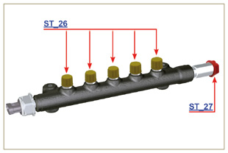  Fig 2.13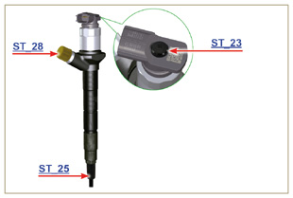  Fig 2.14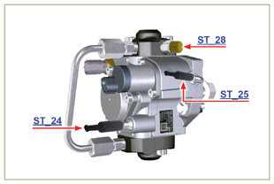  Fig 2.15

Lubrication circuit
2.10.1 Lubrication circuit diagram  The oil pump is driven by the crankshaft on the timing system side.  On the parts of the systems shown in green on In the parts in green, the oil is in intake, in the parts in red, the oil is under pressure and  in those in yellow the oil is returning towards the oil sump 2 (not under pressure).  Tab 2.21  COLOUR DESCRIPTION  Oil in intake  Oil under pressure  Oil returning to the oil sump  Tab 2.22  POS. DESCRIPTION  1 Oil pump rotors  2 Oil sump  3 Crankshaft  4 Camshaft  5 Turbocharger  6 Rocker arm pin  7 Hydraulic tappets  8 Rocker arm cover  9 Cylinder head  10 Upper crankcase  11 Lower crankcase  12 Oil filter  13 Oil Cooler  14 Housing | 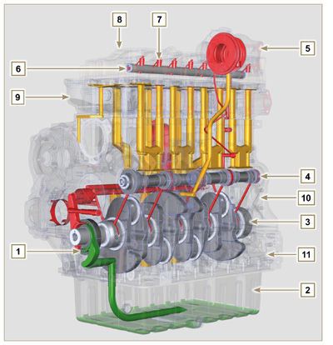  Fig 2.16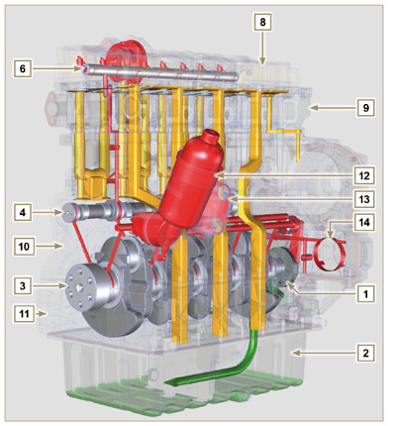  Fig 2.17
NOTE : Click by side to play the procedure. | https://www.youtube.com/embed/Ig3XosQ8h0s?rel=0
2.10.2 Oil pump The oil pump rotors are trochoidal (with lobes) and are activated from the crankshaft by means of the key.  The pump body is situated inside the distribution guard.  It is imperative to assemble the rotors with reference A visible by the operator.  Tab 2.23  POS. DESCRIPTION  1 Internal rotor  2 External rotor  3 Oil pump crankcase  4 Pump control key  5 Timing system crankcase  6 Crankshaft | 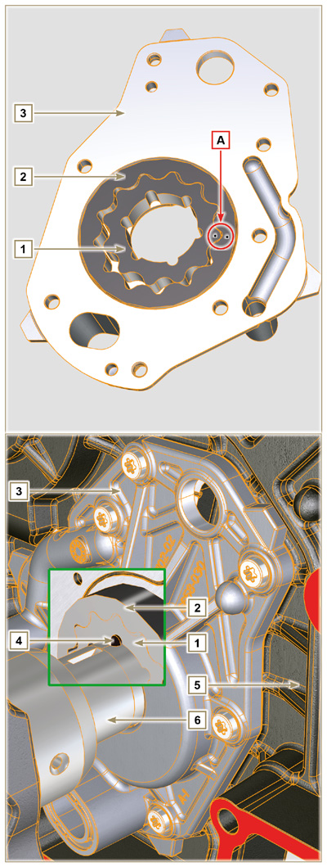  Fig 2.18

2.10.3 Oil filter and Oil Cooler

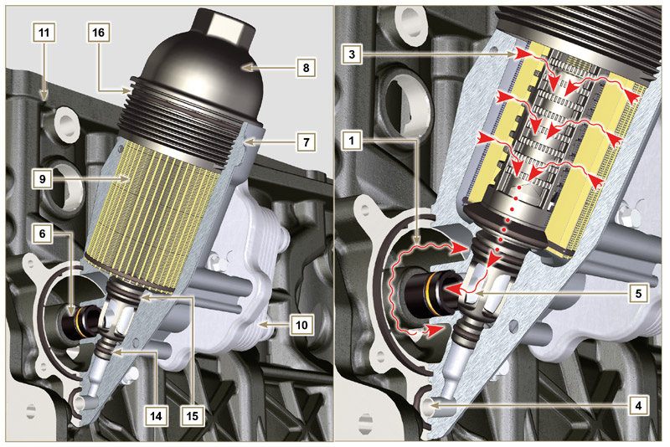
Fig 2.1 9

NOTE : unscrewing the cartridge holder cover makes the oil in support 7 flow towards the oil sump by means of the drain duct 4.
Tab 2.24  POS. DESCRIPTION  1 Oil arriving from the pump  2 Oil cooling  3 Oil filtering  4 Oil drain duct (oil sump return)  5 Oil returning into the circuit  6 Outgoing fitting from filter  7 Oil filter support  8 Cartridge holder cover  9 Oil filter cartridge  10 Oil Cooler  11 Crankcase  12 Oil directly from the cartridge  13 Coolant  14 Oil drain duct closure gasket  15 Oil filtering chamber closure gasket  16 Cartridge holder cover gasket  Tab 2.25 Cartridge characteristics.  DESCRIPTION VALORE  Filtering surface 2.300 cm ²  Degree of filtration 2 µm  Max operating pressure 4.0 Bar  Max flow rate 190 litres/hour | 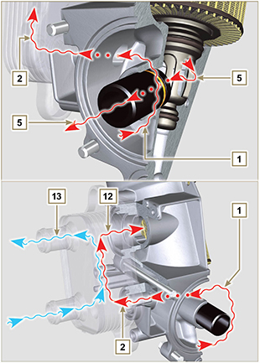  Fig 2.20

Cooling circuit
2.11.1 Cooling circuit diagram
Tab 2.26  POS. DESCRIPTION  1 Coolant pump  2 Coolant intake  3 Coolant, cylinder  4 Coolant, cylinder head  5 EGR gas coolant  6 Coolant to radiator  7 Coolant into radiator  8 EGR valve coolant  9 Coolant in the Oil Cooler  10 Coolant input into the Oil Cooler  11 Coolant output from the Oil Cooler  12 Vent line from radiator (to 15)  13 Vent line to expansion vase (to 15)  14 Return from compensation tank  15 Compensation tank  16 Thermostatic valve | Fig 2.21

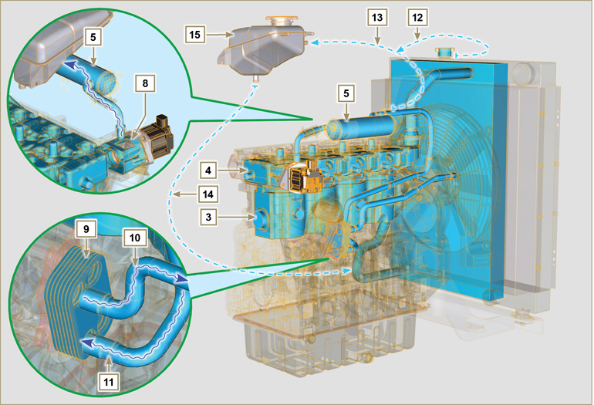
Fig 2.22

2.11.2 Water pump  Tab 2.27  POS. DESCRIPTION  1 Coolant pump control pulley  2 Coolant intake fitting  3 Coolant return hose from the Oil Cooler | Fig 2.23
2.11.3 Radiator with Intercooler (optional)  Tab 2.28  POS. DESCRIPTION  1 Radiator with intercooler  2 Coolant refill cap  3 Radiator coolant vent tube or return  4 Air hose (from Intercooler to manifold)  5 Intercooler air delivery hose  6 Coolant flow manifold  7 Coolant intake manifold  8 EGR Cooler coolant vent tube or return | Fig 2.24
2.11.4 Thermostatic valve  Tab 2.29  POS. DESCRIPTION  1 Cylinder head  2 Coolant outlet cover  3 Thermostatic valve  4 Gaskets  5 Air bleeding hole  Starting opening temperature of +79° ± 2°C. | Fig 2.25
2.11.5 EGR gas circuit cooling (EGR Cooler)  Device that cools exhaust gas  Tab 2.30  POS. DESCRIPTION  1 EGR valve  2 EGR gas passage tubes  3 Coolant outlet hose  4 EGR Cooler  5 Coolant draining union  6 Coolant delivery hose  7 Intake manifold | Fig 2.26

Intake and exhaust circuit
2.12.1 Turbocharger  The turbocharger is controlled by means of exhaust gas that activates the turbine.  Important  - See Par 2.18 .  Tab 2.31  POS. DESCRIPTION  1 Air intake hose  2 Air compression volute  3 Turbo charger central body  4 Turbine housing with Waste Gate valve  5 Gas exhaust flange  6 Waste Gate control valve hose  7 Waste Gate valve control actuator  8 Waste Gate control valve linkage  9 Engine crankcase breather  10 Air compressed flow hose to intercooler  11 Oil drain pipe  12 Turbo charger lubrication pipe | 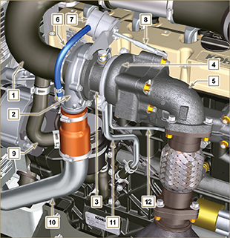  Fig 2.27
2.12.2 ATS device  2.12.2.1 DOC  The DOC is a device to filter exhaust gas by means of its oxidation.  Internally, it is composed of hundreds of small ducts that enable the passage of exhaust gas.  It contains precious metals (platinum, palladium, iridium).  NOTE: The image is indicative only. The installation of the catalyst must be approved by KOHLER, for each application.  In order to prevent breakage on the connection flange, the catalyst is normally connected via a hose.  Important  - In order to prevent breakage on the connection flange, the catalyst must be connected via a flexible exhaust tube.  Tab 2.32a  POS. DESCRIPTION  4 Turbocharger  5 Gas exhaust flange  13 DOC  14 Flexible exhaust tube | Fig 2.28
2.12.2.2 Intake and exhaust circuit diagram with DOC

 | Air in intake |  | Gas in recycle |  | Gas in exhaust

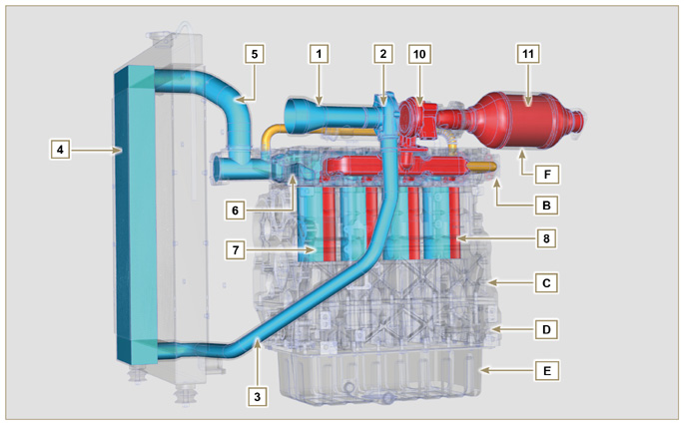
Fig 2.29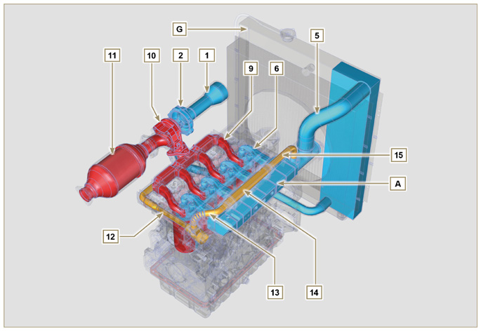
Fig 2.30

Important  - The diagrams in Fig. 2.29 and Fig. 2.30 do not have an air filter, which must always be present and connected by means of an intake hose to the turbocharger.  - The air temperature inside the intake manifold must never exceed that of the environment by 10°C.  Filtered air is sucked by the turbocharger, which compresses and sends it to the intercooler (as a consequence of compression, the air increases the temperature - the Intercooler cools it - this process enables better performance during combustion inside the cylinders). From the Intercooler, it is sent to the  intake manifold and, via ducts in the cylinder head, enters the cylinders. Compressed air inside the cylinders and mixed with the fuel transforms into Gas after combustion. The gas is expelled from the cylinders and sent to the exhaust manifold. The exhaust manifold sends the Gases to 2 ducts:  - 1st duct : to the turbocharger body (the expelled Gases activate the turbine), the Gases then proceed towards the catalyst, which break down the pollutants contained in them before being definitely expelled.  - 2nd duct : to the EGR circuit, which takes care of recovering a part of the Gases that return to intake  (this process burns less oxygen when power is not requested, thus breaking down pollutants further).  The EGR circuit is managed by ECU, which controls the EGR valve that provides for the recovery of Gases when the engine does not require power.  The EGR circuit is furnished with a heat exchanger (EGR Cooler), which cools the recovered Gases (this process enables better performance during combustion inside the cylinders). | Tab 2.32b  POS. DESCRIPTION  1 Air in intake from air filter  2 Air in compression  3 Air in intercooler flow  4 Air cooling  5 Air in intake manifold flow  6 Air in head intake  7 Air in cylinder intake  8 Gas in cylinder outlet  9 Gas in head outlet  10 Gas in outlet towards DOC  11 Gas in oxidation  12 Gas in recycle towards EGR valve  13 Gas in EGR valve outlet  14 Gas cooling (in EGR Cooler)  15 Exhaust gas recirculation into intake manifold  A Intake manifold  B Exhaust manifold  C Upper crankcase  D Lower crankcase  E Oil sump  F Catalyst  G Radiator/intercooler
2.12.2.3 DOC+DPF

The DOC+DPF system reduces emissions because the DPF eliminates the particulate generated by Diesel fuel combustion. The system triggers automatic DPF regeneration cycles depending on the degree of clogging.
The smell of the gases out of the exhaust line is different than the traditional one of gases from Diesel engines. Moreover, during regeneration stages, the exhaust gases could temporarily be white.

NOTE: During regeneration, engine idling will increase.

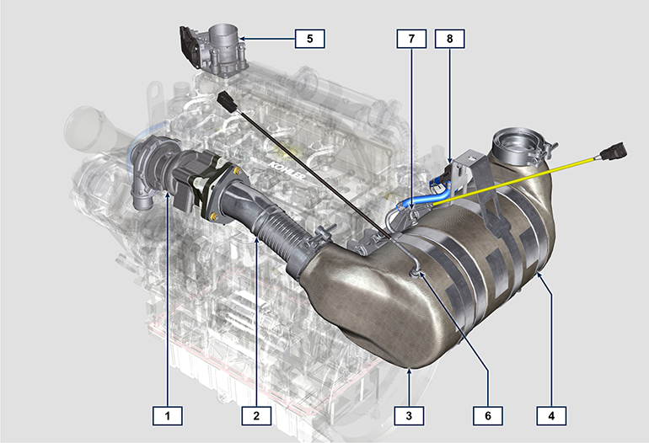
Fig 2.30a
Tab 2.32c
POS. | DESCRIPTION
1 | turbocharger
2 | exhaust pipe from turbine
3 | DOC
4 | DPF
5 | ETB
6 | EGTS (Black)
7 | EGTS (Yellow)
8 | Delta-P (Delta Pressure)

2.12.2.4 DPF regeneration strategy

You can intervene on the machine control panel for the DPF regeneration operations "only if requested by means of specific warning lights or messages on the control panel".

Tab. 2.32d describes the level of particulate accumulation, the relationship with the warning lights that will light up on the panel, the performance limitations of the engine and the operator’s options intervention.

Forced regeneration must be executed in accordance with the machine instructions.

Tab 2.32d
SOOT LEVEL | WARNING LAMPS *1 | ENGINE DE-RATE | OPERATOR POSSIBLE ACTIONS | OPERATING CONDITIONS
Level 0 |  |  |  | - No condition
Level 1
Level 2
Level 3 | Fixed |  | Forced Regeneration is Necessary | - Coolant temperature at 60 °C  - Do not switch the engine off  - Stationary vehicle  - No load applied to the engine *2
Level 4 | Flashing | Engine de-rate | Forced Regeneration is Necessary | - Coolant temperature at 60 °C  - Do not switch the engine off  - Stationary vehicle  - No load applied to the engine *2
Level 5 | Flashing | Strong Engine de-rate | Contact an authorized KOHLER workshop.  Service Regeneration Required | REGENERATION via KOHLER software

*1: The warning lights be different – consult the machine manual.
*2: Unless stated otherwise in the machine manual.

Warning

- Forced regenerations must only be executed if required by the ECU when the "HIGH SOOT" warning light goes on (due to a Level 3 - 5 particulate accumulation).
- Do NOT execute the forced regenerations if not required by the ECU (due to a Level 0 - 2 particulate accumulation).
- The minimum engine speed increases during the forced regeneration phases.
- Repeated forced regenerations cause significant engine oil contamination by the fuel.
- The oil level check must be executed after every forced regeneration.
- If the regeneration inhibition function is misused, the particulate accumulation level will increase within a short time.
- The engine oil filter and oil must be changed after a Service Regeneration is completed via KOHLER software
- (Level 5 Particulate accumulation).
- Fuel contamination allowed in the engine oil is 3% MAX.
- Any engine load must be eliminated during forced regeneration so as to prevent damaging the ATS *2 system.
- Do not switch the engine off during level 3, 4 and 5 regeneration so as to prevent damaging the ATS system.
2.12.2.5 Intake and exhaust circuit diagram with DOC+DPF
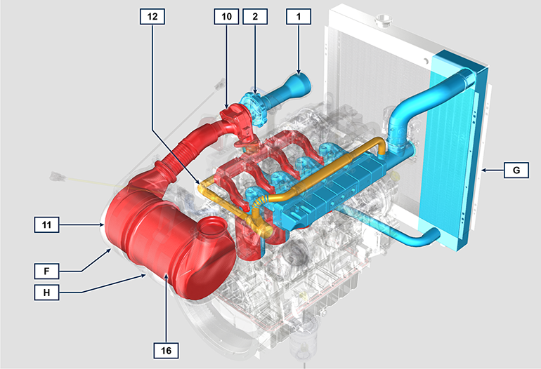

Tab 2.32e
POS. | DESCRIPTION (pos. For DPF components only)
1 | Air in intake from air filter
2 | Air in compression
10 | Gas in outlet towards DOC
11 | Gas in oxidation
12 | Gas in recycle towards EGR valve
16 | DPF
F | DOC
G | Radiator/intercooler
H | ATS

2.12.3 Air filter  NOTE: Component not necessarily supplied by KOHLER .  Important  - The air filter is a dry type of filter with a paper filtering element; element s H and L are replaceable (refer to Tab. 2.8 and Tab.2.9 for procedure frequency on components).  - Filter suction must be positioned in a cool place.  - Should a hose be used, the length must not exceed 400 mm and is to be as straight as possible.  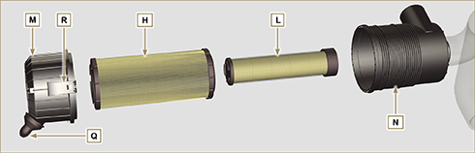  Fig 2.31 | Tab 2.33  POS. DESCRIPTION  H Air filter cartridge  L Air filter safety cartridge  M Filter cover  N Filter support  Q Dust exhaust valve  R Filter cover hook

Electric system
2.13.1 ECU input and output signals diagram
SENSOR/SWITCH (INPUT) |  | DEVICES (OUTPUT)
Power relay | ECU | Electronic injector 1
Engine Revolution Sensor |  | Electronic injector 2
Engine phase sensor |  | Electronic injector 3
Coolant temperature sensor |  | Electronic injector 4
Common Rail pressure sensor |  | EGR valve control
Oil pressure switch |  | Fuel intake adjustment valve
EGR valve position |  | Revolution indicator
Fuel temperature sensor |  | Heater relay
T-MAP sensor |  | Diagnosis indicator lights
ACACT Sensor |  | Throttle body adjustment
Main accelerator pedal (double track) |  | Electric fan control (1-2 speeds or variable speed)
Secondary accelerator pedal (optional) |  | CAN 1 (ISO15765 diagnostics)
Hydraulic oil pressure sensor (optional) |  | CAN 2 (Vehicle SAE J1939)
Fuel level sensor (optional)
Air filter clogging sensor (optional)
Sensor to detect water in the fuel
Throttle body position
EGTS (black) Sensor
EGTS (yellow) Sensor
Delta-P Sensor

2.13.2 Control unit (ECU)  The ECU is a central processor, which monitors and controls engine operation.  The electronic control unit is responsible for engine management.  It is fitted on the frame of the vehicle, or in the cab (refer to the technical documentation of the vehicle).  Important  - The ECU must only be used with the configuration defined  by KOHLER , for each individual engine.  - To look up ECU errors, refer to the Help File manual | 2.13.2.1 T echnical features  - Operating temperature: -40°C - +100°C.  - Storage temperature: -40°C - +100°C.
Fig 2.32 - Fig 2.33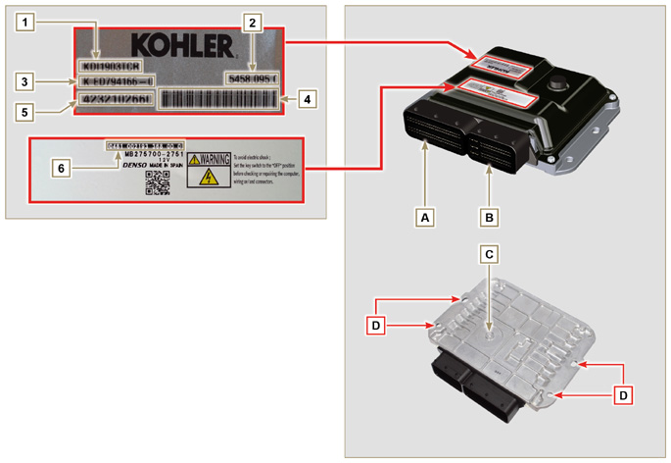

Tab. 2.35
ECU AND ENGINE IDENTIFICATION PLATES
POS. | DESCRIPTION
1 | Engine model
2 | Validation code
3 | Engine specifications
4 | Bar Code of the engine chassis number
5 | Engine chassis number
6 | ECU identification code
A | Connector A (ECU A)
B | Connector B (ECU B)
C | Barometric capsule
D | Fastening points

- Do NOT mount or replace the control unit with that of another engine.
- Although externally each ECU seems to be identical, internally they are specifically configured only for use on the engine that they are supplied with.
- To install a new control unit, is required to recharge on it's the original configuration relating to that specific engine .
- The control units are not interchangeable nor modifiable.
- Each control unit is accompanied by its adhesive identification plate.

2.13.3 Engine electrical wiring

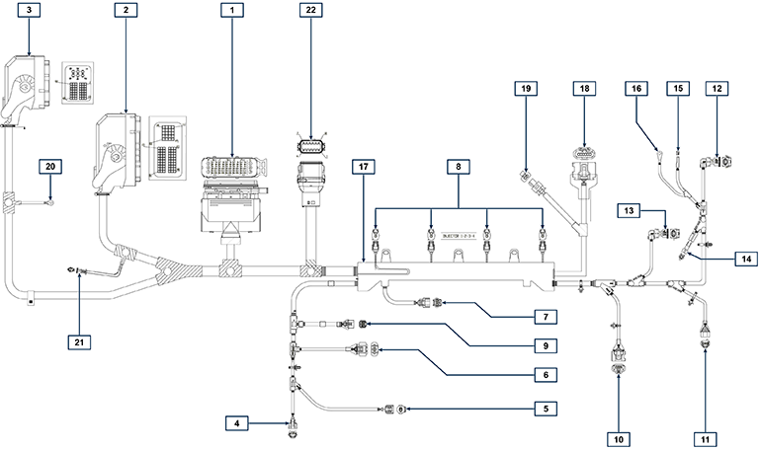
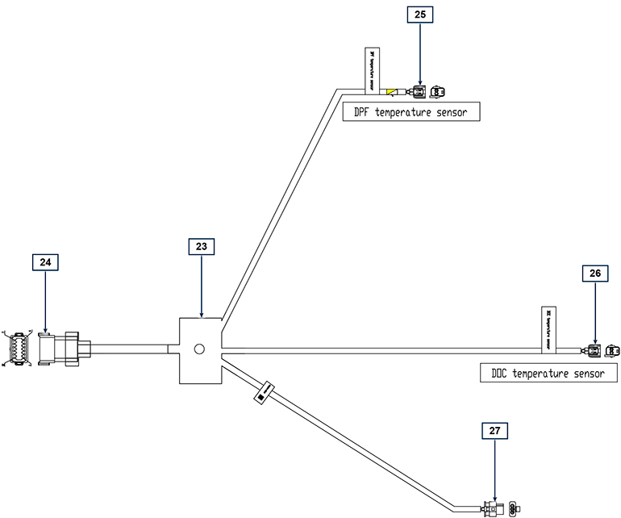
Fig 2.34

Tab. 2.36  RIF. DESCRIZIONE  1 Vehicle interface connector (Fig. 2.34a)  2 ECU Connector A (Fig. 2.34b)  3 ECU Connector B (Fig. 2.34b)  4 Fuel pressure regulating valve connector  5 Fuel temperature sensor connector  6 T-MAP sensor connector  7 Common Rail pressure sensor connector  8 Injectors connectors  9 EGR valve connector  10 Engine speed sensor connector  11 Engine phase sensor connector  12 Oil pressure switch connector  13 Coolant temperature sensor connector  14 D+ Connector Alternator  15 Starter motor connector (50)  16 Starter motor connector 3,2kW (50)  17 Wiring support  18 ETB connector (Stage V versions only)  19 ACACT connector (Stage V versions only)  20 Ground  21 CAN resistor  22 ATS wiring connector (Stage V versions only)  23 ATS interface wiring (Stage V versions only)  24 Engine wiring connector  25 DPF temperature connector (yellow)  26 DPF temperature connector (black)  27 Delta-P sensor connector | 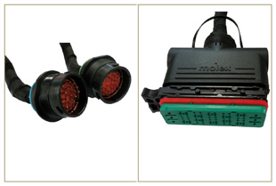  Fig 2.34a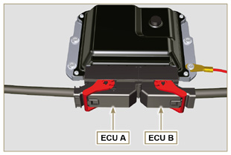  Fig 2.34b
NOTE: Click by side to play the procedure. | https://www.youtube.com/embed/6-0TbYG2EkY?rel=0
2.13.3.1 Wiring disconnection  All sensor connectors and electronic control devices are sealed.  The connectors must be disconnected by means of pressure on tabs A or unblock the retainers B , as illustrated from Fig. 2.34c to Fig. 2.34r. | 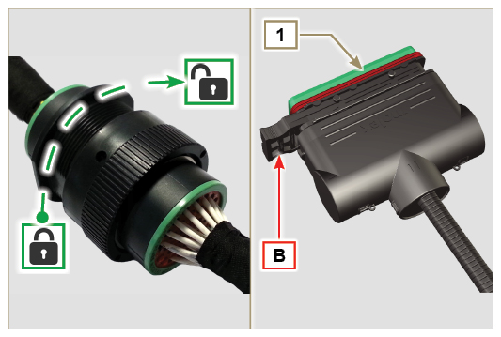  Fig 2.34c
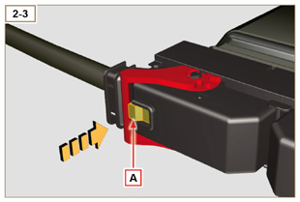  Fig 2.34d | 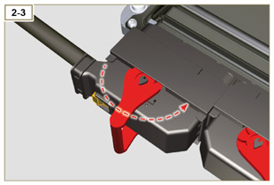  Fig 2.34e
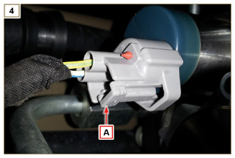  Fig 2.34f | 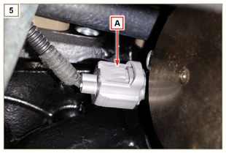  Fig 2.34g
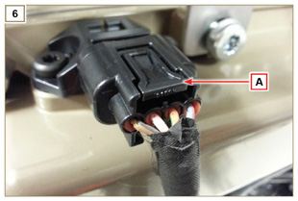  Fig 2.34h | 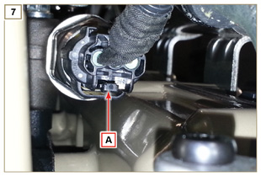  Fig 2.34i
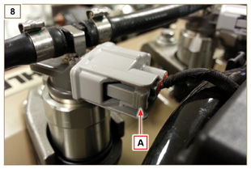  Fig 2.34l | 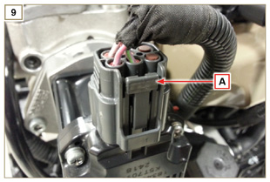  Fig 2.34m
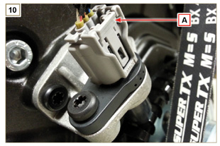  Fig 2.34n | 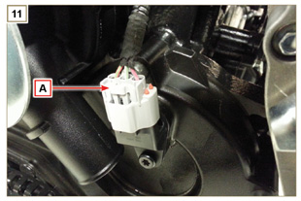  Fig 2.34o
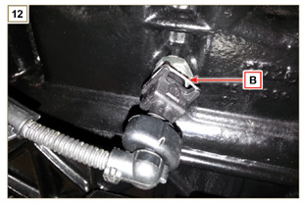  Fig 2.34p | 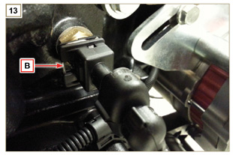  Fig 2.34q
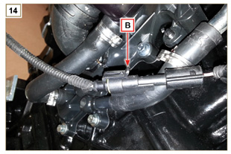
Fig 2.34r

Sensors and switches
2.14.1 Revolution sensor on target wheel  Speed sensor A is situated on the timing system carter.  The sensor detects the signal from the target wheel B (60 - 2teeth) situated on the crankshaft pulley. It sends it to the ECU as an analogical signal.  The sensor sends and analogue signal to the ECU.  The sensor produces a 5V square wave signal having a Hall effect while the crankshaft in rotation detects its position and speed.  The data sent by this sensor enables the ECU to pilot fuel anticipation injection for each piston.  For gap adjusting see Par. 9.15.1.5 . | 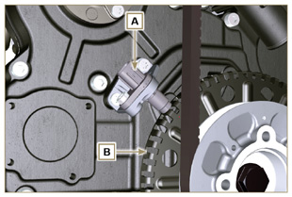  Fig 2.35
2.14.2 Camshaft sensor  Camshaft sensor C is situated on the timing system carter.  The purpose of the camshaft sensor C is to identify the position of the camshaft control gear E with respect to the engine shaft and consequently the position of the pistons with respect to the T.D.C.. The sensor produces a 5V square wave signal having a Hall effect while the camshaft in rotation detects the phases of the 4 strokes of the 1st cylinder. As a consequence, ECU by means of internal calculations, also recognises the phases of the other cylinders.  The data sent by this sensor enables the ECU to pilot fuel anticipation injection for each piston.  For gap adjusting see Par. 9.15.1.4 . | 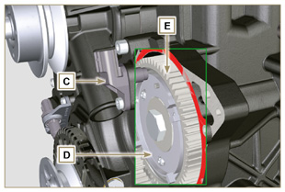  Fig 2.36
2.14.3 T-MAP sensor  The T-MAP F sensor is situated on the intake manifold. It detects the input pressure in the intake manifold by means of electrical voltage variation and the air temperature by means of an electrical resistor.  The sensor sends signals to the ECU, which determines the values and modifies the injection strokes.  Tab. 2.36 reports the electrical resistor values according to the intake air temperature.  NOTE : R indicates the pin where it is possible to measure electrical resistance.  Tab 2.37  °C (°F) R ( Ω )  -30 (-22) 23475 - 25945  0 (32) 5370 - 5935  25 (77) 1900 - 2100  50 (122) 772 - 854  100 (212) 177 - 195  120 (248) 107 - 119 | KDI TCR  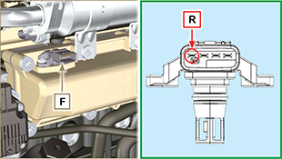  KDI TC  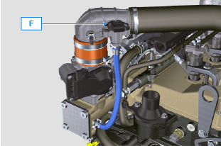  Fig 2.37
2.14.4 ACACT sensor (versions with DPF filter only)  The ACACT sensor J is located on the intake manifold, before the T-Map sensor, and it measures the temperature of the air coming from the turbocharger.  Tab. 2.37b shows the electric resistance values based on the intake air temperature.  Tab 2.37b  °C (°F) R (k Ω )  -40 (-40) 130.3  0 (32) 33.87  25 (77) 17.17  50 (122) 9.603  100 (212) 3.739  150 (302) 1.796  200 (392) 1.000 | 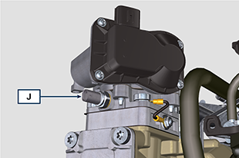  Fig 2.37a
2.14.5 EGTS sensor (yellow - black)  The EGTS sensors K1 and K2 are placed on the ATS system, K1 with black wire before the DOC, K2 with yellow wire after the DOC.  They are both needed for the DPF filter regeneration strategies.  Tab. 2.37b shows the electric resistance values based on the intake air temperature.  Tab 2.37c  °C (°F) R (k Ω )  -40 (-40) 133,8  0 (32) 34,49  50 (122) 9,749  100 (212) 3,771  150 (302) 1,803  200 (392) 1,002  250 (482) 0,6173  300 (572) 0,4127  350 (662) 0,2934  400 (752) 0,2186  450 (842) 0,1690  500 (932) 0,1345  550 (1022) 0,1097  600 (1112) 0,0912  650 (1202) 0,0771  700 (1292) 0,0661  750 (1382) 0,0574  800 (1472) 0,0503  850 (1562) 0,0445 | 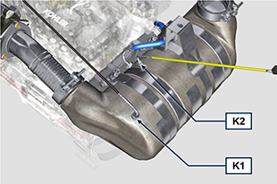  Fig 2.37b
2.14.6 Delta-P sensor  The Delta-P sensor J detects the clogging level of the DPF filter.  Operating temperature: -30°C - +120°C.  Important  - Connect the J1 and J2 pipes to the Delta-P sensor exclusively as shown in Fig. 2.37d . | 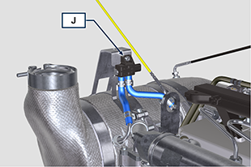  Fig 2.37c  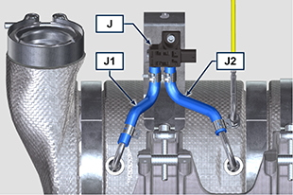  Fig 2.37d
2.14.7 Common Rail pressure sensor  Fuel pressure sensor G assembled on the Common Rail, detects the fuel pressure inside it by means of electrical voltage variation.  Depending on the signal sent, ECU manages the fuel intake valve on the injection pump and, if necessary, modifies the injection strokes.  Important  - Refer to Par. 2.9.5 | 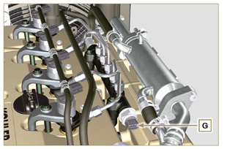  Fig 2.38
2.14.8 Fuel filter water detection sensor  The water presence sensor H is situated in the fuel filter, which is there to indicate the presence of water in the fuel.  Water, if present in the fuel, because of its greater specific weight separates and settles in the lower part of the filter where there is a specific sensor that, by means of the ECU activates an alarm signal on the dashboard.  The butterfly valve nut M situated in the lower part of the body sensor enables the elimination of any water present in the fuel and prevent malfunctions on components of the injection circuit. | 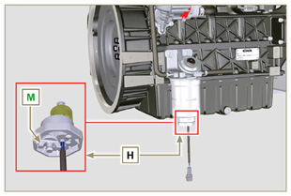  Fig 2.39
2.14.9 Fuel temperature sensor on the fuel injection pump  The fuel temperature sensor L is situated on the high-pressure fuel injection pump.  The fuel temperature sensor L , measures the temperature of the fuel entering the pump at high pressure. The signal sent to the ECU is analogue.  The resistance detected by the ECU is proportional to the fuel temperature.  Important  - Refer to Par. 2.9.3 | 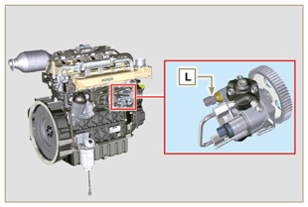  Fig 2.40
2.14.10 Oil pressure switch  Oil pressure switch N is assembled on the crankcase.  It is a N/C sensor, calibrated at 0.6 bar ± 0.1 bar.  With oil low pressure the sensor closes the electrical circuit and the warning lamp in the panel board switches on. | 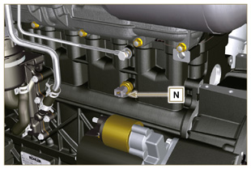  Fig 2.41
2.14.11 Coolant temperature sensor  The P coolant temperature sensor of the coolant circuit is applied to the cylinder head on the side of the thermostatic valve.  It is used by the ECU to obtain information regarding the coolant temperature (via PIN R ) and control the warning light high-temperature signal and control the electric fan of the coolant radiator.  Indicator light operation temperature +106°C / +108°C.  NOTE : R indicates the pin where it is possible to measure electrical resistance.  Tab 2.38  CHARACTERISTICS  Temperature °C R min Ω R max Ω  -40 38.313 52.926  0 5.227 6.623  +140 0.067 0.076 | 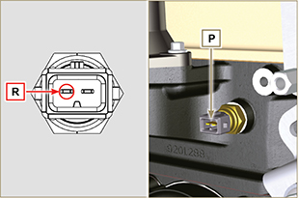  Fig 2.42
2.14.12 Air cleaner clogging switch  NOTE: Component not necessarily supplied by KOHLER.  The switch is assembled on the air cleaner. When the filter is clogged, it sends a signal to the panel.  Features :  - Operating temperature: - 30 °C / +100°C  - Contact usually open.  - Contact closed by vacuum: -50 mbar. | 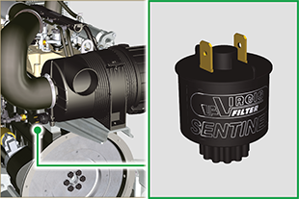  Fig. 2.42 a
2.14.13 ACAT Sensor (KDI 1903 TC model only)  The ACAT Q sensor is placed on the air intake line and measures the temperature of the air coming from the turbocharger. Tab. 2.38a shows the electric resistance values based on the intake air temperature.  Tab 2.38a  °C (°F) R (k Ω )  -40 (-40) 130.3  0 (32) 33.87  25 (77) 17.17  50 (122) 9.603  100 (212) 3.739  150 (302) 1.796  200 (392) 1.000 | 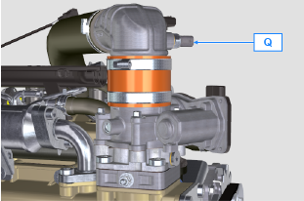  Fig. 2.42b
2.14.14 EGR-T Sensor (KDI 1903 TC model only)  The EGR-T R sensor is placed on the air intake manifold after the EGR gas inlet and measures the temperature of the air mixed with EGR gas coming from the turbocharger. Tab. 2.38b shows the electric resistance values based on the intake air temperature.  Tab 2.38b  °C (°F) R (k Ω )  -40 (-40) 130.3  0 (32) 33.87  25 (77) 17.17  50 (122) 9.603  100 (212) 3.739  150 (302) 1.796  200 (392) 1.000 | 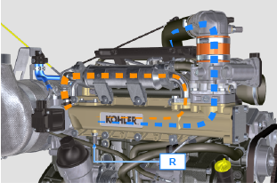  Fig. 2.42c

Electrical components

2.15.1 Alternator (A)  Externally controlled by the crankshaft by means of a belt.  - Ampere 80 A  - Volt 12V | 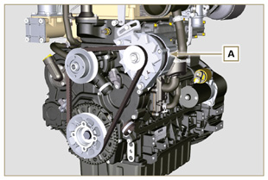  Fig 2.43
2.15.2 Alternator for Poly-V belt (optional) (B)  Externally controlled by the crankshaft by means of a belt.  - Ampere 80 A  - Volt 12V | 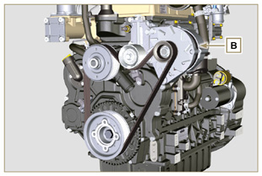  Fig 2.44
2.15.3 Starter Motor (C)  - Type Bosch 12 V  - Power 2 kW  - Anticlockwise rotation (seen from timing system side)  - Type Mahle 12 V  - Power 3.2 kW  - Anticlockwise rotation (seen from timing system side) | 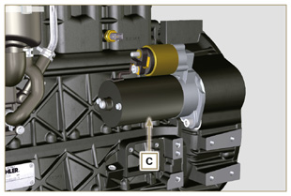  Fig 2.45a  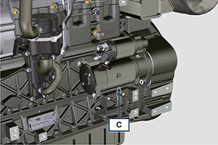  Fig 2.45b
2.15.4 EGR Valve (D)  A device that provides for exhaust gas recovery that is controlled by ECU, which, according to acceleration parameters, RPM and power requested, varies the opening and closing of the valve.  The device has an integrated ECU, which, on each start-up of the control panel, executes an operation self-check.  In the event of a malfunction, it sends a signal to ECU, which, in turn, signals the anomaly on the control panel.  Characteristics:  - Type Dell'Orto EGV A16  - Operating/storage temperature: -30°C / +130°C. | 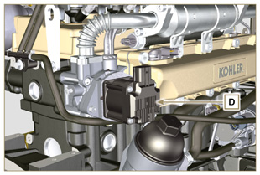  Fig 2.46
2.15.5 Cold starting device (Heater)  The cold starting device consists of a resistance, managed by the ECU, which is activated when the ambient temperature is ≤ -16° C.  The intake air is heated through the resistance and facilitates starting.  Characteristics:  - Type Hidria AET 12 V  - Power 550 W | 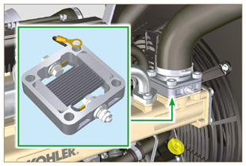  Fig 2.47
2.15.6 Fuel intake regulating valve (SCV)  Valve E is situated on the high-pressure fuel injection pump.  It is managed by ECU, which regulates fuel intake by means of fuel pressure values inside the Common Rail, choking the input entrance of fuel in the injection pump. The digital signal varies the opening of the valve in proportion to the quantity of fuel required for the Common Rail.  Important  - Refer to Par 2.9.3 | 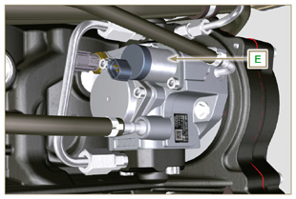  Fig 2.47 a
2.15.7 Electric fuel pump (optional)  NOTE: Component not necessarily supplied by KOHLER.  The electric pump is located before the fuel filter. One of the following pumps can be assembled A1 - A2 - A3 - A4.  Tab. 2.39 (a-d) indicates pump features.  Tab. 2.39  POS. Description  B Electrical connection  C Prefilter pump  IN Ingoing fitting (IN) from tank  OUT Outgoing fitting (out) to fuel filter  Tab. 2.39a  A1 Value  Voltage 12 V - 24 V  Delivery 100 L/h @ 0.44 - 0.56 bar  Tab. 2.39b  A2 Value  Voltage 12 V  Delivery 60.56 L/h @ 0.41 bar  Tab. 2.39c  A3 Value  Voltage 12 V  Delivery 24 L/h @ 0.1 bar  Tab. 2.39d  A4 Value  Voltage 12 V  Delivery 30 L/h @ 0.4 bar | 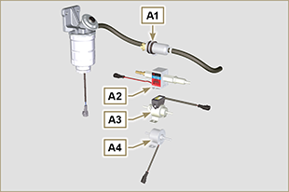  Fig 2.48  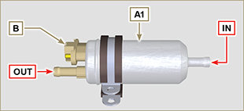  Fig 2.48a  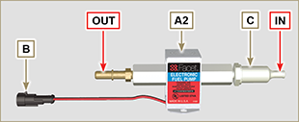  Fig 2.48b  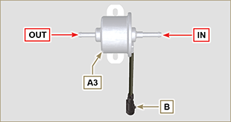  Fig 2.48c  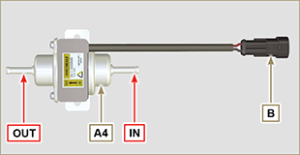  Fig 2.48d
2.15.8 ETB (versions with DOC+DPF device - Stage V only)  The ETB valve F is controlled by the ECU during the DPF filter regeneration strategies. | 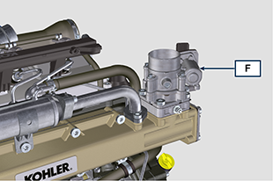  Fig 2.48e

Timing system and tappets
The timing system is equipped with hydraulic tappets that automatically recover the operation of the rocker rods assembly.
No registration is therefore required.

2.16.1 Components identification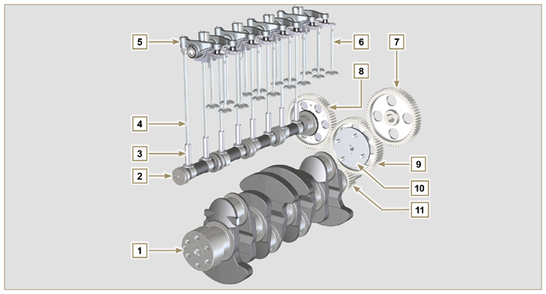
Fig 2.49
Tab 2.40  POS. DESCRIPTION  1 Crankshaft  2 Camshaft  3 Camshaft tappets  4 Rocker arm control rod  5 Rocker arms  6 Valves  7 High-pressure fuel injection gear pump control  8 Camshaft control gear  9 Intermediate gear  10 Intermediate gear pin  11 Crankshaft gear  12 Target wheel positioning reference pin on camshaft  13 Camshaft target wheel  14 Valve control bridge  15 Articulation control valves  16 Hydraulic tappets | 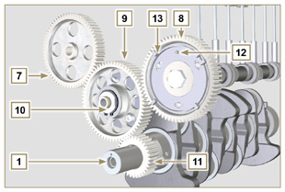  Fig 2.50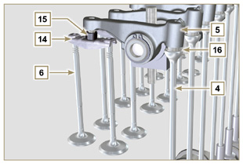  Fig 2.51
2.16.2 Timing system phasing angles  Important  - For information purposes, Tab. 2.41 reports the timing system diagram phasing angle values.  - It should be noted that the said values may be verified by rotating the crankshaft (Pos. 1 of Fig. 2.49) , by means of handling the rocker arm control rod (Pos. 4 of Fig. 2.49) .  NOTE: Detecting the value by means of handling the rocker arm/valves may not be correct due to the hydraulic tappets, which may compress and create clearances that alters the actual value.  Tab 2.41  ENGINE INTAKE EXHAUST  1903 TCR opens 20° before TDC opens 32° before BDC  closes 32° after BDC closes 16° after TDC  2504 TCR opens 10° before TDC opens 20° before BDC  closes 14° after BDC closes 4° after TDC | 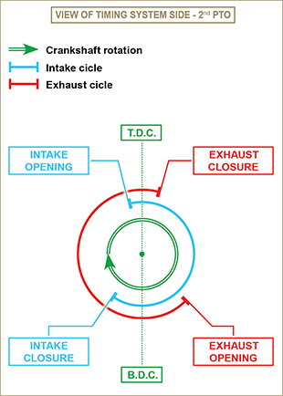  Fig 2.52
2.16.3 Rocker arm pin  Tab 2.42  POS. DESCRIPTION  1 Rocker arm pin  2 Rocker arm distancing spring  3 Rocker arm pin support  4 Exhaust rocker arm  5 Intake rocker arm | 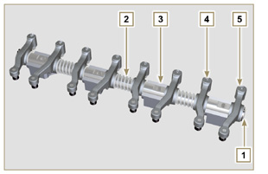  Fig 2.53
2.16.4 Rocker arms  Tab 2.43  POS. DESCRIPTION  1 Rocker arm body  2 Hydraulic tappet oil refill line  3 Valve tappet lubrication line  4 Valve tappet  5 Hydraulic tappet  6 Oil flow line | 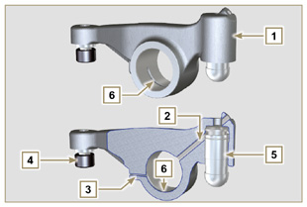  Fig 2.54
2.16.5 Hydraulic tappets  Tab 2.44  POS. DESCRIPTION  A Hydraulic tappets  B Hight pressure chamber  1 Hydraulic tappets oil refill pipe  2 Retaining ring  3 Piston  4 Unidirectional valve  5 Tappet body  6 Spring  2.16.5.1 Hydraulic tappet operation  The operating principle of the hydraulic tappet is based on the incompressibility of the liquids and on controlled leakage.  The oil under pressure enters the tappet chamber A , providing a constant supply of oil in the low-pressure chamber.  Through the non-return valve, 4 the oil can only access the high-pressure chamber B and exit via the clearance between the piston 3 and the tappet body 5 (controlled leakage).  The chamber B is filled when the rocker arm is on the base radius of the cam and the spring 6 keeps the piston 3 against the valve stem, thus eliminating any system play. Thanks to the spring extension, the tappet "extends", creating a small depression in the chamber B , making the non-return  valve 4 open, and allowing the oil in the chamber A to pass to chamber B , restoring the proper amount of oil required to eliminate any play in the valves. | 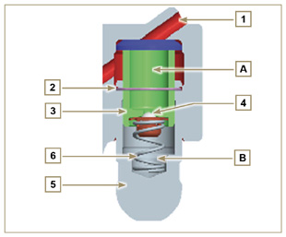  Fig 2.55

2.16.5.2 Difficult operating conditions
For proper operation on the hydraulic tappets it is essential that the low pressure chamber of the piston 3 is always full of oil.

In some conditions this may not occur (due to the fact that the oil leaks away when the engine is switched off, which can also partially drain the tappets). This situation will be the cause of clearances that will result in a characteristic noise similar toa ticking sound.
- When the engine is cold, the tappet filling time could be very long if the oil used is not suitable for the specific environmental conditions ( Tab. 2.2 )
- If the engine is very hot: at idle speed, oil pressure may be low, and small air bubbles could form in the circuit. Because of this, this compressing the tappet slightly and producing valve play which is responsible for the ticking sound. On account of this, the tappet compresses slightly giving rise to a valve clearance, thus generating a slight ticking sound, which however disappears rapidly ( MAX 10 seconds) once normal operating conditions have been restored.

Anyway the duration of ticking Anyway the duration of ticking sound must be MAX 30 seconds. If not, the problem is surely due to the poor quality of the oil, wear or impurities that, transported by the oil, can infiltrate between the ball valve and its seat inside the piston, compromising the operation of the tappet itself; In these cases, the only solution is to replace the oil or hydraulic tappets.

The prolonged persistence of the ticking sound or abnormal noise must be investigating in order to prevent any malfunctions; if necessary, replace the hydraulic tappets and engine oil.

Components handling
2.17.1 High-pressure fuel injection pump  - Only handle by means of the points marked by Y .  - It is forbidden to handle using the points marked by N . | 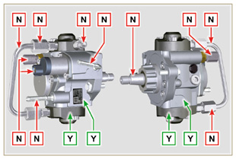  Fig 2.56
2.17.2 Electronic injector  - Only handle by means of the points marked by Y .  -It is forbidden to handle using the points marked by N . | 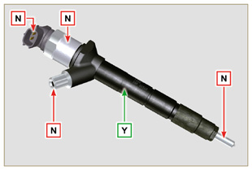  Fig 2.57
2.17.3 Common Rail  - Only handle by means of the points marked by Y .  - It is forbidden to handle using the points marked by N . | 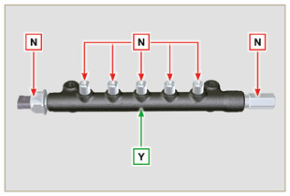  Fig 2.58
2.17.4 Turbocharger  - Only handle by means of the points marked by Y .  - It is forbidden to handle using the points marked by N .  Important  - Refer to Par. 2.18 . | 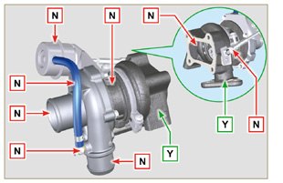  Fig 2.59
2.17.5 ACACT (versions with DOC+DPF device - Stage V only)  - Only handle by means of the points marked by Y .  - It is forbidden to handle using the points marked by N .  NOTE: The sensor includes ceramic material.  - Do not install sensors which suffered impacts or falls.  - Do not install sensors in case of external contamination  - Do not install visibly damaged sensors  - Use exclusively the socket wrench to install the sensor | 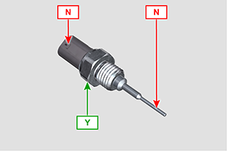  Fig 2.59a
2.17.6 EGTS ( versions with DOC+DPF device - Stage V only )  - Only handle by means of the points marked by Y .  - It is forbidden to handle using the points marked by N .  NOTE: The sensor includes ceramic material.  - Do not install sensors which suffered impacts or falls.  - Do not install visibly damaged sensors  - Do not install sensors in case of external contamination  - Do not apply any force on the cable or the metal elbow | 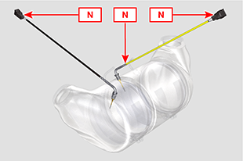  Fig 2.59b  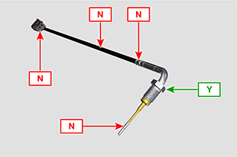  Fig 2.59c

Turbocharger

2.18.1 What to do and what not to do  What to do:  - Before assembling the turbocharger, make sure that the protection caps are fitted on all openings of the turbo.  - Ensure pre-lubrication of the turbocharger.  - Periodically check that the joints are sealed against oil and air.  - Use lubricating oil according to the specifications described in Par. 2.4 .  - Check the engine oil level.  - Before switching it off after it has been used, make the engine run idle, or without a load, for approximately 1 minute.  - Ensure that controls and maintenance intervals of the engine are observed as specified in Tab. 2.8 and 2.9 .  - Make sure that the engine and equipment are used correctly so as not to compromise the life of the turbocharger. | What not to do:  - Do not store turbocharges in damp, wet places if they are not in their original packaging.  - Do not expose the turbocharger to dust and dirt if it is not in its original packaging.  - Do not lift of hold the turbocharger from the actuator rod if it is not in its original packaging.  - Do not apply additives to the lubricating oil and fuel, unless instructed to do so by Kohler.  - Do not increase engine speed, or apply loads, immediately after start-up.  - Do not intervene on the actuator settings A (Fig. 2.61) .  - Do not let the vehicle / engine run at idle speed for more than 20-30 minutes at a time.
2.18.2 Practical operating rules  Users can help to maximise the duration of their turbocharger by following the rules described below.  - Start-up Start the engine at idle speed, or without a load, for approximately one minute. Oil operating pressure is reached within a few seconds and enables the moving parts to warm up and be lubricated.  Immediately increasing the engine speed upon start-up means making the turbocharger run at high speed with suboptimal lubrication, which may compromise the life of the turbocharger.  - After maintenance or a new installation  Proceed with pre-lubrication by filling new oil into the oil supply duct B until filling it completely. Start the engine at idle speed, or without a load, for a few minutes in order to ensure that the oil and bearings system operate satisfactorily.  - Low temperature air or engine inactivity  If the engine has been inactive for some time, or the air temperature is very low, start the engine at idle speed or without a load for a few minutes.  - Engine shutdown  Before switching the engine off after intense activity, one must allow the turbocharger to cool down. One must therefore let the engine run at idle speed or without a load for at least 2 minutes, thus allowing the turbocharger to cool.  - Engine at idle speed  Avoid using the engine at idle speed or without a load for long periods (more than 20-30 minutes). When operating at idle speed or without a load, the turbocharger is at low pressure in the exhaust chamber C and air supply D ; this may cause oil leaks from seals E  to the extremity of the shaft. Even if this does not cause damage, it can cause blue smoke from the exhaust when the engine speed and load are increased. | 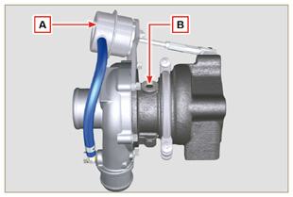  Fig 2.60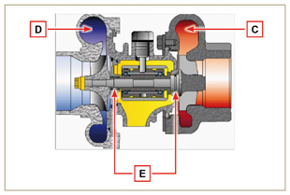  Fig 2.61
2.18.3 Before installing a new turbocharger  Important  - Do not lift the turbocharger with one hand from the box.  - Do not lift turbocharger from Comp hsg side.  - Lift the turbocharger with both hands from box.  - Make sure to use clean gloves.  - Handle the turbocharger as indicated in Par. 2.17.4. | 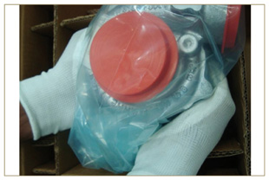  Fig 2.62
- Avoid lifting from the intake side G .  - Remove cap guard F and check that there is no excessive shaft axial and radial clearances. | 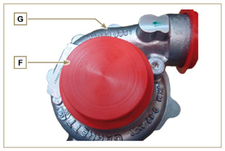  Fig 2.63
- Check for any signs of friction of the turbine on the turbocharger body.  - Check for any traces of oil leaks on the turbocharger body.  - After having check everything, reapply cap F on intake opening H of the turbocharger and do not remove it until assembly has been completed. | 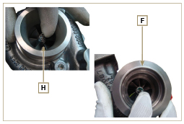  Fig 2.64
- Check the correct assembly of the capscrews and the presence of paint on them. | 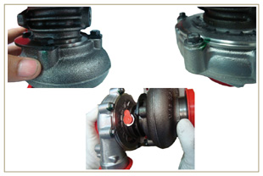  Fig 2.65
2.18.4 Installation instructions  - Remove the cap guards with care only when assembling.  Handle carefully avoiding erratic movements. | 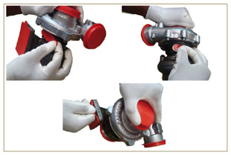  Fig 2.66
2.18.5 Replacement instructions

Always understand the cause of the breakage of the turbocharger before replacing it.

Correct the cause of the breakage before replacing it with a new turbocharger.

If in doubt, contact KOHLER service department.

Important

- Failure to comply with these instructions can cause damage to the turbocharger and void the warranty.
- Modifying the calibration of the turbocharger damages the turbocharger/engine.
- Always use the correct gaskets, and fit carefully to avoid blocking holes when mounting.
- Refer to the manual of the engine / vehicle, for: the correct type and quantity of oil, the correct tightening of components, instructions and installation.
- It is forbidden to use liquid gaskets or sealants, particularly for the oil inlet/outlet.
- Avoid dirt / debris while installing the turbocharger.
- Before mounting the turbocharger, check that the code of the component is correct for the type of engine, as mounting the wrong turbocharger can damage the turbo / engine and void the warranty.

Balancer device (optional)
The balancer device is composed of a special crankshaft that activates 2 additional shafts (balancers).  Rotation of the balancers, which have counterweights that oppose the movement of alternating weights (crankshaft - connecting rods - pistons), reduces vibrations caused by them.  The device is developed under the crankshaft, fixed on the crankcase, closed by the oil sump.  Tab 2.43  POS. DESCRIPTION  1 Crankshaft  2 Balancer shaft control gear  3 Balancer shaft support box  4 Conductor balance shaft  5 Conducted balance shaft | 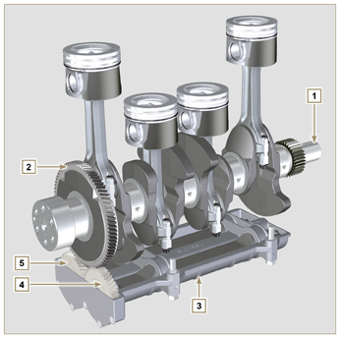  Fig 2.67

Safety information

Before start-up
- Read the manual carefully and carry out the operations described below in compliance with the instructions specified.
- Periodic inspection and maintenance operations must be carried out as indicated in this manual and under the user's responsibility.

Important

- Only use original spare parts and accessories.
- The use of non-original parts, as well as voiding the warranty, affects the life and performance of the engine, and may be dangerous.
- Non compliance with the operations described in the following pages may result damage to the engine and vehicle on which it is installed, as well as to people and/or property.

Safety precautions
- The intended use of the engine is in conformity with the machine on which it is mounted.
- Any use of the machine other than that described cannot be considered as complying with its intended purpose as specified by KOHLER .
- KOHLER declines all responsibility for any change to the engine not described in this manual made by unauthorized KOHLER personnel.
- A proper use of the engine, a strict observance of the rules listed below and the rigorous application of all these precautions will avoid the risk of accidents or injuries.
- Those who carry out the use and maintenance on the engine must wear the safety equipment and the accident-prevention guards (Par 3.4.3) .
- KOHLER declines all direct and indirect liability for failure to comply with the standards of conduct contained in this manual.
- KOHLER cannot consider every reasonably unforeseeable misuse that may cause a potential danger.

General remarks
3.3.1 Note for OEM
- When installing the KDI engines, always bear in mind that any variation to the functional systems may involve serious failures to the engine.
- Any improvement must be verified at KOHLER testing laboratories before application of the engine.
- In the event KOHLER does not approve the type of modification, KOHLER shall not be held responsible for any consequential operation anomalies that the engine may undergo and any damage the engine may cause to persons and things.
- The engine may only be assembled on a machine by personnel specifically trained by KOHLER and who work in compliance with the existing documentation.
- The engine has been built to the specifications of a machine manufacturer, and it is his responsibility to ensure that all necessary action is taken to meet the essential and legally prescribed health and safety requirements. Any use of the machine other than that described cannot be considered as complying with its intended purpose as specified by KOHLER , which therefore declines all responsibility for accidents
caused by such operations.
3.3.2 Note for end user
- The following indications are dedicated to the user of the machine in order to reduce or eliminate risks concerning engine operation and the relative routine maintenance work.
- The user must read these instructions carefully. Failure to do this could lead to serious danger for his personal safety and health and that of any persons who may be in the vicinity of the machine.
- On starting, make sure that the engine is as horizontal as possible, unless the machine specifications differ.
- Make sure that the machine is stable to prevent the risk of overturning.
- The engine must not operate in places containing inflammable materials, in explosive atmospheres, where there is dust that can easily catch fire unless specific, adequate and clearly indicated precautions have been taken and have been certified for the machine.
- To prevent fire hazards, always keep the machine at least one meter from buildings or from other machinery.
- Children and animals must be kept at a due distance from operating machines in order to prevent hazards deriving from their operation.
- Thoroughly wash and clean all the external parts of the engine before performing any operation, in order to avoid the accidental introduction of impurities/foreign bodies. Use only water and/or appropriate products to clean the engine. If cleaning engine with a pressure washer or steam cleaner, it is important to maintain a minimum distance of at least 200mm between the surface to be washed and the nozzle. Avoid directing the nozzle on electrical components, cable connections and sealed rings (oil seals etc). Thoroughly wash and clean the area surrounding the engine following the instructions provided by machine manufacturer.
- Fuel vapour is highly toxic. Only refuel outdoors or in a well ventilated place.
- Make sure that no soundproofing panels and the ground or floor on which the machine is standing have not soaked up any fuel.
- The engine may only be assembled on a machine by personnel specifically trained by KOHLER and who work in compliance with the existing documentation.
- The engine has been built to the specifications of a machine manufacturer, and it is his responsibility to ensure that all necessary action is taken to meet the essential and legally prescribed health and safety requirements. Any use of the machine other than that described cannot be considered as complying with its intended purpose as specified by KOHLER , which therefore declines all responsibility for accidents
caused by such operations.
- Fuel vapour is highly toxic. Only refuel outdoors or in a well ventilated place.
- Do not smoke or use open flames when refuelling.
- During operation, the surface of the engine can become dangerously hot. Avoid touching the exhaust system in particular.
- Before proceeding with any operation on the engine, stop it and allow it to cool.
- Always open the radiator plug or expansion chamber with the utmost caution, wearing protective garments and goggles.
- The coolant fluid is under pressure. Never carry out any inspections until the engine has cooled.
- If there is an electric fan, do not approach the engine when it is still hot as the fan could also start operating when the engine is at a standstill.
- The oil must be drained whilst the engine is hot. Particular care is required to prevent burns. Do not allow oil to come into contact with the skin because of the health hazards involved. It is recommended to use an oil intake pump.
- During operations that involve access to moving parts of the engine and/or removal of rotating guards, disconnect and insulate the negative wire (-) of the battery to prevent accidental short-circuits and to stop the starter motor from being energized.
- Check belt tension only when the engine is off.
- Fully tighten the tank cap each time after refuelling. Do not fill the tank right to the top but leave an adequate space for the fuel to expand.
- To start the engine follow the specific instructions provided in the engine and/or machine operating manual. Do not use auxiliary starting devices not originally installed on the machine (e.g. Startpilot).
- Before starting, remove any tools that were used to service the engine and/or machine. Make sure that all guards have been refitted.
- Do not mix fuel with elements such as oil or kerosene. Failure to comply with this prohibition will cause the non-operation of the catalyst and non-observance of the emissions declared by KOHLER .
- Pay attention to the temperature of the oil filter when the filter itself is replaced.
- Only check, top up and change the coolant fluid when the engine is off and reached the ambient temperature. Coolant fluid is polluting, it must therefore be disposed of in the correct way.
- Do not use jets of air and water at high pressure on the cables, connectors and electronic injectors.
- For engines equipped with ATS device, it is necessary to inhibit regeneration if using the engine in environments featuring risk of fire (e.g.: woods, areas containing flammable materials, areas containing flammable gas or liquids and any type of combustible material - if this function is available).
Important

- Only use the eyebolts A installed by KOHLER to move the engine (Fig. 3.1).
- The angle between each lifting chain and the eyebolts shall not exceed 15° inwards.
- The correct tightening of the lifting brace capscrews is 25 Nm .
- Do not interpose spacers or washers between the eyebolts and engine head.
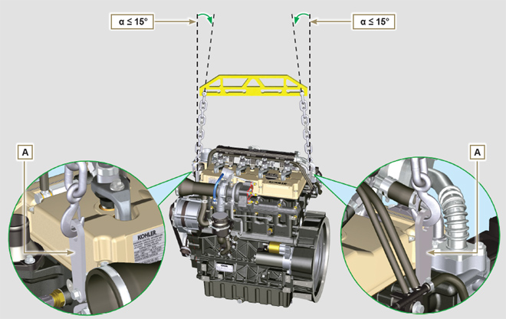
Fig 3.1

Safety signal description
- To ensure safe operation please read the following statements and understand their meaning.
- Also refer to your equipment manufacturer's manual for other important safety information.
- This manual contains safety precautions which are explained below.
- Please read them carefully.

3.4.1 Adhesive safety plates
The following is a list of the adhesive safety plates that may be found on the engine, which indicate potential points of danger to the operator.
Read the Operation and Maintenance handbook before performing any operation on the engine.
Hot Parts.
Danger of burns.
Presence of rotating parts.
Danger of jamming or cutting.
Presence of explosive fuel.
Danger of fire or explosion.
Presence of steam and pressurized coolant.
Danger of burns.
3.4.2 Warnings
Hereunder is a list of safety warnings that may be found in the manual, which advise you to pay attention when carrying out particular procedures that may be potentially dangerous to the operator or things.
Danger
This indicates situations of grave danger which, if ignored, may seriously threaten the health and safety of individuals.
Important
This indicates particularly important technical information that should not be ignored.
Warning
This indicates that failure to comply with it can cause minor damage or injury.
3.4.3 Safety guards Hereunder is a list of safety guards that must be worn prior to carrying out any type of operation and to avoid potential
harm to the operator.
Use suitable protective gloves before carrying out any type of operation.
Use protective goggles before carrying out any type of operation.
Use earmuffs before carrying out any type of operation.

Information and safety signals
ACCIDENTAL START  Accidental Starts can cause severe injury or death.  Before working on the engine or equipment, disconnect the battery negative (-) wire.  HOT PARTS  Hot Parts can cause severe burns.  Engine components can get extremely hot from operation. Do not touch engine while operating or just after stopping.  Never operate the engine with heat shields or guards removed.  ROTATING PARTS  Rotating Parts can cause severe injury.  Stay away while engine is in operation. Keep hands, feet, hair, and clothing away from all moving parts to prevent injury. Never operate the engine with covers, shrouds, or guards removed.  LETHAL EXHAUST GASES  Carbon Monoxide can cause severe nausea, fainting or death.  Avoid inhaling exhaust fumes and never run the engine in a closed building or confined area.  Carbon monoxide is toxic, odorless, colorless, and can cause death if inhaled.  ELECTRICAL SHOCK  Electrical Shock can cause injury.  Do not touch wires while engine is running. | HIGH PRESSURE FLUID RISK OF PUNCTURE  High Pressure Fluids can puncture skin and cause severe injury or death.  Work on the injection system must be carried out by suitably trained staff wearing protection equipment. Injuries caused by fluid penetration are highly toxic and dangerous.  If an injury occurs, seek immediate medical attention.  EXPLOSIVE FUEL  Explosive fuel can cause fires and severe burns.  Fuel is flammable and its vapours can ignite. Store fuel only in approved containers, in well ventilated,  unoccupied buildings. Do not fill the fuel tank while the engine is hot or running, since spilled fuel could ignite if it comes in contact with hot parts or sparks from ignition. Do not start the engine near spilled fuel. Never use fuel as a cleaning agent.  EXPLOSIVE GAS  Explosive Gas can cause fires and severe acid burns.  Charge battery only in a well ventilated area. Keep sparks, open flames, and other sources of ignition away from the battery at all times. Batteries produce explosive hydrogen gas while being charged.  Keep batteries out of the reach of children. Remove all jewelry when servicing batteries. Before  disconnecting the negative (-) ground cable, make sure all switches are OFF. If ON, a spark will occur at the ground cable terminal which could cause an explosion.  CALIFORNIA WARNING - DECLARATION 65  Engine exhaust from this product contains chemicals known to the State of California to cause cancer, birth defects, or other reproductive harm.

Safety and environmental impact
Every organisation has a duty to implement procedures to identify, assess and monitor the influence of its own activities (products, services, etc.) on the environment. Procedures for identifying the extent of the impact on the environment must consider the following factors: - Disposal of liquids.

- Waste management.

- Soil contamination.

- Atmospheric emissions.

- Use of raw materials and natural resources.

- Regulations and directives regarding environmental impact.
In order to minimise the impact on the environment, KOHLER provides some indications to be followed by all those handling the engine, for any reason, during its expected lifetime. - All components and fluids must be disposed of in accordance with the laws of the country in which disposal is taking place.

- Keep the injection system as well as engine management and exhaust pipes in efficient working order to limit environmental and noise pollution.

- When decommissioning the engine, select all components according to their chemical characteristics and dispose of them separately.

Location of safety signals on engine
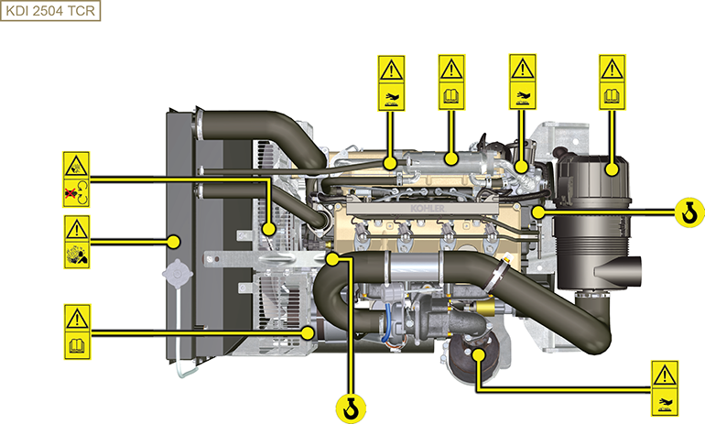

Storage information

Product preservation

Important

- If the engines are not to be used for 6 months, they must be protected by carrying out the operations described in Engine storage (up to 6 months) (Par. 4.2) .
- If the engine is still not in use after the first 6 months, it is necessary to carry out a further procedure to extend the protection period (more than 6 months) (Par. 4.3) .
- If the engine is not to be used for an extended period, the protective treatment procedure must be repeated within 24 months of the previous one.

Engine storage (up to 6 months)
Before storing the engine check that:
- The environments are not humid or exposed to bad weather. Cover the engine with a proper protective sheet against dampness and atmospheric contaminants.
- The place is not near electric panel.
- Avoid storing the engine in direct contact with the ground.

Engine storage (over 6 months)
Follow the steps described in Par. 4.2.
- Pour protective oil in the carter up to the MAX level.
- Refuel with fuel additives for long storage.The following additives are recommended: DEFA Fluid Plus (Pakelo Lubricants),

Diesel Treatment (Green Star),

Top Diesel (Bardhal),

STP® Diesel Fuel Injector Treatment.
- With expansion tank:
make sure that the coolant is up to the maximum level.
- Without expansion tank: Top liquid up until the pipes inside the radiator are covered by about 5 mm.

Do not overfill the radiator, but leave room for the fuel to expand.
- Start the engine and run it at idle speed for around 2 minutes.
- Bring the engine to 75% of maximum rated speed for 5 to 10 minutes.
- Turn off the engine.
- Empty out completely the fuel tank.
- Spray SAE 10W-40 on the exhaust and intake manifolds.
- Seal the exhaust and intake ducts to prevent foreign bodies from entering.
- When cleaning the engine, if using a pressure washer or steam cleaning device, avoid directing the nozzle on electrical components, cable connections and sealed rings (oil seals etc).
If cleaning engine with a pressure washer or steam cleaner, it is important to maintain a minimum distance of at least 200mm between the surface to be washed and the nozzle - avoiding absolutely electrical components such as alternators, starter motors and engine control units (ECU).
- Treat non-painted parts with protective products.
- Loosen the alternator belt Par. 7.3 point 1 and 2
NOTA: For Poly-V belt Par. 11.3 from points 1 to 3 .

If the engine protection is performed according to the suggestions indicated no corrosion damage will be found.

Engine starting after storage
- Remove the protective sheet.
- Use a cloth soaked in degreasing product to remove the protective treatment from the external parts.
- Inject lubricating oil (no more than 2 cm3) into the intake ducts.
- Adjust the alternator belt tension ( Par. 9.15.2 from points 7 to 10 ) - for a Poly-V belt ( Par. 11.3 from point 5 to 8 )or replace if there are signs of deterioration.
- Refill the tank with fresh fuel.

Warning

- Over time, lubricants and filters lose their properties, so itis important to consider whether they need replacing, also based on the criteria described in Tab. 2.9 .

- Make sure that the oil and the coolant are up to the maximum level.
- Start the engine and run it at idle speed for around 2 minutes.
- Bring the engine to 75% of maximum rated speed for 5 to 10 minutes.
- Stop the engine and while the oil still hot, perform the operation in Par. 5.2 .
- Replace the filters (air, oil, fuel) with original spare parts.
- Perform the operations described in Par. 10.1 .
- Perform the operations described in Par. 5.1 and Par. 10.2 .

Information regarding discharge of liquids

Coolant
Important  - Before proceeding with operation, read Par. 3.3.2 .  NOTE: Component not necessarily supplied by KOHLER . The representation of the radiator is purely indicative.  Warning  - Presence of steam pressurized coolant danger of burns.  - Undo the cap A carefully (circuit under pressure). | 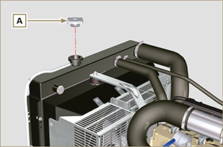  Fig 5.1
- Loosen clamp G and remove cap B from exhaust pipe C , draining the liquid into an appropriate container and refer to ( Par. 3.6 ). | 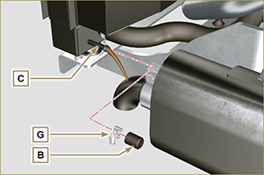  Fig 5.2
- Undo cap F to drain all liquid from the system contained in the engine crankcase ducts into an appropriate container and refer to ( Par. 3.6 ). | 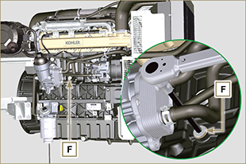  Fig 5.3  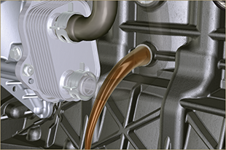 Fig 5.4
NOTE : Click by side to play the procedure. | https://www.youtube.com/embed/_s_qNZuOqQU?rel=0

Engine oil
Important  - Before proceeding with operation, read Par. 3.3.2 .  - This operation should be carried out with vacuum pump. The oil must be drained whilst the engine is hot, which requires particular care to prevent burns. Do not allow oil to come into contact with the skin because of the health hazards involved. It is recommended to use an oil intake pump via the oil dipstick hole B.  - Electric/pneumatic screwdrivers are forbidden.  - Undo the cartridge holder cover C by performing three complete turns and wait 1 minute.  NOTE : this operation will allow to oil contained in the support G to flow into the oil sump in the correct way.  - Unscrew cartridge holder cover C and check that the oil in the lub. oil filter bracket G has flowed towards the oil sump (refer to NOTE in Par. 2.10.3 ).  - Undo the oil filler cap A (Fig. 5.5) .  - Remove the oil dipstick B .  - Remove the oil drain plug D and the gasket E (the oil drain plug is on both sides of the oil sump).  - Drain oil in to an appropriate container.  (For used oil disposal refer to the Par. 3.6 ).  - Replace gasket E .  - Tighten the drain oil plug D (tightening torque at 35 Nm ).  - Perform the operations described in Par. 6.10.2 and the operation 5 Par. 6.10.3. | 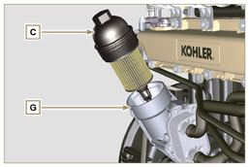  Fig 5.5  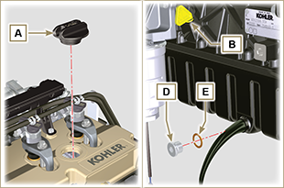  Fig 5.6
NOTE : Click by side to play the procedure. | https://www.youtube.com/embed/7T2NNBQqPpU?rel=0

Information for replacing the functional units

Electronic injector replacement
Important  - Before proceeding with operation, read Par. 3.3.2 .  - In the event of the electronic injectors being disassembled (not necessarily replaced) their position with respect to individual cylinders must not be changed when re-assembled. Refer to the reference between each injector and respective cylinder number.  - Seal all injection component unions as illustrated in Par. 2.9.8 during disassembly.  - Handle the components as described in Par. 2.17 .  - Replace all seal gaskets after each assembly for all components on which they are provided.  - The high pressure pipes must be replaced every time they are disassembled.  - Before disassembling the electronic injectors, make sure the new high pressure pipes are available.  - If a new (or different) electronic injector is fitted on the engine, the new calibration data must be entered in the ECU through a specific instrument ( ST_01 ) .  - Electronic injectors are not repairable.  - This procedure may be performed on one or more electronic injectors.  NOTE: In the event of a leak upon replacement (oil - coolant - fuel - air), do not intervene with the engine running, but stop it and wait for 5/10 minutes before checking and solving the problem. | 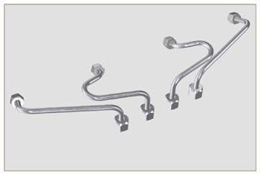  Fig 6.1
6.1.1 Fuel return pipes disassembly (Common Rail/electronic injectors)  - Disconnect the connector C . | 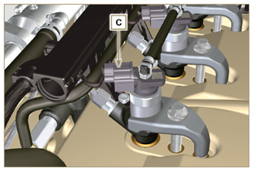  Fig 6.2
- Remove clips E from the electronic injector F .  - Disconnect the junction G from the electronic injector F .  Warning  - After removing the fittings, the clips E must automatically return to their initial position; otherwise they must be replaced.  - Seal all injection component unions as illustrated in Par. 2.9.8 . | 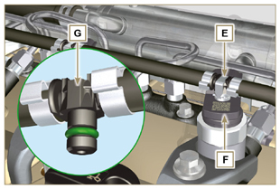  Fig 6.3
6.1.2 High pressure fuel pipes disassembly (Common Rail/electronic injectors)  Danger  - The fuel injection circuit is under high pressure, use safety protections as described in Par 3.4.3 .  - Ensure that the Common Rail is not under pressure by slowly and carefully unscrewing one of the nuts H .  - Undo the nut H on the Common Rail L and then the nut M on the electronic injector F and remove the pipe N .  Important  - In the event that the electronic injectors are disassembled (not necessarily replaced), mark them with the relevant cylinder number from which they originate so as not to confuse them during re-assembly.  - Seal all injection component unions as illustrated in Par. 2.9.8 . | 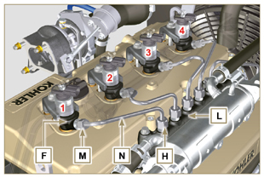  Fig 6.4
6.1.3 Electronic injectors disassembly  - Undo and remove the screw P with the washer R e and then the bracket Q .  Important  - Be careful not to damage the gaskets X .  - Replace rings X , if damaged.  2. Pull out the electronic injector F .  NOTE: Should you be unable to remove the electronic injector (acting only on point BC ), use an open-ended spanner (Ø 34 mm), by applying small rotations to unblock the component.  3. Seal all injection component unions as illustrated in Par. 2.9.8 .  4. Ensure that gasket S has remained in the correct position (Fig. 6.6) . Otherwise, recover the gasket from inside the electronic injector T manifold. | 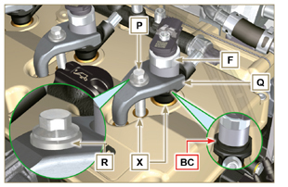  Fig 6.5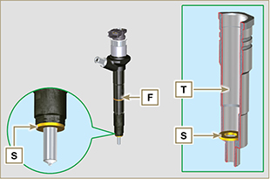  Fig 6.6
NOTE: Click by side to play the procedure. | https://www.youtube.com/embed/QQZtx2i75AY?rel=0
6.1.4 Electronic injector assembly  Important  - Always replace and lubricate the gaskets AA and S of the electronic injectors F with fuel, every time they are replaced.  - Reposition the electronic injectors (not replaced) by following the references made for disassembly, as indicated in Par. 6.1.2.  - If the engine is painted or protected with clear paint, clean the paint off the diesel injector F near to the part in contact with the gasket AB .  - Insert the gasket S on the electronic injectors F (Fig. 6.7) .  - Insert electronic injector F into manifold T , being extra careful not to damage gasket AB and direct it as indicated in Fig. 6.7 . | 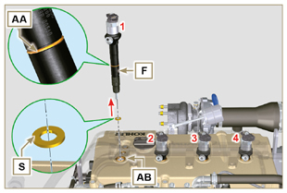  Fig 6.7
6.1.5 High pressure fuel pipes assembly  Important  - Always replace the pipes N after each assembly.  - If the engine is painted or protected with clear paint, replace the fastening screws P to ensure the gaskets are sealed properly.  - Position tube N in the Common Rail seat of the electronic injector; correct the position of the electronic injector by means of the entrance of the electronic injector unions F and Common Rail L .  - Apply the nuts H and M by hand without tightening them.  - Position the fastening brace of electronic injectors Q on capscrew surface AD , insert capscrews P in brace Q inserting washer R . | 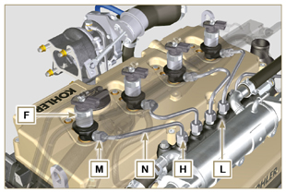  Fig 6.8
Important  - Ensure that brace S is perfectly positioned onto the electronic injector.  4. Tighten the fixing screws P of the electronic injector bracket (tightening torque at 20 Nm ).  5. Tighten the nut M (tightening torque at 25 Nm ).  6. Tighten the nut H (tightening torque at 30 Nm ). | 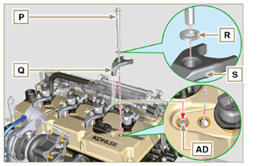  Fig 6.9
6.1.6 Fuel return pipes assembly  - Check the condition of the gaskets AE . | 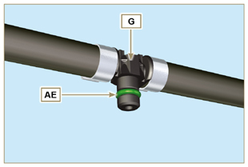  Fig 6.10
- Insert unions AF onto electronic injectors F and block them with clips E .  - Mount the connectors C on the electronic injectors F .  Warning  - Slightly move the wiring support to check that the electrical wire of connector C is not strained in correspondence with the outlet hole AF . | 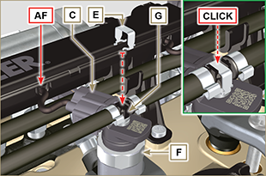  Fig 6.11
NOTE: Click by side to play the procedure. | https://www.youtube.com/embed/ArOgFV739EU?rel=0

High-pressure fuel injection pump replacement
Danger  - The fuel injection circuit undergoes high pressure, use safety protections as described in Par 3.4.3 .  - Ensure that the Common Rail is not under pressure by slowly and carefully unscrewing nut A .  Important  - Before proceeding with operation, read Par. 3.3.2 .  - Always replace the high pressure pipes after each disassembly.  - Before disassembling the injection pump, make sure the new high-pressure pipe is available.  - The injection pump is not repairable.  - Should the fuel feeding pump need to be replaced, after assembly, it is necessary to perform the Pump Learning procedure by means of instrument ST_01 .  - Seal all injection component unions as illustrated in Par. 2.9.8.  - To handling components refer to Par. 2.17.  - Always replace the gaskets (where are provided) after each disassembly. | 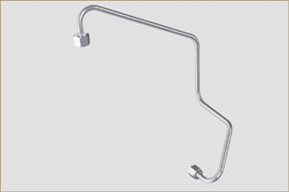  Fig 6.12
6.2.1 High-pressure fuel line disassembly (from the injection pump to the Common Rail).  - Undo the nut A . | 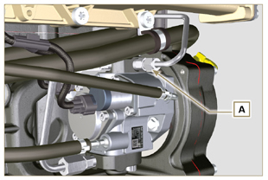  Fig 6.13
- Undo nut D from Common Rail E . | 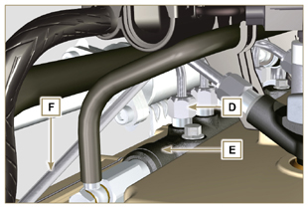  Fig 6.14
- Undo the nut B on the intake manifold C and remove the pipe F . | 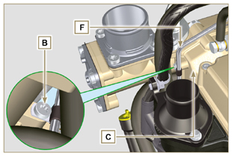  Fig 6.15
6.2.2 Timing system carter oil filling flange disassembly  - Remove starter motor ( Par. 7.3.2 ) and assemble special tool ST_34 ( Par. 7.7 point 2 ) .  - Undo the screws G ( ST_06 ) ,remove the clamp E and the flange H . | 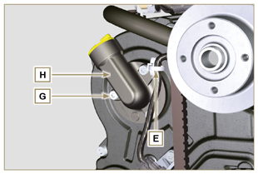  Fig 6.16
6.2.3 High-pressure fuel injection pump disassembly  - Undo and remove nut L fixing the fuel feeding pump control  gear M .  Important  - Be careful that the nut L does not fall into the timing cover.  - Tighten tool ST_04 on the gear M . | 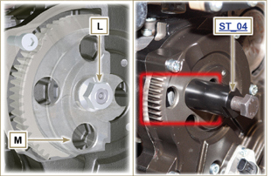  Fig 6.17
Important  - Do NOT use the cylinder connection pipe W as a handle, to prevent damage or fuel leaks.  - Before disassembling, carefully read Par. 2.17 .  - Seal all injection component unions as illustrated in Par. 2.9.8.  - Release the clamps N on the return pipe P and on the fuel inlet pipe Q .  - Disconnect tubes P and Q from fuel feeding pump R .  - Disconnect connectors S and T .  - Loosen the screws U .  - Redo the capscrew of tool ST_04 to disconnect injection  pump R from gear M .  - Undo capscrews U and extract injection pump R with the relevant gasket V .  - Undo and remove the tool ST_04 . | 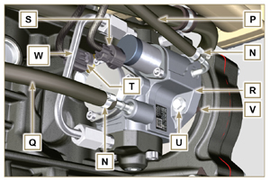  Fig 6.18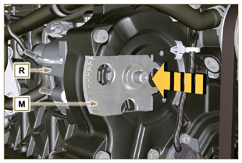  Fig 6.19
NOTE: Click by side to play the procedure. | https://www.youtube.com/embed/UaZgKyWrP48?rel=0
6.2.4 High-pressure fuel injection pump assembly  Important  - Before assembling, carefully read Par. 2.17  - Always replace the gasket V after each assembly. The gasket V can only be fitted in one direction.  - Remove the tool ST_04 from the pump control gear ( Ref. M of Par. 6.2.3 ) if applicable.  - Do NOT use the cylinder connection pipe W as a handle, to prevent damage or fuel leaks.  - Remove the protection caps only when reconnecting the hoses. | 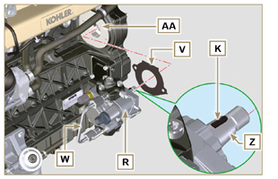  Fig 6.20
- Check that the contact surfaces AA are free from impurities.  - Insert the reference key K in the seat of the shaft Z .  - Assemble the new gasket V on injection pump R . Insert injection pump R in its housing on crankcase AA making key K coincide with key seat AH of gear M . | 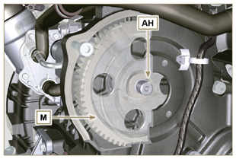  Fig 6.21
- Fully tighten the nut L on the shaft Z of the injection pump.  Important  - Apply nut L by hand, but do not tighten. | 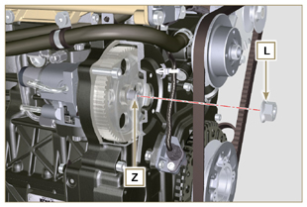  Fig 6.22
Important  - It is mandatory to replace the screws U or apply a few drops of Loctite 270 .  - Clamp the screws U on the crankcase AB (tightening torque at 25 Nm ).  - Clamp the nut L (Fig. 6.22) (tightening torque at 65 Nm ). | 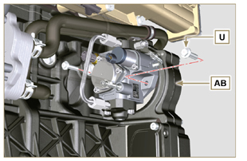  Fig 6.23
- Fit the connector T on the sensor J .  - Fit the connector S on the sensor Y .  - Remove the protection caps.  - Fit the pipe Q on the fitting AA .  - Fit the pipe P on the fitting AB .  - Hook the clamps N on the hoses Q and P . | 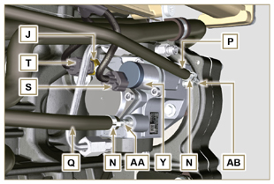  Fig 6.24
6.2.5 High-pressure line assembly (injection pump /  Common Rail)  - Remove the protection cap.  - Position the pipe F .  Important  - Manually tighten the nut A . | 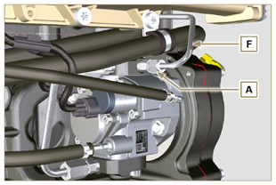  Fig 6.25
- Manually tighten the nut D .  - Fix clamp AC by means of capscrew B on intake manifold C (tightening torque 10 Nm - ST_06 ).  - Clamp nut D (tightening torque at 30 Nm ) and A (tightening  torque at 25 Nm ) in sequence. | 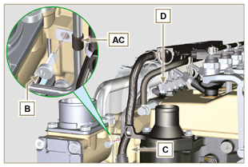  Fig 6.26
6.2.6 Timing system carter oil filling flange assembly  NOTE: Always replace the gasket AE after each assembly.  - Position the gasket AE in the set on the flange H .  - Fix the flange H on the crankcase AF with the screws AG (tightening torque at 10 Nm - ST_06 ).  - Fit the clamp E on the flange H .  - Disassemble the special tool ST_34 and assemble the starter motor (tightening torque 45 Nm ). | 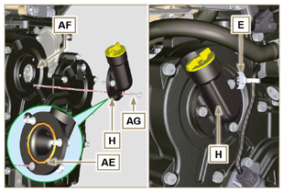  Fig 6.27
NOTE: Click by side to play the procedure. | https://www.youtube.com/embed/o3h6Say9sc4?rel=0

Unit EGR Cooler replacement
6.3.1 Disassembly  Important  - Before proceeding with operation, read Par. 3.3.2 .  - To handling components refer to Par. 2.17.  - Always replace the gaskets (where are provided) after each disassembly.  NOTE: Perform the operations described in Par. 5.1 .  - Undo the screws B of pipe C . | 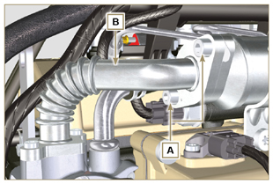  Fig 6.28
- Undo screws D and E .  - Remove pipe F and the relevant metal gaskets.  - Release the clamps G and remove the sleeve M . | 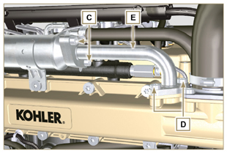  Fig 6.29
- Undo the screws H and remove the EGR Cooler L from the sleeve N ( ST_05 ).  - Should the passage ducts of the gas exhaust be clogged by soot or carbon, replace EGR Cooler L . | 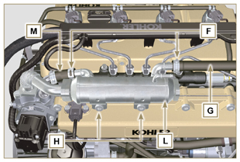  Fig 6.30
NOTE: Click by side to play the procedure. | https://www.youtube.com/embed/xGWUnc-V1YY?rel=0
6.3.2 Assembly  - Insert the fitting U in the manifold M of the EGR valve unit.  - Fit the EGR Cooler L with the screws H on the intake manifold S (tightening torque at 22 Nm - ST_05 )  - Insert the hose G on the fitting V .  - Secure the clamps F . | 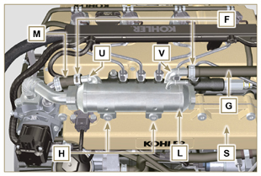  Fig 6.31
- Insert the gasket N between the hose B and the EGR Cooler L and fix the screws A (tightening torque at 25 Nm ) | 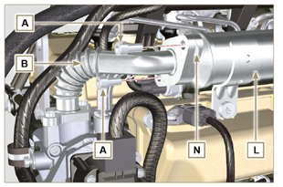  Fig 6.32
- Insert the hose E in its housing on the manifold S inserting the gasket R .  - Insert the gasket T between the hose E and the EGR Cooler L and fit the screws C (tightening torque at 25 Nm ).  - Fit the screws D (tightening torque at 22 Nm - ST_05 ).  NOTE: Perform the operations described in Par. 10.2 . | 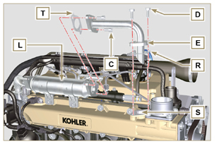  Fig 6.33
NOTE: Click by side to play the procedure. | https://www.youtube.com/embed/XSTfzyJa-9Q?rel=0

EGR valve replacement
6.4.1 Disassembly  Important  - Before proceeding with operation, read Par. 3.3.2 .  NOTE: Perform the operations described in Par. 5.1 .  - Disconnect the connector A from the valve C .  - Undo the screws B and remove the EGR valve C with the relevant gasket. | 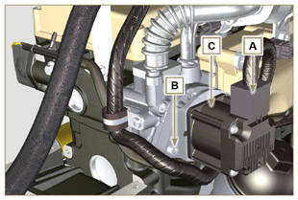  Fig 6.34
NOTE: Click by side to play the procedure. | https://www.youtube.com/embed/lZlk78GFzsg?rel=0
6.4.2 Assembly  Important  - Always replace gasket D after each assembly.  - The EGR valve is not a serviceable item, and if faulty / worn out, should be replaced with a new one.  - Movimentare i componenti come descritto nel Par. 2.17 .  - Mount the new gasket D on the valve C .  - Fit the valve C on the flange E with screws B (tightening torque at 10 Nm ). | 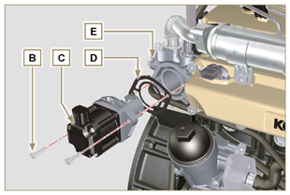  Fig 6.35
- Fit the connector A on the valve C .  NOTE: Perform the operations described in Par. 10.2 | 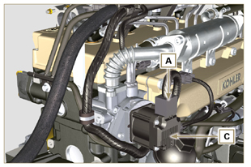  Fig 6.36
NOTE: Click by side to play the procedure. | https://www.youtube.com/embed/KGHm0dnsQdc?rel=0

Coolant pump replacement
6.5.1 Disassembly  NOTE: Perform the operations described in Par. 5.1 .  Important  - Before proceeding with operation, read Par. 3.3.2 .  - If the engine is fitted with the Poly-V belt, perform the operations described in Par. 11.3 .  - Loosen the screws A and B .  - Push the alternator C in the direction of the arrow D and remove the belt E .  - Release clamp F and disconnect tube G from the coolant pump N .  NOTE : If union R , is disassembled, replace it or alternatively apply Loctite 2701 on the thread when assembling on pump G (tightening torque of 20 Nm ). | 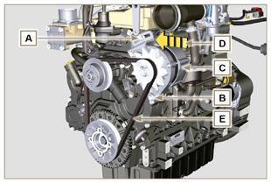  Fig 6.37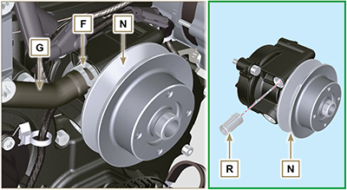  Fig 6.38
- Release the clamp M from the coolant pump N .  - Undo the screws H and remove the pump N with the relevant gasket L . | 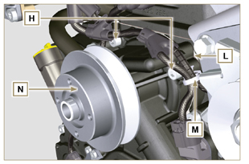  Fig 6.39
NOTE: Click by side to play the procedure. | https://www.youtube.com/embed/_QESHZf50PU?rel=0
6.5.2 Assembly  Important  - Always replace the gaskets L , after each disassembly.  - Always replace the belt E after each assembly.  - If the engine is fitted with the Poly-V belt, perform the operations described in Par. 11.3 .  - To handling components refer to Par. 2.17.  - Always replace the gaskets (where are provided) after each disassembly  - Fit the coolant pump N with the screws H interposing the new gasket L (tightening torque at 25 Nm ). | 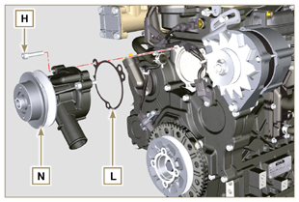  Fig 6.40
- Reinsert the pipe G and hook the clamp F ( Fig. 6.38 ).  - Rehook the clamp M on the pump N (Fig. 6.39) .  - Push the alternator C in the direction of the arrow D .  - Insert the belt E on the pulleys P . | 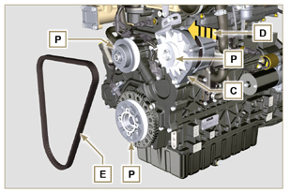  Fig 6.41
- Pull the alternator C in the direction of the arrow Q .  - While tensioning the alternator C , first clamp screw A (tightening torque at 25 Nm ) and then screw B (tightening torque at 69 Nm [thread M10] - 40 Nm [thread M8] ).  - Check the tension of the belt E with the instrument ( DENSO BTG-2 ), positioning it in point P (the tension must be between 350 and 450 Nm ).  - If the tension values do not correspond, tighten screws A and B , then repeat operations 6, 7 and 8 . | 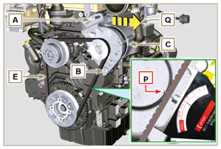  Fig 6.42
NOTE: Click by side to play the procedure. | https://www.youtube.com/embed/GbvNS15R9SQ?rel=0

Target wheel replacement
6.6.1 Disassembly  Important  - Before proceeding with operation, read Par. 3.3.2 .  - Position the crankshaft with the 1st cylinder in TDC, reference A upwards.  - Remove the alternator belt following steps 1 and 2 ( Par. 6.5.1 ) . | 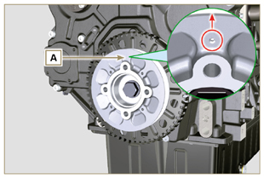  Fig 6.43
- Disassemble the starting motor.  - Mount the tool ST_34 in the seat of the starter motor C and fit it with the two starter motor fixing screws. | 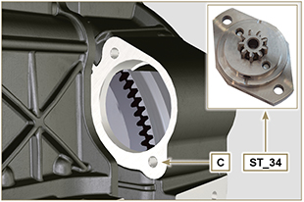  Fig 6.44
- Disconnect the connector L .  - Undo the screw M and remove the revolution sensor N and its respective spacer. | 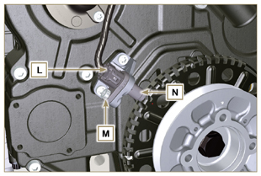  Fig 6.45
- Undo the screw P (clockwise) and remove the pulley/targetwheel unit Q . | 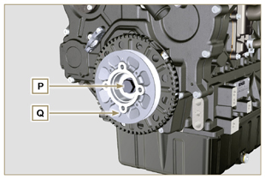  Fig 6.46
- Undo the screws R and remove the target wheel S with the relevant sound-absorption disk T . | 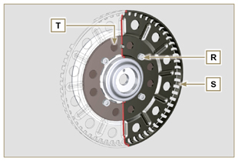  Fig 6.47
6.6.2 Assembly  - Check that the pin U is mounted properly on the pulley V .  - Insert the disk T on the pulley V respecting the reference of the pin U .  - Position the target wheel S on the pulley V respecting the reference of the pin U .  - Fit the target wheel S with the screws W (tightening torque 10 Nm ).  - Perform the operations described in Par. 6.7.7 and then the operations between point 2 and 9 of Par. 6.5.2 . | 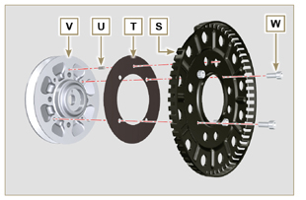  Fig 6.48

Oil pump replacement

Important

- Before proceeding with operations, read Par. 3.3.2 .
- The oil pump is not repairable.

6.7.1 Refrigerant pump disassembly  - Perform the operations described in Par 6.5.1 .  6.7.2 Crankshaft and target wheel pulley disassembly  - Perform the operations described in Par 6.6.1 .  - Disconnect the connector AE from the sensor S . | 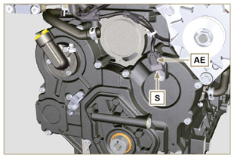  Fig 6.49
6.7.3 Timing system crankcase disassembly  Important  - Perform the operations described in Par. 5.2 .  - Make sure that the reference pin A is facing upwards.  - Undo the screw H ( ST_06 ) and remove the sensor S .  - Undo the screws B and remove the timing system crankcase C . | 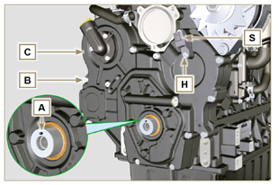  Fig 6.50
6.7.4 Oil pump disassembly  - Undo the screws D ( ST_06 ) and remove the group pump E from the timing system crankcase C .  - Remove the rotors F and G from the oil pump crankcase E . | 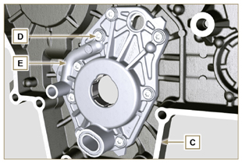  Fig 6.51  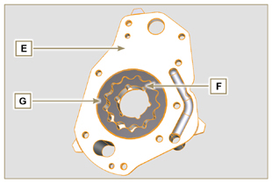  Fig 6.52
6.7.5 Oil pump assembly  NOTE: Carry out the checks described in Par. 8.7 prior to assembly.  - Check that all surfaces in contact between F, G, H, E and C are free from impurities - scratches - dents.  - When assembling, do not use any type of gasket between E and C .  - Thoroughly lubricate the seat of the rotors H on the oil pump crankcase E and the two rotors F and G .  - Within housing H insert the 2 rotors (in sequence) G and F , observing the references BP as described in figure (or refer to Par. 2.10.2 ).  - Check that the 2 pins L are inserted properly in the timing system crankcase C .  - Position the oil pump carter E using the reference pins L .  - Clamp the oil pump carter E with the screws D (tightening torque 10 Nm - ( ST_06 ) ). | 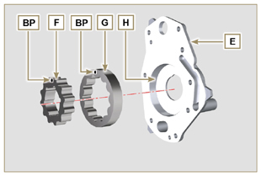  Fig 6.53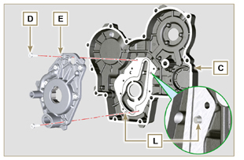  Fig 6.54
6.7.6 Timing system crankcase assembly  Important  - Always replace the oil seal J after each assembly.  - Always replace the gasket P after each assembly.  - Lubricate the lip of the oil seal J .  - Apply a coating of Loctite 5188 around 1mm thick on the surfaces K of the crankcase C .  - Make sure that the key M (Fig. 6.56) is inserted properly on the crankshaft and that it is facing upwards.  - Check that the 2 pins N are inserted properly in the timing system crankcase C . | 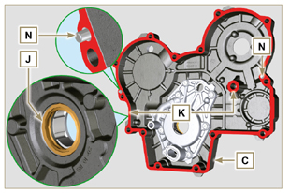  Fig 6.55
- Lubricate and insert the gasket P in the seat of the oil pump Q .  - Tighten the tool ST_10 on the crankshaft.  - Position the crankcase C on the base, using the reference pins N , inserting the oil pump Q on the crankshaft. | 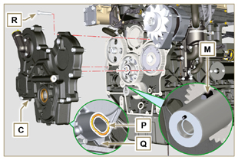  Fig 6.56
- Fit the timing system crankcase C with the screws R observing the indicated clamping sequence (tightening torque at 25 Nm ). | 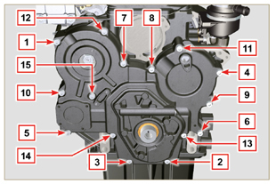  Fig 6.57
- Assemble sensor S by means of capscrew T on carter C inserting gasket U (tightening torque at 10 Nm ST_06 ). | 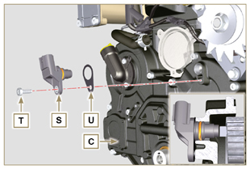  Fig 6.58
6.7.7 Crankshaft and target wheel pulley assembly  - Leave the tool ST_34 mounted ( Fig. 6.44 ) .  - Check that the pin A is mounted properly on the crankshaft Z .  - Position the pulley unit W on the crankshaft Z respecting the reference with the pin A .  - Apply Molyslip grease on the screw thread Y .  - Clamp the pulley unit W with the screw Y (tightening torque at 360 Nm ).  - Remove the special tool ST_34 ( Fig. 6.44 ) . | 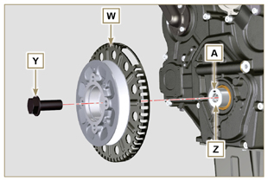  Fig 6.59
- Mount the bracket Z with the screws AA (tightening torque at 10 Nm ).  - Perform the operations described in Par. 9.12 .  - Insert the shim AB on the sensor AC .  - Clamp the sensor AC on the bracket Z with the screw AD (tightening torque at 10 Nm ).  6.7.8 Coolant pump assembly  - Perform the operations described in Par 6.5.2 . | 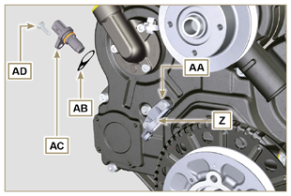  Fig 6.60

Oil pressure valve replacement
6.8.1 Disassembly  Important  - Before proceeding with operation, read Par. 3.3.2 .  - Undo cap A .  - Remove spring B , check its condition and replace it if broken.  - Remove the valve piston C using a magnet. | 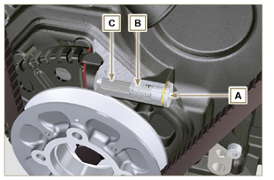  Fig 6.61
6.8.2 Assembly  - Lubricate the piston C and fully insert it in the seat E .  - Insert the spring B in the piston.  NOTE: Always replace the gasket F after each assembly.  - Mount the gasket F on cap A .  - Clamp the cap A on the crankcase D (tightening torque at 50 Nm ). | 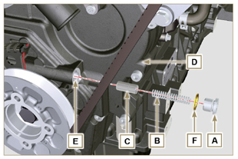  Fig 6.62

Oil vapour separator replacement
6.9.1 Disassembly  Important  - Before proceeding with operation, read Par. 3.3.2 .  - Release the clamp AA and remove the pipe D .  - Release the clamps F .  - Remove the clamp P cutting it in the point indicated and remove the separator body C removing it from the hose AG and G . | 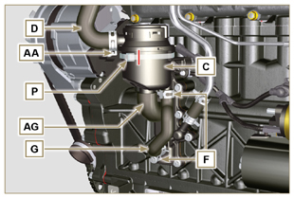  Fig 6.63
- Release the clamp F .  - Remove the pipes G and AG .  - Remove the clamp J .  - Undo the screws B .  - Release the clamp S from the sleeve K .  - Pull the flange H out of the manifold K and remove the relevant gasket, being careful not to bend the pipe E . | 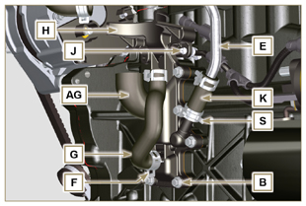  Fig 6.64
6.9.2 Assembly  Warning  - Always carefully inspect the condition of the tubes, and replace them if there is any doubt regarding their integrity.  - Always replace the gasket M after each assembly.  - Check that the contact surface L is free from impurities.  - Position flange H inserting hose K onto the flange union H , being careful not to bend tube E .  - Insert the gasket M between the flange H and the crankcase N .  - Secure the flange H using the screws B on the crankcase N (tightening torque at 10 Nm ).  - Secure the clamp S on the manifold K .  - Fit the pipes G and AG on the flange H .  - Fit the breather body C on the pipes G and D and fit the pipe G with the clamps F and the pipe D with the clamp AA .  - Fit the breather body C on the support flange H with the new clamp P . | 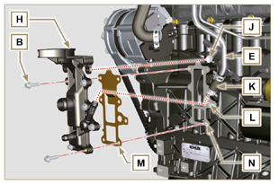  Fig 6.65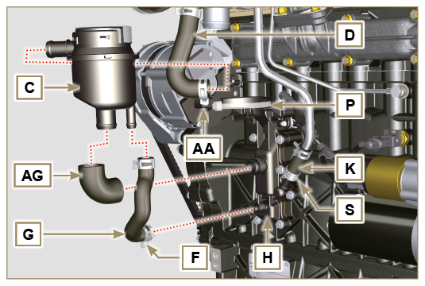  Fig 6.66

Oil cooler unit and oil filter replacement
6.10.1 Oil Cooler unit disassembly  Important  - Before proceeding with operation, read Par. 3.3.2 .  - Perform the operations described in Par 5.1 and Par 5.2 .  - Oil Cooler unit E is not repairable.  - Release the clamps A .  - Remove the pipes B out of the Oil Cooler unit E . | 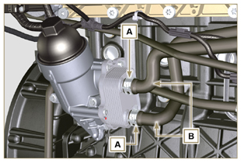  Fig 6.67
Warning  - Electric/pneumatic screwdrivers are forbidden.  - Use a suitable container to recover any residue oil.  - Unscrew cartridge holder cover H by performing three complete turns and wait 1 minute.  NOTE : this operation allows to oil contained in the support E to flow into the oil sump in the correct way.  - Unscrew cartridge holder cover H and check that the oil in the lub. oil filter support E has flowed towards the oil sump.  - Undo the screws C and D and remove the Oil Cooler unit E . | 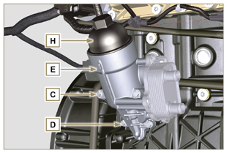  Fig 6.68
- Remove the gaskets F and G from the Oil Cooler unit E . | 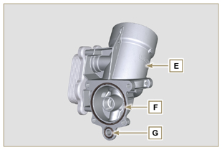  Fig 6.69
6.10.2 Oil filter cartridge replacement  - Remove gaskets L, M and N from element holder cover H .  - Remove cartridge P from element holder cover H . | 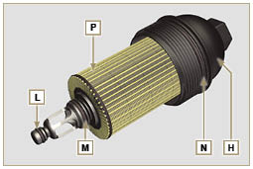  Fig 6.70
- Lubricate and insert gaskets L, M and N in the L1, M1 and N1 seats of element holder cover H .  - Insert element P into element holder cover H . | 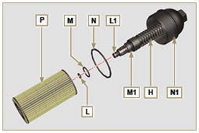  Fig 6.71
6.10.3 Oil Cooler unit assembly  Important  - In the event of assembly of union U on crankcase S , manual tightening torque with Loctite 2701 on the thread).  - Check that the surface Q on the support E and on the crankcase S are free from impurities.  - Lubricate and insert the gasket T on the fitting U .  - Lubricate and insert the gaskets on the support E :  F in seat F1 ;  G in seat G1 .  - Fit the support R with the screws C and D (tightening torque at 10 Nm ).  - Insert and tighten the cartridge support H on the filter support E (tightening torque at 25 Nm ).  - Fit the pipes B on the support E and secure the pipes B with the clamps A . | 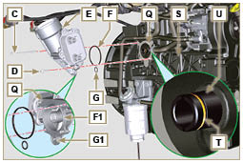  Fig 6.72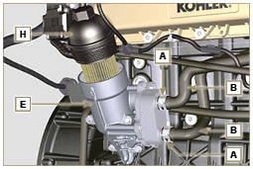  Fig 6.73

Fuel filter replacement
6.11.1 Disassembly  Important  - Before proceeding with operation, read Par. 3.3.2 .  Warning  - The fuel filter is not always mounted in the engine.  - When disassembling the sensor E , use a suitable container to recover the fuel contained in the cartridge F .  - Release the clamps A and pull the pipes B out of the support H .  - Unscrew the sensor E from the cartridge F .  - Unscrew the cartridge F from the support H .  - Undo the screws C and remove the support H . | 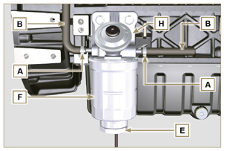  Fig 6.74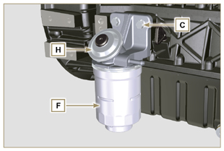  Fig 6.75
Warning  - Check that the fuel supply pump filter is present, and replace if necessary.  - Release the clamp D .  - Demount the hose E .  - Unscrew the filter G from the pump Q . | 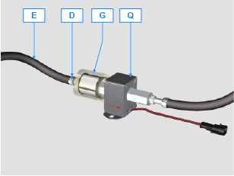
- Screw the new filter G onto the pump Q (tightening torque 20 Nm ).  - Connect the hose E to the filter G and fasten with the clamp D . | 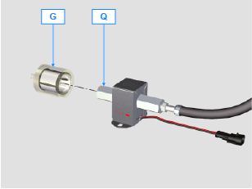
6.11.2 Assembly  - Clamp the fuel filter support H with the screws C on the crankcase M (tightening torque at 25 Nm ).  - Fit the pipes B on the support H .  - Secure the pipes B with the clamps A . | 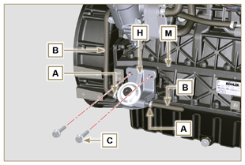  Fig 6.76
- Lubricate the gasket N with fuel.  - Tighten the cartridge F on the support H (tightening torque at 17 Nm ).  - Assemble gasket J onto sensor E and lubricate with fuel.  - Tighten the sensor E on the cartridge F (tightening torque at 5 Nm ). | 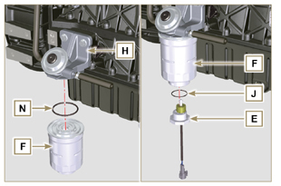  Fig 6.77

Replacement of SCV valve
Important  - Before starting any replacement operations, make sure the work area is free from dust (part X of valve B is extremely sensitive to micro-dust).  - Pay the utmost attention to cleaning in order to prevent any type of contamination during replacement operations  - - Before proceeding with the replacement, clean the outer part of pump A thoroughly - Avoid any type of contact with part X of the valve during replacement.  - Lubricate part X of valve B with oil spray.  - Before starting any replacement operations, make sure that the key on the vehicle’s panel is OFF .  - Assemble the new valve in the same position as the previous one. | 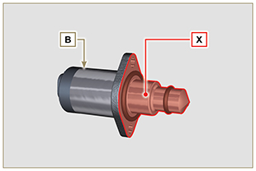  Fig. 6.78
6.12.1 Disassembly  1 - Disconnect connector C from valve B .  2 - Loosen screws D .  3 - Remove valve B from pump A . | 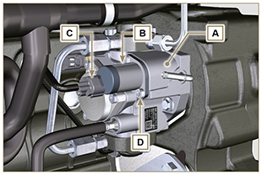  Fig. 6.79
6.12.2 Assembly  1 - Insert studs E supplied with valve B in the fastening holes of pump A and insert gasket F in the seat of pump A .  2 - Assemble valve B on pump A using studs E as positioning guides.  3 - Remove studs E and secure valve B with screws D (tightening torque of 6 Nm).  4 - Fasten valve B by means of screws D (tightening torque of 10 Nm). | 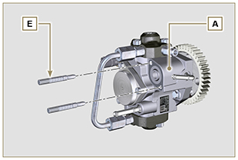  Fig. 6.80
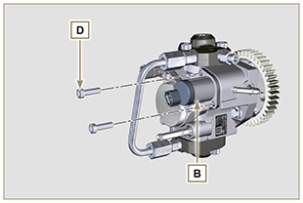  Fig. 6.81 | 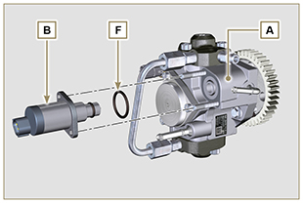  Fig. 6.82

Information for disassembly

Recommendations for disassembly

Important

- The mark ( ) after the title of a paragraph, indicates that the procedure is not required in order to disassemble the engine, however the procedures are featured in order to illustrate the disassembly of components.
- The operator should prepare all equipment and tools in order to enable him to carry out the operations correctly and safely.
- Before disassembly, perform the operation described in Chap. 5 .
- Before proceeding with operation, carefully read Chap. 3 .
- In order to operate safely and easily, we recommend positioning the engine on a rotating stand for engine overhauling.
- Seal all injection component unions as illustrated in Par. 2.9.8 during assembly.
- Protect all disassembled components and coupling surfaces subject to oxidation with lubricant.
- Where necessary, reference to special tools to use during disassembly operations is indicated (es. ST_05 ), identified in Tab. 13.1 - 13.2 - 13.3 .

EGR circuit disassembly
7.2.1 EGR cooler unit  - Undo the screws A ( ST_06 ) and B and remove the pipe C with the relative gaskets. | 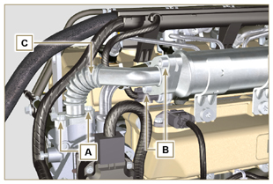  Fig 7.1
- Undo the screws D, E ( ST_06 ) and remove pipe F and the relevant gaskets. | 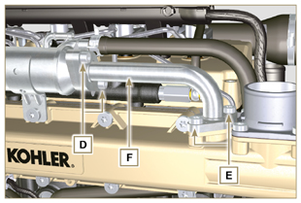  Fig 7.2
- Release the clamp M and remove pipe N .  - Release the clamp L .  - Undo capscrews G and remove EGR Cooler H from hose X ( ST_05 ) . | 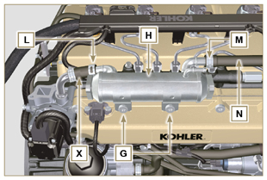  Fig 7.3
7.2.2 EGR Valve  - Disconnect the connector P .  - Undo the screws Q and remove the EGR valve R with the relevant gasket.  NOTE: The EGR valve is not a serviceable item, and if damaged/worn, it should be replaced with a new one. | 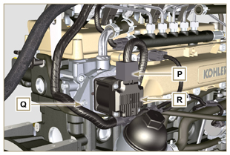  Fig 7.4
- Undo capscrews S and remove flange T with the relative gasket. | 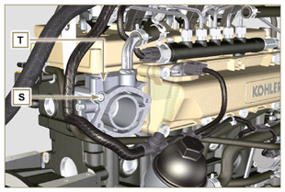  Fig 7.5

Electric components disassembly
7.3.1 Electric wiring  Important  - Refer to Par. 2.13 prior to proceeding with disassembly.  - Disconnect the connectors A, B and C .  - Release the clamp D . | 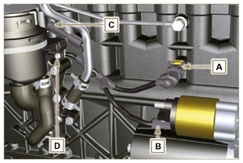  Fig 7.6
- Disconnect the connectors E, F and G .  - Release the clamps J and H . | 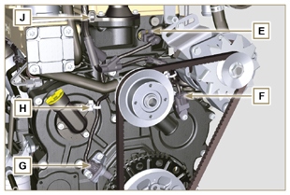  Fig 7.7
- Disconnect the connectors K and L . | 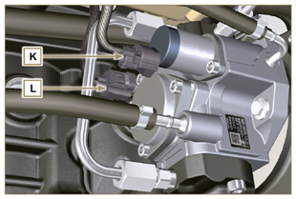  Fig 7.8
- Disconnect the connectors M and P .  - Release the clamp Q . | 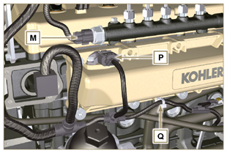  Fig 7.9
- Disconnect the connectors R .  - Undo the screws S and remove the wiring support T ( ST_06 ) . | 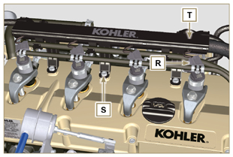  Fig 7.10
7.3.2 Starter motor  Important  - The motor is not repairable.  - Undo the screws U and remove the starter motor V . | 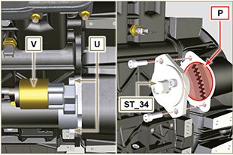  Fig 7.11
7.3.3 Belt and alternator  - Loosen the screws Z and W .  - Push the alternator AA in the direction of the arrow AB .  - Remove the belt AC from the pulleys AR .  - Undo the screws Z and W and remove the alternator AA .  Important  - The belt must always be replaced every time it is disassembled, even if it has not reached the scheduled hours for replacement. | 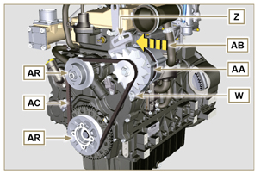  Fig 7.12
7.3.4 Sensors and switches  Important  - After disassembly, protect the sensors suitably against knocks, dampness and any high temperature sources.  - The sensors and switches cannot be repaired, therefore they must be replaced in the event of anomalies.  7.3.4.1 Oil pressure switch ( )  - Unscrew and remove the oil pressure switch AD . | 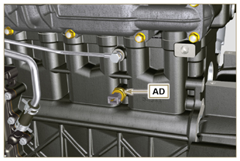  Fig 7.13
7.3.4.2 Coolant temperature sensor ( )  - Unscrew and remove the coolant temperature sensor AE . | 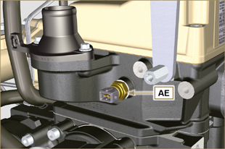  Fig 7.14
7.3.4.3 Speed sensor ( )  - Undo the screw AF and remove the sensor AG with the relative spacer ( ST_06 ) .  - Undo the screws AH and remove the sensor ( ST_06 ) . | 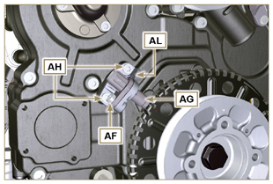  Fig 7.15
7.3.4.4 Camshaft phase sensor  - Undo the screw AM and remove the sensor AN with the relative spacer ( ST_06 ). | 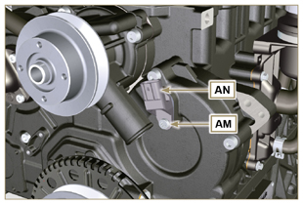  Fig 7.16
7.3.4.5 T-MAP Sensor ( )  - Undo the screw AP and remove the sensor AQ ( ST_06 ). | 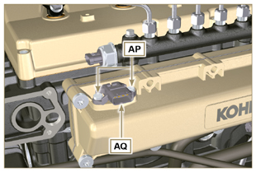  Fig 7.17
7.3.4.6 Fuel filter water detection sensor ( )  Warning  - The fuel filter is not always mounted on the engine.  - When disassembling the sensor A , use a suitable container to recover the fuel contained in the cartridge B .  - Unscrew the sensor A from the cartridge B . | 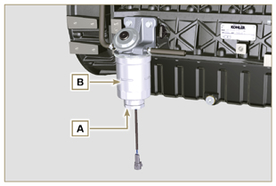  Fig 7.18

Turbocharger disassembly
- Release the clamps A and B and remove the manifold C . | 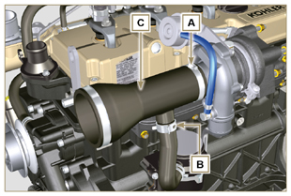  Fig 7.19
- Unscrew the fittings D and remove the pipe E with the relative gaskets G .  - Undo the screws F .  - Release clamp M . | 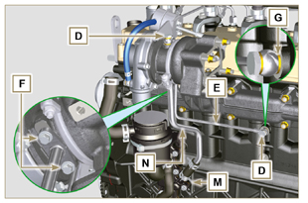  Fig 7.20
- Undo the nuts L .  - Remove tube N . | 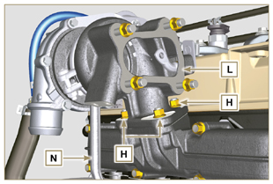  Fig 7.21

Exhaust manifold disassembly
- Undo the nuts A and remove the manifold B and the gaskets C .  - Close the openings and manifolds to prevent foreign bodies from entering. | 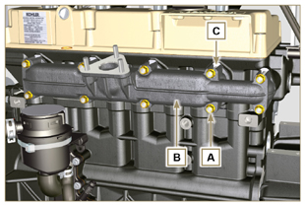  Fig 7.22

Coolant recirculation components disassembly
7.6.1 Oil Cooler manifold  - Release the clamps Z .  - Undo the screw W and remove hoses J ( ST_05 ) . | 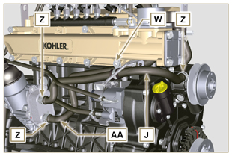  Fig 7.23
- Release the clamp K and remove hoses AA . | 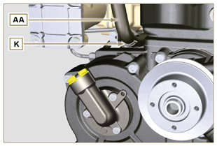  Fig 7.24
7.6.2 Coolant pump  Important  - The pump B is not repairable.  - Undo the screws A and remove the water pump unit B with its gasket C . | 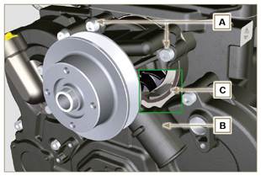  Fig 7.25
7.6.3 Thermostatic valve  - Undo the screws A and remove the thermostatic valve cover B .  - Remove the thermostatic valve C and its gasket.  Important  - Always replace the gasket D every time it is disassembled.  - Check that the air bleeding hole is not clogged or blocked ( Par. 2.11.4 ). | 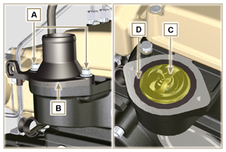  Fig 7.26

Crankshaft and target wheel pulley disassembly
- Position the crankshaft with the 1st cylinder at TDC,reference H .  - Undo the screw C clockwise.  - Remove the drive pulley unit and the target wheel D . | 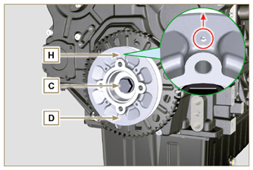  Fig 7.27

Lubrication circuit disassembly
7.8.1 Oil pressure valve( )  - Undo the cap A .  - Remove the spring B , check its condition and replace it if broken.  - Remove the valve piston C using a magnet. | 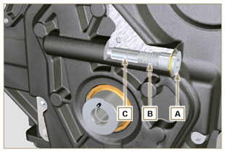  Fig 7.28
7.8.2 Timing system carter oil filling flange ( )  - Undo the screws D and remove the oil filling flange E ( ST_06 ) .  - Remove the gasket F . | 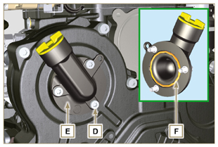  Fig 7.29
7.8.3 Timing system carter  - Ensure that the crankshaft with the 1st cylinder is at the TDC (taper pin W must be facing upwards).  - Undo the screws G .  - Remove the timing system semi-crankcase H . | 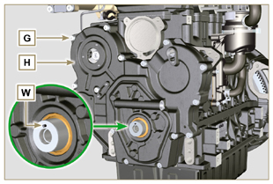  Fig 7.30
7.8.4 Oil pump  Important  - The oil pump is not repairable.  - Undo the screws L and remove the pump unit M from the timing system carter H ( ST_06 ) . | 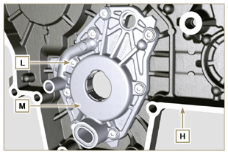  Fig 7.31
- Remove the rotors N and P from oil pump carter M . | 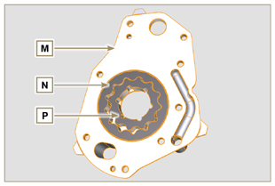  Fig 7.32
7.8.5 Oil Cooler unit and lub. oil filter  - Screw the lid cartridge holder V .  - Undo the screws Q, R and remove Oil Cooler group S .  Warning  - Use a suitable container to recover any residue oil.  - Oil Cooler unit S is not repairable. | 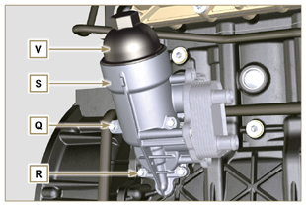  Fig 7.33
- Remove the gaskets T and U .  NOTE: To replace the oil cartridge, refer to Par. 6.10.2 . | 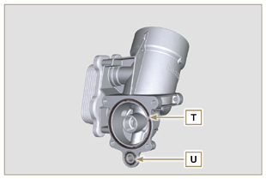  Fig 7.34
7.8.6 Oil vapour separator unit  - Release the clamps AA .  - Remove the manifolds AB, AC and AD .  - Remove the clamp AE by carefully cutting it at the point indicated and remove the oil separator AF . | 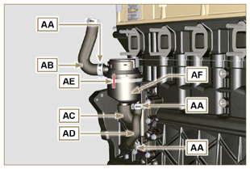  Fig 7.35
- Undo the screws AG .  - Remove la flangia di supportoRemove flange support AH and the gasket seal AL . | 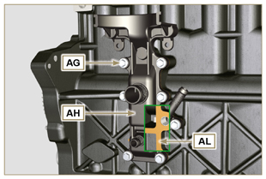  Fig 7.36

Intake manifold disassembly
- Undo the screws A and remove the semi-manifold B ( ST_05 ) .  - Remove the separation plate C and the gaskets H . | 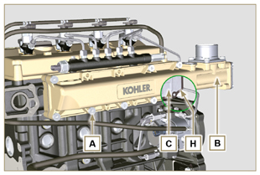  Fig 7.37
- Undo the screws D ( ST_06 ) and E .  - Remove the semi-manifold F and the gasket G . | 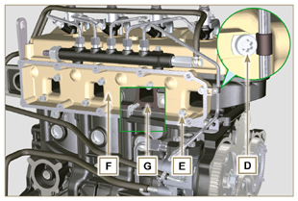  Fig 7.38

Fuel system disassembly
7.10.1 Fuel return pipes  - Release the clip A .  Warning  - After removing the union, the clip A must automatically return to its initial position; otherwise it must be replaced.  - Undo the B distributor return fixing capscrew.  - Release the clamp D .  - Disconnect the pipe E from the fuel return fitting.  - Undo and remove the screw G with the relative gaskets and put the cap on the Common Rail pressure relief valve AA .  - Disconnect unions M from electronic injectors N .  - Remove the fuel return pipes. | 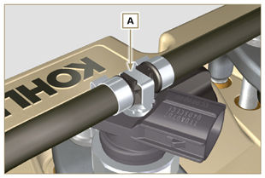  Fig 7.39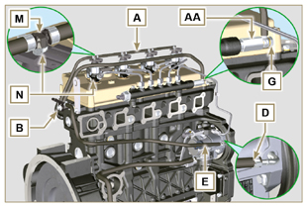  Fig 7.40
7.10.2 Fuel flow pipes  Important  - Seal all openings of the inlet and return unions on the injection pump D with the relevant caps, in order to prevent impurities from entering.  - Loosen the clamps P .  - Remove the pipes Q and R . | 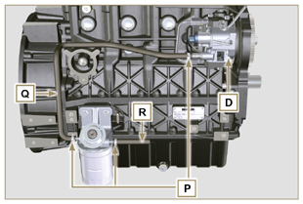  Fig 7.41
7.10.3 High pressure fuel pipes  Danger  - The fuel injection circuit undergoes high pressure, use safety protections as described in Par 3.4.3 .  - Ensure that the Common Rail is not under pressure by slowly and carefully unscrewing one of the nuts S .  - Loosen the nuts S and T in sequence.  - Fully undo the nuts S and T in sequence, and remove the high pressure pipes U and V . | 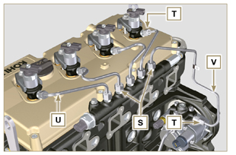  Fig 7.42
7.10.4 Common Rail  - Undo the screws AB and remove the Common Rail AC .  NOTE: Take care to protect te sensor AD from knocks, moisture and any high temperature source. The internal parts of the rail cannot be repaired.  Important  - Seal all injection component unions as illustrated in Par. 2.9.8 .  - Common rail cannot be repaired. | 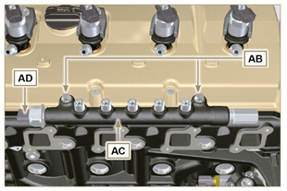  Fig 7.43
7.10.5 Electronic injectors  Important  - In the event that the electronic injectors are disassembled (not necessarily replaced), mark them with the relevant cylinder number from which they originate so as not to confuse them during re-assembly (Fig. 7.45) .  - The electronic injectors cannot be repaired.  - If one or more electronic injectors are to be replaced, the new calibration data must be inserted in the ECU via a specific instrument ( ST_01 ).  - Be careful not to damage the gaskets X .  - Undo capscrews AE and remove them together with the relative washers AF and then brace AG .  - Pull out the electronic injector AH .  NOTE: Should you be unable to remove the electronic injector (acting only on point BC ), use an open-ended spanner (Ø 34 mm), by applying small rotations to unblock the component.  - Seal all injection component unions as illustrated in Par. 2.9.8 .  - Ensure that gasket AL has remained in the correct position (Fig. 7.46) .  Otherwise, recover the gasket from inside the electronic injector AM . | 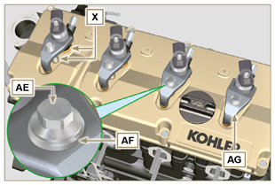  Fig 7.44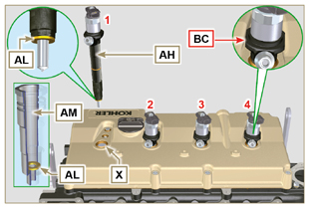  Fig 7.45
7.10.6 Fuel filter ( )  - Undo the fuel cartridge AW from support AP .  - Undo the screws AN and remove the filter support AP . | 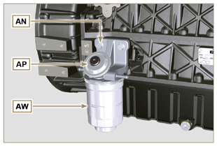  Fig 7.46
7.10.7 High-pressure fuel injection pump  Important  - Before disassembling, carefully read Par. 2.17 .  - The injection pump is not repairable  - Should the fuel feeding pump need to be replaced, after assembly, it is necessary to perform the Pump Learning procedure by means of instrument ST_01 .  - Undo the nut AQ .  - Loosen the screws AR of the injection pump.  - Screw the tool ST_04 on the thread of the gear AS .  - Tighten the screw AT on the puller to disconnect the gear AS from the injection pump and remove the injection pump control gear AS .  - Undo the screws AR .  - Remove injection pump AU and the relative gasket AV .  - Seal all injection component unions as illustrated in Par. 2.9.8 . | 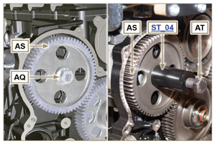  Fig 7.47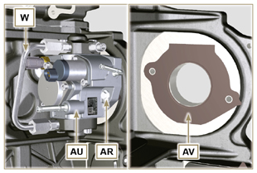  Fig 7.48

Timing system gear disassembly
- Unscrew screws H and remove target wheel G .  - Unscrew screws D and remove camshaft gear E .  - Remove retainer ring A and the shoulder ring B .  - Remove the intermediate gear C . | 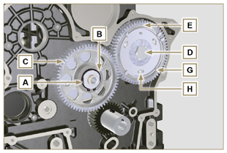  Fig 7.49
- Remove the shoulder ring F .  - Unscrew the screws L and remove the intermediate gear support M . | 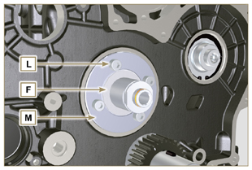  Fig 7.50

Flange unit disassembly
7.12.1 Flywheel  Important  - Leave the special tool ST_34 for blocking the flywheel ( Par. 7.7 ) .  - Only undo the screw C located uppermost.  - Insert the tool ST_09 in the seat of the screw C tightening it all the way.  - Undo the remaining screws D .  Danger  - The flywheel E is very heavy. Pay the utmost attention while removing it in order to prevent it dropping or falling, as this may have serious consequences for the operative.  - Remove the flywheel E .  - Remove the tool ST_09 .  - Remove the tool ST_34 shown in Fig. 7.11 . | 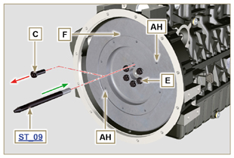  Fig 7.51
7.12.2 Flange housing  - Undo the screws A and remove the engine housing B .  Danger  - The flange housing is very heavy. Pay the utmost attention while removing it in order to prevent it dropping or falling, as this may have serious consequences for the operative. | 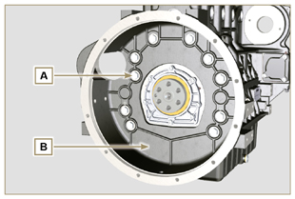  Fig 7.52

Cylinder head unit disassembly
7.13.1 Rocker arms cover  - Undo the screws A .  - Remove the rocker arms cover B .  - Remove the gasket C . | 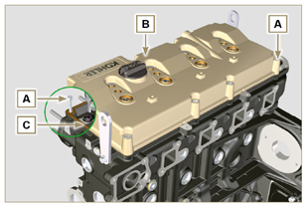  Fig 7.53
7.13.2 Rocker arm pin  - Undo the screws D .  - Remove the rocker arm pin unit E . | 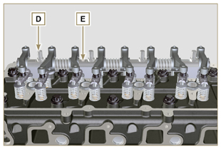  Fig 7.54
7.13.2.1 Rocker arm ( )  - Remove the retainer ring F .  - Remove the shoulder rings G .  - Remove the rocker arms H . | 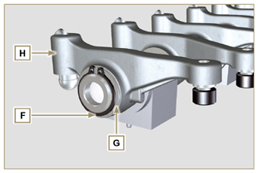  Fig 7.55
7.13.3 Valve rods and bridges  - Remove the valve control U-bolts M .  - Remove the rocker arm control rods N . | 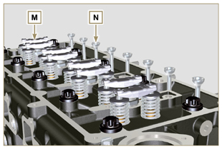  Fig 7.57
7.13.4 Cylinder head  Important  - The cylinder head fastening bolts P must be replaced every time they are disassembled.  - Undo the bolts P .  Important  - To lift cylinder head Q , only use both eyebolts AE provided by KOHLER (refer to Fig. 7.66 ).  - When removing the cylinder head Q and subsequent disassembly, control, and assembly operations, it is necessary to protect the contact surface W of cylinder head Q and crankcase J against impacts.  - Remove the cylinder head Q .  - Remove the head gasket R . | 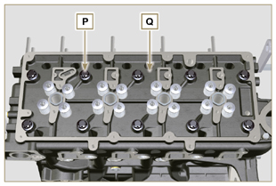  Fig 7.58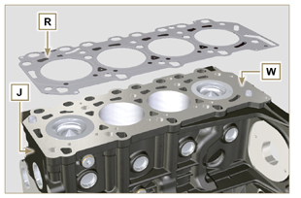  Fig 7.59
7.13.4.1 Valves ( )  - Mount the tool ST_07 on the head AF fixing it on one of the holes for fixing the rocker arm cover.  NOTE: Change the fixing hole according to the position of the valves to be removed.  - Position the tool ST_07 on the valve as shown in the figure. | 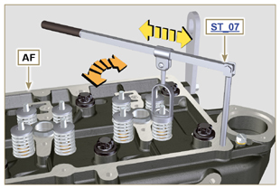  Fig 7.60
- Push the lever of the tool ST_07 downwards, in order to lower the valve plates S in the direction of the arrow T , remove cotters U using a magnet.  NOTE: Repeat all the operations for all the valves concerned. | 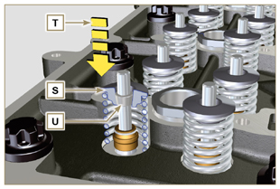  Fig 7.61
Important  - Before removing the valves, make some marks to record their original position, in order to avoid confusing them when reassembling (if they are not replaced).  - Remove the valves V . | 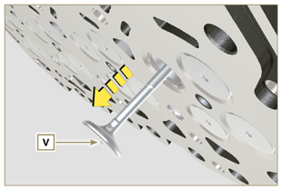  Fig 7.62
7.13.4.2 Electronic injector sleeves ( )  - Unscrew and remove the sleeves Z from the head Q .  - Remove the gaskets AA and AB . | 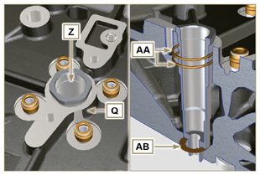  Fig 7.63
7.13.4.3 Valve stem gasket ( )  - Remove the gaskets AC . | 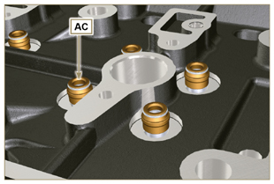  Fig 7.64
7.13.4.4 Lifting eyebolts ( )  - Undo the screws AD and remove the eyebolts AE .  - Thoroughly wash the cylinder head Q . | 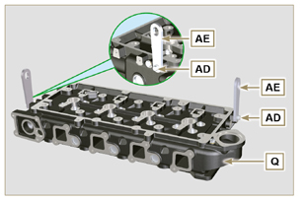  Fig 7.65

Oil sump unit disassembly
7.14.1 Oil sump  - Undo the screws A .  - Remove the oil sump B by inserting a plate in the areas indicated by the arrow AA . | 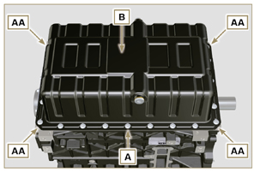  Fig 7.66
7.14.2 Oil suction pipe  - Undo the screws C and remove the oil pipe D . | 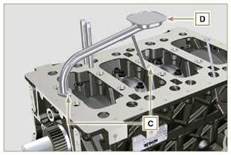  Fig 7.67
7.14.3 Oil vapour pipes ( )  - Unscrew and remove the pipes E . | 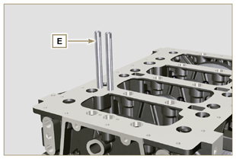  Fig 7.68

Engine block disassembly
7.15.1 Crankshaft gasket flange  - Undo the screws A .  - Remove the flange B and the gasket C . | 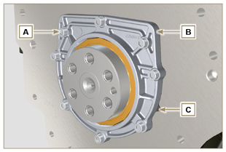  Fig 7.69
7.15.2 Piston unit/connecting rod  Important  - Mark some numerical references (cylinder n°) on the connecting rods, connecting rod caps F1 , pistons and gudgeon pins to prevent unintentionally confusing the components not replaced during assembly. Failure to do this may result in engine malfunctions.  - References on connecting rod M and cap F1 must only be carried out on a side in correspondence with K1 and K2 , as illustrated in Fig. 7.70a .  - Screw the bolt AM temporarily.  - Unsrew bolts E1 and remove the connecting rod caps F1 . | 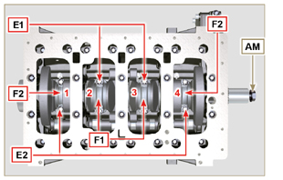  Fig 7.70
NOTE : coupling cap F1 on the connecting rod can be carried out with centring taper pins (Fig. 7.70b) or broken ( Fig. 7.70c - without centring taper pins).  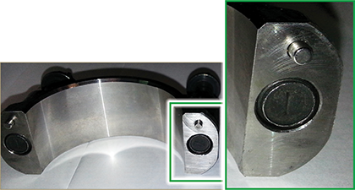  Fig. 7.70b  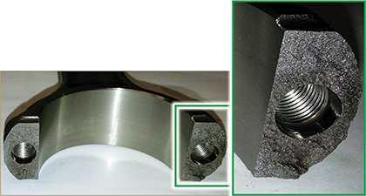  Fig. 7.70c | 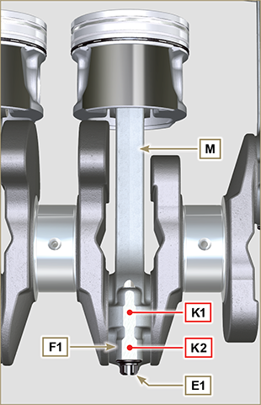  Fig 7.70a
- Pull out the connecting rod - piston assembly from position 2 and 3 by manually applying pressure on the connecting rod big end L in the direction of arrow AK .  - Couple the connecting rod big end caps L with the relevant piston and connecting rod unit M .  - Turn capscrew AM and rotate the crankshaft by 180°.  - Repeat points 2 to 5 to disassemble the connecting rod-piston assembly to position 1 and 4 . | 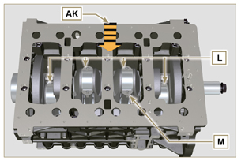  Fig 7.71
Warning  - The connecting rod half-bearings Z are made of special material. Therefore, they must be replaced every time they are removed to prevent seizures. | 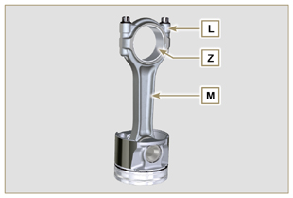  Fig 7.72
7.15.3 Lower semi-crankcase  3 CYLINDERS  - Undo capscrews E and F by following the order indicated in the figure.  - Remove the lower semi-crankcase D and store it in a suitable container for washing. | 3 Cylinders  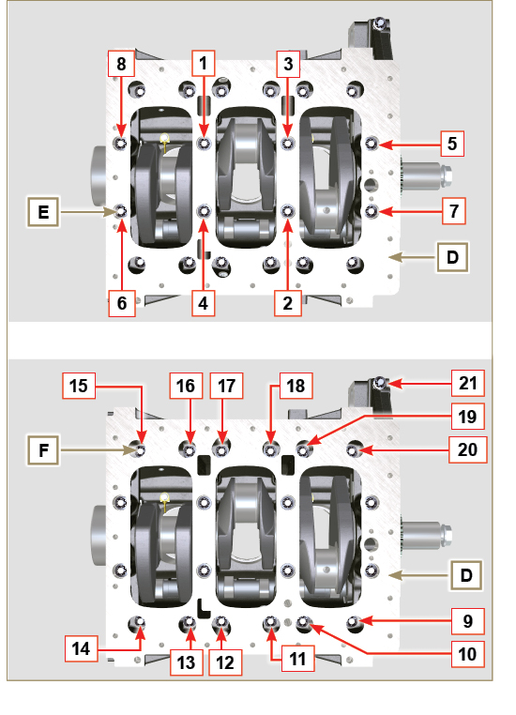  Fig 7.73
4 CYLINDERS  - Undo capscrews E and F by following the order indicated in the figure.  - Remove the lower semi-crankcase D and store it in a suitable container for washing. | 4 Cylinders  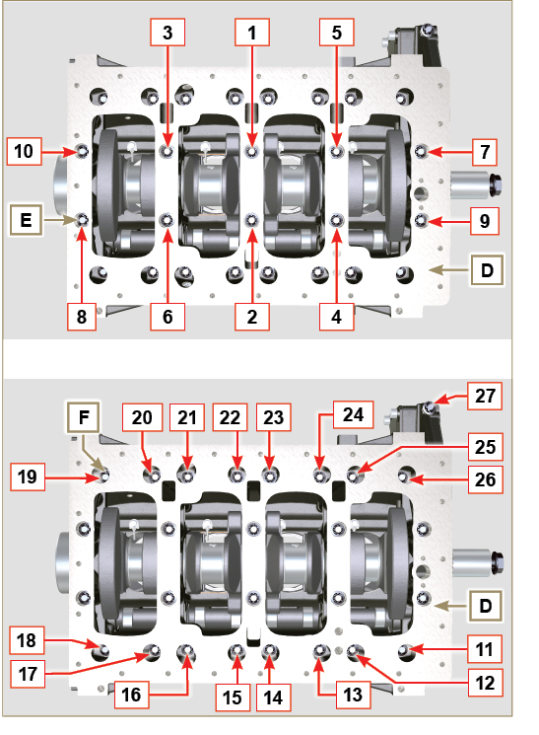  Fig 7.74
7.15.4 Crankshaft  Remove:  - Crankshaft G .  - The shoulder semi-rings H . | 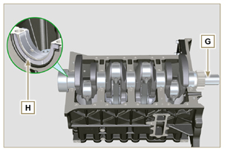  Fig 7.75
7.15.5 7.15.5 Piston ( )  - Remove the retainer ring N .  - Remove the pin P to separate the piston Q from the connecting rod R .  Important  - If they are not replaced, keep the components together (connecting rod - piston - gudgeon pin) by using references in order to prevent them from getting mixed up during assembly. | 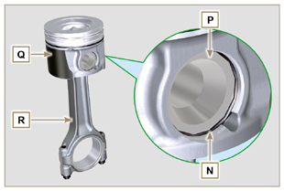  Fig 7.76
7.15.5.1 Rings ( )  - Remove the rings S . | 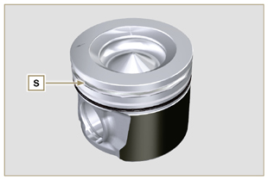  Fig 7.77
7.15.6 Oil spray nozzles ( )  - Undo the screws T and remove the spray nozzles U from the upper semi-crankcase AB . | 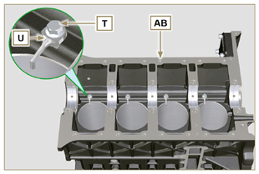  Fig 7.78
7.15.7 Camshaft  - Remove the lock ring V .  - Extract the camshaft W from the upper semi-crankcase AB . | 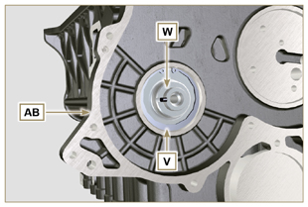  Fig 7.79
7.15.8 Camshaft tappets  - With a magnet, remove the tappets AA from the upper semi-crankcase AB . | 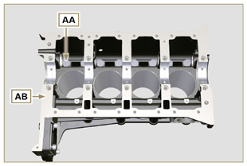  Fig 7.80
7.15.9 Crankshaft bushings  - Remove the crankshaft bushings AC from the upper crankcase AB .  Important  - The crankshaft half-bearings AC are made of special material. Therefore, they must be replaced every time they are removed to prevent seizures. | 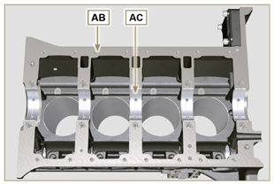  Fig 7.81
- Remove the crankshaft bushings AF from the lower semicrankcase AE . | 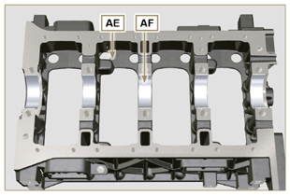  Fig 7.82
7.15.10 Cover 3 ^{th} PTO ( )  - Undo the screws AG .  - Remove the cover AH and the gasket AL from the semicrankcase top. | 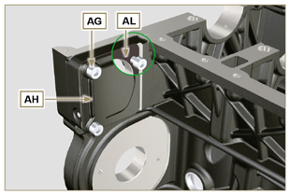  Fig 7.83

Information about overhauling

Recommendations for overhauls and tuning
- The information is laid out in sequence, according to operational requirements, and the intervention methods have been selected, tested and approved by the manufacturer's
technicians.
- This chapter describes procedures for checking, overhauling and tuning units and/or individual components.

NOT E : To easily locate specific topics, the reader should refer to the analytical index or chapter index.

- Before any intervention, the operator should lay out all equipment and tools in such a way as to enable him to carry out operations correctly and safely.
- The operator must comply with the specific measures described in order to avoid errors that might cause damage to the engine.
- Before carrying out any operation, clean the units and/or components thoroughly and eliminate any deposits.
- Do not wash the components with steam or hot water. Use suitable products only.
- Do not use flammable products (petrol, diesel, etc.) to degrease or wash components. Use suitable products only.
- Dry all washed surfaces and components thoroughly with a jet of air or special cloths before reassembling them.
- Apply a layer of lubricant over all surfaces of all disassembled components to protect them against oxidation.
- Check the integrity and state of wear of all disassembled components in order to ensure good working condition of the engine.
- When indicated, some components are to be replaced in pairs or together with other parts (e.g. crankshaft half-bearings/connecting rod, piston complete with rings and gudgeon pin, etc.).
- When indicated, some grinding operations are to be carried out in series (e.g. grinding of cylinders, crankpins, journals, etc.).

Crankcase
8.2.1 Oil line check
Use a pipe cleaner in access points A, B, C, D, E to clean the oil ducts of crankcase G . Use compressed air to eliminate any residues.

Replace and assemble the conical cap in hole B ( B1 if present - tightening torque at 30 Nm ) and caps in holes D , after having performed cleaning operations.

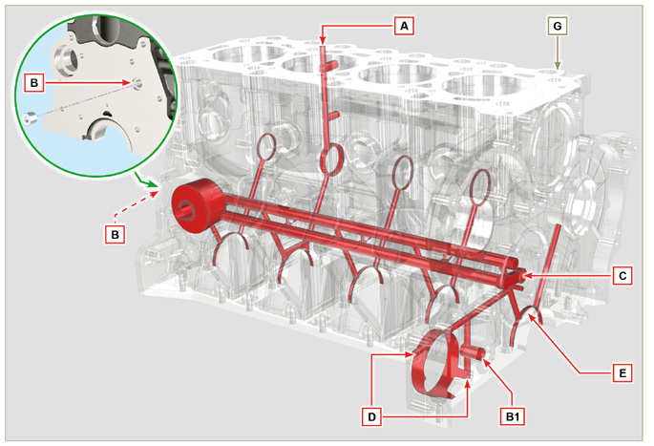
Fig 8.1

8.2.2 Cylinder check
Position crankcase G onto a workbench.

With a dial gauge, measure the diameter in correspondence to points J-M-N (Fig. 8.2) lengthwise and diagonally with regard to axis H of the crankshaft.
If ovalisation or wear detected in a single point in J-M-N is greater than +0.05 mm with regard to the value in Tab. 8.1a , you are required to perform grinding operations on all cylinders F.
Refer to Tab. 8.1a

to establish the clearance value of cylinders subjected to grinding operations.
Important

- Grinding is prohibited before 10000 h of operation on all engines provided with an EPA name plate (refer to Par. 1.3 ).
- The grinding involved is of +0.20, +0.50 e + 1 mm .
- Cylinder grinding operations must observe KOHLER SPECIFICATIONS - cod. ED0035612500.
- Grinding must be strictly performed on all cylinders F .
Tab. 8.1a details the dimensional values of new components only.
- ⁽¹⁾ The increase of +0.20 mm , may already be present on the engine.
Tab 8.1a Grinding values
PISTON | Ø CILINDER (± 0.007 mm) | Ø PISTON (± 0.007 mm) | CLEARANCE VALUE (mm)
STD | 88.010 | 87.950 | 0.046 - 0.074
+0.20 ⁽¹⁾ | 88.210 | 88.150
+0.50 | 88.510 | 88.450
+1.00 | 89.010 | 88.950

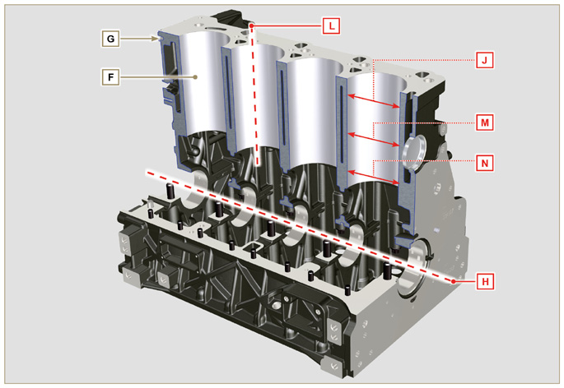
Fig 8.2
N.B.: if removing the Z2 hole closing cap, the new cap must comply with the MAX measurement of 1.5 mm from the surface G1.

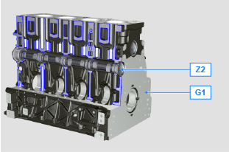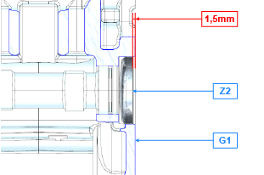
Fig 8.2a

8.2.3 4-cylinder camshaft housing check  The camshaft housings only contain the timing system side bushing Q .  Use an internal dial gauge to measure the diameters of housings X - W - K - Y - Z .  With a micrometer, measure the diameters of gudgeon pins X1 - W1 - K1 - Y1 - Z1 (Fig. 8.4) . According to the values measured, calculate the clearance between the housing and gudgeon, which is to observe the  values in Tab. 8.2a .  The MAX value of wear allowed is 0.120 mm  Important  - Tab. 8.2a details the dimensional values of new components only. | Tab 8.2a Housing and camshaft gudgeon dimensions.  REF. DIMENSIONS (mm) CLEARANCE VALUE (mm)  X 44.000 - 44.025 0.040 - 0.085  X1 43.940 - 43.960  W 43.000 - 43.025 0.060 - 0.105  W1 42.920 - 42.940  K 42.000 - 42.025 0.060 - 0.105  K1 41.920 - 41.940  Y 41.000 - 41.025 0.060 - 0.105  Y1 40.920 - 40.940  Z 36.000 - 36.025 0.060 - 0.105  Z1 35.920 - 35.940
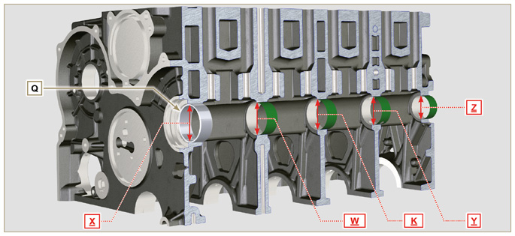
Fig 8.3
8.2.3.1 Block Surface Flatness  Use a dial gauge to check if the cylinder head surface A1 is level.  The MAX value of allowable irregularity of surface A1 is:  - 0.10 mm on the entire area;  - 0.03 mm on an area of 100x100 mm.  Grinding of surface A1 is not permitted | 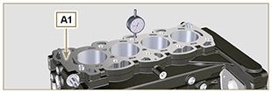  Fig 8.3b

8.2.4 Camshaft control for 4 cylinder engine  With a micrometer, measure the maximum dimensions of intake camshaft R and exhaust camshaft S (Tab. 8.2b) .  The MAX value of wear allowed is 0.1 mm .  Important  - Tab. 8.2b details the dimensional values of new components only. | Tab 8.2b Camshaft dimensions.  REF. DIMENSIONS (mm)  R 32.638 - 32.700  S 32.998 - 32.060
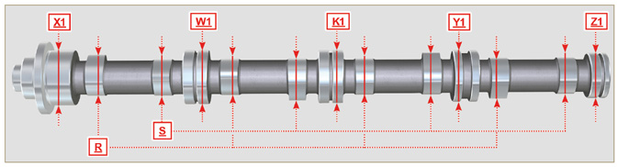
Fig 8.4

8.2.5 3 -cylinder camshaft housing check  The camshaft housings only contain the timing system side bushing Q .  Use an internal dial gauge to measure the diameters of housings X - W - K - Z .  Use an internal dial gauge to measure the diameters of housings X1 - W1 - K1 - Z1 (Fig. 8.5) . According to the values measured, calculate the clearance between the housing and gudgeon, which is to observe the  values in Tab. 8.2a .  The MAX value of wear allowed is 0.120 mm  Important  - Tab. 8.3a details the dimensional values of new components only. | Tab 8.3a Housing and camshaft gudgeon dimensions.  REF. DIMENSIONS (mm) CLEARANCE VALUE (mm)  X 44.000 - 44.025 0.040 - 0.085  X1 43.940 - 43.960  W 43.000 - 43.025 0.060 - 0.105  W1 42.920 - 42.940  K 42.000 - 42.025 0.060 - 0.105  K1 41.920 - 41.940  Z 36.000 - 36.025 0.060 - 0.105  Z1 35.920 - 35.940
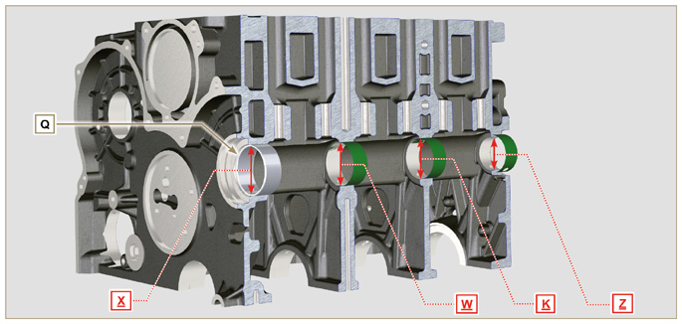
Fig 8.5

8.2.6 Camshaft control for 3 cylinder engine  With a micrometer, measure the maximum dimensions of intake camshaft R and exhaust camshaft S (Tab. 8.3b) .  The MAX value of wear allowed is 0.1 mm .  Important  - Tab. 8.3b details the dimensional values of new components only. | Tab 8.3b Camshaft dimensions  REF. DIMENSIONS (mm)  R 32.834 - 32.896  S 33.335 - 33.397
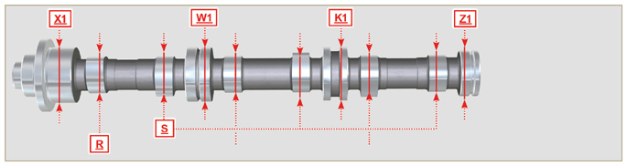
Fig 8.6

Tappets and tappet housings
8.3.1 Tappets check  Use a surface plate and a dial gauge as shown in Fig. 8.7 .  Check the perpendicularity of the plate C , making the tappet D rotate in the direction of the arrow.  The MAX value of wear allowed is 0.02 mm .  With a gauge, check the length of value A and B (Tab. 8.4) . The MAX value of wear allowed is 0.08 mm . | 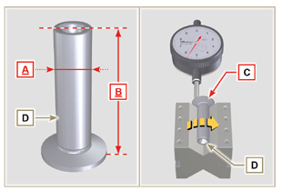  Fig 8.7
8.3.2 Tappet housing check  Use an internal dial gauge to measure the diameter of the tappet housings X .  Use value of A detected (Par. 8.3.1) to calculate the clearance value ( Tab. 8.4 ).  If the clearance values are not observed, replace the worn component.  Important  Tab. 8.4 T appets and t appet housing size.  REF. DIMENSIONS (mm) CLEARANCE VALUE (mm)  A 11.966 - 11.984 0.060 - 0.105  X 12.000 - 12.018  B 46.5 ± 0.2 --- | 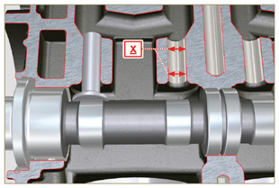  Fig 8.8

Crankshaft
8.4.1 Dimensional check and overhauling

Wash the crankshaft thoroughly using suitable detergent.
Insert the pipe cleaner into all lubrication ducts B and blow compressed air to free them completely from any dirt residues.
Check the state of wear and integrity of journals C and connecting rod D .
Perform the operations described in Par. 9.3.1 , perform the operations described in Par. 9.3.6 - except Points 2, 4, 9 and 10 .
Measure the crank pins A1 with a micrometer, and using a dial gauge measure the internal diameter of the connecting rod half-bearings A2 .
Measure the main journals B1 , with a micrometer, and using a dial gauge measure the internal diameter of the crankshaft half-bearings B2 .
If the values described in Tab. 8.5 do not correspond, proceed with grinding all gudgeon pins A1 and B1 .
Gear A on the crankshaft is timed by a key, assembly of gear A on the shaft occurs after heating at a stabilized temperature of +180° C for 5 mins.

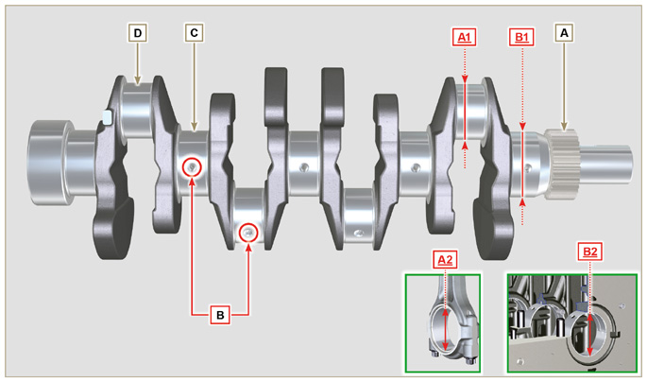
Fig 8.9

Important  - The crankshaft and connecting rod must be replaced every time they are assembled to prevent seizure, as they are made of special lead-free material.  - The MAX allowed value of wear for A1 and A2 is 0.120 mm.  - The MAX allowed value of wear for B1 and B2 is 0.120 mm.  - To grind the crankshaft, a decrease in diameter of the halfbearings and connecting rod is provided for at 0.25 mm and 0.50 mm, to grind gudgeon pins A1 and B1 , measure the values of diameters A2 and B2 by assembling the decreased half-bearings, define the diameter to grind of pins A1 and B1 ,  observing the clearance indicated in Tab. 8.5.  - La Tab. 8.5 riporta i valori dimensionali solo per i componenti nuovi. | Tab 8.5 Connecting rod and journal diameter  REF. DIMENSIONS (mm) CLEARANCE VALUE (mm)  A1 53.981 - 54.000 0.035 - 0.085  A2 54.035 - 54.066  B1 63.981 - 64.000 0.035 - 0.102  B2 64.035 - 64.083
8.4.2 Checking the axial clearance of the crankshaft  Perform the operations described in Par. 9.3.5 and 9.3.6 .  Using a dial gauge, measure the axial shift of crankshaft E .  Axial shift must be a MIN of 0.18 mm and MAX 0.38 mm..  If the values measured do not correspond, replace shoulder rings D . | 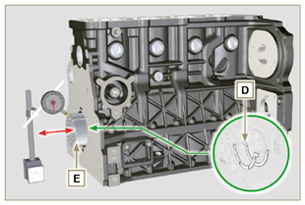  Fig 8.10

Connecting rod - piston assembly
8.5.1 Connecting rod dimensions check  Important  - Before assembling the connecting rod and pistons ( Par. 9.3.7 e 9.3.8 ), check that the difference in weight between the complete connecting rod and piston units do not exceed 8 gr to prevent weight imbalances during rotation of the crankshaft and consequent damage.  - Mark some references on the connecting rods, caps Q , pistons and gudgeon pins to prevent unintentionally confusing the components during assembly. Failure to do this may result in engine malfunctions.  - Connecting rod half-bearings S must be there with each assembly.  Check that the contact surfaces are perfectly clean and intact.  Assemble the connecting rod cap Q to the connecting rod with the half-bearings S and tighten capscrews P (tightening torque at 25 Nm ).  With a dial gauge, measure diameters B and D .  The MAX allowed value of wear for B and D is 0.06 mm.  Tab 8.6  REF. DIMENSIONS (mm) CLEARANCE VALUE (mm)  A 169.980 - 170.020  B 30.020 - 30.030 0.025 - 0.030  C 29.995 - 30.000  D 54.035 - 54.066  E 67.700 - 68.000  F 29.750 - 29.790  Important  - Tab. 8.6 details the dimensional values of new components only.  - Check that the connecting rod and crankshaft half-bearings are coupled properly.  - Refer to the warnings in Par. 8.4.1 for value D decreased.  - If the clearance value between B and C is not observed, you are required to replace bearing R (Fig. 8.12) .  Measure value A, C, D, E and F and confront them with those described in Tab.8.6 .  If the measured values do not follow those described in Tab.8.6 , replace connecting rod T . | 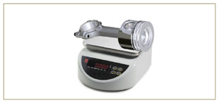  Fig 8.11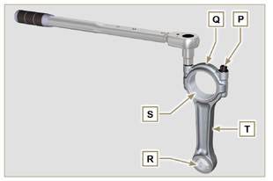  Fig 8.12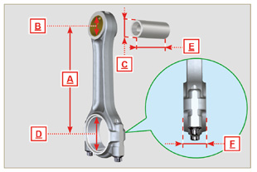  Fig 8.13
8.5.2 Checking the gudgeon pin-pin axes are parallel  Lubricate gudgeon pin A and bearing R (Fig. 8.12) .  Insert the gudgeon pin into bearing R . Use a dial gauge to check the axis parallelism of the connecting rod big end and small end.  Parallel deviation (value V ) measured at the tip of the gudgeonpin, must be a MIN of 0,015 and MAX of 0,030 mm.  If the parallelism values do not comply with the specified ones,replace the connecting rod with a new one.  8.5.3 Piston rings check  Insert ring U into the cylinder, measure value H (distance between the points of ring U ). Repeat for all the seal rings.  If the measured value H does not correspond to the values indicated in the table (Tab. 8.7) , replace the seal rings U .  Important  - Seal rings cannot be replaced separately.  NOTE: refer to Fig. 8.19 to locate the rings.  Tab. 8.7  RINGS H (mm)  U1 0.100 - 0.300  U2 0.250 - 0.500  U3 0.250 - 0.400 | 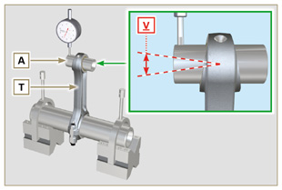  Fig 8.14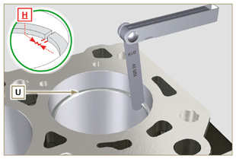  Fig 8.15
8.5.4 Piston dimension check  Clean the piston thoroughly.  Measure the diameter of the piston at 12 mm (quota L ) from the base of the skirt in correspondence with the graphite lubrication windows M .  Refer to Tab. 8.1b to establish the clearance value of the pistons with a decreased diameter.  In correspondence with point W , there are: 3 digits for the STD piston;  3 digits followed by R for a piston with an increased diameter of 0.20 mm; +0.5 for a piston with an increased diameter of 0.50 mm;  +1 for a piston with an increased diameter of 1.00 mm;  If clearance between cylinder and piston is greater than 0,074 mm, the piston and seal rings must be replaced.  Important  - Tab. 8.1b details the dimensional values of new components only.  Tab. 8.1b  PISTON Ø CYLINDERS (± 0.007 mm) Ø PISTON (± 0.007 mm) CLEARANCE VALUE (mm)  STD 88.010 87.950 0.046 + 0.074  +0.20 88.210 88.150  +0.50 88.510 88.450  +1.00 89.010 88.950 | 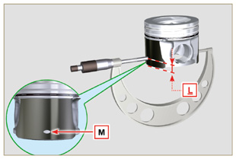  Fig 8.16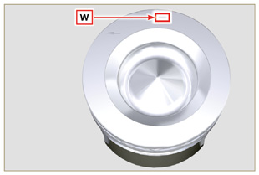  Fig 8.17
Important  - With a feeler gauge, measure the clearance of the seal ring in the respective seat (value L1, L2 e L3 ).  - If the clearance does not comply with the values shown in the Tab. 8.8 , replace the seal rings and the piston.  Tab 8.8  SEAL RINGS CLEARANCE VALUE (mm)  U1 (L1) 0.110 - 0.150  U2 (L2) 0.070 - 0.115  U3 (L3) 0.030 - 0.065 | 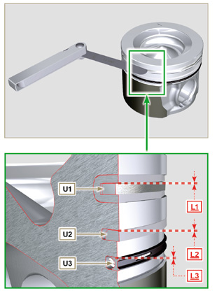  Fig 8.18 e 8.19

Cylinder head
8.6.1 Flatness check  Put the cylinder head on a surface plate and, with a dial gauge, check the flatness of surface C .  The MAX value of allowable irregularity of surface C is 0.10mm.  If the value is not observed, you are required to grind surface C .  The MAX removal allowed is 0.20 mm.  Important  - Grinding is to be performed with sleeves A of the electronic injectors assembled.  - Grinding is prohibited on all engines provided with an EPA name plate (refer to Par. 1.3 ). | 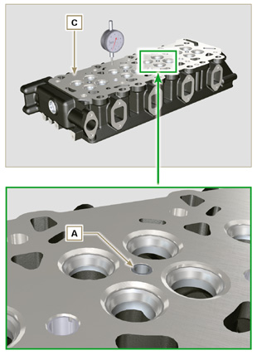  Fig 8.20a - Fig 8.20b
8.6.2 Valve seats check  Measure indentation B of each valve with regard to the cylinder head surface C , which is to be a MIN of 0.60 mm and MAX of 0.85 mm.  The B MAX indentation allowed on worn components is 1.10 mm.  If the measured value does not correspond with the values indicated, replace the worn component.  Important  - The seats must be worked after driving to reach value B , go to a rectification workshop for such operations.  8.6.3 Valve springs  Using a dynamometer, subject the spring to two different forces (in Tab. 8.9) and check that the length of the spring corresponds to the values indicated in the table.  ^{(*1)} The code ED0057551850-S is installed from S/N 4418801760  Tab 8.9  WEIGHT (kg) LENGHT (mm)  ED0057552810-S ED0057551850-S ^{(*1)}  0 0 Z 48.34  13.5 20.4 Z1 30.00  19.5 29.8 Z2 22.00 | 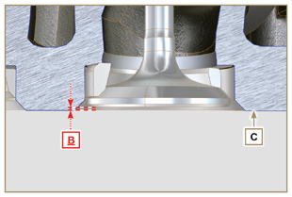  Fig 8.21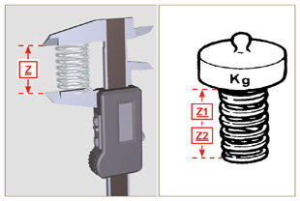  Fig 8.22
8.6.4 Valve guides check  Measure the diameters D and E of the rods and guides valve (Tab. 8.10) .  If the diameters don't correspond to the values indicated, replace the valves or guides.  The MAX allowed value of wear for D and E is 0.10 mm.  Observe values G from surface F when assembling guides H (Tab. 8.10) .  Important  - Carry out the measurements in different points to detect any ovalisation and/or concentrated wear.  - Tab. 8.10 details the dimensional values of new components only.  Tab 8.10 Valve stem - valve guide dimensions  REF. DIMENSIONS (mm) CLEARANCE VALUE (mm)  D 5.978 - 5.990 0.040 - 0.064  E 6.030 - 6.042  G 7.000 - 7.020 | 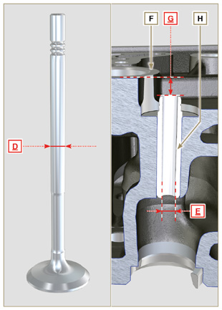  Fig 8.23
8.6.5 Valve guides replacement  The intake and exhaust guides are both made out of grey iron with pearlitic phosphoric matrix and they have the same dimensions.  The guides are press-fit assembled; assembly is possible by cooling the guides with the aid of liquid nitrogen.  Before assembling a new guide, measure value L and M ,calculate the press-fit value, which must observe the values in Tab. 8.11 .  Observe values G from surface F when assembling guides H (Tab. 8.10 - Fig. 8.23) .  Important  - The guides must be worked for value E (Tab. 8.10 - Fig.8.23) after driving. Contact a rectification workshop for such operations.  Tab 8.11 valve guides - housing dimensions  REF. DIMENSIONS (mm) PRESS-FIT VALUE (mm)  L 10.000 - 10.015 0.030 - 0.054  M 10.045 - 10.054 | 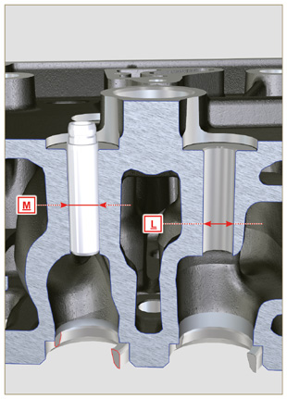  Fig 8.24
8.6.6 Rocker arm check  Measure values W1 in correspondence with holes M located on rocker arm gudgeon L (seen from B in Fig. 8.25 ).  Measure values W2 (Fig. 8.27).  Based on the values measured, calculate the clearance between W1 and W2 , which is to observe the values in Tab. 8.12.  Check that all oil pipes N and M are free from impurities or obstructions.  Tab 8. 12  REF. DIMENSIONS (mm) CLEARANCE VALUE (mm)  W1 19.985 - 20.005 0.035 - 0.076  W2 20.040 - 20.061  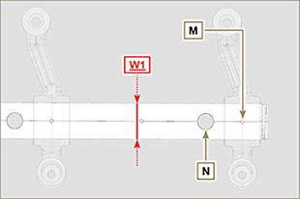  Fig. 8.26 | 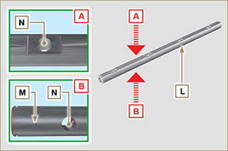  Fig 8.25  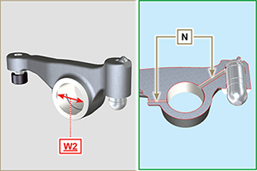  Fig 8.27

Oil pump check
8.7.1 Dimensional and visual check  Perform the operations described in Par.7.8.1 and Par.7.8.4.  Measure clearance value B between the rotor teeth, the value of allowable wear is MAX 0.28 mm.  Clean all the components thoroughly, check that the work surfaces C of the rotors and pump body are not worn.  Important  - Should the results from checks carried out not be in accordance with the conditions described, replace the timing system carter together with the oil pump.  On assembly, references A must be visible. | 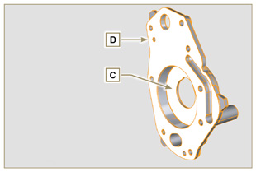  Fig 8.28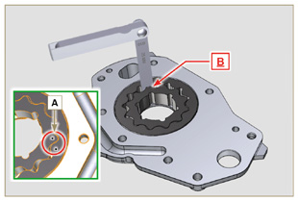  Fig 8.29
8.7.2 R otors clearance check  Important  Replace carter R complete with its oil pump, if there are signs of wear in area P of surface Q (Fig. 8.32 - 8.32a) .  Measure values G and H (Fig. 8.30) .  Measure values L, M and N (Fig. 8.31) .  According to the values measured, calculate the clearance between G and H, L and M and L and N which are to observe the values in Tab. 8. 13 .  For assembly, carry out the operations described from Par. 9.11.3 to Par. 9.11.4 . | 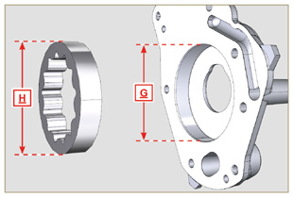  Fig 8.30
Tab 8.13  REF. DIMENSIONS (mm) CLEARANCE VALUE (mm)  G 82.820 - 82.855 0.032 - 0.075  H 82.500 - 82.540  L 15.500 - 15.525 0.036 - 0.086  M 15.464 - 15.489  N | 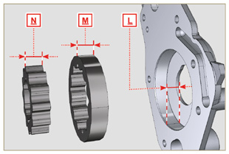  Fig 8.31
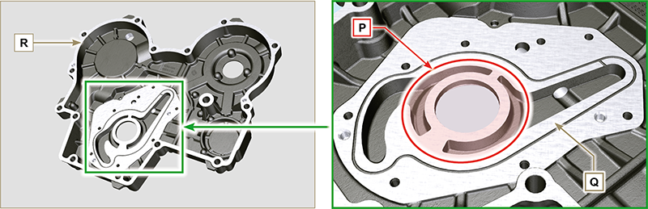
Fig 8.32 - Fig 8.32a
8.7.3 Oil pressure valve check  Measure the free length F of spring D , which must be 47.91 mm .  If the measured value does not correspond to the value indicated, replace spring D .  Tab 8.14  POS DESCRIPTION  B Oil stopper  C Gasket  D Spring  E Piston | 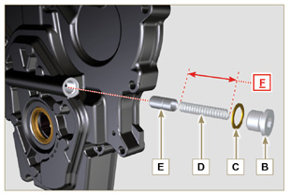  Fig 8.33

Assembly information

Information on engine configuration
- In this chapter, the engine is represented as "BASE CONFIGURATION" (refer to Par 1.4 - Par. 1.5 ).
- For the assembly of components not described in this chapter refer to Chap. 11 .
- The following are the components described in Chap. 11 .

11.1 Oil dipstick in cylinder head
11.2 Heater (replacement)
11.3 Poly-V alternator belt (replacement and adjustment)
11.4 Tightening pulley and alternator for Poly-V belt
11.5 Idler gear (for 3 ^{rd} / 4 ^{th} PTO)
11.6 3 ^{rd} PTO (replacement)
11.7 4 ^{th} PTO (replacement)
11.8 3 ^{rd} + 4 ^{th} PTO (configurations)
11.9 Balancer shafts (replacement)
11.10 Air filter (cartridge replacement)
11.11 Remote oil filter (disassembly and assembly)
11.12 Oil sump with supporting structure
11.13 ETB (REPLACEMENT)
11.14 ACACT (REPLACEMENT)
11.15 EGTS (REPLACEMENT)
11.16 DPF & DOC filter (REPLACEMENT)
11.17 Oil dipstick on timing gear side

Assembly recommendations
- The information is laid out in sequence, the intervention methods have been selected, tested and approved by the manufacturer's technicians.
- This chapter describes the installation procedures for the assemblies and/ or individual components which have already been checked, overhauled or possibly replaced with original spare parts.
- Where necessary, reference to special tools during assembly operations is indicated and identified in Tab. 13.1 , Tab. 13.2 and Tab. 13.3 hereinafter in Tab. 9.1 an example of a special tool ( ST_05 ).

Tab. 9.1
SPECIAL TOOLS
"ST" Code | Picture /draw | DESCRIPTION | PART NUMBER
ST_05 | 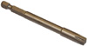 | Six nicks Key SN 8 | ED0014603650-S

Important

- Before proceeding with operations, read Par. 3.3.2 .
- To easily locate specific topics, the reader should refer to the analytical index or chapter index .
- The operator must check that:
  - the components, the assemblies, the coupling surfaces of the parts are washed, clean and thoroughly dried;
  - the coupling surfaces are undamaged;
  - the equipment and tools are ready so that all work can be carried out correctly and safely;
  - ensure that the working environment is safe.
- The operator must:
  - carry out the procedures smoothly and safely. It is thus recommended to install the engine on a special rotating stand used when servicing engines to ensure the safety of the operator and the other individuals involved;
  - tighten the assemblies and / or components in a criss-cross or alternating pattern, initially with a value lower than that preset, and then subsequently, with the tightening torque specified in the procedure;
  - replace all seal gaskets after each assembly for all components on which they are provided.

Engine block assembly
9.3.1 Crankshaft bushings  Important  - Execute the procedure in Par. 8.2.1 and 8.2.2 , before proceeding with assembly..  - The crankshaft half-bearings are made of special material. Therefore, they must be replaced every time they are assembled to prevent seizures.  - Fit the new half-bearings B onto the crankcase upper half E adhering to the reference notches C .  Important  - After the half-bearings are fitted, check that the lubrication holes D correspond with the crankcase grooves E .  - The lower and upper half bearings CANNOT be singularly replaced, and both halves must be replaced together.  - Fit the new half-bearings S onto the lower crankcase F using the reference notches C .  - Lubricate the half-bearings A and B with oil. | 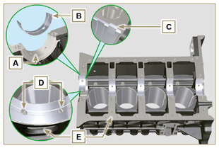  Fig 9.1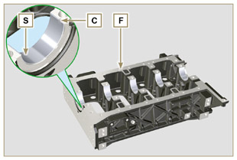  Fig 9.2
9.3.2 Tappets  - Lubricate the tappets G with oil.  - Insert the tappets G into the housings H of the upper crankcase. | 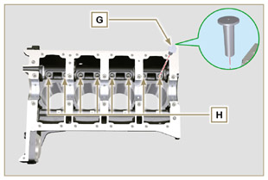  Fig 9.3
9.3.3 Camshaft  - Check that the bushing Q is correctly fitted.  - Lubricate the pins L , the cams M of the camshaft N , all the housing P and the bushing Q with oil.  - Insert the camshaft N all the way into its housing P .  - Fit the lock ring R on to the crankcase E to hold the position of the camshaft N .  - Manually rotate the camshaft N ensuring that it is free. | 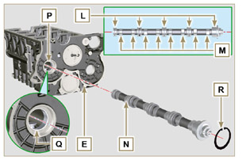  Fig 9.4
9.3.4 Oil spray nozzles  - Insert the sprayers V onto the upper crankcase E manually screwing the screw fittings U .  - Direct the sprayers V as shown Z and tighten the connecting screws U (tightening torque of 10 Nm ). | 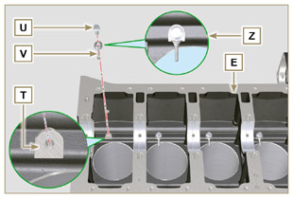  Fig 9.5
9.3.5 Crankshaft  Important  - Carry out the checks described in Par. 8.4.1 and Par. 8.4.2 .  - Check that the crankshaft half-bearings are mounted correctly on the upper crankcase E .  - Lubricate the main journal and crankpin J , with oil.  - Insert the crankshaft W into its seat on the upper crankcase E .  - Insert the 2 shoulder half-rings K , between the crankshaft W and the upper crankcase E ( AB detail). | 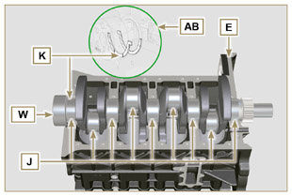  Fig 9.6
9.3.6 Lower crankcase  - Check that the crankshaft half-bearings are mounted correctly on the lower crankcase F ( AC detail).  - Assemble the 2 shoulder half-rings AD onto the lower crankcase F applying two drops of grease to keep them in their seat.  - Check that the coupling surfaces AE are free from dirt and grit. | 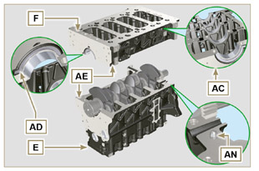  Fig 9.7
- Spread a bead of Loctite 5660 (rif. AL) of approx 1 mm thickness on the surface AM of the upper crankshaft half C being careful not to block the oil feed grooves AG and the return oil sump AH .  - Join the two crankshaft halves E and F observing the guide pins AN . | 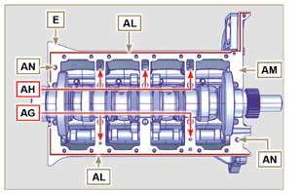  Fig 9.8
Important  - Failure to adhere to the bolt fixing procedures may compromise the functionality of the engine, and may also cause damage to persons and property.  - Tighten the fastening screws strictly following the sequence and the tightening torque indicated.  Tightening sequence for 3 cylinders  Tightening Screws Torx M12x1.25 (from the n° 1 to the n° 8 ):  CYCLE 1 - with a torque of 40 Nm ;  CYCLE 2 - with a torque of 70 Nm ;  CYCLE 3 - with a torque of 120 Nm .  Tightening Screws M8x1.25 (from the n° 9 to the n° 21 ):  CYCLE 4 - with a torque of 20Nm ;  CYCLE 5 - with a torque of 35 Nm ;  - Perform the operations described in Par. 8.4.2 .  - Check that crankshaft W rotates smoothly.  NOTE: In the next illustrations of Par. 9.1 the coupled crankcase half will be indicated with the letter E . | 3 Cylinders  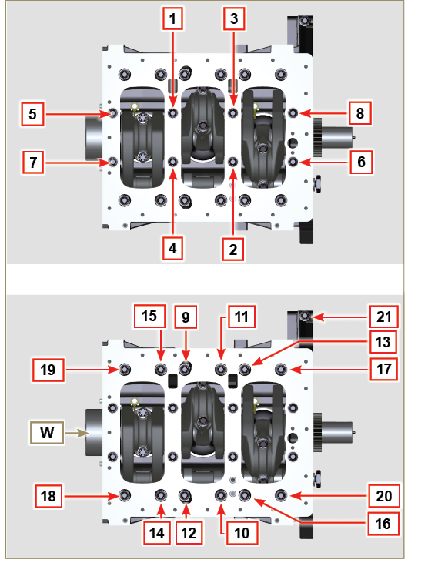  Fig 9.9
- Tightening sequence for 3 cylinders  Tightening Screws Torx M12x1,25 (from the n° 1 to the n° 10 ):  CYCLE 1 - with a torque of 40 Nm ;  CYCLE 2 - with a torque of 70 Nm ;  CYCLE 3 - with a torque of 120 Nm .  Tightening Screws M8x1.25 (from the n° 11 to the n° 27 ):  CYCLE 4 - with a torque of 20Nm ;  CYCLE 5 - with a torque of 35 Nm ;  - Perform the operations described in Par. 8.4.2 .  - Check that crankshaft W rotates smoothly. | 4 Cylinders  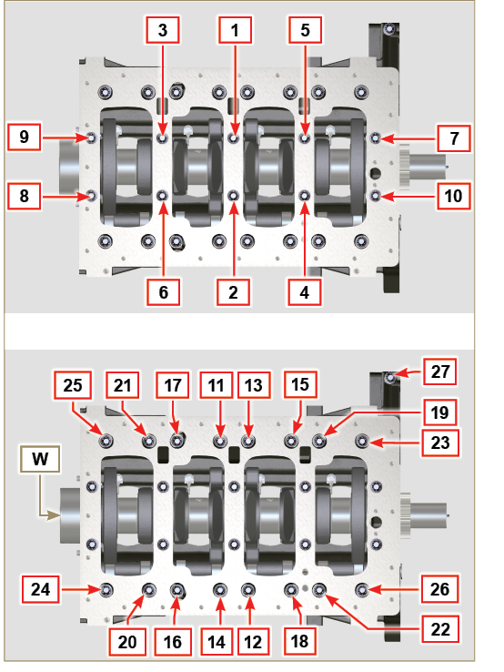  Fig 9.10
9.3.7 Piston rings  - Perform the operations described in Par. 8.5.3 .  - Put the scraper ring AP onto the piston AQ .  - Put the 2° seal ring AR on the piston AQ .  - Put the 1° seal ring AS onto the piston AQ . | 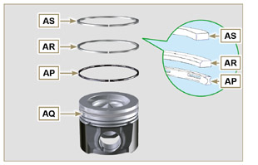  Fig 9.11
- Perform the operations described in Par. 8.5.4 .  - Position the segment openings with a 120° angle between them ( Y ).  NOTE: do not use the segment opening with the pin hole ( N )  - Lubricate the piston skirt and piston rings with oil. | 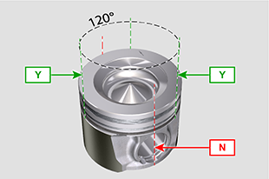  Fig 9.12
9.3.8 Piston  Important  - Before proceeding to the assembly of the piston and connecting rod, carry out the checks described in Par. 8.5.1 .  - Always replace the bearings CE after each assembly.  - Mate components respecting references at Par. 7.15.5 .  - Loosen the screws AU and remove the connecting rod cap AV .  - Fit the new bearings CE .  - Insert the connecting rod AZ into the piston AQ and align the seats BA .  - Insert the gudgeon pin BB into the seat BA for the assembly of the connecting rod and piston unit.  - Insert the lock rings BD inside the seat BE of the piston AQ to lock the gudgeon pin BB . | 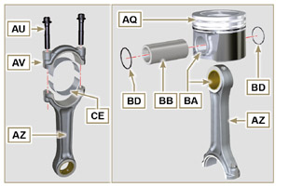  Fig 9.13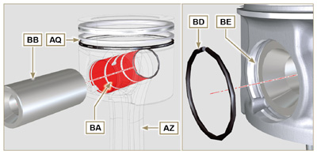  Fig 9.14 - Fig 9.15

9.3.9 Piston and connecting rod assembly  Important  - Before assembling the piston and connecting rod assemblies, execute the controls described in Par. 8.5.5 .  - Rotate the crankshaft W by moving the crankpin BG to a TDC position of the affected cylinder. | 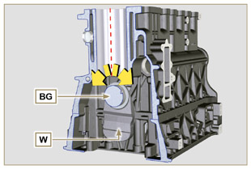  Fig 9.16
- Lubricate the piston skirt and rings AQ .  - Check that the half-bearing AS is mounted correctly and lubricate it thoroughly.  - Using the piston ring compression pliers, insert the piston inside the cylinder BQ by around 10mm (height BM ).  Important  - Make sure you are at the stage described in Point 1 .  - The piston AQ must be mounted with the arrow BN (stamped on the piston crown) facing the timing system side.  - Rotate the piston AQ by 10° counter-clockwise with respect to its correct assembly position ( Fig. 9.18 - height BP ).  NOTE: Doing this prevents the impact between the connecting rod AZ and the sprayer V . | 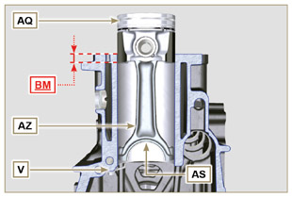  Fig 9.17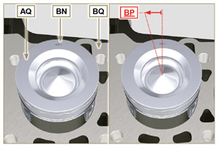  Fig 9.18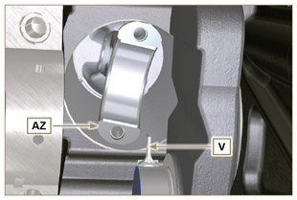  Fig 9.19
Important  - Leave the ring compressor assembled on the piston  - Push piston AQ downwards without introducing the segments in the cylinder, rotate piston AQ by 10° in a clockwise direction (value BR  – correct assembly position). | 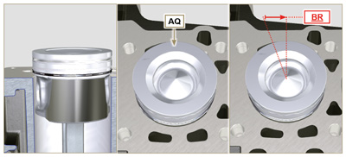  Fig 9.20

- Push the piston AQ downwards by centering the crankpin BG with the connecting rod AZ .  - Turn the crankcase on support to assemble the con rod capp on cylinder 1 and 4.  - Check that the half-bearing AS is mounted correctly on the connecting rod cap AV .  Important  - Check that the break levels of connecting rod cap AV coincide perfectly onto connecting rod AZ before screwing on and tightening capscrews AU.  - Couple the connecting rod cap AV to the connecting rod AZ using the marks made at disassembly ( Par. 7.15.2 and 7.15.5 ).  - Screw in the screws AU .  - Repeat the operations from 1 to 10 for each cylinder.  Important  - Failure to adhere to the assembly procedures may compromise the functionality of the engine, and also cause damage to persons and property.  - Tighten the screws AU , alternately, strictly following the tightening torques indicated.  Tightening sequence of screws Torx M10x1 :  1° CYCLE - with a torque of 40 Nm;  2° CYCLE - with a torque of 85 Nm ;  - Check that the connecting rods have axial play and the crankshaft W rotates smoothly.  NOTE: After the check carried out at point 14 , position the shaft W with the first cylinder to TDC. | 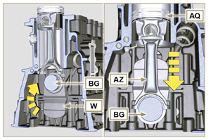  Fig 9.21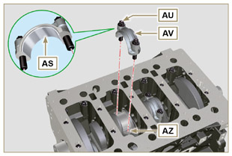  Fig 9.22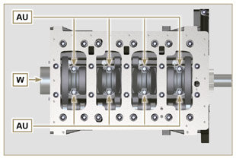  Fig 9.23
NOTE: Click by side to play the procedure. | https://www.youtube.com/embed/Ba8qqxTx6wA?rel=0
9.3.10 Crankshaft gasket flange  Important  - Check that the contact surface between the flange and the crankcase is free of grit and dirt.  - Always replace the gasket BS at each assembly.  - Check that there are bushings BT on the crankcase E .  - Lubricate the oil seal lip BU .  - Position the gasket BS and flange BV on the crankcase E in correspondence with the bushings BT .  - Put Loctite 243 on the 2 screws BW matching the bushings BT .  - Screw the fastening screws all the way in BW without tightening them.  - Tighten all the screws BW strictly following the tightening sequence indicated (tightening torque to 10 Nm ). | 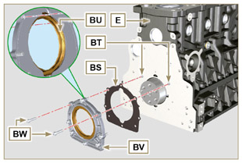  Fig 9.24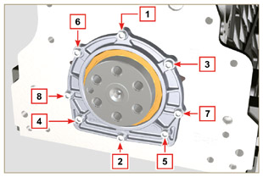  Fig 9.25
9.3.11 Cover 3 ^{rd} PTO  Important  - Replace capscrews CA with each assembly or alternatively apply Loctite 2701 on the thread.  - Secure the cover CB with the screws CA and CC inserting the gasket CD (tightening torque 25 Nm ). | 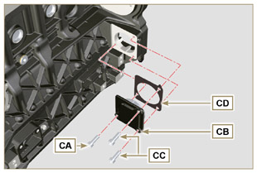  Fig 9.26

Oil sump unit assembly
9.4.1 Oil vapour pipes  - Apply Loctite 648 on the pipe threads A .  - Screw and tighten the pipes A (tightening torque of 15 Nm ). | 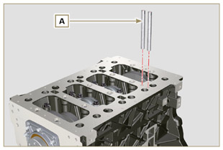  Fig 9.27
9.4.2 Oil suction pipe  Important  - It is mandatory to replace the gasket B after each assembly.  - Always replace capscrews D with new ones or alternatively apply Loctite 2701 .  - Insert the new gasket B in the seat of the oil suction hose flange D .  - Secure the hose C on the crankcase E with the screws D (tightening torque 10 Nm ). | 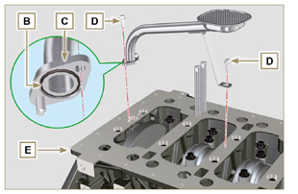  Fig 9.28
9.4.3 Oil Sump  - Ensure that the contact surfaces F of the oil sump G and the crankcase E are completely clean.  - Apply a bead of approx. 2.5 mm of sealant (Loctite 5660) on the surface F of the oil sump G . | 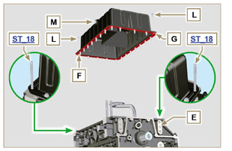  Fig 9.29
Important  - Tighten the screws L , strictly following the sequence and tightening torque indicated.  - Tighten the screws L following the sequence indicated (tightening torque 25 Nm ).  - After tightening all of the screws, loosen screw n°1 and retighten it to the torque value specified in step 4 .  - Check that the oil drain plugs M are tight (tightening torque 35 Nm ). | 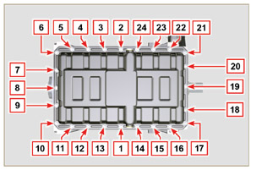  Fig 9.30

Flange unit assembly
9.5.1 Bell housing  Danger  - Bell A is very heavy; pay special attention during assembly operations to avoid dropping and causing serious risks to the operator.  - Install the bell housing A in accordance with the reference pins B on the base C . | 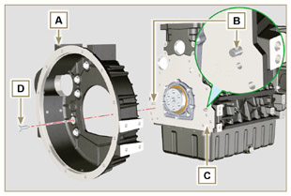  Fig 9.31
Important  - Failure to adhere to the assembly procedures may compromise the functionality of the engine, and also cause damage to persons and property.  - Tighten the fastening screws strictly following the tightening sequence indicated (tightening torque 50 Nm ). | 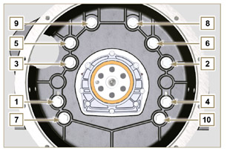  Fig 9.32
9.5.2 Flywheel  Danger  - Flywheel F is very heavy; pay special attention during assembly operations to avoid dropping and causing serious risks to the operator.  - Screw the special tool ST_09 on the crankshaft E instead of the screws G positioned higherup ( Fig. 9.33 ).  - Insert the flywheel F on the crankshaft E using the tool as a guide ST_09 and manually tighten all the screws G , remove the tool ST_09 and install the last screw G.  - Mount the tool ST_34 in the seat of the starter motor H and fit it with the two starter motor fixing screws.  - Tighten the screws G (tightening torque at 140 Nm ). | 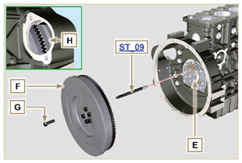  Fig 9.33

Timing system gear assembly and injection pump
9.6.1 Timing system gear assembly  - Check that the key A is correctly fitted on the camshaft B .  - Position the gear C on the camshaft B adhering to the key reference A .  - Screw capscrew D until the end.  - Insert the reference pin E on the gear C .  - Screw the encoder F with the screws G on the gear C observing the plug E .  - Tighten the middle gear pin H , in the housing J of the crankcase, with the screws K (tightening torque 25 Nm ).  Important  - The fitting of the middle gear pin H has only one position, the 4 screw holes K are not equally spaced.  - Always replace the gasket L after each assembly.  - Insert the shoulder ring M .  - Check the integrity of the bushing N on the middle gear P , and ensure that it is free from impurities.  - Thoroughly lubricate the pin H and the bushing N .  - Position the gear P on the pin H observing all the marks W of the gears C and S , (Fig. 9.37).  Important  - Failure to comply with the marks W on the gears C, P and S , causes engine malfunction and serious damage.  - Insert the shoulder ring Q and the lock ring R .  - Tighten the gear C with the screw D ( Fig. 9.34 - tightening torque at 100 Nm ).  - Tighten the screws G on the gear C (tightening torque at 5 Nm ). | 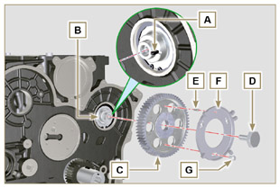  Fig 9.34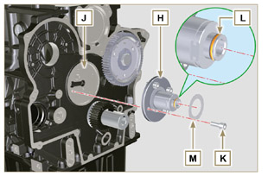  Fig 9.35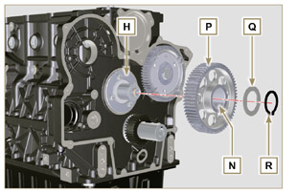  Fig 9.36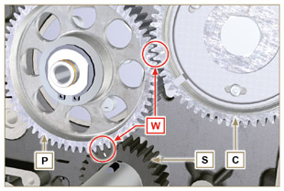  Fig 9.37
9.6.2 High-pressure injection pump  - Check that the surface V is free from impurities ( Fig. 9.38 ).  Important  - Always replace gasket U with every assembly.  - The seal gasket U can only be fitted in one direction( Fig. 9.38 ).  - Always replace capscrews T with new ones or alternatively apply Loctite 2701 (Fig. 9.38) .  - Fit the new gasket U on the injection pump Z (Fig. 9.38) .  - Fix the pump Z into the housing V together with the gasket U by the screws T ( Fig. 9. 38 - tightening torque at 25 Nm ).  - Check the correct fitting of the key AA on the shaft AB of the injection pump ( Fig. 9.39 ).  - Place the gear AC on the shaft AB of the pump respecting the reference to the key AA and the reference Q of the gear A E (Fig. 9.39) .  Serrare il dado AD (coppia di serraggio a 65 Nm ).  - Remove special tool ST_34 ). | 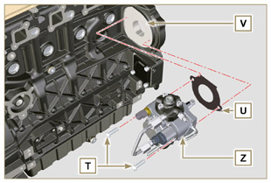  Fig 9.38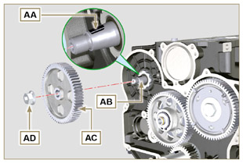  Fig 9.39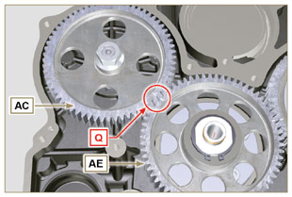  Fig 9.40

Cylinder head unit assembly
9.7.1 Valve stem gasket  Important  - Carry out the checks described in Par. 8.6.4 before proceeding with the following operations.  - Lubricate the oil seals A on the inside.  - Fit the oil seals A on the valve guides B using the tool ST_08 . | 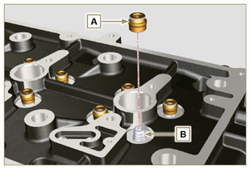  Fig 9.41
9.7.2 Electronic injector sleeves ( )  - Insert the seals C in the seats of the sleeve D .  - Insert the seal E with the convex side facing upward at the base of the sleeve D .  - Lubricate the gaskets C .  - Insert and carefully screw the sleeve D into the seat of the head F .  NOTE: The sleeve D must not protrude above the surface of the head BF .  - Clamp the sleeve D (tightening torque at 30 Nm ). | 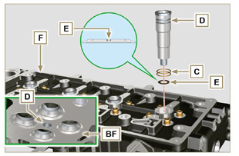  Fig 9.42
9.7.3 Electronic injectors projection  - Insert the electronic injector G inside the sleeve H .  - Mount the rocker arm pin fixing screw L up to the stop.  - Mount the electronic injector fixing bracket M and secure it with the screw N , without performing the calibration.  - Check using ST_03 tool (Fig. 9.44) , the projection of the injector, which must range between 1.68 ÷ 2.42 mm.  NOTE : if the value detected does not correspond, replace gasket Q with a different thickness. | 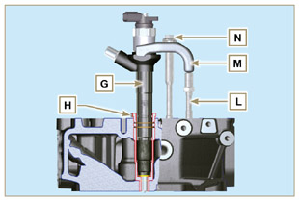  Fig 9.43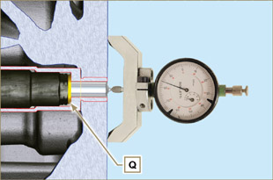  Fig 9.44
9.7.4 Valves  - Pre-lubricate and insert the valves X into the head F taking care to fit them in the original positions as per the reference marks made in Par. 7.13.4.1 .  - Position the spring Y on the seat of the head F .  - Position the disk S on the spring Y centering the valve X .  - Mount the tool ST_07 on the head F fixing it on one of the holes for securing the rocker arm cover.  NOTE: Change the fixing hole according to the position of the valves to be fitted.  - Position the tool ST_07 on the valve as shown in the figure.  - Push the lever of the tool ST_07 downwards, in order to lower the valve disks S in the direction of the arrow AK , and insert the valve cotters AJ inside the disk S .  - Check that the valve cotters AJ are properly mounted on the valve seats X and release the tool ST_07 .  NOTE: repeat all the steps for the relevant valves and remove the tool ST_07 . | 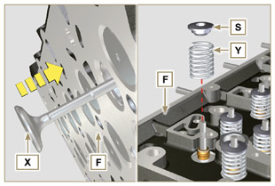  Fig 9.45
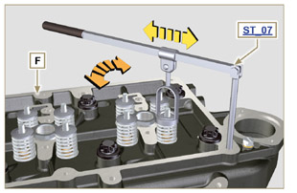
Fig 9.46
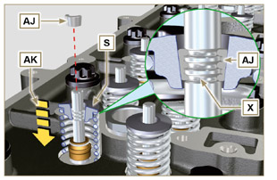
Fig 9.47
9.7.5 Cylinder head  - Fix the eyebolts AW with the screws AX onto the head F (tightening torque of 25 Nm ).  - Position the piston P at the TDC.  - Position the tool ST_03 on the crankcase surface of the head and measure the piston protrusion P from head level K in 4 diametrically opposed points R. Repeat the operation for all pistons P and take note of the highest average value, determining valu e S (Tab. 9.2) .  Tab. 9.2  S (mm) Hole number  0.030 - 0.126 1  0.127 - 0.250 2  0.251 - 0.375 3  - Based on the value detected at point 3 , select the relevant gasket T as shown in the Tab. 9.2 (Fig. 9.50 detail U ).  - Check that the crankcase surface K and the gasket T are completely free of dirt and grit.  Important  - The head gasket must be replaced for each assembly.  - Position the gasket T on the surface K with reference to the centering bushings J . | 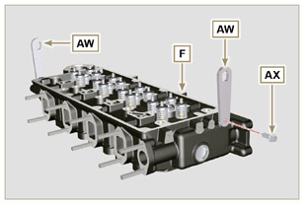  Fig 9.48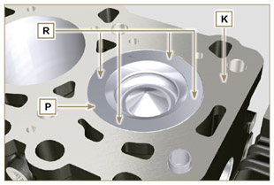  Fig 9.49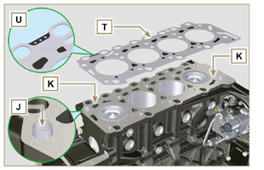  Fig 9.50
- Check that the surface head W is free from impurities.  - Position the head F on the crankcase Z with reference to the centering bushings J .  Important  - The fastening bolts V must be replaced every time they are assembled.  - Secure the head F by tightening the screws V strictly following the sequence indicated in the Fig. 9.52 or Fig. 9.53 and the tightening torque indicated in the Tab. 9.3 . | 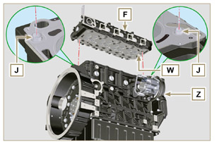  Fig 9.51
Important  - Failure to adhere to the bolt fixing procedures may compromise the functionality of the engine, and also may cause damage to persons and property.  - Tighten capscrews V observing the cycles, tightening, and subsequent rotation as indicated in Tab. 9.3 .  - For engine KDI 1903 TCR : 8 screws Torx M12x1,25 (Fig. 9.52) .  - For engine KDI 2504 TCR : 10 screws Torx M12x1,25 (Fig. 9.53) . | 3 CYLINDERS  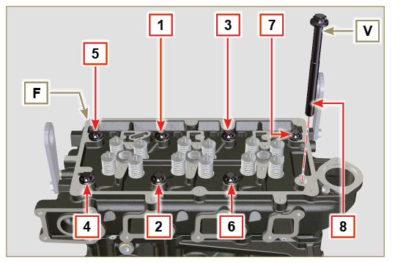  Fig 9.52
Tab. 9.3  CYCLE TORQUE  1 40 Nm  2 70 Nm  3 100 Nm  4 90°  5 90°  6 90° | 4 CYLINDERS  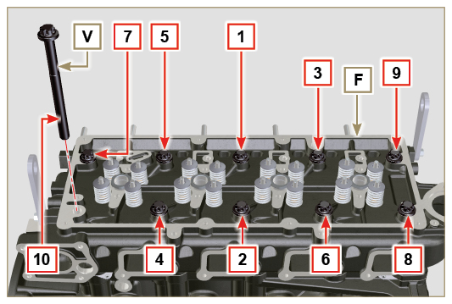  Fig 9.53
9.7.6 Rods and valve bridges  - Insert the rocker control rods AA into the niches of the head F .  Important  - Properly centre the rods AA into the spherical housing of the camshaft tappets AB .  - Mount the valve bridge AC on to the pairs of discharge and suction valves. | 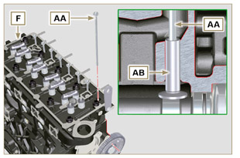  Fig 9.54
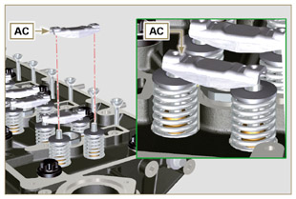
Fig 9.55
9.7.7 Rocker arms  Important  - To correctly position the rocker arms, turn the rocker arm pin AH with the lower height AL towards the timing system side as in Fig.9.57 .  - The discharge rocker arm AT is shorter than the suction arm AR .  - Fit the lock ring AM into the seat AN of the rocker arm pin AH .  - Position the pin AH with the screw support surface AP facing upwards and insert the 2 shoulder rings AQ .  - Insert in sequence the suction rocker arm AR , the holder AS and the discharge rocker arm AT in the pin AH .  - Insert the spring AU in the pin AH .  - Repeat points 3, 4 for all the rocker arms.  NOTE: The holder AV must be fitted with the last pair of rocker arms towards the flywheel.  - Insert 2 shoulder rings AQ and the lock ring AN to lock all the components inserted in the pin AH .  NOTE : The spring AU ensures that the supports AS and AV are kept in place. | 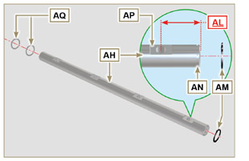  Fig 9.57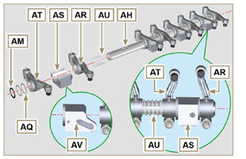  Fig 9.58
9.7.8 Rocker arm pin assembly  Important  - Position the rocker arm pin assembly BB on a level to align all the support surfaces.  - Check that the pistons are positioned half way between the TDC and BDC. Rotate the crankshaft 90° counterclockwise with regard to the 1st cylinder TDC, positioning the crankshaft pin BP as shown in Fig 9.60a . If the crankshaft pulley and the timing gear cover have not been removed, rotate the  crankshaft positioning the reference BQ located on the target wheel in correspondence of the speed sensor, as shown in Fig. 9.60b .  - If the engine is painted or protected with clear paint, replace the fastening screws BE .  - Position the rocker arm pin assembly BB on the head F , respecting the plug BC on the head using the holder indicated AV .  - Check the correct positioning of all the rocker arms and the u-bolt control valves (detail BD ). House the tappet in the seat of the rocker arms control rod.  - Secure the rocker arm pin BB tightening the screws BE (tightening torque to 25 Nm ). Adhere to the screw tightening sequence BE as shown in Fig. 9.60 . | 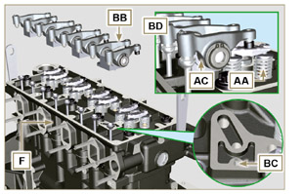  Fig 9.59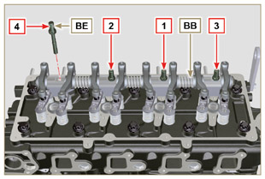  Fig 9.60
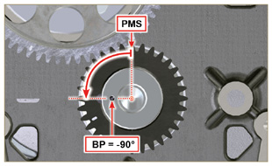  Fig 9.60a | 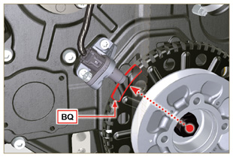  Fig 9.60b
9.7.9 Assembly Rocker arm cover  Important  - Replace gasket BF, BL and BM with each assembly ( ST_11 - ST_12 ) .  - Observe the order of tightening illustrated in Fig. 9.62 - 9.63 .  - Position tool ST_17 onto the head in correspondence with the two fastening holes 5 and 6 .  - Position gasket BF on cylinder head F using tool ST_17 as a guide.  - With vaseline lubricate the gaskets BL in the upper part, and the gaskets BM in the lower part.  - Attach the rocker arm cover BN on the head F with the screw BG (tightening torque to 10 Nm ). | 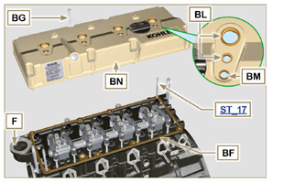  Fig 9.61
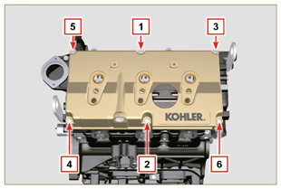  Fig 9.62 | 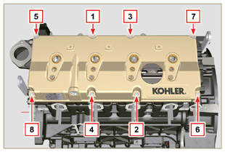  Fig 9.63

Fuel system assembly
Important  - Do NOT mount new or different injectors without the required tool ( Chap. 13 ).  - Remove the protective caps from all the components of the fuel circuit just before assembly just before assembly.  9.8.1 Fuel filter  - Secure the fuel filter holder R with the screws S on the crankcase T (tightening torque of 25 Nm ).  NOTE: For the assembly of the fuel cartridge, refer to operations 4 and 5 of Par. 6.11.2 . | 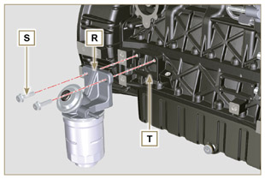  Fig 9.64
- Insert the tube K on the fitting coming out of the filter holder R and on the fuel inlet fitting of the injection pump M and secure it with the clamps N . | 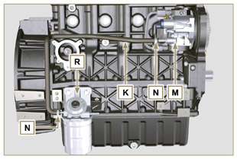  Fig 9.65
9.8.2 Common Rail  - Secure the rail AA on the head AB with the screws AC (tightening torque at 25 Nm ). | 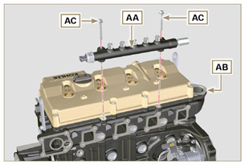  Fig 9.66
- Fit the gaskets AD and the fitting AE on the screw AF .  - Tighten the parts so assembled on the Common Rail AG (tightening torque at 15 Nm ) with the entrance of union AE facing upward. | 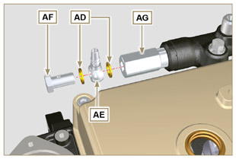  Fig 9.67
9.8.3 Electronic injectors  Important  - Always replace and lubricate the gaskets AH and AL of the electronic injectors AM with fuel, every time they are assembled.  - Pay attention when repositioning the electronic injectors, using the marks as described inl Par. 7.10.5 .  - If a new (or different) electronic injector is fitted on the engine, you are required to prepare tool ST_01 .  - If the engine is painted or protected with clear paint, clean the paint off the diesel injector AM near to the part in contact with the gasket ( BL > Fig. 9.61 ) .  - Insert the gasket AL inside the injector sleeve BQ .  - Insert the electronic injectors AM inside the rocker arm cover AN and orientate them as per Fig. 9.68 . | 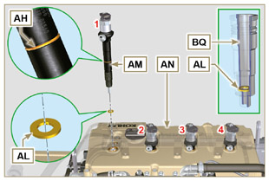  Fig 9.68
9.8.4 High pressure fuel pipes  Important  - Always replace the pipes AQ and tube E after each assembly.  - Position the pipes AQ on the Common Rail AA and on the electronic injectors AM , adjust the position of electronic injectors AM via the fitting inlets with the pipes AQ.  Important  - Tighten the nuts AS and AT manually, without clamping them.  - If the engine is painted or protected with clear paint, replace the fastening screws AU to ensure the gaskets BQ are sealed properly.  - Position the injector fastening brackets AV and the screws AU , inserting the washer AJ .  Important  - Replace the pipes AQ (Fig. 9.69) if the screws AU do not rotate freely.  - Tighten all the nuts AS (tightening torque at 30 Nm ).  - Tighten the nuts AT (tightening torque at 25 Nm ).  - Make sure that the mounting brackets AV are positioned correctly on electroinjectors BR and on fixing screws of the rocker arm assembly AM.  - Tighten the fixing screws of the injector mounting bracket (tightening torque of 20 Nm ).  - Position the pipe E screwing the screws BA and BB .  Important  - Screw the nuts BA and BB manually without tightening them.  - Tighten the nut BA (tightening torque of 30 Nm ).  - Tighten the nut BB (tightening torque of 25 Nm ).  - Tighten the Common Rail fastening screws BC (tightening torque of 25 Nm ). | 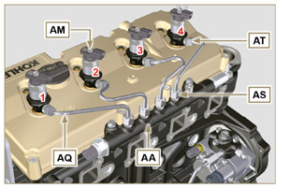  Fig 9.69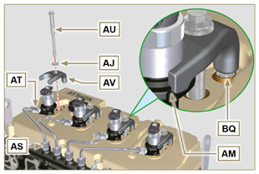  Fig 9.70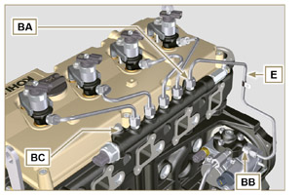  Fig 9.71
9.8.5 Fuel return pipes  - Check the gaskets BD on the fittings BG .  NOTE: Do not disconnect the pipes from the distributor. | 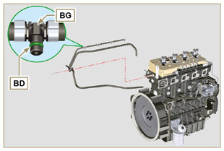  Fig 9.72
- Position the return pipes and fitting the distributor BE with the screw BC on the head BF ( Fig. 9.72 - tightening torque of 10 Nm ).  - Mount the fittings BG ( Fig. 9.74 ) on the injectors AM and lock them with the clips BH .  - Insert the pipe BL on the fitting BN .  - Insert the pipe BM on the fitting BP . | 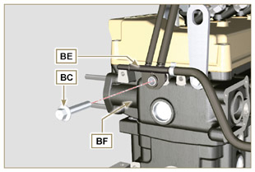  Fig 9.73
Important  - Pipes of a "BASE CONFIGURATION" (refer to Par. 1.5 ) engine are shown. Other return pipes can be missing or different.  - The pipes can vary in quantity, size and dimensions depending on the engine version. | 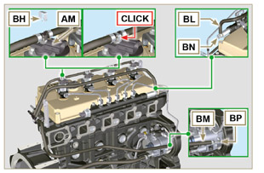  Fig 9.74

Intake manifold assembly
9.9.1 Semi-collettor external  Important  - Check that the contact surfaces between the semi-collector C and the head D are free from impurities.  - Insert the special tool ST_18 into indicated point.  - Insert the screws A and the gasket B on the semi-collector C .  - Secure the semi-collector C with the screws A on the head D (tightening torque of 25 Nm ).  - Tighten the clamp E with the screw F on the semi-collector C (tightening torque of 10 Nm - ST_06 ).  - Tighten the screw G and the holder H on the semi-collector C (tightening torque of 10 Nm - ST_06 ). | 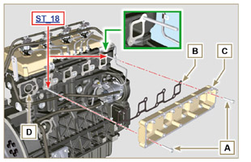  Fig 9.75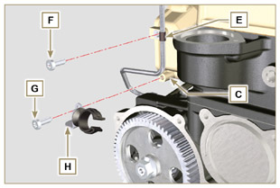  Fig 9.76
9.9.2 External half-manifold  Important  - Check that the contact surfaces between the two semi collectors C and M are free from impurities.  - Fit the screws L on the semi-collector M freeing the holes Q indicated in Fig. 9.78 .  - Mount the gaskets N on the semi-collector by interposing the separation sheet P .  - Fit the semi-collector M on the semi-collector C with the screws L (tightening torque of 22 Nm - ST_05 ). | 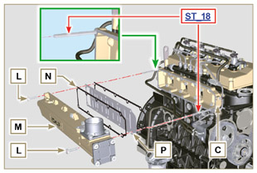  Fig 9.77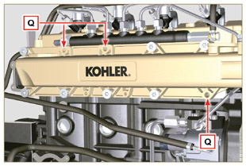  Fig 9.78

Exhaust manifold assembly
Important  - Replace the self-locking nuts B and the metal gaskets D between the manifold and the cylinder head every time they are disassembled.  - In the event of mounting the studs C , fix ( 25 Nm tightening torque) with Loctite 2701 on the thread.  - Check that the contact surfaces F are free from impurities.  - Insert the gaskets D and E on the studs C .  - Position the manifold A on the studs C .  - Fix the manifold A on the cylinder head by tightening the self-locking nuts B (tightening torque of 25 Nm ). | 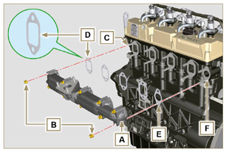  Fig 9.79

Assembly lubrication circuit
9.11.1 Assembly oil mist separator unit  Important  - Always replace the gasket B after each assembly.  - Always carefully inspect the condition of the pipes, and replace them if there is any doubt regarding the integrity of their seal.  - Check that the contact surfaces A are free from impurities.  - Mount the gasket B on the holder C .  - Fix the separator body holder C on the crankcase E with the screws D (tightening torque of 12 Nm ) fitting the gasket B . | 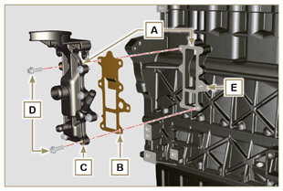  Fig 9.80
- Fit the pipes F and G on the holder C .  - Insert the bleeder H attaching it to the pipes F and G. Secure the pipe F with the clamps J .  - Secure the bleeder H onto the holder C with the clamp K . | 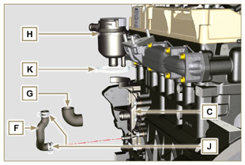  Fig 9.81
9. 11 .2 Oil Cooler and oil filter Unit Assembly  - Check that the surface L on the holder V and on the crankcase E are free from impurities.  - Lubricate and insert the gasket N on the fitting P .  Important  - Always replace the gaskets Q and S every time they are disassembled.  - Lubricate and insert the gaskets Q and S respectively in the seats R and T of the holder V .  - Secure the holder V with the screws AA and AB (tightening torque of 10 Nm ).  Important  - In the event of mounting the fitting P on the crankcase E (tightening torque of 15 Nm with Loctite 2701 on the thread). | 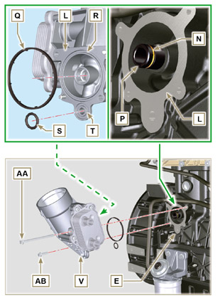  Fig 9.83 e Fig 9.83
NOTE: To assemble the oil cartridge refer to operations 5 and 6 of Par. 6.10.2 .  Important  - Always replace the gaskets BM and BN every time they are assembled.  - Insert and tighten the cartridge-holder cover AC on the filter holder V (tightening torque of 25 Nm ). | 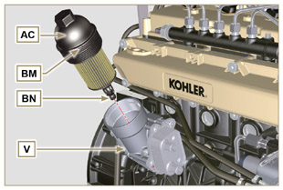  Fig 9.84
9. 11 .3 Oil pump  NOTE: Carry out the checks described in Par. 8.7 before proceeding with the following operations.  - Check that all contact surfaces between AL, AH, AF, AG and AN are free of impurities – scratches - dents.  - When assembling, do not use any type of gasket between AG and AN .  - Thoroughly lubricate the seat of the rotors AF on the oil pump crankcase AG and the two rotors AH and AL .  - Insert, inside the seat AF , the 2 rotors (in sequence) AH and AL , respecting the reference BP as the picture (or refer to Par. 2.10.2 ).  - Check that the 2 pins AM are inserted properly in the crankcase timing system AN .  - Position the oil pump assembly AG using the pin marks AM.  - Fasten the oil pump cover AG with the screws AH (tightening torque 10 Nm ). | 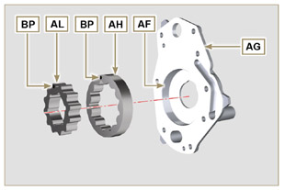  Fig 9.85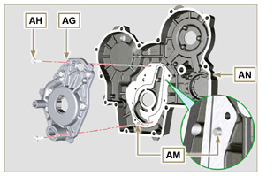  Fig 9.86
9. 11 .4 Timing system carter  Important  - Always replace the the gasket AP after each assembly ( ST_14 ).  - Always replace the gasket AU after each assembly.  - Distribute a bead of Loctite 5188 , of about 1mm thickness, on the surfaces AQ of the crankcase AN.  - Make sure that the key AS (Fig. 9.88) is inserted properly on the crankshaft and that it is facing upwards.  - Lubricate and insert the gasket AU in the seat of oil pump AV .  - Apply the tool ST_10 onto the crankshaft.  - Check that the 2 pins AT ( Fig. 9.88 ) are properly insertedin the timing system crankcase AN .  - Lubricate oil seal AP with oil and position the carter AN on the crankcase E , using the pins AT , inserting the oil pump AV on the crankshaft.  - Fasten capscrews AW observing the indicated clamping sequence (tightening torque of 25 Nm ). | 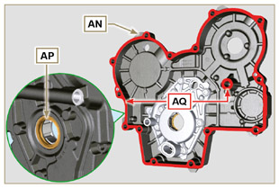  Fig 9.87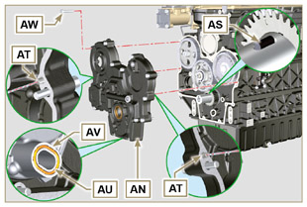  Fig 9.88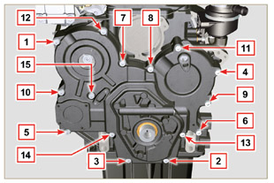  Fig 9.89
9. 11 .5 Crankcase oil filler flange Timing System  Important  - Always replace the gasket BA after each assembly.  - Position the gasket BA in the seat on the flange BB .  - Fasten the flange BB on the crankcase BC with the screws BD (tightening torque of 10 Nm - ST_06 ). | 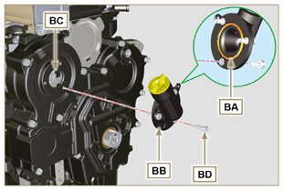  Fig 9.90
9. 11 .6 Oil pressure relief valve  - Lubricate the piston BE and fully insert it in the seat BF .  - Insert the spring BG in the piston.  Important  - Always replace the gasket BH after each assembly.  - Mount the gasket BH on cap BL .  - Tighten the cap BL on the crankcase AN (tightening torque of 50 Nm ). | 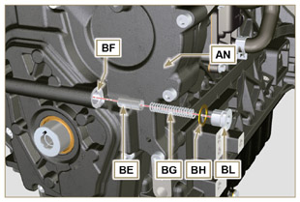  Fig 9.91

Crankshaft and phonic wheel pulley unit assembly
NOTE: To fit the target wheel refer to the operations in Par. 6.6.2 .  - Check that the pin F is mounted properly on the crankshaft G .  - Position the pulley unit H on the crankshaft G using the pin mark F (detail M ).  - Apply Molyslip grease on the screw thread N .  - Fix the pulley T with the screw Z (tightening torque of 360 Nm ) and remove special tool ST_34 ( Fig. 9.33 ). | 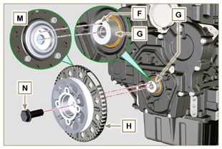  Fig 9.92

Coolant circuit assembly
9.3.1 Thermostatic valve  Important  - Always replace the gasket A after each assembly.  - Check the condition of the seal gasket A and fit it on the thermostatic valve B .  - Position the thermostatic valve B in the seat on the head C (detail D ).  - Secure the cover E with the screws F on the head C (tightening torque of 10 Nm ). | 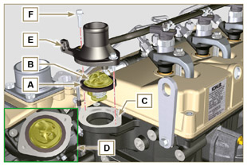  Fig 9.93
9.13.2 Coolant pump assembly  Important  - Always replace the gasket L every time it is assembled.  - Fit the pump G with the screws H interposing the gasket L (tightening torque of 25 Nm ). | 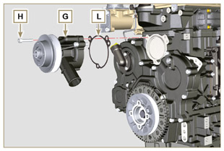  Fig 9.94
9.13.3 Oil Cooler hoses  - Assemble the Oil Cooler hose behind the injection pump and connect to oil heat exchanger.  - Insert hose L into clamp N .  - Fasten hose L by means of clamp P on Oil Cooler M . | 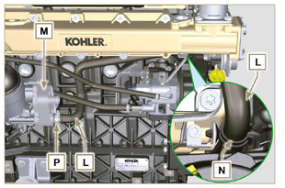  Fig 9.95
4 . Secure the sleeve Q on Oil Cooler M and to the coolant pump T with the clamps K .  5. Fasten the clamp Y with the screw S (tightening torque of 22 Nm - ST_05 ). | 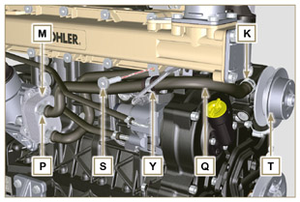  Fig 9.96

Turbocharger Assembly
Important  - Before proceeding, perform the operation described in Par. 2.18 .  - Ensure that tube B is not clogged.  - Fasten the connecting sleeve A to the pipe B with the clamp C onto the flange fitting D .  Important  - Always replace the gasket F after each assembly.  - Lubricate and insert the gasket F into the seat of the pipe G .  Important  - Remove the plastic or foam caps from the turbo compressor before assembling.  - Replace nuts M with each assembly.  - Check that the contact surfaces E are free from impurities deformations or cracks, otherwise replace exhaust manifold L .  - Position the turbo-compressor H on the bolts on the manifold L .  - Fasten the turbo-compressor H with the nuts M (tightening torque of 25 Nm ).  - Fasten the pipe G with the screws N to the turbo-compressor H .  Important  - Always replace the gasket P after each assembly.  - Before assembly of the tube Q , perform the operation described in Par. 2.19.2 - point 2 .  - Ensure that tube Q is not clogged.  - Fasten the fuel outlet pipe Q with the fittings R on the turbocompressor H and on the crankcase S (tightening torque of 15 Nm ).  Insert the gaskets P between:  - Q and R ;  - Q and S ;  - Q and H .  - Insert the sleeve T on the turbo-compressor H and secure it with the clamp U .  - Insert the pipe V onto the sleeve T and onto the relief valve Z . Secure tube V with the clamps W . | 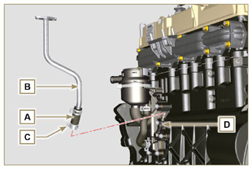  Fig 9.97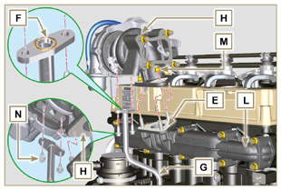  Fig 9.98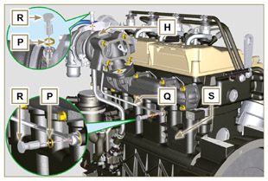  Fig 9.99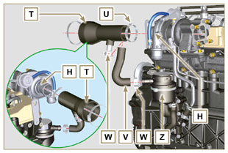  Fig 9.100

Electric component assembly
9.15.1 Sensors and switches
9.15.1.1 T-MAP Sensor  - Fasten the sensor A with the screws B on the manifold C (tightening torque of 10 Nm - ST_06 ). | 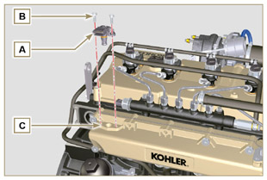  Fig 9.101
9.15.1.2 Coolant temperature sensor  - Secure the sensor D onto the head E (tightening torque of 20 Nm ). | 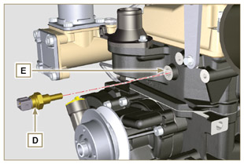  Fig 9.102
9.15.1.3 Oil Pressure Switch  - Clamp the oil pressure switch F on the crankcase G (tightening torque at 35 Nm ). | 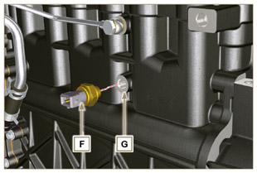  Fig 9.103
9.15.1.4 Camshaft phase sensor disassembly  - Rotate the crankshaft H posizioning a tooth L of the target wheel which is mounted on the camshaft at the center of hole M .  - Carry out the steps described in points 5, 6 and 7 to insert the correct number of spacers N .  - Fit the spacer N on the sensor P .  - Fasten the phase sensor P on distribution guard L with the screw Q (tightening torque of 10 Nm - ST_06 ). | 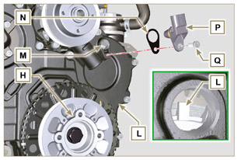  Fig 9.104
- Measure the distance from the coupling surface AD to the tooth surface on the target wheel (X1) .  - Measure the distance between the coupling surface AD and the sensor surface R (Y1) .  - The difference between the 2 measurements determines the air gap value (Z1) .  The value (Z1) permitted must be a minimum of 0.2 mm and a maximum of 1.2 mm .  Insert one or two spacers N (Fig. 9.104) based on the value (Z1) detected.  NOTE: The calibrated spacers N have a thickness of 0.2 mm . | 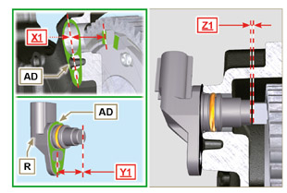  Fig 9.105
9.15.1.5 Speed sensor  - Measure the distance from the coupling surface AE to the external diameter of the target wheel (X2) .  - Measure the distance between the coupling surface AE and the sensor surface V (Y2) .  - The difference between the 2 measurements determines the air gap value (Z2) .  The value (Z2) permitted must be a minimum of 0.2 mm and a maximum of 1.2 mm .  Insert one or two spacers N (Fig. 9.104) based on the value (Z2) detected.  NOTE: The calibrated spacers U have a thickness of 0.2 mm .  Mount the bracket S with the screws T (tightening torque at 10 Nm - ST_06 ).  - Insert the shim U on the sensor V .  Clamp the sensor V on the bracket S with the screw Z (tightening torque at 10 Nm - ST_06 ). | 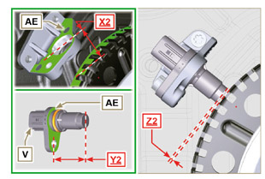  Fig 9.106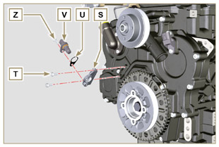  Fig 9.107
9.15.1.6 Fuel filter water detection sensor  - Lubricate and insert the gasket AA on the fitting AB .  - Tighten the sensor AB onto the cartridge AC (tightening torque of 5 Nm ). | 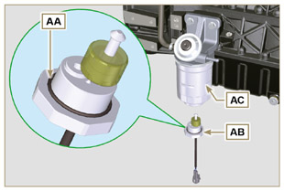  Fig 9.108

9.15.2 Alternator  - Insert the screw BA onto the alternator BB .  - Insert the washer BC onto the screw BA .  - Manually fit the screw BA all of the way onto the crankcase BD without tightening.  - Manually fit the screw BE all of the way onto the head BF without tightening. | 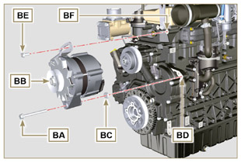  Fig 9.109
- Pull out the dipstick BB in the direction of the arrow BG .  Important  - The belt BH must always be replaced every time it is assembled, even if it has not reached the scheduled hours for replacement.  - Insert the belt BH on the pulleys BJ . | 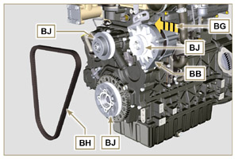  Fig 9.110
- Pull out the dipstick BB in the direction of the arrow BK .  - While tensioning the alternator BB , first clamp screw BE (tightening torque at 25 Nm ) and then screw BA (tightening torque at 69 Nm [thread M10] - 40 Nm [thread M8] ). | 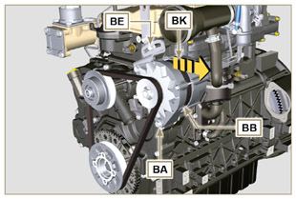  Fig 9.111
- Check the tension of the belt BH with a Clavis type instrument, positioning it in point (the tension must be between 350 and 450 Nm ).  - If the tension values do not correspond, tighten screws BA and BE , then repeat operations 7, 8 and 9 . | 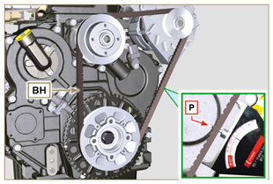  Fig 9.112
9.15.3 Starter Motor  Important  - Remove the ST_34 tool if it remains in position on the engine  - Fit the starter BQ with the screws BR on to the flange bell BS (tightening torque of 45 Nm ). | 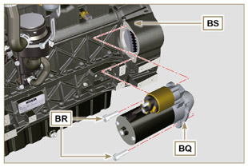  Fig 9.113
9.15.4 Electric cabling  - Position the cable holder BT together with the cabling BU on the rocker cap BV .  - Mount the connectors C1 on the electronic injectors S1 .  - Screw the wiring holder BT on the rocker cap BV with the screws BW (tightening torque of 10 Nm - ST_06 ). | 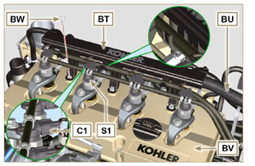  Fig 9.114
- Fit the connector C2 on the sensor S2 .  - Fit the connector C3 on the sensor S3 .  - Insert the clamp H1 on the collector DA . | 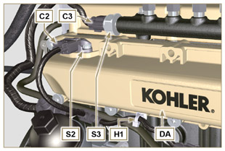  Fig 9.115
- Insert the connector C4 on the fuel intake valve S4 .  - Insert the connector C5 on fuel temperature sensor S5 . | 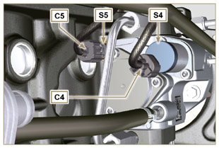  Fig 9.116
- Fit the connector C6 on the sensor S6 .  - Fit the connector C7 on the sensor S7 .  - Insert the clamps H2 on the thermostat cover DB and H3 on the lateral oil intake flange DC .  - Fit the connector C8 on the sensor S8 . | 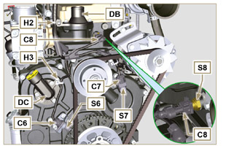  Fig 9.117
- Fit the connector C9 on switch S9 .  - Insert the terminal C10 on the engine S10 .  - Insert the connector C11 on the alternator cable S11 .  - Insert the clamp H4 on the vent holder DD . | 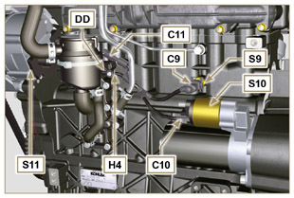  Fig 9.118

EGR Circuit Assembly
9.16.1 EGR valve  Important  - Check that the contact surfaces between flange B and the head D are free from impurities.  - Always replace the gasket A after each assembly.  - Mount the gasket A on the flange B .  - Secure the flange B with the screws C on the head D (tightening torque of 10 Nm ). | 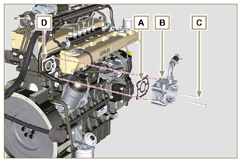  Fig 9.119
- Insert the screws E into the holder F .  - Position the gasket G in correspondence with the screws E on the holder F .  - Secure the EGR valve holder F with the screws E on the flange B (tightening torque of 10 Nm ). | 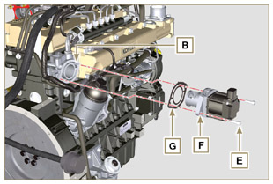  Fig 9.120
- Fit the connector H on the valve L .  - Tighten the clamp J with the screw K on the flange B . | 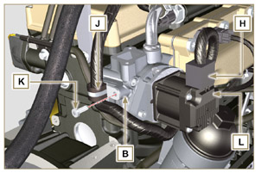  Fig 9.121
9.16.2 EGR Cooler  - Insert the fitting N of EGR Cooler M in the sleeve P of the EGR valve unit.  - Position EGR Cooler M on the intake manifold Q with the screws R ( ST_05 ) .  - Secure the fitting N with the clamp S to the sleeve P . | 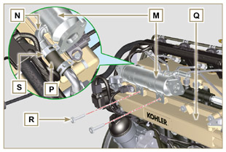  Fig 9.122
- Fasten the pipe T with the screws U on the EGR valve unit V inserting the gasket W (tightening torque of 10 Nm - ST_06 ).  - Fasten the pipe T with the screws AA on EGR Cooler M inserting the gasket AB (tightening torque of 25 Nm ). | 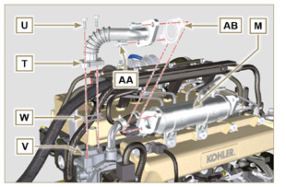  Fig 9.123
- Fasten the pipe AC on the intake manifold AD with the screws AE (tightening torque of 25 Nm - ST_05 ) inserting the gasket AF .  - Fasten the pipe AC on the EGR Cooler M with the screws AG (tightening torque of 25 Nm ) inserting the gasket AH .  - Fit the EGR Cooler M on the intake manifold Q with the screws R (tightening torque of 25 Nm - ST_05 - Fig. 9.122 ).  - Connect hose AL on EGR Cooler M . | 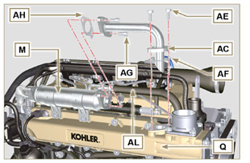  Fig 9.124

Tightening torques and the use of sealants
Tab. 9.4 - *Alternatively to the capscrew replacements, with "Dri-loc"
BASE CONFIGURATION

SHORT BLOCK

Component | Thread (mm) | Torque (Nm) | Sealer
Oil sprays fastening capscrew | M6x1 | 10
Lower crankcase fastening capscrew | M12x1.25 | 3 Torque cycles
1st Cycle |  | 40
2nd Cycle |  | 70
3rd Cycle |  | 120
Lower crankcase fastening capscrew | M8x1.25 | 2 Torque cycles
1st Cycle |  | 20
2nd Cycle |  | 35
Connetting road screw | M8x1 | 2 Torque cycles
1st Cycle |  | 40
2nd Cycle |  | 85
Flange oil seal fastening capscrew | M6x1 | 10
Closing cover fastening capscrew 3rd PTO | M8x1.25 | 25 | Loctite 2701*
Idle gear lubr. hole cap closure | M14x1.5 | 30 | Loctite 2701*
Coolant drain hole closing cap | M16x1.5 | 50
OIL SUMP ASSEMBLY
Component | Thread (mm) | Torque (Nm) | Sealer
Oil fumes tube | M12x1,5 | 15 | Loctite 648
Oil suction hose fastening capscrew | M6x1 | 10 | Loctite 2701*
Oil sump fastening capscrew | M8x1.25 | 25
Oil drain cap | M18x1.5 | 35
FLANGE ASSEMBLY (1ST PTO)
Component | Thread (mm) | Torque (Nm) | Sealer
Flange bell fastening capscrew | M10x1,5 | 50
Flywheel fastening capscrew | M12x1,25 | 140
GEAR DISTRIBUTION
Component | Thread (mm) | Torque (Nm) | Sealer
Intermediate gear gudgeon fastening screw | M8x1.25 | 25
Camshaft gear control fastening capscrew | M10x1 | 100
Gear fastening nut on high-pressure fuel injection pump | M14x1.5 | 65
ENGINE CYLINDER HEAD ASSEMBLY
Component | Thread (mm) | Torque (Nm) | Sealer
Air bleeding cap | M6x1 | 8
Lifting brace fastening capscrew | M8x1.25 | 25
Electronic injector manifold | M12x1 | 30
Cylinder head fastening capscrew | M12x1.25 | 6 Torque cycles
1st Cycle |  | 40
2st Cycle |  | 70
3st Cycle |  | 100
4st Cycle |  | 90°
5st Cycle |  | 90°
6st Cycle |  | 90°
Rocker arm gudgeon fastening capscrew | M8x1,25 | 25
Rocker arm cover fastening capscrew | M6x1 | 10
INJECTION SYSTEM
Component | Thread (mm) | Torque (Nm) | Sealer
Fuel filter fastening capscrew | M8x1.25 | 25
Fuel cartridge fastening | ... | 17
Common rail fastening capscrew | M8x1.25 | 25
Electronic injector brace fastening capscrew | M8x1.25 | 20
Distributor fastening capscrew | M8x1.25 | 10
Waste line fastening drilled capscrew on common rail | M10x1 | 15
Electronic Injector side injection tube nuts | M12x1.5 | 25
Injection pump side injection tubes nuts | M12x1.5 | 25
Common Rail side injection tubes nuts | M14x1.5 | 30
Injection pump fastening capscrew | M8x1.25 | 25 | Loctite 2701*
INTAKE MANIFOLD
Component | Thread (mm) | Torque (Nm) | Sealer
Internal semi-manifold fastening capscrew (on cylinder head) | M8x1.25 | 25
External semi-manifold fastening capscrew | TG8 | 22
Intake flange fastening capscrew | TG8 | 22
EXHAUST MANIFOLD
Component | Thread (mm) | Torque (Nm) | Sealer
Exhaust manifold fastening stud | M8x1.25 | 25
Exhaust manifold fastening nut | M8x1.25 | 25
Exhaust/manifold/muffler flange fastening nut | M8x1.25 | 25
LUBRICATION CIRCUIT
Component | Thread (mm) | Torque (Nm) | Sealer
Oil fumes support fastening capscrew (on crankcase) | M6x1 | 12
Oil filter fastening union | M20x1.5 | 15 | Loctite 2701*
Oil cooler fastening capscrew | M6x1 | 10
Cartridge-holder cover | ... | 25
Oil pump carter fastening capscrew | TG6 | 10
Carter distribution fastening capscrew | M8x1.25 | 25
Side oil load flange fastening capscrew (onto carter distribution) | TG6 | 10
Pressure relief valve cap | M16x1.5 | 50
CRANKSHAFT AND TARGET WHEEL PULLEY ASSEMBLY (2 ^{ND} PTO)
Component | Thread (mm) | Torque (Nm) | Sealer
Phonic wheel fastening capscrew (on crankshaft pulley) | M6x1 | 10
Crankshaft pulley fastening capscrew | M16x1.5 | 360 | Molyslip
COOLANT CIRCUIT
Component | Thread (mm) | Torque (Nm) | Sealer
Coolant tube clamp fastening capscrew (Oil Cooler return) | TG6 | 10
Thermostatic valve cover fastening capscrew | M6x1 | 10
Coolant pump fastening capscrew | M8x1.25 | 25
TURBO COMPRESSOR
Component | Thread (mm) | Torque (Nm) | Sealer
Oil return tube fastening capscrew | M6x1 | 10
Oil supply tube fastening capscrew | M10x1 | 15
Turbine fastening stud (on manifold) | M8x1.25 | 25
Exhaust flange fastening stud (on turbine) | M8x1.25 | 25
Turbine fastening nut | M8x1.25 | 25
Exhaust flange fastening nut (on turbine) | M8x1.25 | 25
ELECTRICAL COMPONENTS
Component | Thread (mm) | Torque (Nm) | Sealer
MAP sensor fastening capscrew | TG6 | 10
Coolant temperature sensor | M12x1.5 | 20 max.
Oil pressure switch | M12x1.5 | 35
Phase sensor fastening capscrew | TG6 | 10
Speed sensor fastening capscrew | TG6 | 10
Sensor for water presence in fuel |  | 5
Alternator bracket fastening capscrew | M8x1.25 | 25
Alternator fastening capscrew | M8x1.25 | 40
Alternator fastening capscrew | M10x1.5 | 69
Starter motor fastening capscrew | M10x1.5 | 45
Supply cable fastening nut (starter motor) | M8x1.25 | 10
Cabling support fastening capscrew | TG6 | 10
EGR CIRCUIT

Component | Thread (mm) | Torque (Nm) | Sealer
Flange EGR valve fastening capscrew | M6x1 | 10
EGR valve fastening capscrew | M6x1 | 10
EGR Cooler tube fastening capscrew (on flange EGR valve) | TG6 | 10
EGR Cooler fastening capscrew | TG8 | 22
Tube fastening capscrew on EGR Cooler | M8x1.25 | 25
Tube fastening capscrew on intake manifold | M8x1.25 | 25
* Alternatively to the capscrew replacements, with "Dri-loc"
OPTIONAL COMPONENTS (CHAP. 11)
OIL DIPSTICK ON CYLINDER HEAD
Component | Thread (mm) | Torque (Nm) | Sealer
Oil dipstick tube fastening capscrew | M6x1 | 10
HEATER

Component | Thread (mm) | Torque (Nm) | Sealer
Flange intake with heater fastening capscrew | M8x1.25 | 22
ALTERNATOR WITH POLY-V BELT
Component | Thread (mm) | Torque (Nm) | Sealer
Pulley fastening capscrew | M10x1.5 | 48
Pulley positioning blocking nut capscrew | M10x1.5 | 45
Alternator brace fastening capscrew | M8x1.25 | 25
Alternator fastening capscrew (upper) | M8x1.25 | 25
Alternator fastening capscrew (lower) | M8x1.25 | 40
Pulley sliding plate fastening capscrew | M8x1.25 | 25
IDLE GEAR (FOR 3TH /4TH PTO)
Component | Thread (mm) | Torque (Nm) | Sealer
Gear drilled fastening capscrew | M14x1.5 | Consultare il Par. >> | Molyslip
3 ^{TH} PTO
Component | Thread (mm) | Torque (Nm) | Sealer
Pump support fastening capscrew | M8x1.25 | 25 | Loctite 2701*
Pump fastening capscrew | M8x1.25 | 25
4 ^{TH} PTO
Component | Thread (mm) | Torque (Nm) | Sealer
Grooved crankshaft support fastening capscrew | M8x1.25 | 25 | Loctite 2701*
Cover fastening capscrew (3 ^{rd} PTO side) | M8x1.25 | 25
Sump support fastening capscrew | TG6 | 10
Pump fastening capscrew | M8x1.25 | 25
BALANCE DEVICE (4 CYLINDERS)
Component | Thread (mm) | Torque (Nm) | Sealer
Housing closing panel fastening capscrew | M6x1 | 8
Shafts support fastening capscrew | M10x1.5 | 50
REMOTE OIL FILTER
Component | Thread (mm) | Torque (Nm) | Sealer
Head fastening and Oil Cooler union on crankcase | M20x1.5 | 25 | Loctite 2701*
Crankcase head nipple and oil filter support | M14x1.5 | 40
Tube union on crankcase head | G3/8 | 30
Tube union on filter support | G3/8 | 35
Oil filter | M20x1.5 | 20
Filter support head air bleeding cap | M8x1.25 | 25
INTAKE CIRCUIT
Component | Thread (mm) | Torque (Nm) | Sealer
Air filter support plate fastening capscrew (on flange bell) | M8x1.25 | 25
Air filter support fastening capscrew | M8x1.25 | 25
EXHAUST CIRCUIT
Component | Thread (mm) | Torque (Nm) | Sealer
Muffler brace support fastening capscrew | M8x1.25 | 25
Muffler fastening capscrew on muffler | M8x1.25 | 25
Muffler fastening nut | M8x1.25 | 25
COOLING CIRCUIT
Component | Thread (mm) | Torque (Nm) | Sealer
Blower fastening capscrew | M6x1 | 10
Radiator support fastening capscrew | M16x1.5 | 150
Shroud radiator fastening capscrew | M6x1 | 10
Radiator lower brace fastening capscrew | M8x1.25 | 25
Radiator on anti-vibrating | M8x1.25 | 25
Anti-vibrating radiator fastening nut (on lower brace) | M8x1.25 | 25
Anti-vibrating and brace fastening capscrew (upper) | M6x1 | 10
Upper brace fastening capscrew (on engine cylinder head) | M8x1.25 | 25
Side bulkheads fastening capscrew | M6x1 | 10
ENGINE SUPPORT
Component | Thread (mm) | Torque (Nm) | Sealer
Side feet fastening capscrew (on flange bell or crankcase) | M12x1.75 | 50
Rear feet fastening capscrew | M16x1.5 | 200

Fluids filling information

Engine oil
Important

- Before proceeding with operation, read Par. 3.3.2 .
- Loosen the oil filler cap A or the oil filler cap C if the cap A is not accessible.  - Add the type and amount of oil recommended ( Tab. 2.2 ). | 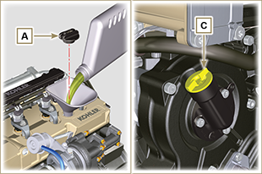  Fig 10.1
- Remove the oil dipstick B and check that the level is up to but does not exceed the MAX .  - If the oil level is not at MAX , insert more oil until the MAX level is reached as indicated on the dipstick.  - Re-tighten the cap A or C .  NOTE: See the Par. 11.1 for the various configurations of the oil dipstick. | 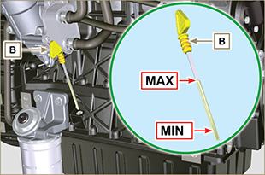  Fig 10.2
NOTE : Click by side to play the procedure. | https://www.youtube.com/embed/cVpoy_m253A?showinfo=0&rel=0

Coolant
Important

- Before proceeding with operation, read Par. 3.3.2 .
- Tighten the cap G , replacing the copper gasket (Tightening torque of 50 Nm ). | 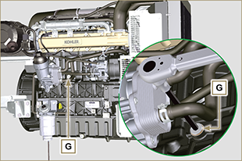  Fig 10.3
NOTE: A sealing plug or connecting pipe to the expansion tank may be present on the junction B , both should be secured with a strap.  - Reinsert on the junction B the sealing plug or a connecting pipe to the expansion tank. | 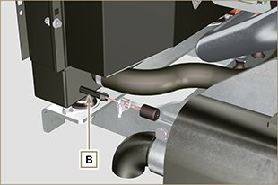  Fig 10.4
Warning  - Presence of steam pressurized coolant danger of burns.  - Refill the radiator with coolant (refer to Par. 2.6 for the liquid specifications).  - Top liquid up until the pipes inside the radiator are covered by about 5 mm.  - For engines equipped with separate expansion tank, pour in fluid until reaching the max level mark.  - Loosen the screw F on the head H , release any air and tighten the screw F (Tightening torque of 8 Nm - Fig. 10.7 ).  - Start the engine without the radiator cap A or the expansion tank (C) cap B.  - Keep the engine at idle speed or without a load until the coolant level goes down and becomes steady (the waiting times varies according to the ambient temperature).  - Turn off the engine and allow it to cool.  - If there is an expansion tank (C) top liquid up to the mark MAX .  - Without expansion tank top liquid up until the pipes inside the radiator are covered by 5 mm. Do not overfill the radiator, but leave room for the coolant to expand.  - Tighten the radiator cap A or the expansion tank (C) cap B.  Warning  - Before starting make sure that the radiator cap and expansion tank cap, if present, are installed correctly to avoid loss of liquid or vapour at high temperatures.  - After a few hours of operation stop the engine and allow it to cool.  Check and top up the coolant. | 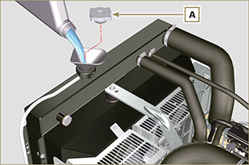  Fig 10.5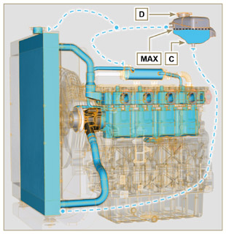  Fig 10.6
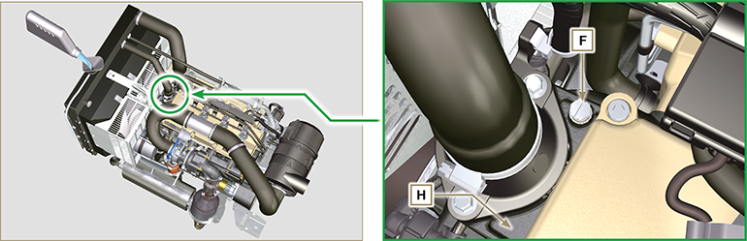
Fig. 10.7

NOTE : Click by side to play the procedure. | https://www.youtube.com/embed/S79xPhTZMps?showinfo=0&rel=0

Information about optional components

Oil dipstick in cylinder head
Important

- Before proceeding with operation, read Par. 3.3.2 .
11.1.1 Check  - Pull out the dipstick B in the direction of the arrow A .  - Check that the mark left by the oil on the dipstick is between the MIN and MAX notches. | 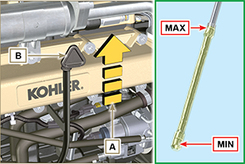  Fig 11.1
11.1.2 Replacement  11.1.2.1 Disassembly  - Undo the screw D .  - Pull out the oil dipstick hose E in the direction of the arrow F | 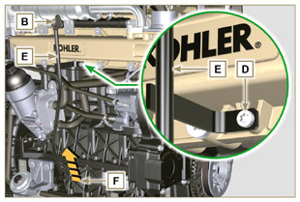  Fig 11.2
11.1.2.2 Assembly  Important  - Always replace the gasket G every time it is disassembled.  - Insert the gasket G in the seat K of the hose E .  - Insert the hose E in the crankcase H . | 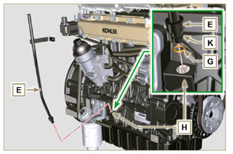  Fig 11.3
- Secure the oil dipstick hose E using the screw D on the manifold L (tightening torque at 10 Nm ). | 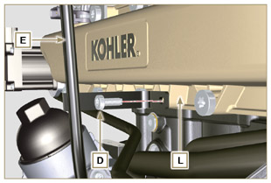  Fig 11.4
NOTE: Check the integrity of the gaskets J .  - Insert the dipstick B inside the hose E . | 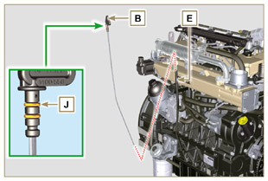  Fig 11.5

Heater (replacement)
Important

- Before proceeding with operation, read Par. 3.3.2 .
11.2.1 Disassembly  - Undo the screws A and the relevant washers and remove the earth cable B .  - Remove the flange C and the manifold D .  - Remove the heater E and the relevant gaskets F . | 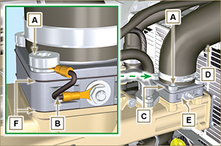  Fig 11.6
11.2.2 Assembly  Important  - Always replace gaskets F , with each assembly.  - In sequence, fit the manifold G with the gasket F , the new heater E , the second gasket F , the flange C , the washers H , the screws A and the cable B .  - Secure the flange H with the screws A (tightening torque at 22 Nm ).  - Secure the earth cable B with the nut J and the relevant washer on the heater E . | 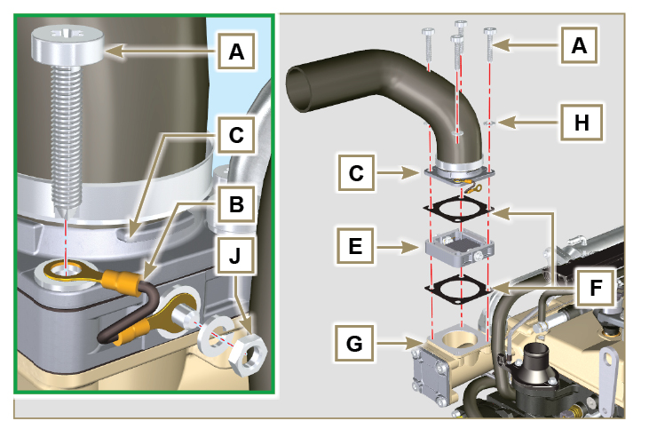  Fig 11.7

Poly-V alternator belt (replacement and adjustment)
Important

- Before proceeding with operation, read Par. 3.3.2 .
- Loosen the nut B and manually tighten the screw C until it just touches the pulley pin D (Fig. 11.9) . | 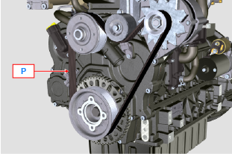  Fig 11.8
- Untighten the screw E by around 32mm (A) .  - Untighten the screw C .  NOTE: The belt tensioner pulley F should move towards the arrow G . If it does not, please move it manually. | 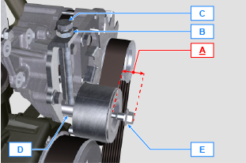  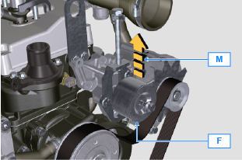  Fig 11.9
- Remove the V-Belt H and install the new one.  NOTE: Ensure that the internal profile of belt H is properly inserted into the grooves of the pulley A (as illustrated in D1 e D2 ). | 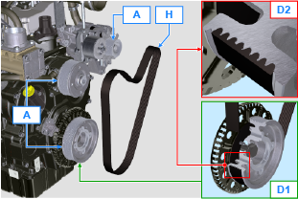  Fig 11.10
- Tighten capscrew C , to shift gudgeon D fully to the bottom of the grooved guide.  - Tighten capscrew E (tightening torque at 45Nm ).  - Hold the screw C still with a key, and tighten the screw B on the plate L to secure the screw C (tightening torque at 45Nm ).  - Check, in point P (Fig. 11.8) ,the tension of the belt. Check by the appropriate tool that at point p the tension value is between 149 and 196 Hz .  NOTE: After the engine has been in operation for around 15 minutes, repeat point 8 . | 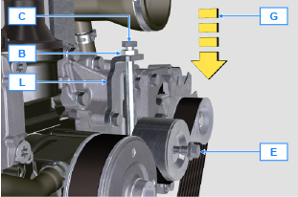  Fig 11.11

Tightening pulley and alternator for Poly-V belt
Important

- Before proceeding with operation, read Par. 3.3.2 .
11.4.1 Disassembly  - Perform the operations from point 1 to 3 of Par. 11.3 .  - Remove the belt H ( Fig. 11.10 ) .  - Undo and remove the screw A .  - Fully undo the screw B and remove the tightening pulley C . | 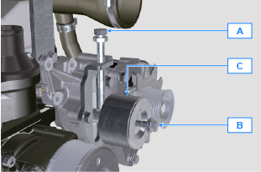  Fig 11.12
- Undo the screws D and remove the plate E and the pin F . | 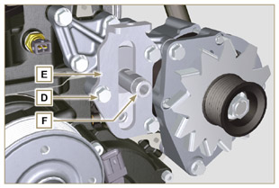  Fig 11.13
- Undo the screws G and H remove the alternator L . | 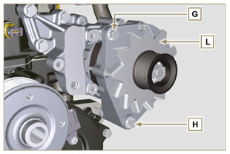  Fig 11.14
- Undo the screws M and remove the bracket N . | 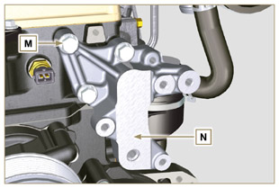  Fig 11.15
11.4.2 Assembly  - Secure the bracket N using the screws M on the cylinder head P (tightening torque at 25 Nm ). | 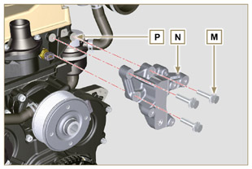  Fig 11.16
- Insert the screw H into the fixing hole on the alternator L .  - Insert the spacer R on the screw H (between the alternator and crankcase).  - Tighten the screw manually H onto the crankcase Q .  - Orientate the second fixing hole of the alternator L with the hole of the bracket N , secure the alternator L using the screw G (tightening torque at 25 Nm ) onto the bracket N and then the screw H (tightening torque at 25 Nm ). | 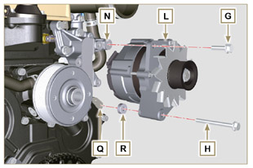  Fig 11.17
- Insert the pin F in the plate slot E .  - Orientate the pin F with the surface S (support for screw A ) upwards.  - Secure the plate E using the screws D on the bracket N (tightening torque at 25 Nm ). | 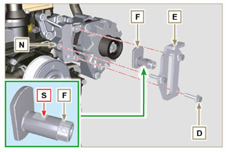  Fig 11.18
- Insert the screw B in the plate C1 and pulley C .  - Manually tighten the screw B onto the pin F up to the stop; Undo the screw B again by one turn.  NOTE: The screw B must protrude by about 32 mm (A) from the surface of the tightening pulley C (see detail X ).  - Install the new belt H (Fig. 11.10) .  - Tighten the screw A onto the plate E up to the stop on the pin F .  - Perform the operations from point 6 to 8 of Par. 11.3 . | 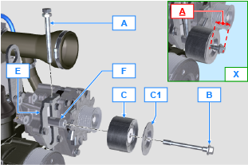  Fig 11.19

Idler gear (for 3rd / 4th PTO)
Important

- Before proceeding with operation, read Par. 3.3.2 .
11.5.1 Disassembly  - Undo the screw A and remove the gear unit B . | 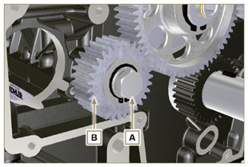  Fig 11.20
- Remove the retainer ring C from the seat of the pin D .  - Remove the shoulder washer E , the gear B , the shoulder ring F and the bushing G from the pin G .  11.5.2 Assembly  - Insert gudgeon D :  - shoulder ring F (minimum shim)  - gear B  - shoulder ring E  - retainer ring C .  - Insert the bushing G on the crankcase L . | 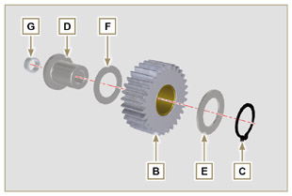  Fig 11.21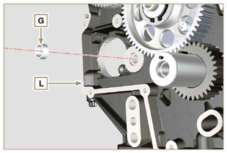  Fig 11.22
Important  - Always replace the washer H every time it is disassembled.  Modified component, see service letter 700019. *  - Check that the perforated screw A is free from impurities inside it.  - Lubricate the thread and under the head of the screw A with Molyslip .  - Position the gear unit B on the hole J using the bushing G to centre.  - Secure the gear unit B using the screw A inserting the washer H (tightening torque at 85 Nm ). | 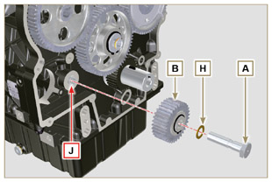  Fig 11.23

3rd PTO (replacement)
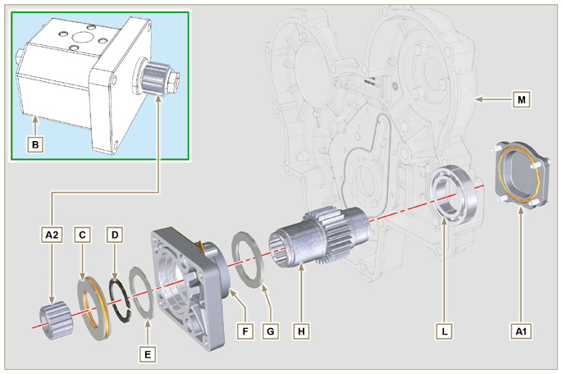
Fig 11.12

Important

- Before proceeding with operation, read Par. 3.3.2 .
11.4.1 Disassembly  - Undo the screws A and remove the pump B . | 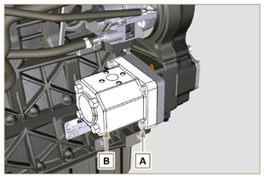  Fig 11.13
- Remove the centring ring C and the relative gaskets.  - Undo the screws N . | 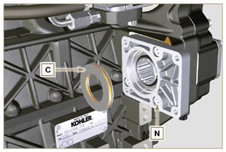  Fig 11.14
- Remove the flange F with the components D, E, G and H in the direction of the arrow P .  - Remove the gasket J . | 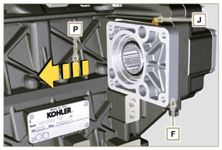  Fig 11.15
- Remove the retainer ring D and the shoulder washer E .  - Remove the gear H and the shoulder ring G from the flange F in the direction of the arrow Q . | 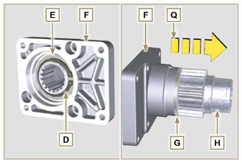  Fig 11.16
11.4.2 Assembly  Important  - Always replace the gasket J after each assembly.  - Lubricate the gear H with oil.  - Insert the gear H in the flange F in the direction of the arrow R inserting the shoulder ring G .  - Insert the shoulder ring E on the flange F and clamp the gear H using the retainer ring D .  - Position flange F on the crankcase K inserting the gasket J , and inser gear H in crankcase K . | 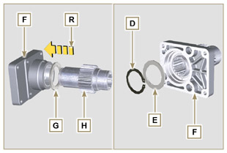  Fig 11.17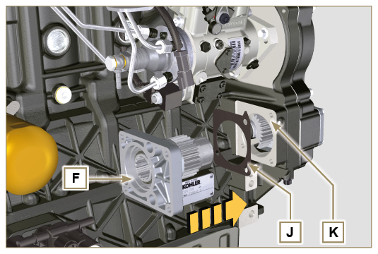  Fig 11.18
- Secure the flange F using the screws N (tightening torque at 25 Nm ). | 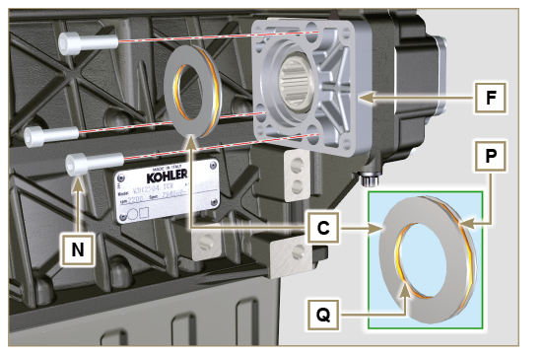  Fig 1
Important  - Always replace rings P and Q after each assembly.  5. Insert the centring ring C in the flange F up to the stop.  6. Position the pump B on the flange F engaging the gear H .  7. Secure the pump B using the screws A on the flange F (tightening torque at 25 Nm ). | 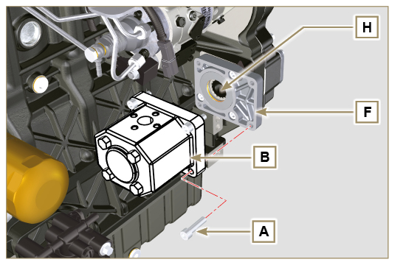  Fig 11.20

4th PTO (replacement)
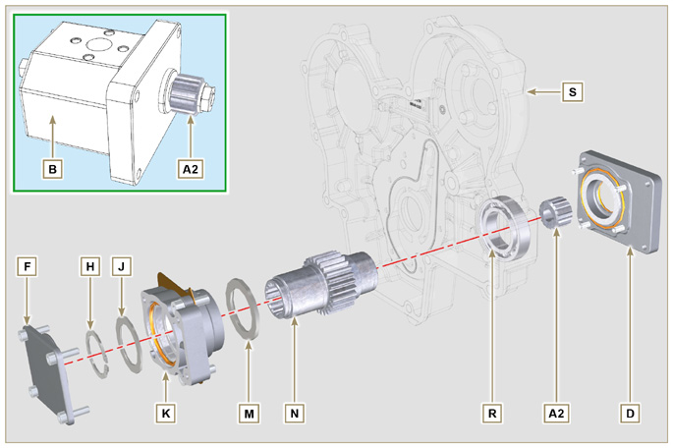
Fig 11.21

Important

- Before proceeding with operation, read Par. 3.3.2 .
11.7.1 Disassembly  - Undo the screws A and remove the pump B . | 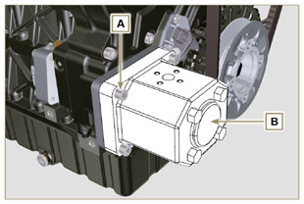  Fig 11.22
- Undo the screws C and remove the flange D . | 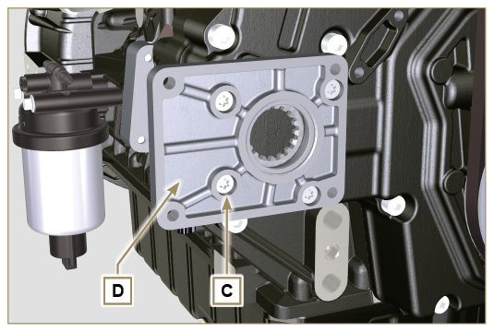  Fig 11.23
- Undo the screws E and remove the cover F . | 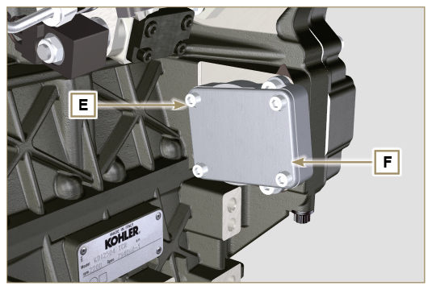  Fig 11.24
- Undo the screws G and remove the flange K with the components H, J, M, N and P . | 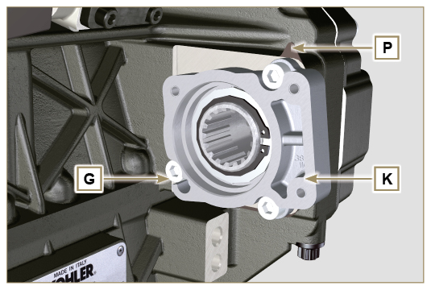  Fig 11.25
- Remove the retainer ring H and the shoulder ring J from the flange K .  - Remove the gear N and the shoulder ring M from the flange K . | 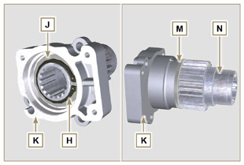  Fig 11.26
11..2 Assembly  Important  - Always replace the gasket J after each assembly.  - Lubricate the gear H with oil.  - Insert the gear N in the flange K in the direction of the arrow W inserting the shoulder ring M .  - Insert the shoulder ring J on the flange K and clamp the gear N using the retainer ring H . | 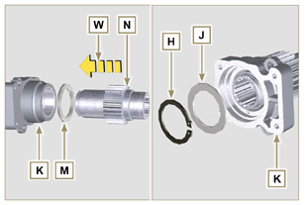  Fig 11.27
- Position flange K onto crankcase Q inserting gasket P and insert gear N in crankcase Q .  Important  - Always change capscrews G with new ones or alternatively apply Loctite 2701 .  - Secure the flange K using the screws G (tightening torque at 25 Nm ). | 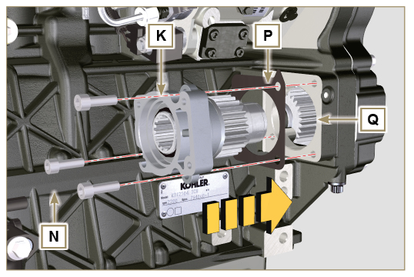  Fig 11.28
Important  - Always replace the gasket V after each assembly.  - Insert gasket V on cover F , insert and position the cover F on flange K .  - Secure the cover F using the screws E (tightening torque at 25 Nm ) on the flange K . | 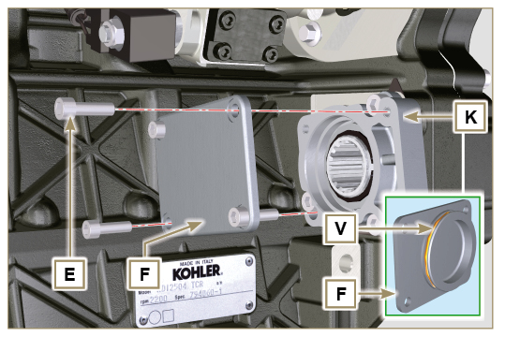  Fig 11.29
Important  - Always replace the gasket T after each assembly.  - Position and tighten flange D by means of capscrews C on carter S (tightening torque 10 Nm - ST_06 ). | 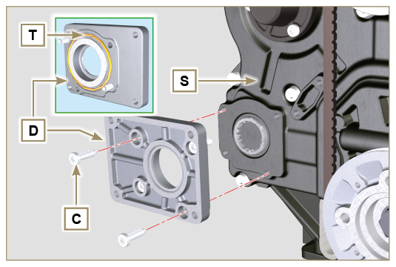  Fig 11.30
Important  - Always replace the gasket U after each assembly.  - Position the gasket U on the flange D .  - Secure the pump B using the screws A (tightening torque at 25 Nm ) on the flange D . | 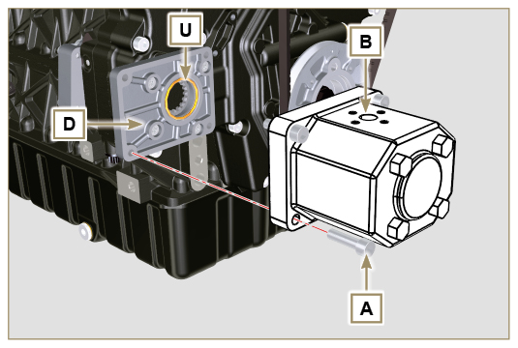  Fig 11.31

3rd + 4th PTO (configurations)
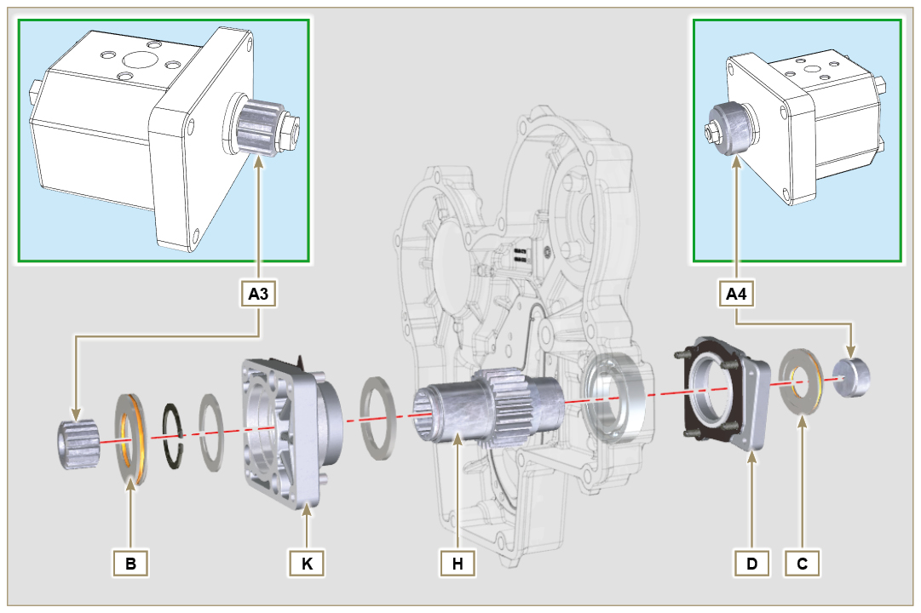
Fig. 11.45

11.8.1 Information  Hydraulic pumps on the 3rd and 4th PTO can be installed at the same time.  In some configurations, there is also the centering ring C on the 4th PTO.  Important  - For disassembly or installation, refer to Par. 11.5 , Par. 11.6 e Par. 11.7 .  - Always replace the gasket of the rings B and C and flanges D and K at each assembly.  - Lubricate the gear H with oil. | 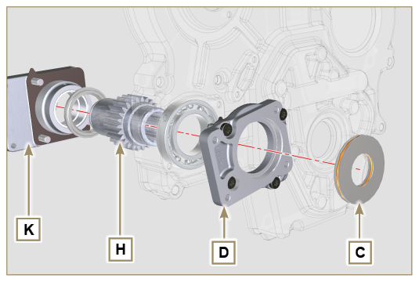  Fig. 11.46

Balancer device (replacement)
Important

- Before proceeding with operation, read Par. 3.3.2 .
11.9.1 Disassembly  - Perform the operations described in Par. 5.2 .  - Undo the screws A and remove the oil sump B . | 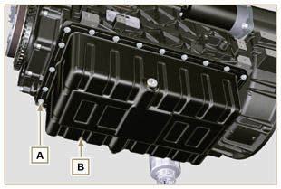  Fig 11.47
- Undo the screws C and remove the hose D . | 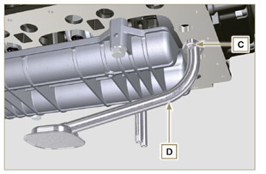  Fig 11.48
- Undo the screws E and remove the shaft support box F . | 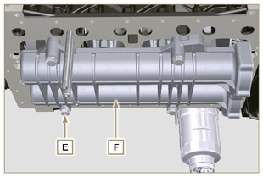  Fig 11.49
- Undo the screws G and remove the plate H . | 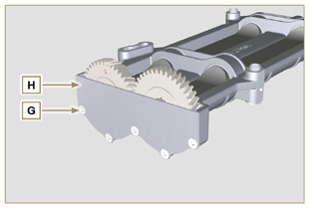  Fig 11.50
- Remove the shafts J and K in the direction of the arrow L from box F . | 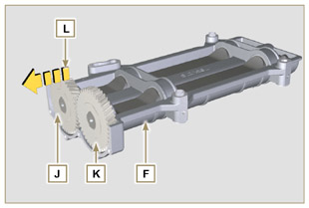  Fig 11.51
11.9.2 Assembly  - Lubricate the bushings V with Molikote grease.  - Insert the shafts J and K inside the box F in the direction of the arrow M . | 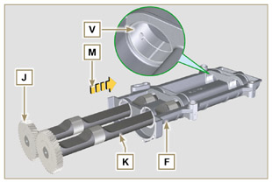  Fig 11.52
- Make sure that the shafts J and K i nside the box F observe the marks N and that the shaft J with the gear indicated by letter " S " stamped on it is on the left with respect to the box F . | 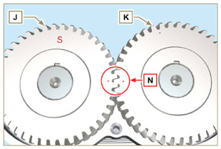  Fig 11.53
- Secure the plate H using the screws G on the box F (tightening torque at 8 Nm ). | 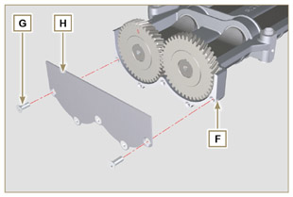  Fig 11.54
- Manually tighten the retainer screw ST_15 on the box F by slightly rotating the shaft K , centring the hole on it using the ST_15 , to lock the device. | 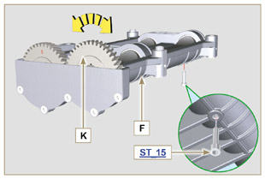  Fig 11.55
- Rotate the crankshaft and clamp it on the TDC (Ref. P upwards) using the tool ST_34 secured in place of the starter motor (detail Q ). | 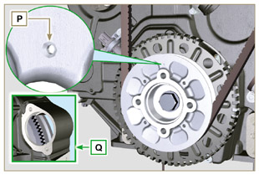  Fig 11.56
- Position the box F on the surface of crankcase R observing the reference bushings.  - Secure housing F using capscrews E and insert washers U (tightening torque at 50 Nm ).  - Remove the retainer screw ST_15 from the box F . | 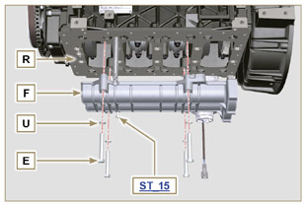  Fig 11.57
Important  - Check that the retainer capscrew ST_15 (Fig. 11.55) is not present in point X on housing F .  - Always replace the gasket W after each assembly.  - Lubricate the gasket W with oil before assembling it.  - Insert the gasket W in the seat on the flange of the oil hose D .  - Secure the oil intake hose D using the screws C .  - Perform the operations described in Par. 9.4.3 to assemble the oil sump. | 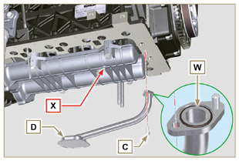  Fig 11.58

Air filter (cartridge replacement)
- Release the two hooks A and remove the cover B from the body C .  - Remove the cartridges D and E .  Important  - Before proceeding with operation, read Par. 3.3.2 .  - The safety cartridge E (if present) must always be replaced if it is dirty or damaged.  - Insert the new cartridge E inside the new cartridge D and both of them inside the filter body C .  - Secure the cover B via the hooks A . | 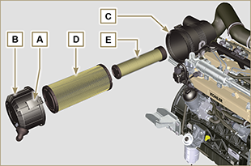  Fig 11.59

Remote oil filter (disassembly and assembly)
11.11.1 Option A  11.11.1.1 Disassembly  - Perform the operations described in Par. 5.2 .  Important  - Before proceeding with operation, read Par. 3.3.2 .  - For the replace the cartridge, please refer to operation n° 4 (Par. 11.11.1) and operation n° 7 (Par. 11.11.2) .  - For the disassembly of the pipes B and C , lock with a tool the fittings K, H (Fig. 11.61) and L (Fig. 11.62) in order to prevent their lose together with the nuts A , with the consequent of oil leakage.  - The threads of unions L and H have different features - Before removing the unions L and H , apply a distinguishing mark on them in order to reposition them correctly on the support M or on the head J during the assembly phase.  - The threads of nuts A have different features - Before removing the tubes B and C, apply a distinguishing mark on them in order to correctly screw the nuts A to the unions L and H during the assembly phase.  - Undo the nuts A and remove the hoses B and C .  - Unscrew the fittings L and remove the copper gaskets from the support M .  - Unscrew the cartridge N with gasket from the support M . | 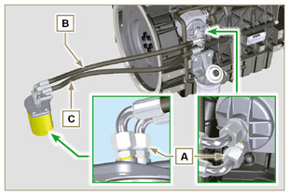  Fig 11.60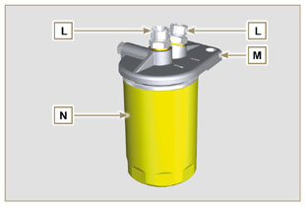  Fig 11.61
- Release the clamps D and remove the hoses E and F from Oil Cooler G .  - Unscrew and remove the fitting H with its copper gasket from the oil filter head J .  - Unscrew and remove:  - the fitting K with the copper gasket;  - Oil Cooler G and the relative gasketsi;  - the oil filter head J . | 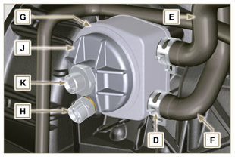  Fig 11.62
11.11.1.2 Assembly  Important  - Always replace the gaskets P, Q, R and W at each assembly.  - Lubricate the gaskets P, Q and R with oil before assembling them.  - Insert the gasket P on the seat of the fitting K .  - Insert flange head J on the fitting K and the gasket Q in the seat of head J .  - Insert the Oil Cooler G on the fitting K and the gasket R in the seat of Oil Cooler G .  - Onto crankcase S apply Oil Cooler G and flange J by means of union K (tightening torque at 25 Nm + Loctite 2701 on thread) as positioned in Fig. 11.64.  - Clamp union H on flange J inserting gasket U (tightening torque at 40 Nm ). | 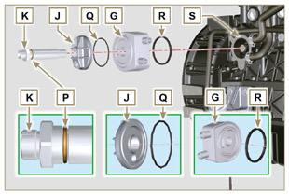  Fig 11.63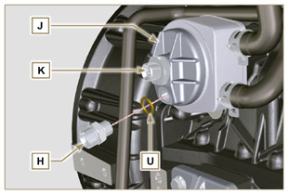  Fig 11.64
Important  - Always replace the gaskets V after each assembly.  - Clamp unions L on support M inserting gasket V (tightening torque at 40 Nm ).  - Lubricate gasket W and clamp cartridge N on support M (tightening torque at 20 Nm ). | 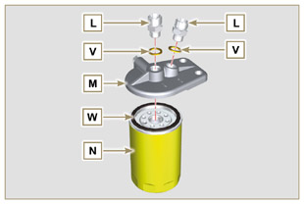  Fig 11.65
8. Connect tube B to the central fitting of support M and of head J .  9. Connect tube C to the side fitting of support M and of head J .  10. Clamp the nuts A on the head J (tightening torque at 30 Nm ).  11. Clamp the nuts A on support M (tightening torque at 35 Nm ).  Important  - Check the tightening of the fittings K, H (Fig. 11.64) and L (Fig. 11.65) (tightening torque at 40 Nm ). | 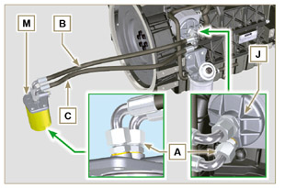  Fig 11.66
11.11.2 Option B  11.11.2.1 Disassembly  - Perform the operations described in Par. 5.2 .  - Perform the operations indicated in point 1 of Par. 7.3.2 .  Important  - Before proceeding with operation, read Par. 3.3.2 .  - The oil filter cartridge may not be supplied by KOHLER (in such cases, refer to the machine’s documentation)  - To replace only the cartridge, refer to operations 5 ( Par. 11.11.1 ) and 7 ( Par. 11.11.2 ).  - to remove the tubes B and C , use a wrench to lock the unions L ( Fig. 11.70 ) and H ( Fig. 11.72 ) in order to prevent them from being loosened and removed together with the nuts A , with subsequent oil leaks.  - The threads of unions L and H have different features - Before removing the unions L and H , apply a distinguishing mark on them in order to reposition them correctly on the support M or on the head J during the assembly phase.  - The threads of nuts A have different features - Before removing the tubes B and C , apply a distinguishing mark on them in order to correctly screw the nuts A to the unions L and H during the assembly phase. | 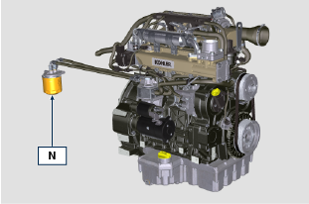  Fig 11.67
- Undo the nuts A and remove the hoses B and C .  - Unscrew the fittings L and remove the copper gaskets from the support M .  - Unscrew the cartridge N with gasket from the support M . | 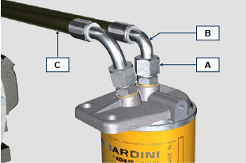  Fig 11.68  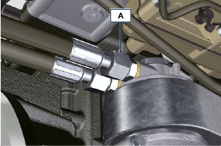  Fig 11.69  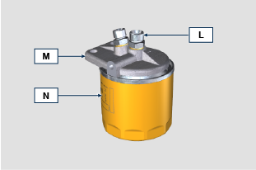  Fig 11.70
- Release the clamps D and remove the hoses E and F from Oil Cooler G .  - Unscrew and remove the unions H together with the relevant copper gasket from the head J .  - Unscrew and remove:  - the union K with its gasket;  - the head J ;  - the Oil Cooler G with relevant gaskets;  - the screws X and Y ;  - the support T ; | 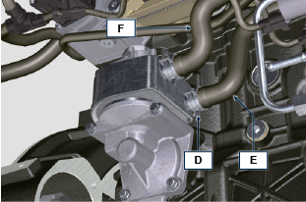  Fig 11.71  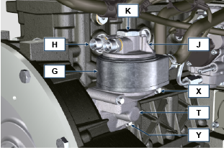  Fig 11.72
11.11.2.2 Assembly  Importante  - Replace the gaskets H1 , J1 , J2 , K1 , L1 , T1 and Z1 at every assembly.  - Lubricate the gaskets J1 , J2 , K1 , T1 and Z1 with oil before performing the assembly.  - Insert the gasket K1 on the seat of the union K .  - Insert the gaskets J1 and J2 on the seats of the union J .  - Assemble on the support T :  Oil Cooler G  head J  - Fix the union K to the support T , aiming the Oil Cooler G and the head J correctly (tightening torque of 25 Nm + Loctite 2701 on the thread). | 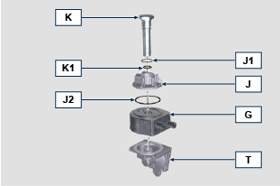  Fig 11.73
- Insert the gasket Z1 on the seat of the union Z .  - Insert the gasket T1 on the seat of the support T .  - Assemble on the support T on the crankcase S and fix it using the screws X and Y (tightening torque of 10 Nm ).  - Fit the tubes E and F on the Oil Cooler G and fix them using the clamps D ( Fig. 11.71 ). | 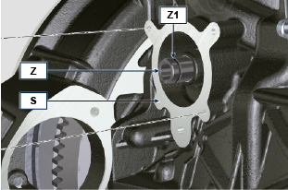  Fig 11.74  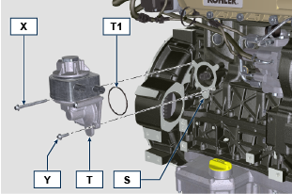  Fig 11.75
- Fix the unions H to the head J placing the gasket H1 in-between (tightening torque of 40 Nm ). | 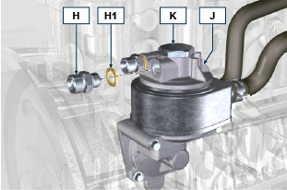  Fig 11.76
- Fix the unions L to the support M placing the gaskets L1 in-between (tightening torque of 40 Nm ).  - Lubricate the gasket N1 and fix the cartridge N to the support M (tightening torque of 20 Nm ). | 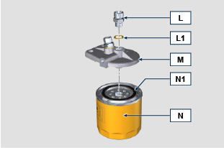  Fig 11.77
- Connect the tubes B and C onto the unions L of the support M and H of the head J .  - hten the nuts A on the head J (tightening torque 30 Nm ).  - Tighten the nuts A on the support M (tightening torque 35 Nm ).  - Perform the operations indicated in point 1 of Par. 9.15.3 .* | Fig 11.78  Fig 11.79

Oil sump with supporting structure
11.12.1 Flywheel (J) disassembly  - Execute the operations described in Par. 7.12.1 .  11.12.2 Plate/flange housing (L) disassembly  - Loosen supplementary capscrews A and B .  - Execute the operations described in Par. 7.12.2 .  - Remove housing or plate L . | 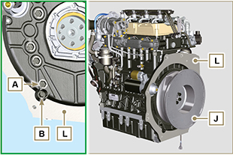  Fig. 11.80

11.12.3 Oil sump disassembly  - Execute the operations described in Par. 5.2 .  - Loosen capscrews C and remove bypass tube D .  - Loosen capscrews E and remove oil sump F . | 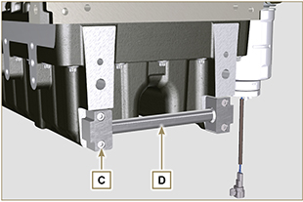  Fig. 11.81

11.12.4 Oil sump assembly  - Make sure contact surfaces G of oil sump F and crankcase H have no impurities.  - Apply a sealing bead of approximately 2.5 mm ( Loctite 5660 ) onto surface G of crankcase H .  - Place oil sump F onto crankcase H in correspondence with the fastening holes (use tool ST_18 ). | 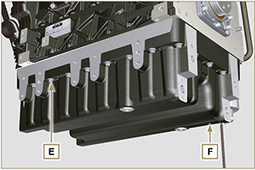  Fig. 11.82

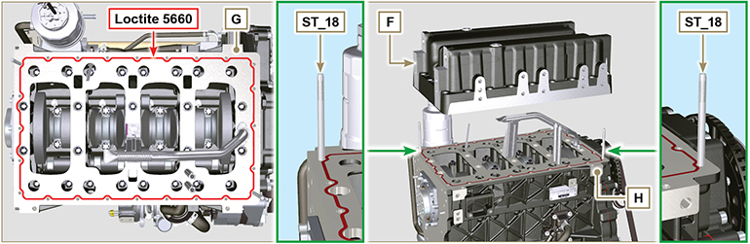
Fig. 11.83

- Apply capscrews E into the fastening holes and use torque at 10 Nm .  - Loosen capscrews E , leaving approximately 1 mm leeway ( position A ) between the neck surface of capscrews E and oil sump F .  - Place flange housing or plate L onto crankcase H , complying with centring tap pins M .  - Using 2 capscrews A , fasten housing or plate L onto crankcase H (tightening torque at 20 Nm ).  - Using 2 capscrews A , fasten housing or plate L onto oil sump F (tightening torque at 20 Nm ). | 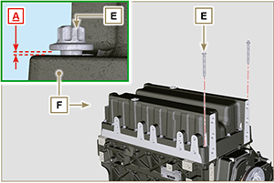  Fig. 11.84

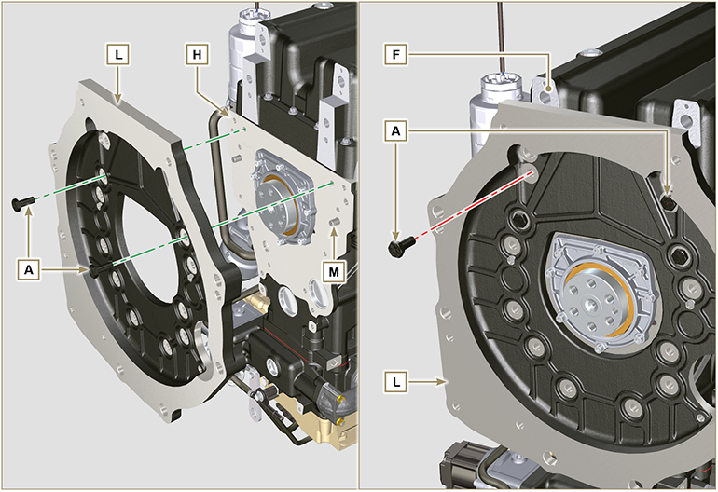
Fig. 11.85

- Fasten oil sump F by tightening capscrews E and strictly following the order shown in Fig. 11.73 (tightening torque at 20 Nm ).  - Loosen capscrews A and remove housing or plate L ( Fig. 11.72 ).  - Fasten oil sump F by tightening capscrews E and strictly following the order shown in Fig. 11.73 (tightening torque at 47 Nm ).  Loosen the screw 1 again and tighten it to 47 Nm . | 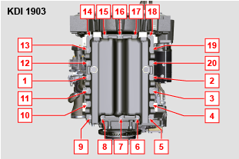  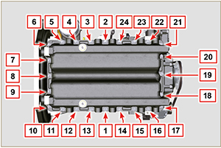  Fig. 11.86

- Insert gaskets N into seats P of bypass tube D .  - Fasten bypass tube D onto oil sump F using capscrews C (tightening torque at 10 Nm ). | 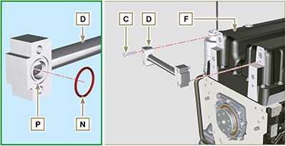  Fig. 11.87

11.12.5 Flange plate / housing assembly  - Execute the operations described in point 6 of Par. 11.12.4 .  - Fasten housing or plate L by using capscrews A and strictly following the order shown in Fig. 11.75 (tightening torque at 85 Nm ).  - Fasten housing or plate L by using capscrews B (tightening torque at 270 Nm ).  11.12.6 Flywheel assembly  - Execute the operations described in Par. 9.5.2 . | 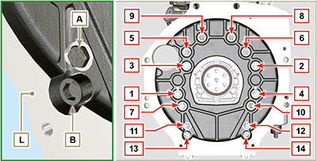  Fig. 11.88

ETB (replacement)
- Unscrew screws A and remove the ETB valve B with its gasket C .  Important  - Always replace the gasket C at each assembly. | 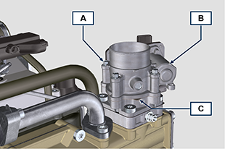  Fig. 11.89
- Fix the ETB valve B and its gasket C by means of screws A (tightening torque 10 Nm ) | 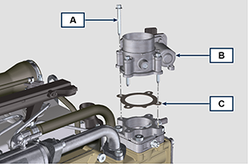  Fig. 11.90

ACACT (replacement)
- Unscrew sensor A and its gasket B .  Important  - Before assembling the new sensor, see Par. 2.17.5  - Always replace the gasket B at each assembly. | 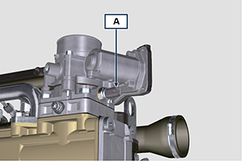  Fig. 11.91
- Fix sensor A and gasket B on their support C (tightening torque 20 Nm ). | 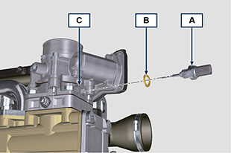  Fig. 11.92

EGTS (Black | Yellow - replacement)
- Unscrew sensors A .  Important  - Before assembling the new sensor, see Par. 2.17.6 | 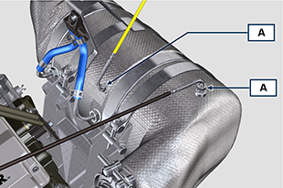  Fig. 11.93
- Fix sensors A on the ATS B (tightening torque 30 Nm ). | 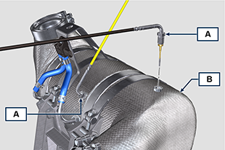  Fig. 11.94

DPF & DOC filter (replacement)
Danger
- Highly carcinogenic material!
- The dust contained inside the DPF is particularly fine and therefore classified as highly dangerous to living beings.
- Before proceeding to any operation, wear:
dust mask
gloves
goggles
- Do not allow any other operator who is not equipped with the above mentioned protective equipment to approach.
- Obtain a new replacement KIT for the DPF filter or a replacement KIT with regenerated DPF filter from your spare parts service.  Important  - Before disassembling/assembling any sensors, see Par. 2.17.5 and 2.17.6  - Always replace the seal P upon every assembly.  - During disassembly, do not expose the DPF to the surrounding environment for a long time and store it in a sealed bag as soon as possible.  - During disassembly operations, avoid using electric screwdrivers as vibrations could release the dust inside the DPF  - Do not try to clean the DPF  - Do not blow with compressed air  - Do not release the DPF or the dust contained in it in the environment  - Dispose of the DPF only in authorised centres  - Perform the operations indicated in point 1 of Par. 11.15 .  - Open the package of the DPF replacement KIT, taking care not to damage it.  - Unscrew screw A and loosen clamps B , then remove the Delta-P sensor D .  - Disconnect pipes C from their unions J and remove the Delta-P sensor D .  - Unscrew and remove unions J . | 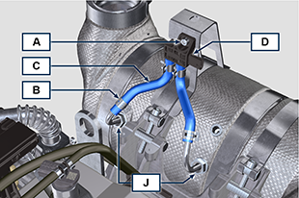  Fig. 11.95
- Loosen clamps E and remove manifold N . | 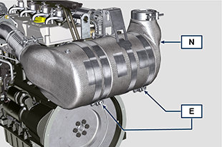  Fig. 11.96
- Loosen clamp G and remove the DPF filter H .  NOTE: do not remove clamp G .  - Inspect the DPF filter to detect any visible signs of oil contamination.  - Put the removed DPF filter in the plastic container supplied with the replacement KIT and send it to your spare parts service using the replacement KIT package.  NOTE : a residual value will be recognised depending on whether the used DPF is intact and recyclable or damaged and requiring a correct disposal. | 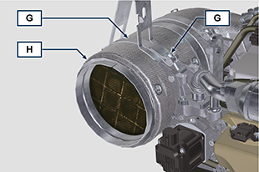  Fig. 11.97
- Loosen the clamps Q and S and remove the manifold with DOC M from the flexible hose R . | 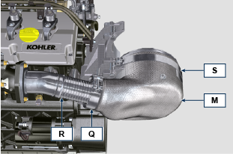  Fig. 11.98
- Fit the new manifold with the DOC filter M on the support T , inserting the flexible hose R inside the inlet of the manifold M . | 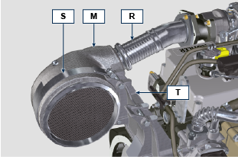  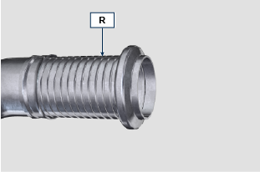  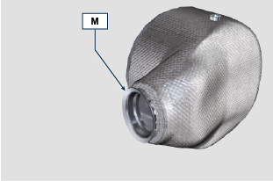  Fig. 11.99
Important  - Do not apply any tension during the assembly of components.  - Before fastening the manifold M , it must be oriented in the same position as the previously installed DOC filter.  - Tighten the clamp Q (tightening torque of 10 Nm ).  - Tighten the clamp S (tightening torque of 12 Nm ). | Fig. 11.100
- Insert the gasket P on the manifold with DOC filter M .  - Insert the new DPF filter H inside clamp G .  - Insert the DPF filter H on manifold M until reaching the gasket P . | 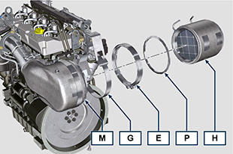  Fig. 11.101
Important  - Before fastening the DPF filter H , it must be oriented in the same position as the previous filter.  - Do not apply any tension during the assembly of components.  - Fasten the DPF filter H with clamp E (tightening torque 12 Nm ). | 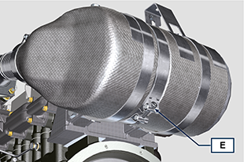  Fig. 11.102
- Insert gasket P on the DPF filter H .  - Insert manifold N on the DPF filter H until reaching the gasket P .  Important  - Before fastening manifold N , it must be oriented in the original position.  - Fasten manifold N with clamp E (tightening torque 12 Nm ). | 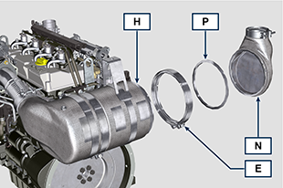  Fig. 11.103
- Position support K in contact with support K1 and fasten clamp G (tightening torque 12 Nm ). | 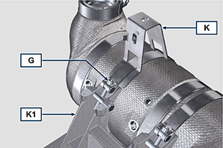  Fig. 11.104
- Screw unions J on the DPF filter H and position them about 20° away from the centre line (as in Fig. 11.90 ). | 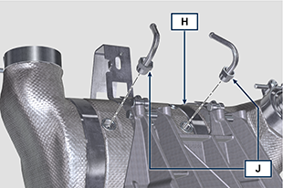  Fig. 11.105
- Fix unions J (tightening torque 60 Nm ). | 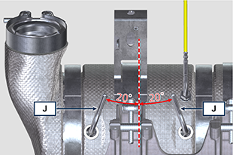  Fig. 11.106
- Fit pipes C on unions J and fasten them with clamps B .  - Fix the Delta-P sensor D on its support K by means of screw A (tightening torque 10 Nm ).  - Provide the machine owner with the warranty certificate of the new DPF filter KIT installed.  - Perform the " DPF replacement " procedure to reset the ASH & SOOT through the relevant KOHLER diagnostic tool interfaced with the ECU. | 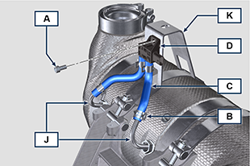  Fig. 11.107

Oil dipstick on timing gears side
Important

- Before proceeding with operation, read Par. 3.3.2 .
11.17.1 Check  - Remove dipstick A .  - Verificare che il segno lasciato dall'olio sull'asta sia tra le tacche MIN e MAX .  NOTE: Check the condition of seal A1 every time dipstick A is inserted into dipstick tube D . | 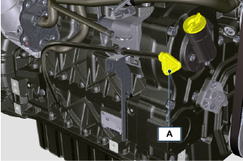  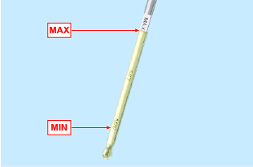  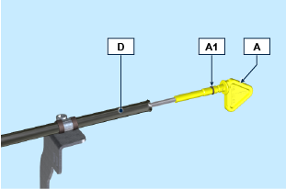  Fig 11.108
11.17.2 Replacement  11.17.2.1 Disassembly  - Unscrew screws B and C .  - Remove the oil dipstick tube D from crankcase H along with support E.  - Unscrew screw F and remove the dipstick tube D from support E along with cable tie G . | 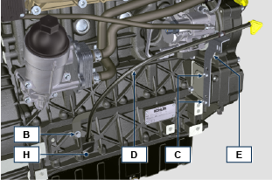  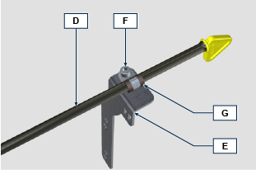  Fig 11.109
11.1.2.2 Assembly  Important  - Always replace O-ring D1 during every assembly.  - Insert cable tie G on dipstick tube D.  - Fit the clamp G onto support E using screw F .  NOTE: Do not tighten screw F.  - Insert the dipstick tube D into position on the crankcase H .  - Position the support E onto cover L , slide clamp G onto the tube D to ensure the correct position.  - Secure the clamp G onto support E (tightening torque 10 Nm ). | 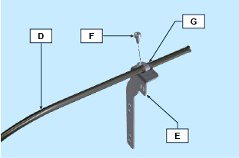  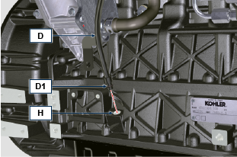  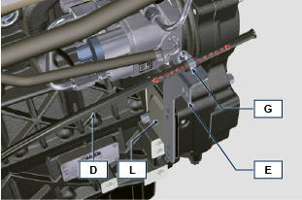  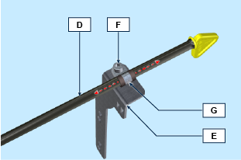  Fig 11.110
- Secure support E using screws C onto crankcase H (tightening torque at 25 Nm ).  - Secure the dipstick tube D to the crankcase H using screw B (tightening torque at 25 Nm ). | 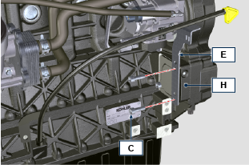  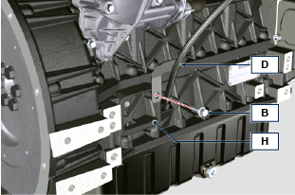  Fig 11.111

Information on adjustments

'Waste Gate' opening valve regulation

Important

- Before proceeding with operation, read Par. 3.3.2 .
- Regulation must not be carried out with the engine running.
- During the procedure in point 5 , pay special attention not to bend rod H .

- Disconnect the hose A from the turbocharger, and connect a pressure gauge B (scale from 0 to 5 bar).
- Connect the gauge B to the network of compressed air, interposing a pressure reducer C .
- Position dial gauge D in such a way that feeler F rests onthe Waste Gate rod control valve extremity H (point E ).
- By using gradually the reduction gear C send the air to the Waste Gate actuator control L in order to move rod H forward by 1 mm (value M to check on dial gauge D). Pressure read on gauge B must be: 1350 mbar for engine model KDI 2504 TCR and 1250 mbar for engine model KDI 1903 TCR.
- If pressure is less or more than the indicated value, proceed as follows: - Undo lock nut G from rod H.

- Remove the retainer cotter pin (point E ) and disconnect rod H from the Waste Gate control lever.
- Tighten (to increase) / or loosen (to decrease) pressure of the ring nut of rod H until reaching the corrected calibration.
- Redo lock nut G .
- Reconnect rod H and assemble the cotter pin point E .

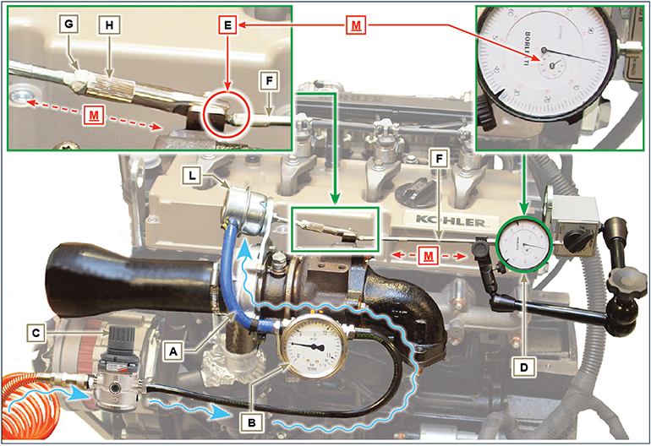
Fig 12.1

Air filter check
Important

- Before proceeding with operation, read Par. 3.3.2 .
- When the cartridge G is dirty, do not clean it but replace cartridges B and G .

- All manifolds connected to the turbo must be fully clean and not damaged.  - Clean the inside components A and D with a damp cloth.  - Do not use compressed air , repeatedly tap the front side E on a flat surface. | 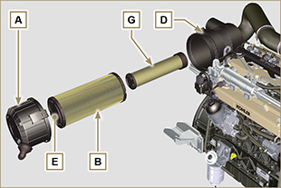  Fig 12.2

Oil steam separator check
Important

- Before proceeding with operation, read Par. 3.3.2 .

- Loosen clamp B and remove hose C from hose D .  - Start the engine at idle speed or without a load; check if air comes out of hose C .  NOTE: If what is described in Point 2 does not occur, proceed with cleaning or replacing oil separator A and accurately clean support flange F , all connecting  hoses, and repeat the operation from P oint 2. | 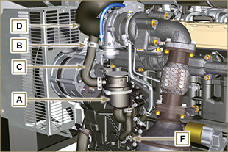  Fig 12.3

Rubber hoses and manifolds check
Important

- Before proceeding with operation, read Par. 3.3.2 .
The check is carried out by applying slight deflection or bending along the tube/hose and next to the hose clamps.  Components must be replaced if they have clear signs of cracks, tears, cuts, leaks, or do not retain a certain degree of elasticity.  - Check the condition of all rubber hoses A .  - Check whether there are any leakages of air, refrigerant, oil or fuel next to their connections. | 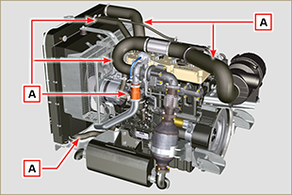  Fig 12.4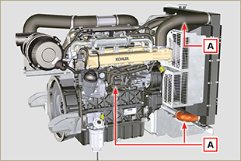  Fig 12.5

Oil leak check
Important

- Before proceeding with operation, read Par. 3.3.2 .

Check that there are no leakages next to area A .  - Start the engine at idle speed or without a load and check whether there are any leakages next to area A.  - It is anyhow necessary to also check the seals of all main components and their surface contact, such as:  - crankcase and gasket (side 1 ª PTO) - oil sump and exhaust caps  - cylinder head and its assembled components  - rocker arm cover  - Timing system carter and gasket (side 2 ª PTO) - oil dipstick housing or rod support tube.  NOTE: Perform the checks described in Points 1 and 2 periodically and during maintenance procedures.  It is also necessary to check for leakages on the components that are not listed.  If necessary, disassemble the components that have a leakage and investigate the possible cause.  The components must be replaced otherwise they do notguarantee their sealing. | 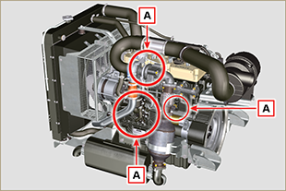  Fig 12.6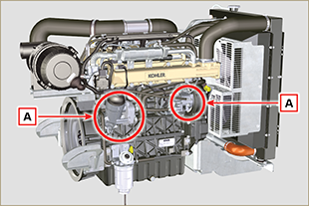  Fig 12.7

Oil pressure check
Important

- Before proceeding with operation, read Par. 3.3.2 .
- Insert a thermocouple instead of the oil dipstick A .  - Unscrew and remove the oil pressure switch and screw on a 10 bar pressure gauge in its seat (Fig. 12.10) .  - Start the engine at idle speed and without a load, check the oil pressure value according to the oil temperature (Fig. 12.9 ).  NOTE : The graph in Fig. 12.9 illustrates the pressure line with speed of 1000 Rpm.  - If the pressure values are below the values indicated in Fig. 12.9 , check to identify the cause of the problem.  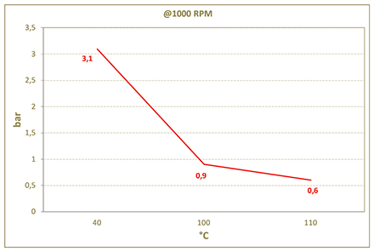  Fig. 12.9 | 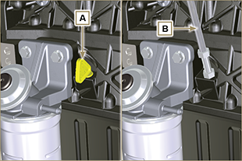  Fig. 12.8  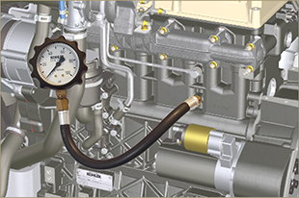  Fig. 12.10

Tools information

Information regarding specific tools

In Tab 13.1 - 13.2 - 13.3 there is a list of all the specific tools that are required and approved to carry out operations of disassembly - assembly - regulations - settings - repairs on engine series KDI

, correctly and safely.
Warning

- KOHLER declines all responsibility for any damage to the engine, persons, or things caused by the use of different types of tools to those indicated in Tab 13.1 - 13.2 - 13.3 , where referred to them in the manual.

Tab. 13.1
SPECIAL TOOLS FOR DISASSEMBLY AND ASSEMBLY
"ST" | Picture/Draw | DESCRIPTION | PART NUMBER
ST_03 | 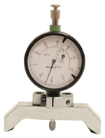 | Piston protrusion - electronic injectors cylinder head surface control tool | ED0014602980-S
ST_04 | 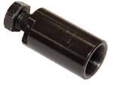 | High-pressure fuel injection pump puller gear | ED0014603680-S
ST_05 | 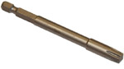 | Spanner for capscrews Six nicks SN 8 | ED0014603650-S
ST_06 | 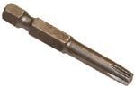 | Spanner for capscrews Six nicks SN 5 | ED0014603640-S
ST_07 | 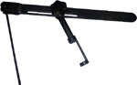 | Tool for disassembling / reassembling valves | ED0014603720-S
ST_08 | 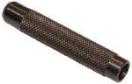 | Tool for gasket valve stem | ED0014603660-S
ST_09 | 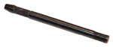 | Tool for flywheel assembling / disassembling | ED0014603610-S
ST_10 | 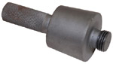 | Crankshaft gasket assembling tool | ED0014603670-S
ST_11 | 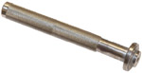 | Rocker arm cover gasket assembling tool (electronic injector seat) | ED0014603620-S
ST_12 | 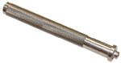 | Rocker arm cover gasket assembling tool (rocker arm capscrew gudgeon seat - electronic injector fastening capscrew brace seat) | ED0014603630-S
ST_14 | 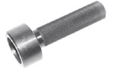 | Buffer insertion of a crankshaft gasket onto a timing system carter | ED0014603750-S
ST_15 | 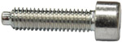 | Locking screw balance shafts | ED0097301980-S
ST_17 | 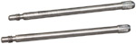 | Rocker arm cover mounting studs | ED0014603730-S
ST_18 | 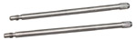 | Intake and oil sump manifold mounting studs | ED0014603740-S
ST_34 | 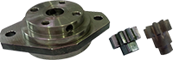 | Crankshaft blocking tool | ED0014604270-S
Tab. 13.2
SPECIFIC EQUIPMENT TO PROTECT COMPONENTS OF THE INJECTION CIRCUIT

ST_40 | 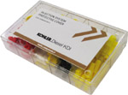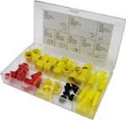 | Complete box with caps to close holes and unions for high-pressure injection circuit components. | ED0082051380-S
Tab. 13.3
SPECIAL TOOLS TO TEST THE ENGINE ON THE TEST BENCH - DIAGNOSTIC PROCEDURE
ST_01 |  | Complete instrument Kit for diagnostics  "POLAR XL" | ED0014603690-S
ST_49 |  | Complete instrument Kit for diagnostics  "DIAGBOX" | ED0014604210-S
ST_50 |  | Complete instrument Kit for engines bench test | ED0014604110-S

Information about failures

Possible causes and trouble shooting
IMMEDIATELY STOP THE ENGINE WHEN:
- Engine rpm increases and decreases suddenly without being able to control them;
- A sudden and unusual noise is heard;
- The colour of the exhaust fumes suddenly darkens or turns white;
- The oil pressure warning light or a Warning Lamp turns on during operation;
- The coolant temperature warning light turns on during operation.

Tab. 14.1 contains the possible causes of some failures, which may occur during operation.

Always perform these simple checks before removing or replacing any part.
Warning

- Do not carry out any checks or operations on the engine when it is running.

Tab. 14.1

Glossary

Glossary
A

ACACT: | After Charge Air Cooler Temperature
Air gap: | Distance to respect between a fixed component and one in movement.
Alternator: | A component that transforms mechanical energy into AC electrical energy.
Authorised workshop: | KOHLER authorised service centre.
Authorised service station: | KOHLER authorised workshop.
ATS: | After Treatment System - Post-treatment system, referred to the exhaust gases produced by the engine.

B

Balancer device: | A device that reduces vibrations caused by movement of the alternating weights (Crankshaft - Connecting rods - Pistons).
Base configuration: | Engine having components represented in Par. 1.4 - 1.5 .
BDC: | Bottom Dead Centre; a moment in which the piston is at the start of its stroke.
Bore: | Internal diameter of the cylinder in combustion engines.

C

CAN: | "Controller Area Network" - also known as CAN-bus, is a data communication standard for ECUs.
Catalyst: | see " DOC "
Combustion: | Chemical reaction of a mixture composed of fuel and fuel (air) inside a combustion chamber.
Common Rail: | A high-pressure "Common Duct" that produces a constant supply of fuel directly to the Electronic injectors.
Crankshaft: | A component that transforms straight operation into rotary operation, and vice-versa.

D

DOC : | Diesel Oxidation Catalyst - Catalyst for diesel engines that reduces harmful exhaust gas emissions produced by the engine.
DPF : | Diesel Particulate Filter - A filter that captures particles of carbonaceous origin emitted by diesel engines.

E

EC: | "European Community".
ECS: | Emission Control System
ECU: | Electronic Control Unit; an electronic device in charge of electronically detecting and controlling other electronic control devices.
EGR: | Exhaust Gas Recirculation, in internal combustion engines; a system that enables recirculation of combusted gas by means of taking it in once again, which enables it to break down  a part of the pollutants present in the exhaust gas.
EGR Cooler: | Recirculated exhaust gas cooling; a system that is able to cool recirculated gas (EGR) from the exhaust. This enables the temperature to remain constant inside the intake manifold,  thus improving combustion inside the cylinders and breaking down pollutants further.
EGR-T: | "Exhaust Gas Recirculation Temperature" - temperature sensor for EGR
EGTS: | "Exhaust Gas Temperature Sensor"
EGR valve: | Electronically-controlled device that adjusts the entrance of exhaust gas recirculated inside the intake manifold.
Electronic Injector: | An electronically activated component able to inject jets of atomised fuel inside the cylinders.
EPA: | Environmental Protection Agency. The United States' authority that safeguards the environment; its duty is to govern and control polluting emissions.
ETB: | Electronic Throttle Body - This is controlled by the ECU upon request of the accelerator pedal, and its function is crucial for the correct regeneration of the ATS system.

F

Fig.: | Figure.
Functional units: | Component, or group of main components, able to carry out specific functions on the engine.

G

Galvanised: | Material that has undergone surface protection treatment.
Grinding (valves and seats): | Cleaning operation of the valves and seats carried out with an abrasive paste (refer to an authorised service station for this type of operation).

H

Heater: | A device that heats the intake air by means of an electrical resistor.
Heavy conditions: | Type of extreme condition referred to the work environment in which the engine is used (very dusty - dirty area, or in a contaminated environment due to various types of gas).

I

Idle speed operation: | Operation of a running engine with the vehicle stopped and on idle speed.
Intercooler: | Air-cooling element under pressure from the turbo situated between the turbine and intake manifold.

K

KDI: | "Kohler Direct Injection"

M

Maintenance - periodic: | A group of maintenance actions that have the sole objective to control and replace elements on their expiry, without modifying or improving the functions carried out by the system, neither increasing the value nor improving performance.
MAX: | Maximum.
Methyl ester: | It is a mixture of products by means of a chemical conversion of oils and animal and/or vegetable fat, which is used to produce Biofuel.
Min.: | Minutes.
MIN: | Minimum.
Model: | Model, engine identification plate, which indicates the engine's model.

N

N/C: | Normally Closed, referred to switches (oil-pressure switch).

O

Oil Cooler: | Small radiator used to cool the oil.

P

Par.: | Paragraph.
Paraffin.: | Fatty and solid substance that may form inside the diesel.
Pipe cleaner: | An instrument having a metal cylindrical body with bristles that jut outwards. It is similar to a brush and is used to clean areas that are not easily accessible manually (e.g. oil ducts inside an engine).
Poly-V: | Poly-V, the name associated with a service belt, which derives from the profile of its section that is constructed with joined Vs.
Power operation: | Operation of the engine at high speeds.
PTO: | Power Take Off - a point provided to take advantage of alternative operation transmission.
Pump Learning: | Automatic procedure carried out by ECU (by means of a diagnostics instrument - ST_01 ) to discover the operating characteristics of the fuel feeding pump (should the injection pump or ECU be replaced).

Q

QR: | Quick Response (code) - QR Code, a two-dimensional matrix bar code composed of black modules placed inside a squareshaped structure.

R

Ref.: | Reference.
Rpm: | Rounds per minute.

S

s/n: | Serial number (engine identification name plate) indicating the engine identification series/chassis number.
SCV: | Suction Control Valve - it is situated on the high-pressure injection pump and is directly controlled by the ECU adjusting the intake of fuel to send to the Common Rail .
Spec.: | Specification, (engine identification name plate) indicating the engine version.
STD: | (Standard), base configuration of a component, or a group of components.

T

Tab.: | Table.
Target Wheel: | A wheel that is a part of a device to control angular operation by means of teeth placed on the circumference, which enable to determine and transmit the speed and position of the crankshaft to a sensor.
TCR: | Turbo Common Rail.
TDC: | Top Dead Centre; a moment in which the piston is at the end of its stroke.
Thermostatic valve: | A valve that adjusts the flow of coolant liquid; it is able to operate by means of temperature variation.
Tightening torque: | A term indicated for installation of threaded components and which is determined by means of a unit of measurement Nm .
T-MAP: | T-MAP (sensor), measures the temperature and absolute pressure inside the intake collector.
Torque: | Force applied to an object that rotates on an idler shaft.
Trochoid: | Rounded toothed profile (also known as "lobes").
Turbocharger: | Device that compresses air intake by sending it to the intake manifold by means of a turbine.

U

Used oil: | Oil altered by operation or time, which is no longer compliant for correct lubrication of the components.

W

Waste-Gate valve: | A device, which is directly or automatically controlled, used to limit the pressure of exhaust gas inside the turbine.
Warning Lamp: | A warning light (usually red) that indicates a serious anomaly during engine operation.

SYMBOLS AND UNITS OF MEASUREMENT
SYMBOL | UNIT OF MEASUREMENT | DESCRIPTION | EXAMPLE
α | degree | Rotation/inclination angle | 1°
cm ² | square centimetre | Area | 1 cm ²
Ø | millimetre | Circumference | Ø 1 mm
Nm | newton-metre | Torque | 1 Nm
mm | millimetre | Length | 1 mm
µm | 1/1000 of a millimetre (micron) |  | 1 µm
H | hour | Time | 1 h
g/kW | grammes per kilowatt per hour | Specific consumption | 1 g/kWh
kg/h | kilogramme per hour | Max. flow rate | 1 kg/h
Lt./min. | litres per minute | Flow rate | 1 Lt./min.
Lt./h | litres per hour |  | 1 Lt./h
ppm | parts per million | Percentage | 1 ppm
N | newton | Force | 1 N
A | Ampere | Intensity of electrical current | 1 A
gr. | gramme | Weight | 1 gr.
kg | kilogramme |  | 1 kg
W | Watt | Power | 1 W.
kW | kiloWatt |  | 1 kW
pa | pascal | Pressure | 1 pa
KPa | Kilopascal |  | 1 KPa
bar | barometric pressure |  | 1 bar
mbar (1/1000 bar) | barometric pressure |  | 1 mbar
R | Resistance | Resistance to electrical current (referred to a component) | 1 Ω
Ω | ohm | Resistance of electrical current | 1 Ω
Rpm | revs per minute | Rotation of an axis | 1 Rpm
Ra | average roughness expressed in microns | Roughness | 1 Ra
°C | degree centigrade | Temperature | 1°C
V | Volt | Electrical voltage | 1 V
 | millimetre | Hex-head capscrew | 1 mm
cm ³ | cubic centimetre | Volume | 1 cm ³
Lt. | litre |  | 1 Lt.

