Service procedures
KSD 1403 Workshop Manual (Rev. 00_DRAFT_01)

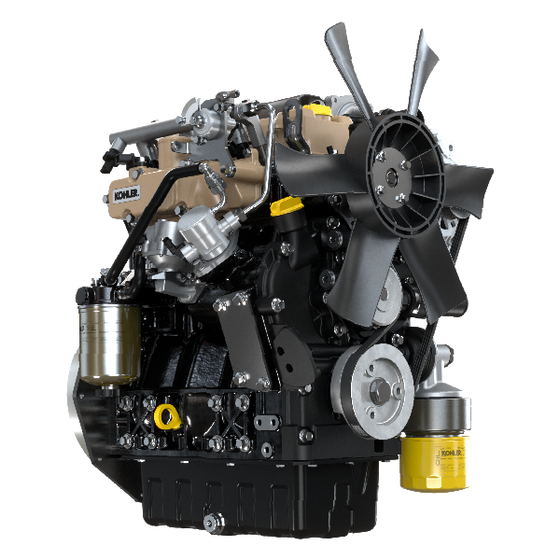

Registration of modifications to the document
Any modifications to this document must be registered by the drafting body, by completing the following table.

Released by | Code | Revision | Release Date | Revision date | Edited by | Endorsed
 | KSD1403-WS

Translated from the original manual in Italian language
Data reported in this issue can be modified at any time by KOHLER.

Sommario
1. TITOLO 1 2
1.1. Asdfsdfsdf 2
1.2. Asdfsdfsdfggg 2

Service procedures

Preliminary information

Important

- The mark ( ) after the title of a paragraph, indicates that the procedure is not required in order to disassemble the engine, however the procedures are featured in order to illustrate the disassembly of components.
- The operator should prepare all equipment and tools in order to enable him to carry out the operations correctly and safely.
- Before proceeding with operation, carefully read Chap. 3 .
- In order to operate safely and easily, we recommend positioning the engine on a rotating stand for engine overhauling.
- Seal all injection component unions as illustrated in Par. xx during assembly.
- Protect all disassembled components and coupling surfaces subject to oxidation with lubricant.
- Where necessary, reference to special tools to use during disassembly operations is indicated (es. ST_05 ).
- Replace all gaskets or rubber components at each disassembly.

Cooling circuit
Uncscrew the cap A1 of the radiator A to drain the remaining coolant. | 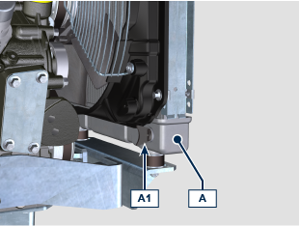
DISASSEMBLING
Radiator NA - TC model | 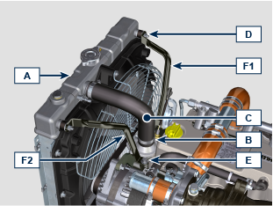
Loosen the clamps B and remove the hose C .
Unscrew the nuts D and the screw E to remove the rods F1 , F2 .
Loosen the clamps B and remove the hose C .  Unscrew the nuts B to remove the radiator A . § | 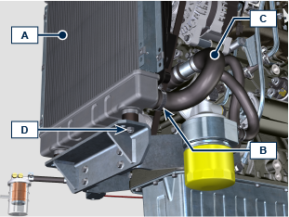
Radiator TCA model | TBD
Oil Cooler hoses | 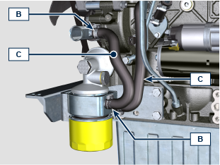
Loosen the clamps B and remove the hoses C .

NOTE: the oil cooler has various configurations and can be installed also on the intake side.  Unscrew the screws E1 and clamps B1 if present. | 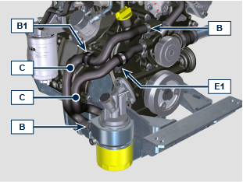
Fan and belt | 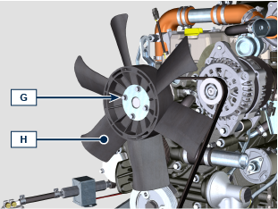
Unscrew the screws G and remove the fan H .
Remove the belt L using ST_57 tool. | 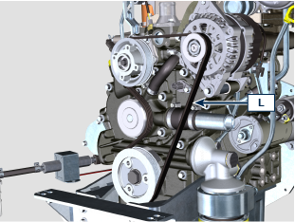  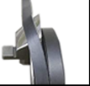  DISASSEMBLING
Coolant pump | 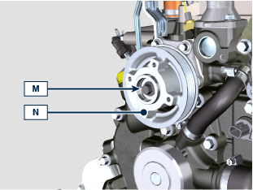
Unscrew the screw M and remove the pulley N .
Loosen the clamps B and remove the hose C . | 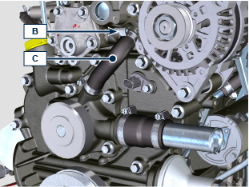
Do not disassemble the flange R .  NOTE:  the flange R for pulley N can be intalled in various positions based from engine specification, each configuration has a specific belt and pulley.  It is not necessary to remove the flange R for pulley N to proceed with following operations below.  In case of flange disassembling, take note of its original position to avoid a wrong positioning at the assembling.  + Apply Loctite 242 on the thread of screws (tightening torque 10 Nm ). §  Unscrew the screws P and remove the coolant pump Q . | 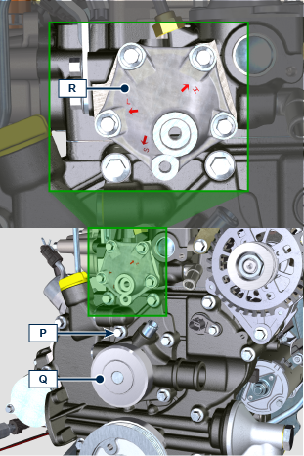
Thermostatic valve | 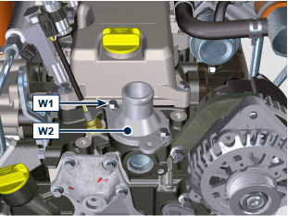
Unscrew the screws W1 and remove the cover W2 .
Remove the thermostatic valve W3 . | 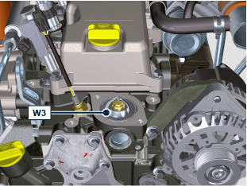
+ Thermostatic valve specifications

Opening start |  | Opening stop
0.1 mm | @ 80° C | 7 mm | @ 95° C

Radiator support | 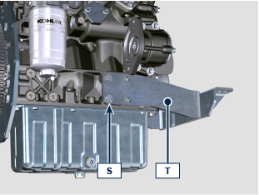
Unscrew the screws S and remove the radiator support T .
ASSEMBLING
Radiator support | 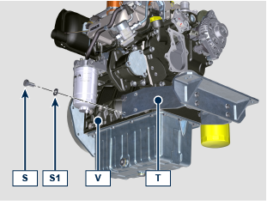
Fix the radiator support T on the crankcase V using the screws S and washers S1 (tightening torque 45 Nm ).
Thermostatic valve | 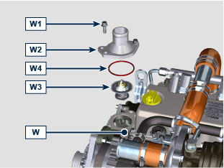
Place the thermostatic valve W3 inside the seat of cylinder head W .
Place the gasket W4 inside the seat of cover W2 .

+ Apply Loctite 270 on the thread of screw W1 . §

Fix the cover W2 with gasket W4 on the cylinder head W using the screws W1 (tightening torque 10 Nm ).

NOTE: make sure that the gasket W4 stays in its seat during cover W2 assembly process.
Coolant pump | 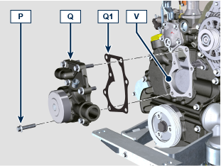
Fix the coolant pump Q on the crankcase V with the gasket Q1 using the screws P (tightening torque 25 Nm ).
Install components N1 , N2 inside pulley N .  + Apply Loctite 242 on the thread of screw M . §  Fix the pulley N on flange R using the screw M (tightening torque 25 Nm ). | 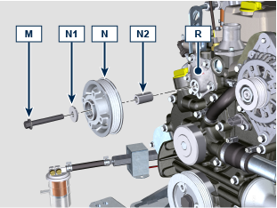
Fan and belt | 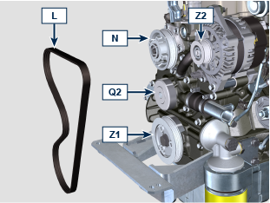  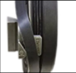  INSTALLING
Install the new belt A on pulleys N , Q2 , Z1 , Z2 using the ST_57 tool.
+ Apply Loctite 242 on the thread of screw G . §  Fix the fan H with the plate H1 and the spacer H2 on pulley N (tightening torque 10 Nm ).  NOTE: the spacer H2 can be different based on engine specification. | 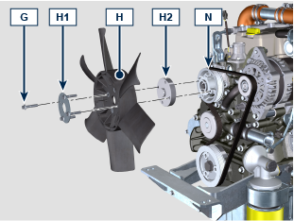
Oil Cooler hoses
Fix the hoses C using the clamps B .
NOTE: the oil cooler has various configurations and can be installed also on the intake side.

Fix the clamps B1 using screws E1 if present.
Radiator NA - TC model | 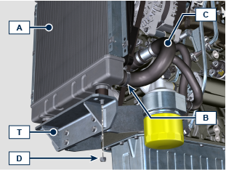
Place the radiator A on support T .
Fix the radiator A using nuts D (tightening torque 25 Nm ).
Fix the hoses C using the clamps B .

Place the rods F1 , F2 for the radiator fixing A .  Fix the rods F1 , F2 using the nuts D with washers D1 and screws E (tightening torque 10 Nm ). | 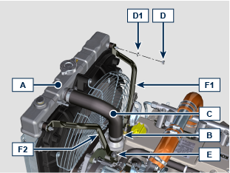
Radiator TCA model | TBD

Exhaust line

NA Model | TBD
TC - TCA Model | 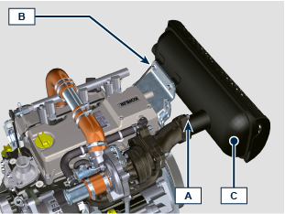
Muffler option A §
DISASSEMBLING

Unscrew the nuts A .
Unscrew the screws B and remove the muffler C .
ASSEMBLING  Fix the muffler C on the bracket C1 using the screws B (tightening torque xx Nm ).  Fix the muffler C on the flange D1 using the nuts A (tightening torque xx Nm ). | 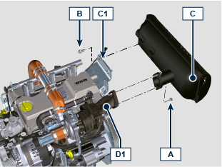
Turbocharger | 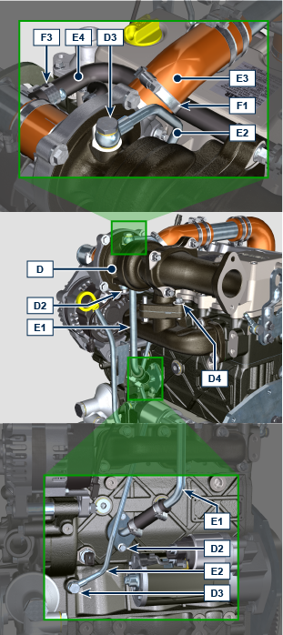
DISASSEMBLING

Unscrew the screws D3 and remove the tube E2 .
Unscrew the screws D2 and remove the tube E1 .
Loosen the clamp F1 and disconnect the hose E3 .
Loosen the clamp F3 and disconnect the hose E4 .
Unscrew the nuts D4 and remove the turbocharger D .
ASSEMBLING  Place the turbocharger D on the interfacing falnge of exhaust manifold H . | 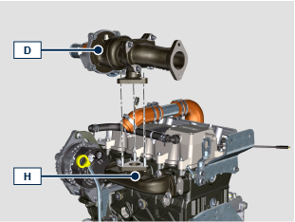
Fix the turbocharger D on the exhaust manifold H using the nuts D4 (tightening torque 25 Nm ).  Connect the hose E3 with the turbocharger D and fix it using the clamp F1 .  Place the tube E2 on the turbocharger D and the crankcase G with screws D3 and copper washers D5 .  Fix the tube E2 using the screws D3 (tightening torque 1 5 Nm ).  Place the tube E1 on the crankcase G and under the turbocharger D with screws D2 and gskets E5 , E6 .  Tighten the screws D2 (tightening torque 10 Nm ). | 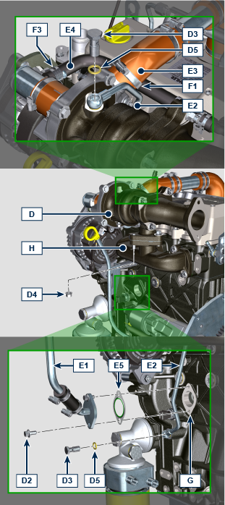  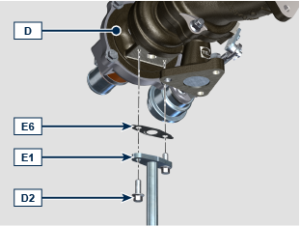
Only for TC model | 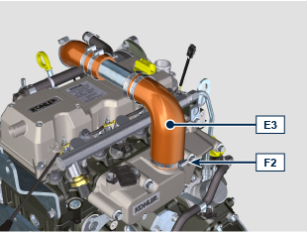
DISASSEMBLING

Loosen the clamp F2 and remove the hose E3 . §

ASSEMBLING  Connect the hose E3 with the inlet manifold L and fix it using the clamp F2 . | 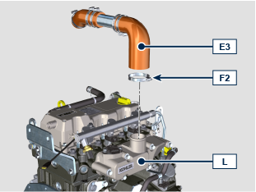

Fuel System

Fuel feed pump
Electric fuel feed pump § | 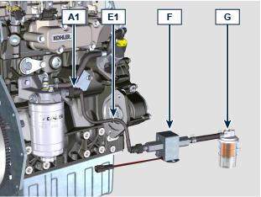
DISASSEMBLING

Disconnect the junction A1 and remove the tube E1 with the pump F and the pre-filter G .
ASSEMBLING  Connect the junction A1 on the filter D .  Check the condition of tubes F and pre-filter G . | 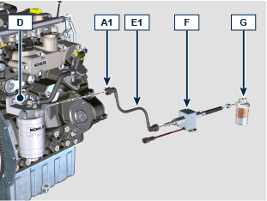
Mechanical fuel feed pump § | 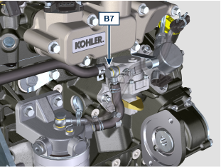  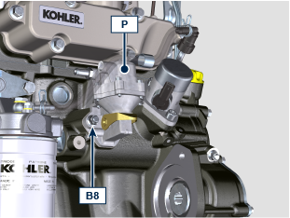
DISASSEMBLING

Unscrew the screw B7 .
Unscrew the nuts B8 and remove the pump P .
ASSEMBLING  Place the pump P with gasket P1 on the crankcase Q .  Fix the pump P on the crankcase Q using the nuts B8 (tightening torque 25 Nm ).  Fix the tube E3 on the pump P using the screw B7 with copper washers B9 (tightening torque 15 Nm ). | 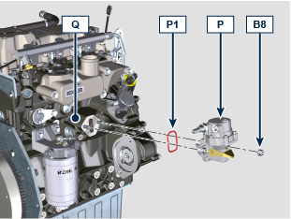  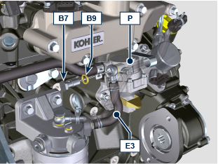
Fuel filter
DISASSEMBLING  Disconnect the connector A1 from the injection pump A .  Unscrew the screw B1 .  Unscrew the screws B2 and remove the fuel filter D with the tube C . | 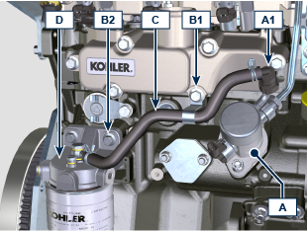
ASSEMBLING  Fix the fuel filter D using the screws B2 (tightening torque 25 Nm ).  Conect the connector A1 on the injection pump A .  Fix the tube C using the screw B1 (tightening torque 25 Nm ). | 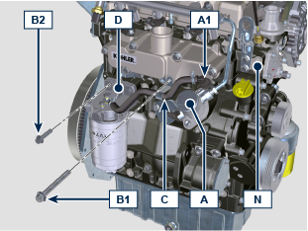
Rail §
DISASSEMBLING  Unscrew the nuts A2 , A3 and remove the tube E2 from the rail H and injection pump A . | 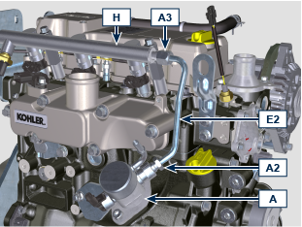
Remove the lockers H2 .  Unscrew the screws B2 and remove the spacers H1 and the rail H . | 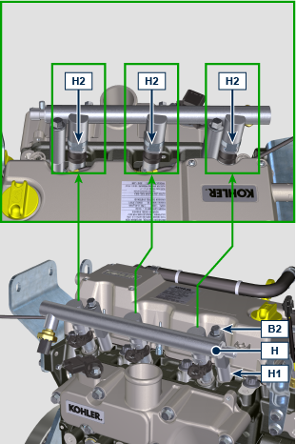
ASSEMBLING  + Apply oil EMI-385 on injector gaskets. §  Place the rail H on the injectors L . | 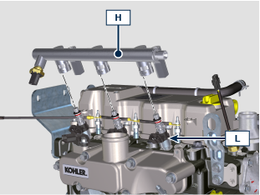
Install the lockers H2 on the rail H . | 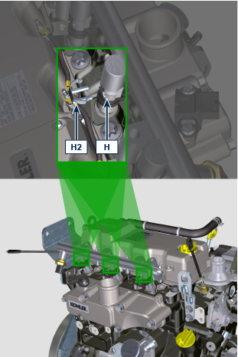
Place the spacers H1 under the rail H and fix the rail H using the screws B2 (tightening torque 25 Nm ). | 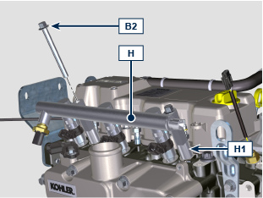
Place the tube E2 on the injection pump A and Rail H , screw the nuts A2 , A3 .
Tight the nut A2 (tightening torque 28 Nm ).
Tight the nut A3 (tightening torque 28 Nm ).
Electronic injectors
DISASSEMBLING  Place the the sockets L1 of the tool ST_48 on the injectors L .  Fix the nuts B3 on the cylinder head N . | 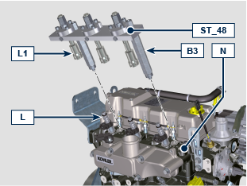
Install the lockers L2 on the sockets L1 to lock the injectors L . | 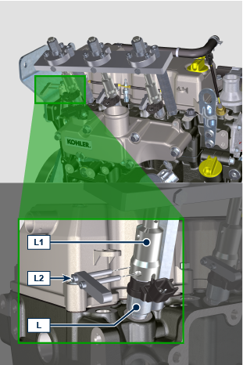
Unscrew the nuts B4 to extract the injectors L from the cylinder head N . | 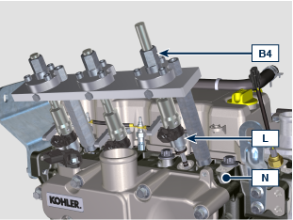
ASSEMBLING  + In case of injector reinstallation: before the reinstallation, replace all injector gaskets. §  + Apply oil EMI-385 on injector gaskets. §  Place the injectors L inside the cylinder head N .  Place the sockets L1 of the tool ST_48 on the injectors L .  Place the washers B6 under the nuts B3 and fix the nuts B3 on the cylinder head N . | 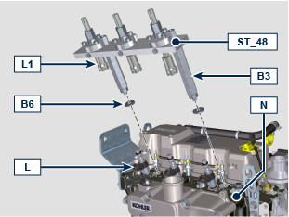
Install the lockers L2 on the sockets L1 to lock the injectors L .  Screw the nuts B4 to install the injectors L inside the cylinder head N . | 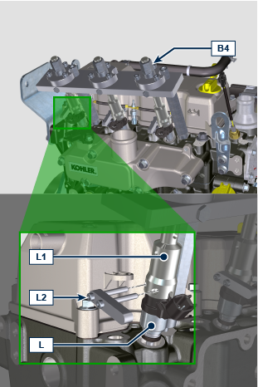
Injection pump
DISASSEMBLING  Unscrew the screws B5 and remove the injection pump A . | 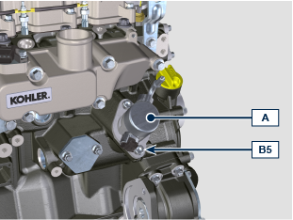
ASSEMBLING  Install the roller tappet A4 inside the crankcase M if not allready present.  Place the injection pump A on the crackcase M .  + Fix the pump A using the screws B5 respecting the tightening cycle below listed:  - cycle 1: 15 Nm  - cycle 2: 2 5 Nm | 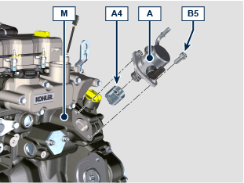

Sensors and Switches

T-MAP Sensor (only for model TC - TCA)
DISASSEMBLY  Unscrew the screws A1 and remove the sensor A . | 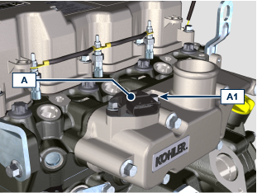
ASSEMBLY  Place the sensor A on the intake manifold A3 .  Fix the sendor A using the screws A1 (tightening torque 10 Nm ). | 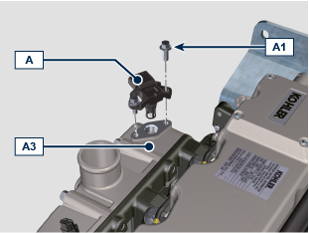
RPM Sensor
DISASSEMBLY  Unscrew the screw B1 and remove the sensor B . | 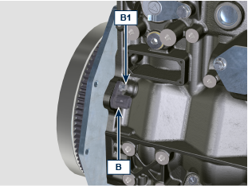
ASSEMBLY  Place the sensor B on the crackcase B3 with the shim B2 .  Fix the sensor A using the screw B 1 (tightening torque xx Nm ). | 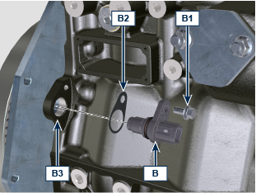
Phase Sensor
DISASSEMBLY  Unscrew the screw C1 and remove the sensor C . | 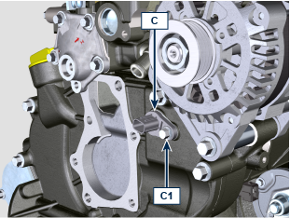
ASSEMBLY  Place the sensor C on the carter C4 with the shim C2 .  + Apply Loctite 242 on the thread of screw C1 . §  Fix the sensor C using the screw C1 (tightening torque 10 Nm ). | 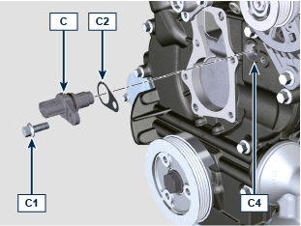
Coolant temperature Sensor
DISASSEMBLY  Unscrew and remove the sensor D . | 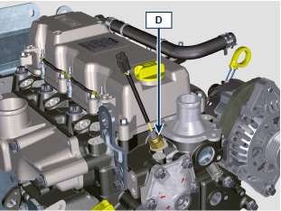
ASSEMBLY  Fix the sensor D with the gasket D1 on the cylinder head D2 (tightening torque 12 Nm ). | 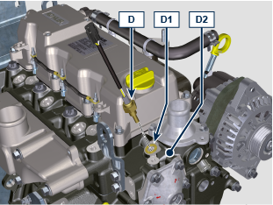
Oil Pressure Switch
DISASSEMBLY  Unscrew and remove the switch E . | 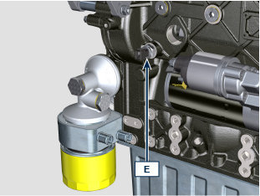
ASSEMBLY  Fix the switch E on the crankcase E1 (tightening torque 25 Nm ). | 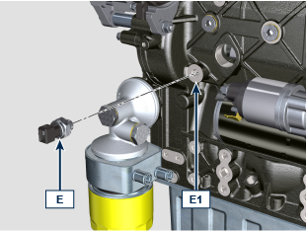

Electrical components

Starter Motor
DISASSEMBLY  Unscrew the screws A and remove the motor B . | 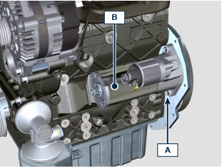
ASSEMBLY  Fix the motor B to the flanging plate/bell C using the screws A (tightening torque 25 Nm ). | 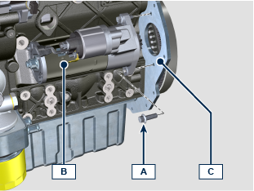
Voltage alternator
Alternator 45A | 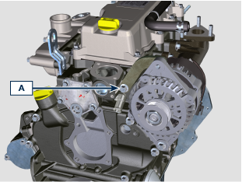
DISASSEMBLY

Unscrew the screw A .
Unscrew the nut B and remove the alternator C . | 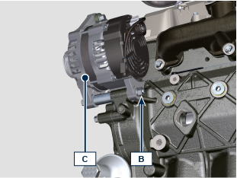
ASSEMBLY  Place the alternator C on the crankcase D , install the screw B4 inside the fixing hole and install the spacer B3 .  Screw the nut B with the washer B1 on the screw B4 . | 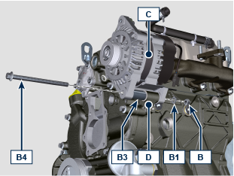
Fix the bracket C1 on the cylinder head E using the screw A (tightening torque 25 Nm ).  Fix the alternator C using the nut B and the screw B4 (tightening torque 25 Nm ). | 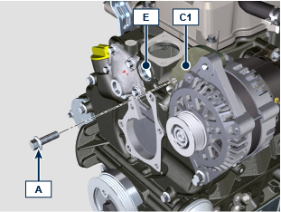
Alternator 80A - 100A § | 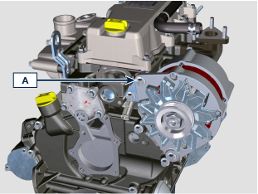
DISASSEMBLY

Unscrew the screw A .
Unscrew the nut B and remove the alternator C . | 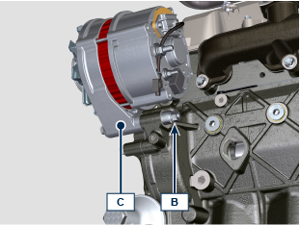
ASSEMBLY  Place the alternator C on the crankcase D , install the screw B4 inside the fixing hole and install the spacer B3 .  Screw the nut B with the washer B1 on the screw B4 . | 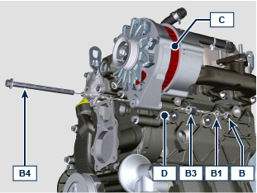
Fix the alternator C using the screw A , the nut A1 with the washer A2 on the bracket C1 (tightening torque 25 Nm ).  Fix the alternator C using the nut B and the screw B4 (tightening torque 25 Nm ). | 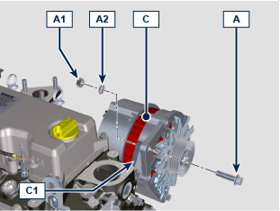
Glow plugs
DISASSEMBLY  Unscrew the nuts A and remove the cables B1 , B2 . | 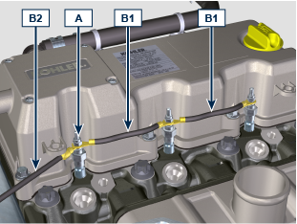
Unscrew and remove the glow plugs C . | 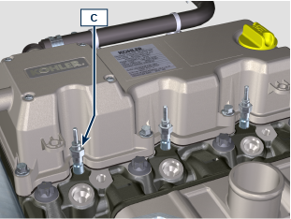
ASSEMBLY  Install and fix the glow plugs C on cylinder head D (tightening torque 15 Nm ). | 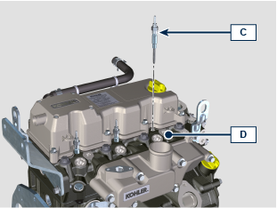
Fix the cables B1 , B2 on the glow plugs C using the nuts A (tightening torque 2.5 Nm ).

Intake manifold

DISASSEMBLY  Unscrew the screws A and remove the manifold B . | 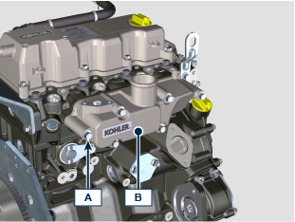
ASSEMBLY  Place the manifold B on the cylinder head C using the tool ST_18 .  Fix the manifold B and the gasket B1 on the cylinder head C using the screws A (tightening torque 25 Nm ). | 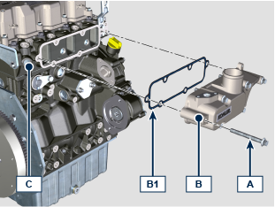

Exhaust manifold

DISASSEMBLY  Unscrew the nuts A and remove the manifold B . | 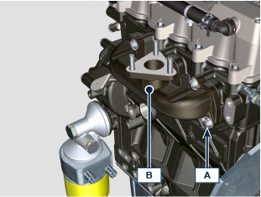
ASSEMBLY  Place the gaskets B1 and the manifold B on the cylinder head C using the studs B2 .  Fix the manifold B on the cylinder head C using the nuts A (tightening torque 25 Nm ). | 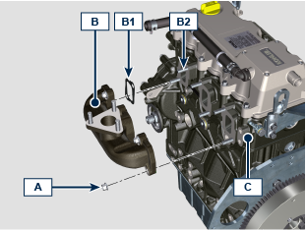

PTOs

1st PTO
Flywheel
DISASSEMBLY  Install the tool ST_16 on pulley C .  Install the component T3 on the crankcase D using the screws T2 entering the component T4 inside the groove of the component T3 .  Fix the screws T5 to lock the pulley C to the tool ST_16 .  NOTE: in this way the crankshaft is locked. | 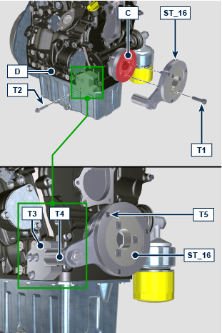
Unscrew the screw A and remove the flywheel B . | 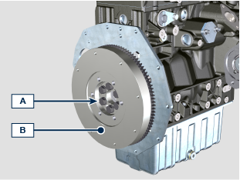
ASSEMBLY  Place the flywheel B on the crankshaft C using the ST_46 .  Fix the flywheel B on the crankshaft C using the screws A (tightening torque 140 Nm ). | 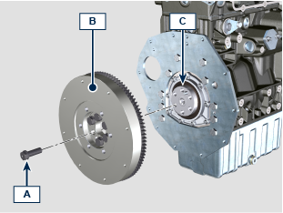
Flanging plate
DISASSEMBLY  Unscrew the screws A and remove the plate B . | 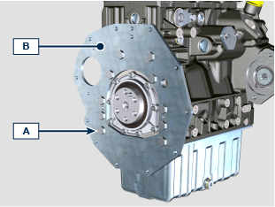
ASSEMBLY  Place the plate B on the crankcase C .  NOTE: use the proper reference pins.  Fix the plate B on the crankcase C using the screws A (tightening torque 45 Nm ). | 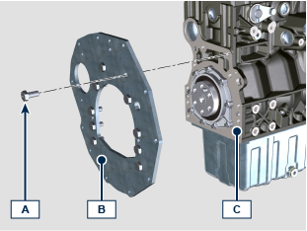
Flanging bell (TBD)
DISASSEMBLY  Unscrew the screws A and remove the bell B . | TBD
ASSEMBLY

Place the bell B on the crankcase C .

NOTE: use the proper reference pins.

Fix the bell B on the crankcase C using the screws A (tightening torque xx Nm ).
2nd PTO
DISASSEMBLY  Unscrew the screw A and remove the pulley B with the tool ST_16 .  Remove the component T3 from the crankcase D . | 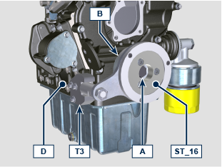
ASSEMBLY  Install the pulley B on the crankshaft C using the screw A .  NOTE: do not fix the screw A .  Install the tool ST_16 on pulley B .  Install the component T3 on the crankcase D using the screws T2 entering the component T4 inside the groove of the component T3 .  Fix the screws T5 to lock the pulley C to the tool ST_16 .  Fix the screws A (tightening torque 360 Nm ). | 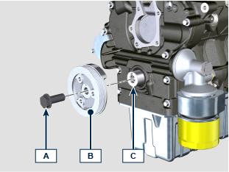  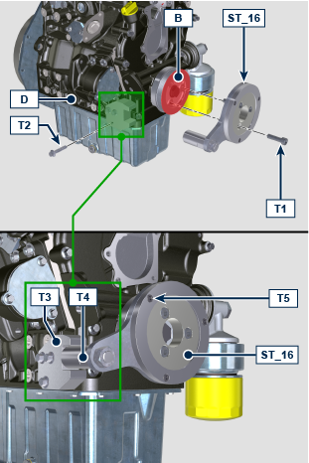
3rd PTO
DISASSEMBLY  Unscrew the nuts A and remove the 3rd PTO B . | 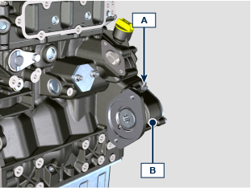
ASSEMBLY  Place the 3rd PTO B on the crankcase C with the gasket B1 .  Fix the 3rd PTO B using the nuts A (tightening torque xx Nm ). | 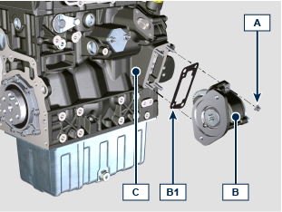

Cylinder head

DISASSEMBLY  Unscrew the screws A1 and remove the cover A . | 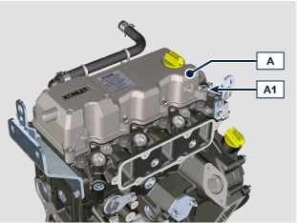
Unscrew the screws B1 and remove the rocker arms B . | 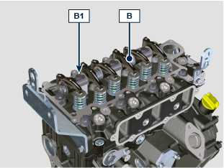
Remove the rods C . | 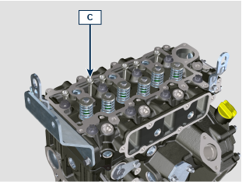
Unscrew the screws D1 and remove the cylinder head D . | 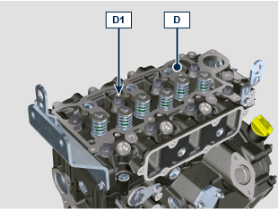
ASSEMBLY  ENTER THE PISTON PROTUSION VALUES TO CHOOSE THE CORRECT HEAD GASKET  Check the tappets E1 are correctly installed inside the crackcase E .  Place the gasket D2 on the crankcase E using the reference pins E2 .  Place the head D on the gasket D2 using the reference pins E2 . | 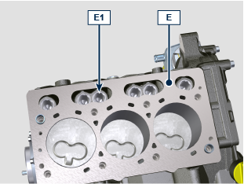  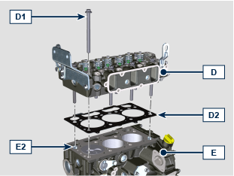
Apply MOLY GREASE on the screw D1 (20 mm from the head bottom )  Tighten the screws D1 respecting the tightening order as per illustration indication at each cycle below listed:  - cycle 1: 10 Nm  - cycle 2: 35 Nm  - cycle 3: 90°  - cycle 4: 90°  - cycle 5: 90°  - cycle 6: 90° | 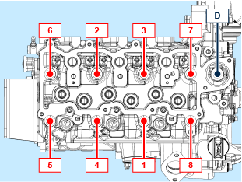
Install the rods C inside the proper niches inside the cylinder head D . | 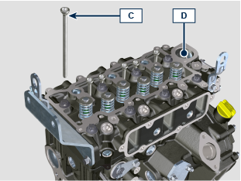
Place the spacers B2 correctly on the valves B3 .  Place the rocker arms B on the head D using the proper reference pins.  Check all spacers B2 are correctly installed on the valves B3 .  + Apply Loctite 242 on the thread of screw B1 . §  Fix the rocker arms B using the screws B1 (tightening torque 25 Nm ). | 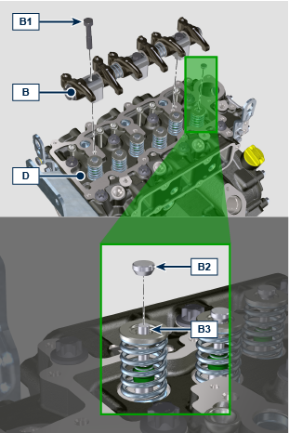
Check the gasket A2 is correctly installed insde its seat inside the cover A .  Place the cover A on the head D using the tool ST_17 .  Place the screws A1 inside the fixing holes. | 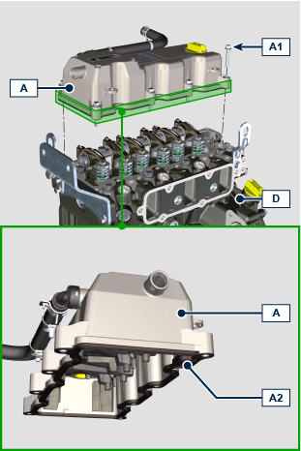
Tighten the screws A 1 respecting the tightening order as per illustration indication ( tightening torque 10 Nm ). | 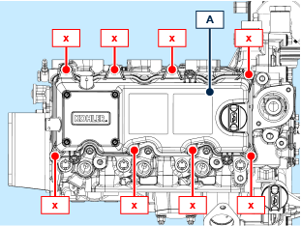

Oil circuit

Oil Cooler
DISASSEMBLY  Unscrew and remove the filter A . | 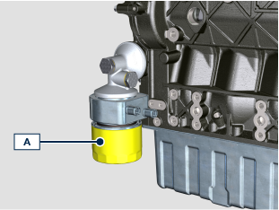
Unscrew the joint C and remove the oil cooler D . | 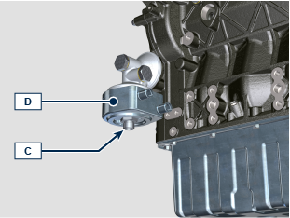
Unscrew th screw E and remove the support F . | 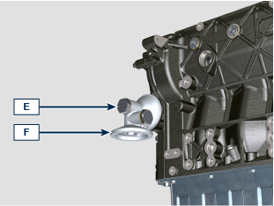
ASSEMBLY  Install the gasket E1 in the proper seat on the screw E .  Install the gasket F1 on the support F .  Fix the support F on the crankcase G using the screw E with the gasket E2 (tightening torque 25 Nm ). | 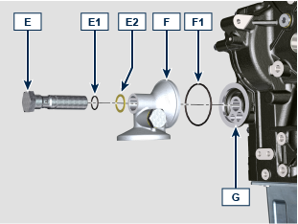
Check the oil cooler gasket is correctly installed.  Fix the oil cooler D on the support F using the joint C (tightening torque 30 Nm ). | 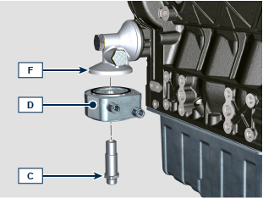
Check the gasket D1 is correctly installed inside the proper seat of the oil filter D .  Tifgten the filter D on the support F (tightening torque 20 Nm ). | 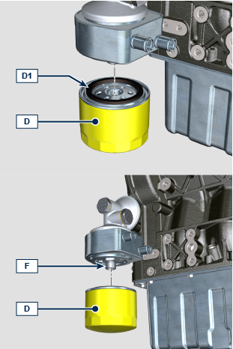
Oil Pressure valve
DISASSEMBLY  Unscrew the plug A and remove the gasket A1 , the spring A2 , the piston A3 from the carter B . | 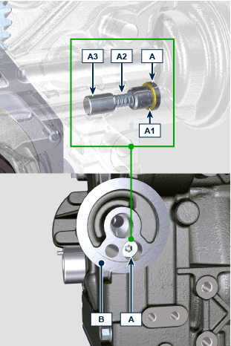
ASSEMBLY  Install the piston A3 , the spring A2 inside the carter B .  Tighten the plug A with the cooper washer A1 on the carter B (tightening torque 17.5 Nm ). | 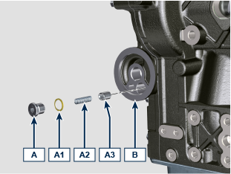
Oil sump
DISASSEMBLY  Unscrew the screws A1 and remove the oil sump A .  NOTE: Use a metal sheet/spatula between the crankcase and oil sump to detach them. | 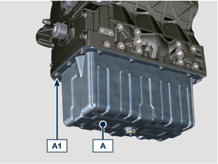
Unscrew the screw B1 .  Unscrew the screw B2 and remove the tube B .  Unscrew the screws C1 and remove the plate C . | 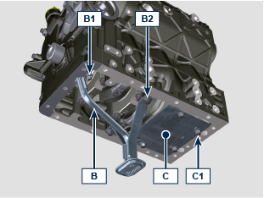
ASSEMBLY  Install the gaskets B3 inside the proper seat of the tube B .  Place the tube B installing it inside the oil inlet hole of the crankcase D .  + Apply Loctite 242 on the thread of screw B 1, B2 . §  Fix the tube B using the screws B2 (tightening torque 25 Nm ).  Fix the tube B using the screws B1 (tightening torque 10 Nm ). | 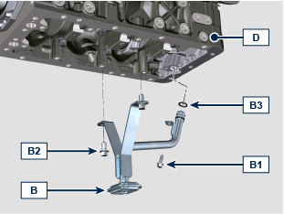
+ Apply Loctite 242 on the thread of screw C1 . §  Fix the plate C using the screws C1 (tightening torque 25 Nm ). | 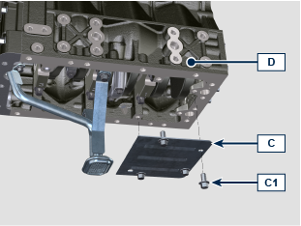
Apply about 2.5 mm cord of sealant S ( Loctite 5699 ) on the oil sump A as per illustration.

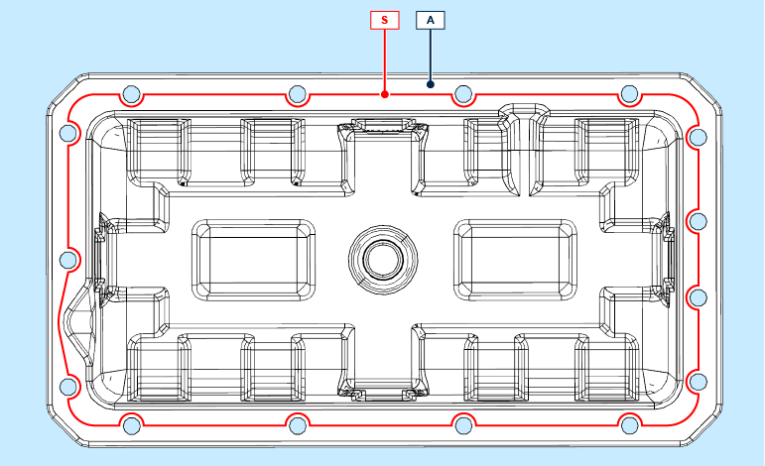
Place the oil sump A on the crankcase sulbasamento D using the tool ST_18 .  + Apply Loctite 242 on the thread of screw A1 . §  Fix the oil sump A on the crankcase D using the screws A1 (tightening torque 25 Nm ). | 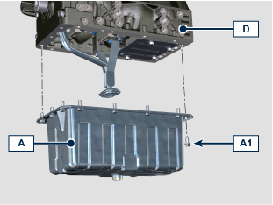
Timing gear cover (oil pump)
DISASSEMBLY  Unscrew the screws A1 and remove the carter A . | 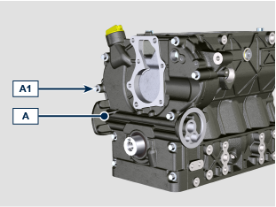
ASSEMBLY

Apply about 2.5 mm cord of sealant S ( Loctite 5699 ) on the carter A as per illustration.

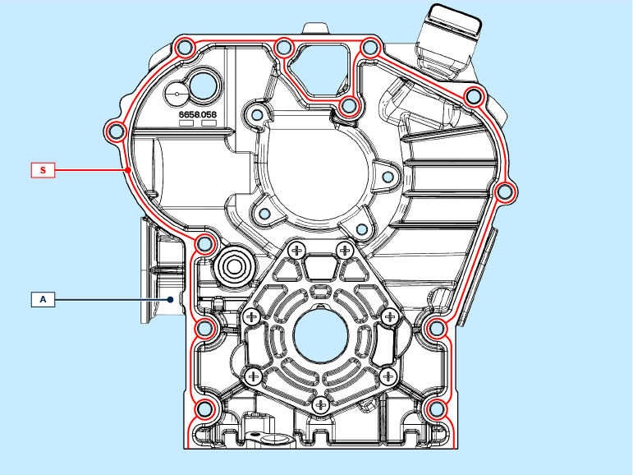
Place the gasket A3 in the proper seat of the carter A .  Install the gasket A2 on the carter A using the tool ST_58 .  Place the carter A on the crankcase B using the tool ST_18 . | 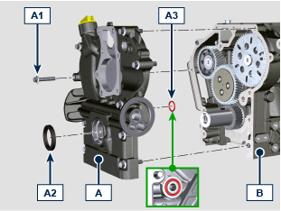
+ Apply Loctite 242 on the thread of screw A1 . §

Fix the carter A on the crankcase B using the screws A1 respecting the fixing order as per illustration indication (tightening torque 25 Nm ).

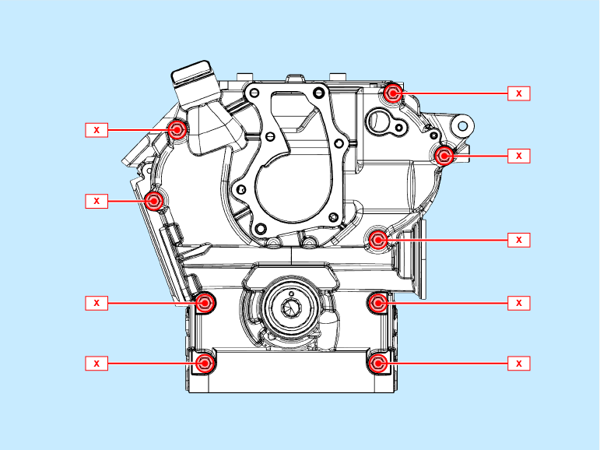

Crankcase

Timing gear (camshafts)
DISASSEMBLY  Remove the tappets D1 from the crankcase D . | 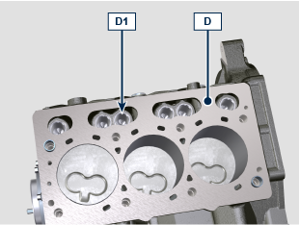
Unscrews the screws A1 and remove the gear A . | 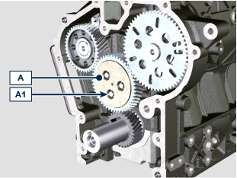
Unscrews the screws B1 and remove the shaft B .  Unscrews the screws C1 and remove the shaft C . | 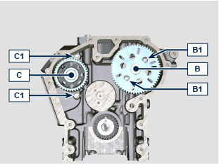
ASSEMBLY  Install the shaft C inside the crankcase D .  + Apply Loctite 242 on the thread of screw C1 . §  Fix the shaft C using the screws C1 (tightening torque 10 Nm ). | 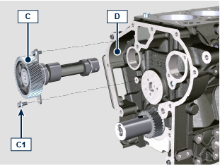
Install the shaft B inside the crankcase D .  + Apply Loctite 242 on the thread of screw B1 . §  Fix the shaft B using the screws B1 (tightening torque 10 Nm ). | 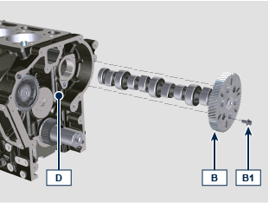
Install the gear A2 on the support A .  Install the washer A3 on the support A . | 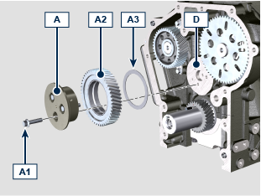
Place the gear A2 on the crankcase D aligning the references as per illustration.

+ Apply Loctite 242 on the thread of screw A1 . §

Fix the support A on the crankcase D using the screws A1 (tightening torque 10 Nm ).

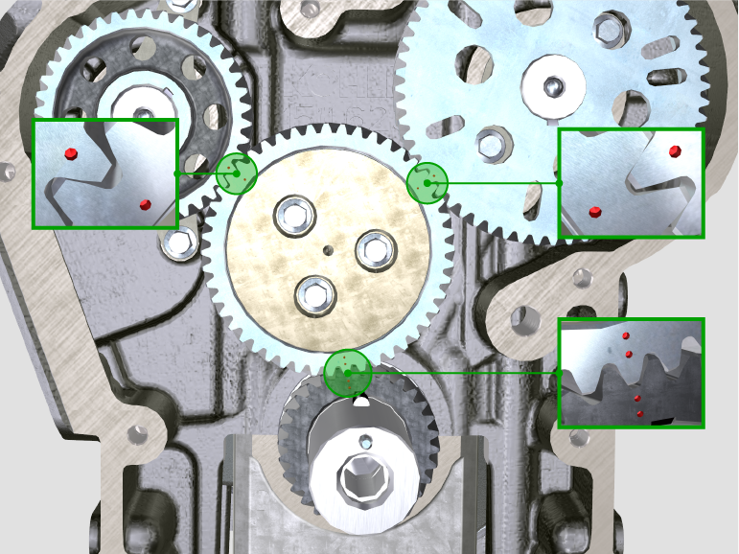
Crankshaft seal support - flywheel side
DISASSEMBLY  Unscrew the screws A1 and remove the flange A . | 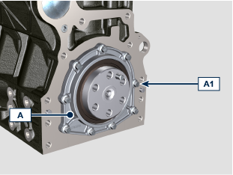
ASSEMBLY  Install the gasket A2 inside the flange A using the tool ST_42 .  Place the flange A on the crankcase B . | 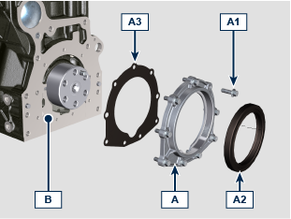
+ Apply Loctite 242 on the thread of screw A1 . §  Fix the flange A using the screws A1 respecting the fixing order as per illustration (tightening torque 10 Nm ). | 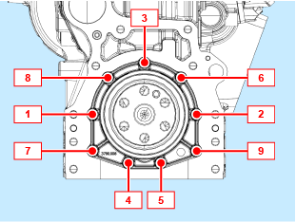
Conrod and piston
DISASSEMBLY  Unscrew the screws B4 and remove the conrod caps B1a , B2a , B3a . | 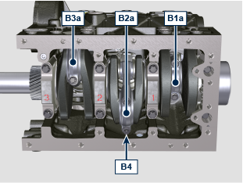
Extract the conrod and piston P from the crankcase C . | 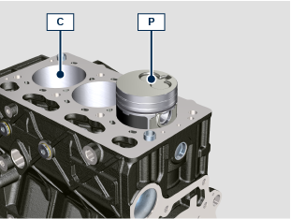
Replace the bearings D on B1a , B2a , B3a, B1b , B2b , B3b .  NOTE: the bearing position D on B1a , B2a , B3a, B1b , B2b , B3b must be centered as per illustration.  Install B1a , B2a , B3a su B1b , B2b , B3b using the screws B4 .  NOTE: do not tighten the screws B4 . | 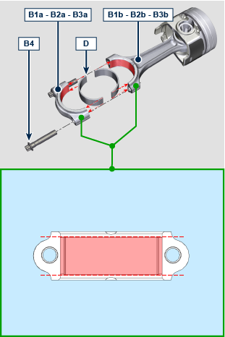
Check the conrod and piston groups P , weight difference must not exceed 10 gr .  Unscrew the screws B4 and remove B1a , B2a , B3a da B1b , B2b , B3b . § | 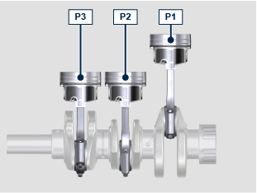
ASSEMBLY  Rotate the crankshaft D moving the crankpin D1 at BDC . | 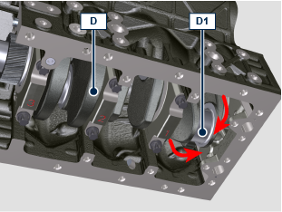
The combustion chamber H of the piston must be oriented towards the inlet manifold. | 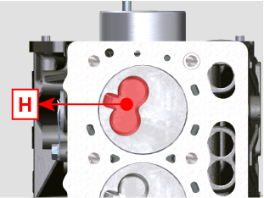
+ Lubricate the piston mantle, segments, conrod bearings and cylinder surface with engine oil 15W-40 .  Install the conrod and piston groups P about 10 mm of the piston skirt. | 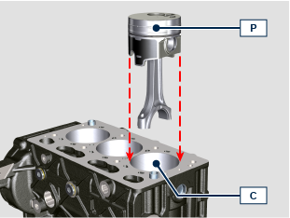
Align the gudgeon pin axle with engine center axle.  Rotate the piston P about 15° anticlockwise. | 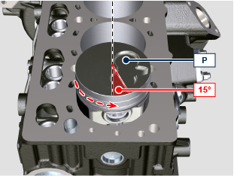
This operation avoid the conrod impact against the oil sprayer E during the conrod and piston installation inside the cylinder C .  Gently push the piston in the cylinder C paying attention to the sprayer E . | 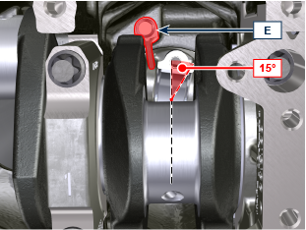
+ Lubricate the crankpins with engine oil 15W-40 .  + Apply BRB100 MOLY GREASE under the screw head P1c .  Place the conrod P1a on crankpin D1 .  Install the cap P1b using the screws P1c .  NOTE: the caps P1b have the mating plan fractured, each cap can be mate with its origin conrod P1a , pay attention to the right mating.  + Tighten the screws P1c respecting the tightening cycle below listed:  - cycle 1: 5 Nm  - cycle 2: 20 Nm  - cycle 3: 33°  - cycle 4: 33° | 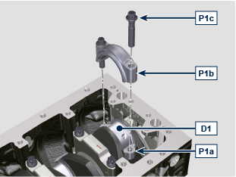
Piston
DISASSEMBLY  Remove the lock ring R and extract the gudgeon pin G from the piston P . | 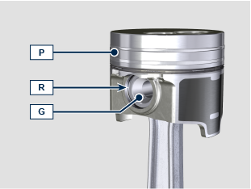
Remove the rings S1 , S2 , S3 from the piston P . | 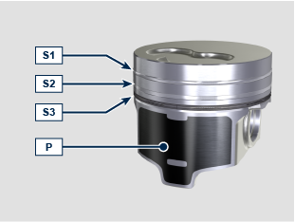
ASSEMBLY  Install the rings S1 , S2 , S3 on the piston P . | 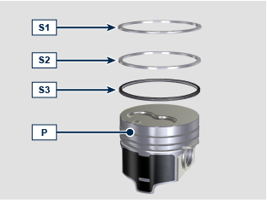
+ Apply MOLYSLIP on gudgeon pin G .  Mate the conrod P1a with the piston P and install the gudgeon pin G .  Install the lock rings R to lock the gudgeon pin G . | 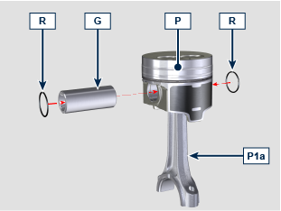
Crankshaft
DISASSEMBLY  Take note of caps A1 , A2 , A3 marking their position on the crankcase.  Unscrew the screws A and remove the caps A1 , A2 , A3 , A4 .  Remove the crankshaft B . | 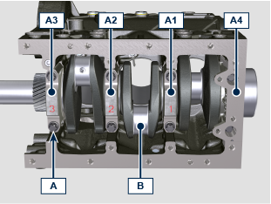
Unscrew the screws C1 and remove the sprayers C2 . | 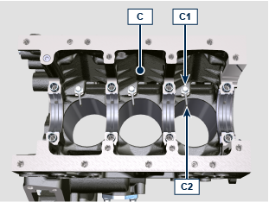
Remove the bearings C3 , C4 . | 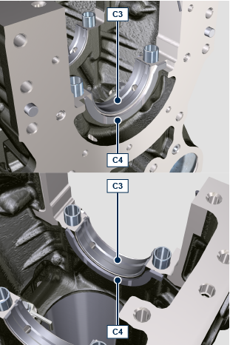
Remove the bearings C5 , C4 from the caps A1 , A2 , A3 , A4 . | 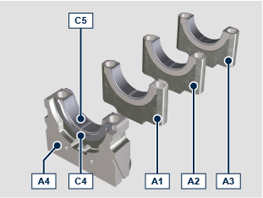
ASSEMBLY  Fix the sprayers C2 on the crankcase C using the screws C1 (tightening torque 8 Nm ). | 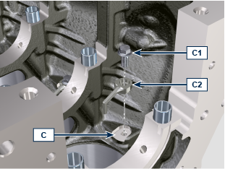
Install the bearings C3 on crankcase C seats respecting the notches C3a and make sure the oil delivery holes C3b is matching with the crankcase ones. | 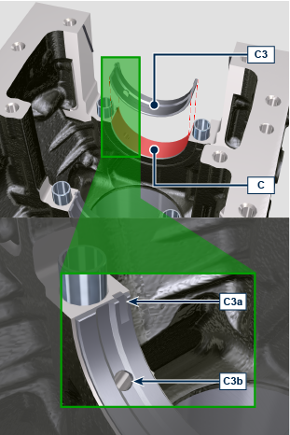
Install the bearings C4 on the crankcase C seats. | 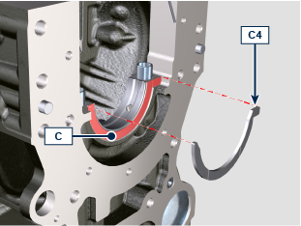  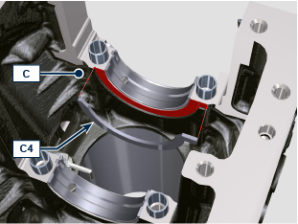
Install the crankshaft B on the bearings C3 . | 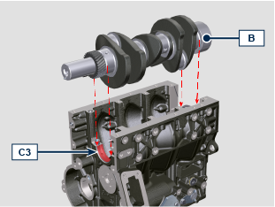
Install the bearings C5 on caps A1 , A2 , A3 seats respecting the notches C5a . | 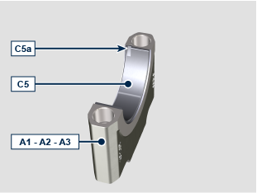
Install the caps A1 , A2 , A3 on the crankcase C respecting their original position using the screws A .  + Apply MOLYSLIP under the screw head A  + Tighten the screws A respecting the tightening cycle below listed:  - cycle 1: 15 Nm  - cycle 2: 45°  - cycle 3: 45° | 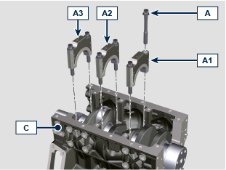
Install the bearing C5 on cap A4 seat respecting the notch C5a . | 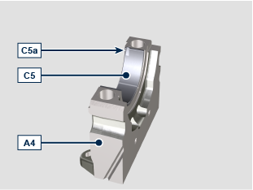
Install the bearings C4 on the cap A4 seat. | 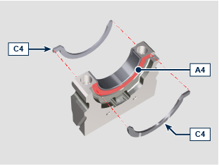
Install the gaskets A4a inside the proper seat on cap A4 and keep in position using the tool ST_49 .  Install the cap A4 inside the crankcase C paying attention to not cut the gasket A4a during installation.  Install the cap A4 using the screws A .  + Apply MOLYSLIP under the screw head A  + Tighten the screws A respecting the tightening cycle below listed:  - cycle 1: 15 Nm  - cycle 2: 45°  - cycle 3: 45° | 